# **Report Assignment2**

Team :

Venkatesh Duvvuri ([VED14@pitt.edu](mailto:VED14@pitt.edu))

Haifa Alnasser([HIA11@pitt.edu](mailto:HIA11@pitt.edu))

Gopi Tata([GKT3@pitt.edu](mailto:GKT3@pitt.edu))

Software Used : R, R Studio

Plot for Spend :

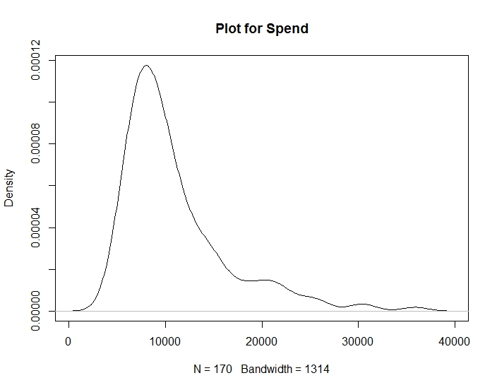

The plot for Spend is not normal. It is a bit Skewed to Right

Plot for apret:

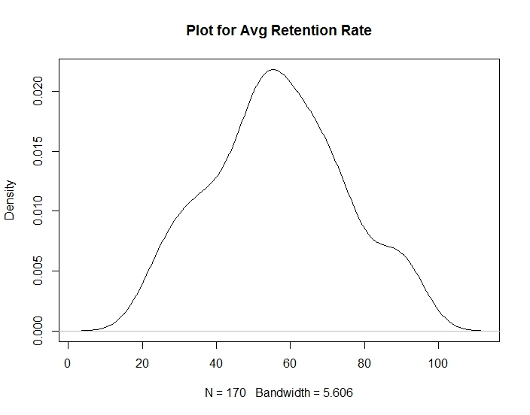

Plot for Retention Rate is not normal

Plot for Top10 :

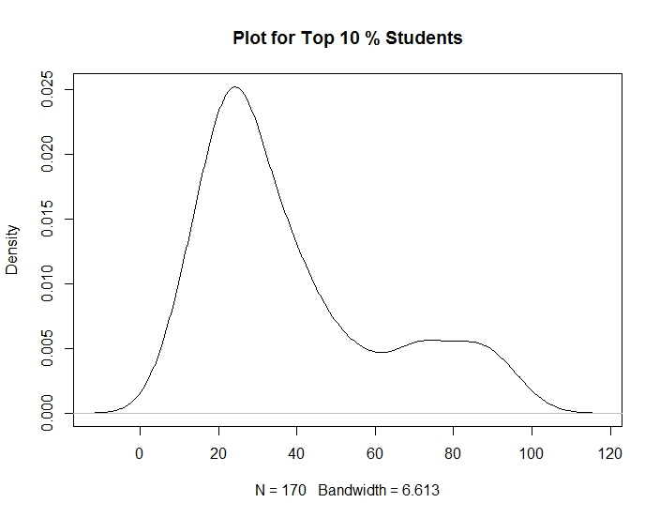

Plot for Top10 is not normal

Plot for Rejection Rate(rejr):

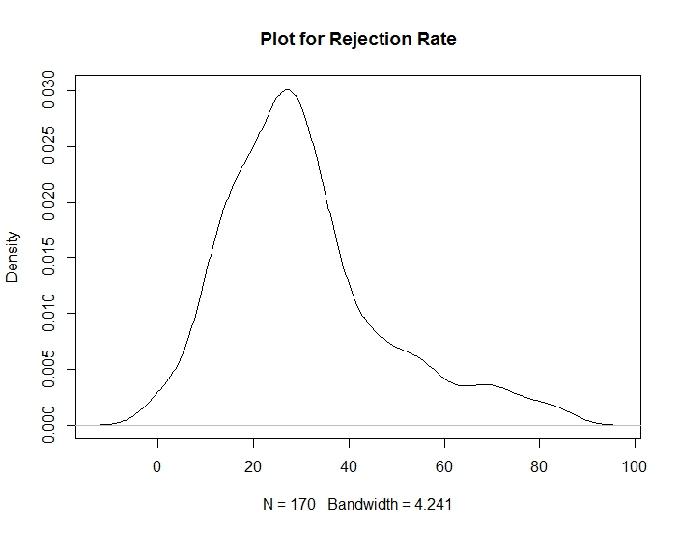

Plot for Rejection Rate is not Normal

Plot for Average Test Scores(tstsc) :

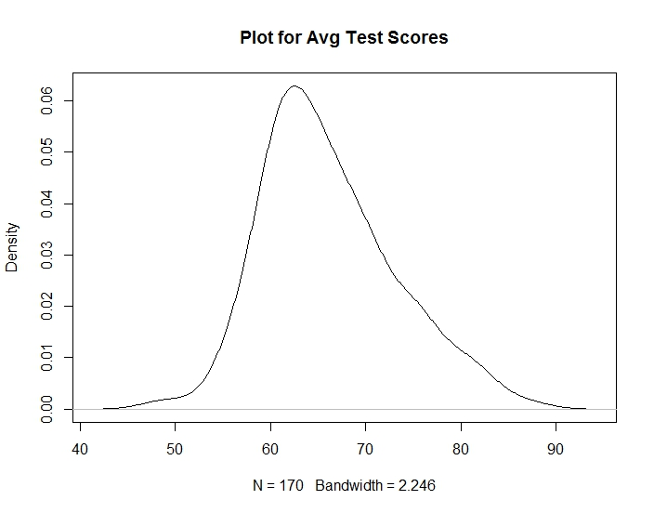

Plot for Average Test Scores is Right Skewed

Plot for % of Admitted Applicants(pacc) :

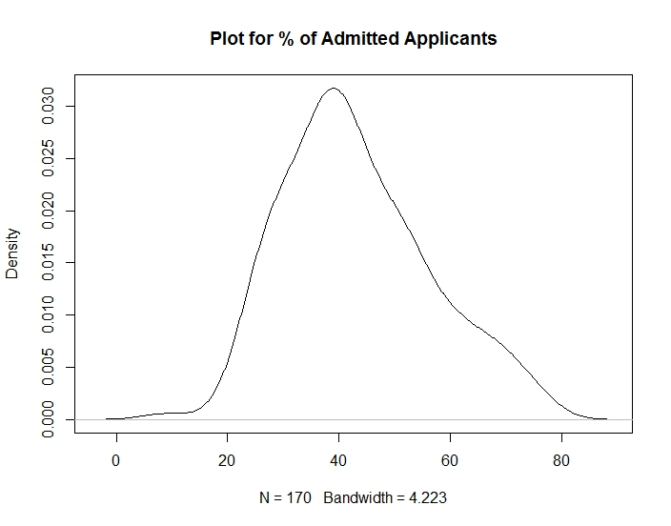

The Plot for Admitted Applicants is a bit Right Skewed

Plot for Student Teacher Ratio(strat) :

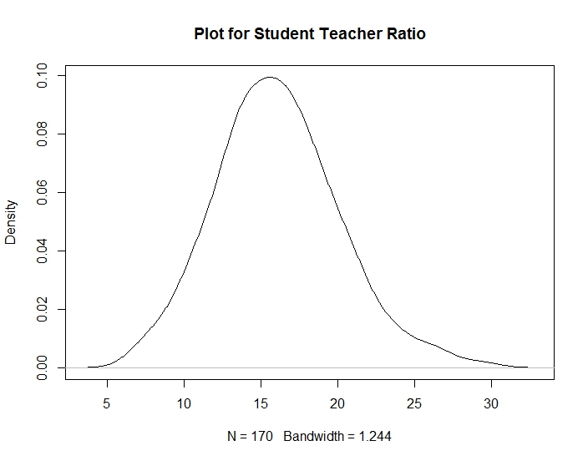

The Plot for Student Teacher Ratio is almost Normal and a bit Right Skewed

Plot for Average Faculty Salary(salar) :

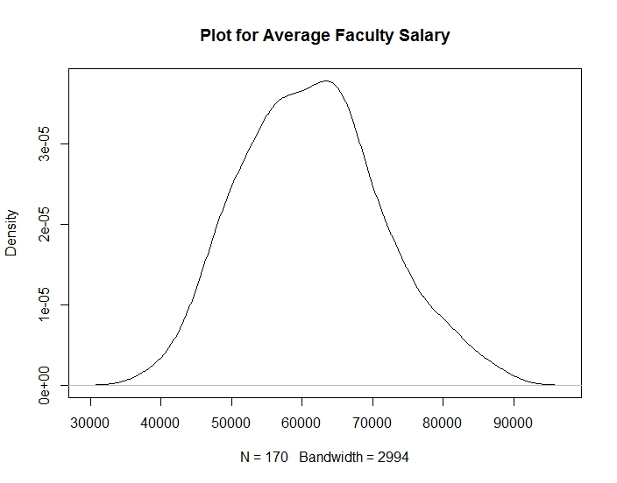

Plot for Average Faculty Salary is almost Normal

1. Descriptive Statistics Summary :

spend apret

Min. : 4125 Min. :18.75

1st Qu.: 7372 1st Qu.:45.37

Median : 9265 Median :55.71

Mean :10975 Mean :56.72

3rd Qu.:12838 3rd Qu.:68.69

Max. :35863 Max. :95.25

top10 rejr

Min. : 8.00 Min. : 0.00

1st Qu.:22.00 1st Qu.:19.17

Median :30.00 Median :27.39

Mean :38.46 Mean :30.65

3rd Qu.:49.50 3rd Qu.:36.81

Max. :98.00 Max. :84.07

tstsc pacc

Min. :48.12 Min. : 8.964

1st Qu.:61.11 1st Qu.:33.904

Median :64.78 Median :40.850

Mean :66.16 Mean :43.173

3rd Qu.:70.45 3rd Qu.:51.773

Max. :87.50 Max. :76.253

strat salar

Min. : 7.20 Min. :38640

1st Qu.:13.40 1st Qu.:54650

Median :16.00 Median :61150

Mean :16.09 Mean :61358

3rd Qu.:18.57 3rd Qu.:67100

Max. :29.20 Max. :87900

Histogram of Average Retention Rate(apret) :

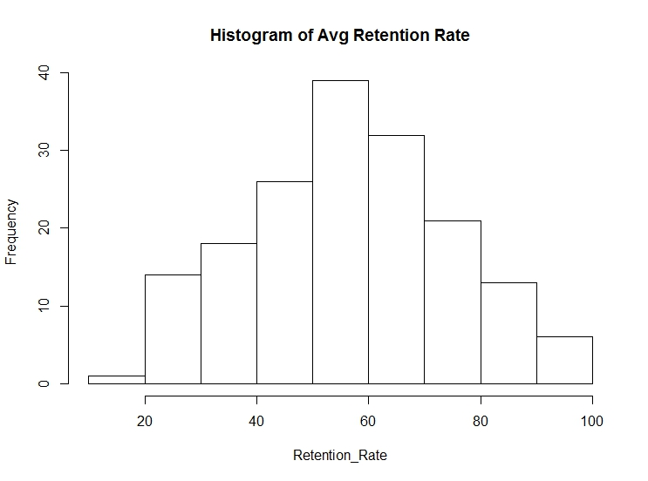

Histogram of Average Test Scores :

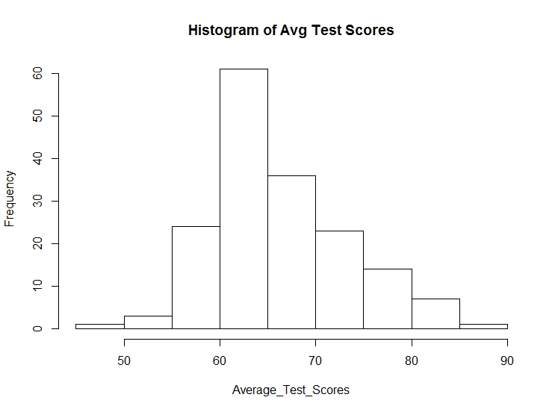

Histogram of Average Faculty Salary:

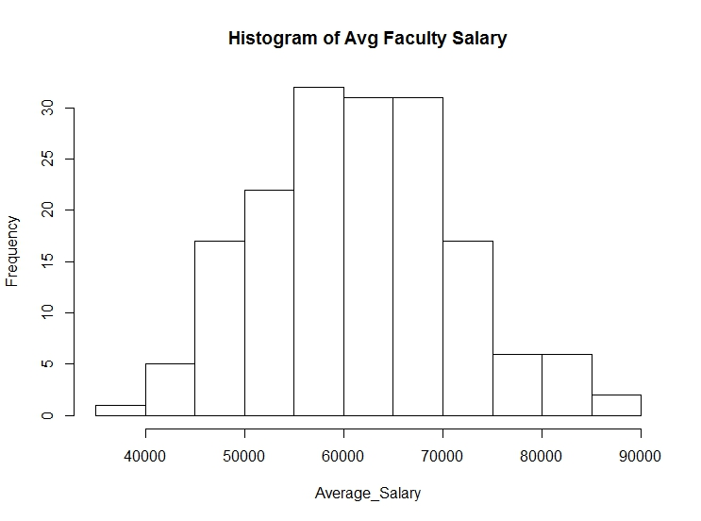

Plot for Regression 1:

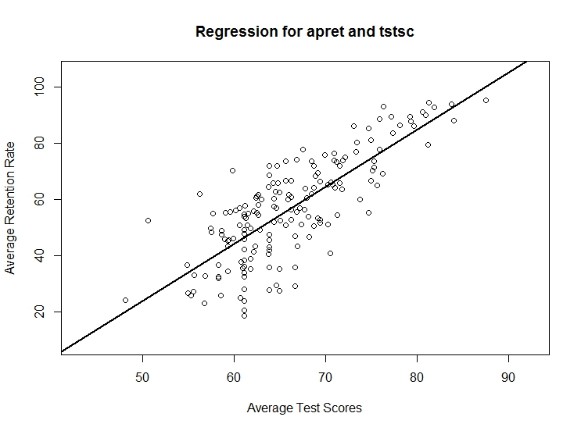

Summary :

Residuals:

Min 1Q Median 3Q Max

-28.490 -7.957 1.857 7.552 27.278

Coefficients:

Estimate Std. Error t value Pr(>|t|)

(Intercept) -77.3999 8.2878 -9.339 <2e-16 ***

retention$tstsc 2.0271 0.1246 16.272 <2e-16 ***---

Signif. codes: 0 ‘***’ 0.001 ‘**’ 0.01 ‘*’ 0.05 ‘.’ 0.1 ‘ ’ 1

Residual standard error: 11.3 on 168 degrees of freedom

Multiple R-squared: 0.6118, Adjusted R-squared: 0.6095

F-statistic: 264.8 on 1 and 168 DF, p-value: < 2.2e-16

* From the above result we can find that the test scores have a significant relation with the apret.
* In the linear regression equation, the value of the intercept is -77.3999

Plot for Regression 2 :

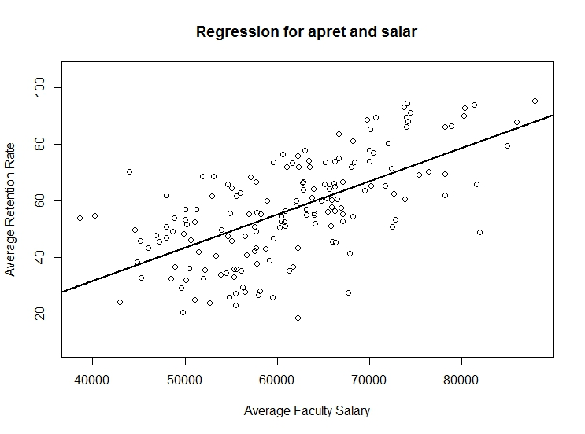

Residuals:

Min 1Q Median 3Q Max

-38.959 -10.170 0.362 11.151 33.965

Coefficients:

Estimate Std. Error t value Pr(>|t|)

(Intercept) -1.522e+01 6.823e+00 -2.231 0.027 *

retention$salar 1.173e-03 1.098e-04 10.678 <2e-16 ***

Signif. codes: 0 ‘***’ 0.001 ‘**’ 0.01 ‘*’ 0.05 ‘.’ 0.1 ‘ ’ 1

Residual standard error: 13.99 on 168 degrees of freedom

Multiple R-squared: 0.4043, Adjusted R-squared: 0.4008

F-statistic: 114 on 1 and 168 DF, p-value: < 2.2e-16

* From the above result we can find that the salary has a significant relation with the apret.
* In the linear regression equation, the value of the intercept is -1.522e+01

Regression 3 :

Residuals:

Min 1Q Median 3Q Max

-29.458 -7.915 1.270 7.777 29.538

Coefficients:

Estimate Std. Error t value Pr(>|t|)

(Intercept) -7.591e+01 8.210e+00 -9.246 <2e-16 ***

retention$tstsc 1.738e+00 1.761e-01 9.868 <2e-16 ***

retention$salar 2.880e-04 1.253e-04 2.298 0.0228 *

---

Signif. codes: 0 ‘***’ 0.001 ‘**’ 0.01 ‘*’ 0.05 ‘.’ 0.1 ‘ ’ 1

Residual standard error: 11.16 on 167 degrees of freedom

Multiple R-squared: 0.6237, Adjusted R-squared: 0.6192

F-statistic: 138.4 on 2 and 167 DF, p-value: < 2.2e-16

* From the above result we can find that both the test scores and the salary have a significant relation with the apret but the significance of the test scores is more with respect to the salary.
* In the linear regression equation, the value of the intercept is -7.591e+01