**System Architecture Diagram**

The Diagram shows an entire view of our system which consists of four components such as Front-end(mobile application), Back-end(website for admin portal), API, and the Database, along with the interaction between each component.

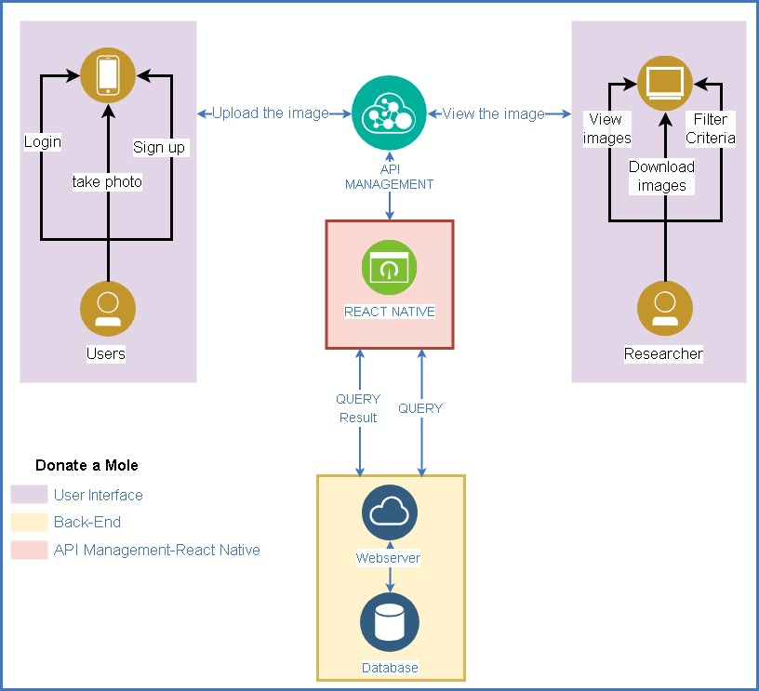

Back-End

The Backend includes the web server and Database which aim to accomplish two functionalities as a mobile application app for Users and the admin portal for Researcher. The backend provides the interface that the information could commute through it, it could store the image which uploads from the front-end users, then be reached by the front-end Researcher. By far, the PHP server has been settled on the UQ cloud and could retrieve the data from users who use the mobile application, then store the image, email address, and password by the individual user.

Front-End Users

The front end composes of two application which is the donate a mole App and the admin portal. The purpose of App is gathering the images from users and then store it to the backend database. The user could review the history of their donations, however, they could not retrieve the image from the other donors. To-date, the fundamental function has been built, which user can upload their image via Donate a mole App, then the image can be reached on the database. The interface could distinguish whether the donor is the member or the anonymous by providing the login page to them.

API