Cost-Sensitive Electricity Demand Forecasting
via Asymmetric Loss Optimisation
Beyond the Linear Newsvendor Framework
Or Aleksandrowicz Avigdor Gal Gilad Kutiel Omri Savir
Technion — Israel Institute of Technology
March 2026
Abstract
Accurate electricity demand forecasting is critical for market participants in deregulated power markets, where procurement decisions must be made before actual demand is observed. Traditional forecasting approaches minimise symmetric loss functions such as mean squared error (MSE), which implicitly treat over- and under-prediction as equally costly. In practice the costs of under-predicting demand — triggering emergency reserve activation, load shedding, or costly real-time purchases — substantially exceed those of over-prediction. We formalise this asymmetry through an explicit cost function and incorporate it directly into the training objective, replacing symmetric loss functions with a cost-sensitive alternative. Concretely, we train a feedforward neural network with an asymmetric loss function that directly targets the cost-minimising prediction under the prevailing cost structure. Using a dataset of daily electricity demand in Israel spanning March 2023 to February 2026, augmented with meteorological data from three major cities, we evaluate our approach against MSE-trained baseline models. Synthetic asymmetric cost functions are generated to assess performance across a range of cost scenarios. Our results demonstrate that cost-aware training leads to statistically significant reductions in operational cost compared to symmetric baselines, and that MSE is a poor surrogate for operational cost under asymmetric loss. We benchmark against the real day-ahead forecasts published by the Israeli system operator Noga: although predictive accuracy was not our objective, our practical, open-source model improves on this operational forecast even under symmetric error metrics, while additionally delivering an economic benefit we argue is realistic to adopt.
Table of Contents

Introduction
The modern electricity grid operates through wholesale markets in which producers and large consumers interact—directly or through a central operator—to determine how much power is generated and consumed. In a stylised day-ahead market, producers submit offers specifying the quantities of electricity they are willing to supply at various price points, while suppliers (and possibly a handful of very large consumers) submit corresponding demand bids. A system operator then clears the system by finding the price at which aggregate supply equals aggregate demand, setting a single clearing price for each settlement period (typically one hour). This mechanism promotes economic efficiency by rewarding low-cost producers and incentivising demand response (Stoft 2002; Kirschen and Strbac 2018).
Real markets differ considerably in how centralised this process is. The Israeli market, which is the setting of this study, is comparatively centralised: the system operator (Noga) forecasts national demand for each hour of the following day, and this day-ahead forecast—together with the resulting price signal—determines how much electricity producers are scheduled to deliver in each settlement period. The process is therefore less the continuously cleared double auction of textbook descriptions and more a coordinated, forecast-driven dispatch. Regardless of the precise market design, however, the day-ahead demand forecast is the pivotal quantity: it is fixed before real-time demand is known, and its accuracy propagates directly into generation scheduling and price.
A central challenge in this architecture is that procurement decisions must be finalised a day in advance, before actual real-time demand is known. The accuracy of demand forecasts therefore directly affects the operational decisions and financial outcomes of all market participants. It remains an open question to what extent individual suppliers maintain their own demand models. A plausible account of current practice is that, once the operator publishes its day-ahead demand forecast, each supplier simply draws its own share from that forecast based on experience, and the market settles on a relatively stable price that is reasonable on average but may embed sizeable, systematic error margins. If so, more sophisticated forecasting—whether by the suppliers or by the system operator—could translate into lower retail prices, which is part of what motivates the present work.
A system operator that accurately anticipates demand can procure the right amount of energy at competitive prices. Inaccurate forecasts, by contrast, force participants into costly corrective actions in the balancing or real-time markets, where prices can be dramatically different from day-ahead levels. It is worth stressing that these price differences arise from two distinct sources of uncertainty: errors in predicting demand, and errors in predicting available production capacity—the latter being especially pronounced in systems that rely heavily on variable renewable generation such as solar and wind (Morales et al. 2014). This paper is concerned exclusively with the first source, uncertainty in day-ahead demand; production-side uncertainty, while important, is outside our scope.

Asymmetric Costs in Electricity Markets
A critical and often overlooked aspect of electricity demand forecasting is the asymmetry of the costs associated with forecast errors. When demand is overestimated, the system operator or retailer procures more electricity than is ultimately needed. The excess supply can typically be sold back into the balancing market, curtailed, or stored (if storage is available), resulting in a relatively modest financial loss. In deregulated markets with well-functioning balancing mechanisms, the per-unit cost of over-procurement is generally bounded and predictable.
When demand is underestimated, the cost of error is usually much higher. The system operator must source additional electricity in the real-time market at short notice to prevent blackouts. Real-time prices are typically highly volatile and can spike to several multiples of the day-ahead price during periods of scarcity. In extreme cases, the system may lack sufficient reserve capacity to meet demand, triggering involuntary load shedding, emergency imports, or the activation of expensive peaking units. Beyond the direct financial costs, supply shortfalls carry significant reliability and regulatory implications (Stoft 2002; Kirschen and Strbac 2018).
Empirical studies in various electricity markets suggest that the ratio of under-procurement costs to over-procurement costs, $c_{u}/c_{o}$, typically lies in the range $\left[5, 20\right]$, depending on market structure, regulatory context, and the availability of real-time resources (Zhang, Wang, and Hug 2022). This asymmetry fundamentally changes the optimal forecasting problem: rather than seeking a prediction that minimises expected squared error, a rational market participant should seek a prediction that minimises expected asymmetric cost.
This decision-theoretic view has developed alongside a substantial body of work on electricity forecasting more broadly. Weron (2014) provides a comprehensive review of the state of the art in electricity price forecasting, surveying statistical, machine-learning, and hybrid approaches. While its focus is on price rather than demand, the review highlights the central role of model selection, loss-function choice, and benchmark comparisons that also apply in the load-forecasting context.
Hong and Fan (2016) offer a tutorial review of probabilistic electric load forecasting, covering methods ranging from regression-based quantile estimation to ensemble and Bayesian approaches. Crucially, they argue that point forecasts are insufficient for operational decision-making and advocate for full predictive distributions or at least prediction intervals—a view consistent with the quantile-forecasting objective we adopt.
The practical importance of probabilistic evaluation metrics, and of the pinball loss in particular, was cemented by the Global Energy Forecasting Competition 2014 (Hong et al. 2016). GEFCom2014 was the first major forecasting competition to use pinball loss as its primary scoring rule across the electricity load, price, wind, and solar tracks. It established pinball loss as a community standard and demonstrated that models explicitly optimised for quantile accuracy substantially outperform those adjusted only post-hoc.
Despite the theoretical clarity of this framing, the majority of practical forecasting systems in electricity markets continue to use symmetric loss functions—most commonly MSE or mean absolute error (MAE)—both for training predictive models and for evaluating their performance. This disconnect between training objective and operational cost constitutes a systematic source of suboptimality that has received growing attention in the academic literature (Wang et al. 2019; Lin et al. 2020; Wu et al. 2021; Zhang, Wang, and Hug 2022) but has yet to see widespread adoption in practice.

Cost-Oriented and Asymmetric Learning for Load Forecasting
The theoretical foundation for prediction under asymmetric costs was laid by Koenker and Bassett (1978), who introduced regression quantiles as a natural generalisation of sample quantiles to the linear model. They showed that minimising the asymmetric pinball loss (equivalently, the “check function”) yields an estimator of the conditional $τ$-quantile of the response, and established its asymptotic properties. This result directly underpins our use of a cost-sensitive asymmetric loss function—instantiated as a non-linear variant of the pinball loss—as the training objective for day-ahead demand forecasting.
Christoffersen and Diebold (1997) provided the corresponding decision-theoretic foundation. They showed that under a general asymmetric loss function the optimal point forecast is biased, and that the optimal amount of bias is time-varying and depends on higher-order conditional moments such as conditional variance. In particular, their analysis implies that any forecast trained with a symmetric objective (e.g. MSE) will be systematically suboptimal when the true cost structure is asymmetric, even if the conditional mean is estimated perfectly.
Building on these foundations, a more recent line of work addresses the mismatch between symmetric training objectives and asymmetric operational costs directly in the electricity setting, embedding the cost asymmetry into the learning objective itself rather than correcting for it after the fact.
Wang et al. (2019) train a Long Short-Term Memory (LSTM) network directly with the pinball loss to produce probabilistic individual load forecasts. By guiding the network to minimise $E\left[L_{τ}\right]$ rather than MSE, their approach yields calibrated quantile predictions without requiring post-hoc quantile regression on the residuals. Their results show improved reliability and sharpness compared to symmetric-loss baselines.
Lin et al. (2020) address the related problem of contract-capacity optimisation for high-voltage consumers, where the electricity pricing structure is inherently asymmetric: underestimating demand triggers penalty charges at a higher per-unit rate than overestimating. They propose several asymmetric loss functions derived directly from the Taiwan Power Company’s pricing formula, and demonstrate that LSTM models trained with these loss functions reduce electricity costs by 0.88%–2.42% over symmetric MSE baselines.
Wu et al. (2021) extend this idea to support vector regression (SVR), developing a cost-oriented asymmetric SVR (AsySVR) framework based on a linear-linear loss function with an insensitivity parameter to improve generalisation. Evaluated on New South Wales load data, their asymmetric framework achieves daily economic cost reductions of 42%–57% relative to standard SVR, underscoring that the choice of loss function can have a large practical impact on operational outcomes.
Zhang, Wang, and Hug (2022) further formalise the decision-oriented perspective on load forecasting, framing the problem explicitly in terms of the downstream cost incurred by the system operator. Their cost-oriented framework bridges the gap between forecast-accuracy metrics and operational objectives, and provides theoretical justification for replacing standard point-forecast losses with cost-aware alternatives.
Taken together, this body of work establishes that asymmetric, cost-sensitive training objectives are both theoretically motivated and empirically superior to symmetric alternatives in electricity applications. Two gaps, however, remain. First, existing studies almost exclusively employ piecewise-linear asymmetric losses—the pinball loss, or the linear-linear penalties derived from a specific tariff—and thus inherit the newsvendor model’s linearity assumption, even though real procurement costs are frequently non-linear. Second, and more practically, these methods are typically benchmarked against statistical baselines rather than against the forecast an experienced system operator actually deploys, leaving open whether cost-aware training improves upon a strong, real-world operational forecast.
Our work is designed to close both gaps. We formulate the forecasting problem with a general, not-necessarily-linear asymmetric cost function that subsumes the pinball loss as a special case, and train a neural network to minimise it end-to-end. Crucially, we evaluate against the real day-ahead forecasts published by the Israeli system operator Noga—an operational baseline with access to proprietary data and domain expertise—rather than against a synthetic statistical model. This lets us ask not merely whether cost-aware training beats a symmetric loss in the abstract, but whether it can improve upon the forecast currently used to help run a national grid. The cost-minimising quantile that this training targets is characterised formally in Section 2.

Contributions
The contributions of this paper are as follows:
- A general asymmetric-cost formulation. We formulate day-ahead demand forecasting under a general, not-necessarily-linear asymmetric cost function that subsumes the pinball loss as a special case, and we train a feedforward neural network to minimise it end-to-end (Sections 2–3).
- Evaluation against a real operational forecast. Rather than benchmarking against a synthetic statistical baseline, we compare against the actual day-ahead forecasts published by the Israeli system operator Noga — a strong, real-world baseline produced with proprietary data and domain expertise.
- A practical model that improves on the operator’s forecast. Although raw predictive accuracy was not a goal of this work, our model outperforms the Noga forecast not only on cost-sensitive metrics but even under symmetric error metrics such as mean squared error. We regard this as an incidental by-product of a deliberately simple architecture and believe that substantial further improvement is readily achievable.
- A demonstration of economic impact. We quantify the operational cost reduction that cost-aware training delivers over symmetric baselines across a range of cost scenarios, showing an effect that is large enough — and cheap enough to obtain — to be practical to adopt in a live market setting.
- An open-source implementation. We release our complete code and data pipeline, from raw data ingestion through model training and evaluation, as open source, so that our results can be reproduced and extended.

Cost-Sensitive Forecasting: Problem Formulation and Asymmetric Loss

Problem Formulation
In day-ahead electricity demand forecasting, the system operator must commit to a procurement quantity $p$ before observing actual demand $X$. We model $X$ as a random variable whose distribution is unknown and must be inferred from data; we make no parametric assumption about its form.

Assumptions.
We adopt the following assumptions, which are mild and operationally grounded:
- Asymmetry. Under-prediction is more costly than over-prediction of equal magnitude: the costs incurred when actual demand exceeds the forecast are larger than those incurred when the forecast exceeds actual demand ($c_{u}>c_{o}>0$).
- Monotonicity. Costs are non-decreasing in the magnitude of the prediction error: larger errors are never cheaper than smaller errors, in either direction.
- Known, differentiable costs. For the purposes of this paper we assume that the cost functions are known and differentiable, so they can be incorporated directly as training objectives for gradient-based optimisers.

Cost structure.
Let $ℓ_{o}:R_{≥0}→R_{≥0}$ and $ℓ_{u}:R_{≥0}→R_{≥0}$ denote the cost functions for over- and under-prediction respectively, where the argument is the magnitude of the error. The total realised cost of procurement decision $p$ against actual demand $X$ is:
$$C\left(p,X\right)=\left\{\begin{matrix}ℓ_{o}\left(p−X\right) & \text{if }X≤p \text{(over-prediction)} \\ ℓ_{u}\left(X−p\right) & \text{if }X>p \text{(under-prediction)}\end{matrix}\right.$$

Goal.
The objective is to find a procurement decision $p^{*}$ that minimises the expected cost, and not the expected prediction error.

The Newsvendor Special Case:
to gain analytical insight, we first consider the classical special case in which costs are linear the setting of the newsvendor model (Arrow, Harris, and Marschak 1951), a classical inventory-theoretic framework in which a decision-maker commits to a quantity before demand is realised. Let $c_{o}>0$ and $c_{u}>c_{o}$ be the per-unit overage and underage costs.
This is a well known problem in which the optimal procurement level is given by the critical fractile formula:
$$p^{*}=F^{−1}​\left(\frac{c_{u}}{c_{u}+c_{o}}\right)$$

Limitations of the Linear Newsvendor Framework
While the newsvendor model provides a tractable and theoretically grounded formulation, it does not always capture the complexities of real-world electricity markets.
Our general formulation (Equation [eq:cost]) addresses this limitation: it does not assume linear costs and it does not require knowledge of the demand distribution, relying instead on empirical samples via the training loss.

Synthetic Cost Functions for Evaluation
Since we do not have access to actual cost data from the electricity market operator, we evaluate our models against synthetic cost functions that satisfy the qualitative properties stated in the problem formulation.
For simplicity, we conduct our main evaluation using two pinball loss functions with under/over-prediction cost ratios of $1​:​5$ and $1​:​20$ respectively. These ratios are consistent with the findings of prior work on asymmetric costs in electricity demand forecasting, which reports that the cost of under-prediction typically exceeds the cost of over-prediction by a factor of five to twenty (Weron 2014). Pinball losses are piecewise linear and widely used in quantile regression, making them a natural and interpretable baseline for cost-sensitive evaluation.

Methods
The objective of this study is to determine whether a demand forecaster trained end-to-end to minimise an asymmetric operational cost can outperform both a symmetric-loss model and the real operational forecast of the Israeli system operator, under the cost asymmetries characteristic of electricity procurement. This section describes the material and procedures used to answer that question: the dataset (Section 3.1), the neural architecture and the three training objectives we compare, and the protocol under which they are evaluated (Section 3.2).

Dataset
The dataset is collected from the Israeli electricity market. Israel is a small country in the Middle East, covering an area of approximately 22,145 km² with a population of roughly 9.8 million people. Despite this small size, the population is highly concentrated: the vast majority of Israelis live along the narrow Mediterranean coastal plain, a strip approximately 150 km long stretching from Haifa in the north through the greater Tel Aviv metropolitan area and on to Ashdod in the south. Figure 1 illustrates this concentration and directly motivates our choice of weather stations: Tel Aviv, Jerusalem, and Haifa are the three largest urban centres and together capture the climatic conditions experienced by the bulk of the population, whose electricity use drives the national demand signal.

Population density of Israel (2018). The coastal plain, running approximately 150 km from Haifa to Ashdod, concentrates the overwhelming majority of the population. This spatial clustering justifies using weather observations from Tel Aviv, Haifa, and Jerusalem as the primary climatic features for demand forecasting.
The dataset consists of two complementary sources: electricity consumption data obtained from the Israeli electricity system operator Noga (“Noga – Israel Independent System Operator: Annual Hourly Consumption Data” 2025), and weather data sourced from the Israeli Meteorological Service (“Israel Meteorological Service – Open Data Portal” 2025). Electricity consumption data includes readings of power usage at 5-minute intervals. Crucially, it also includes the real day-ahead forecasts published by Noga as part of the market clearing process. These are the actual forecasts used by the system operator in the day-ahead market, not post-hoc reconstructions. Their inclusion in our dataset provides two important opportunities: (i) we can directly compare the performance of our learned models against the operational forecasts actually used in the market, serving as a strong real-world baseline; and (ii) we can analyze the distribution of real-world prediction errors produced by an experienced operator, which motivates and contextualizes the cost asymmetries studied in this paper. The weather data includes temperature, humidity, and wind speed measurements taken every three hours in the three major cities of Israel: Tel Aviv, Jerusalem, and Haifa.

Data Analysis
To better understand the dataset, we performed an exploratory data analysis (EDA) to identify patterns and relationships between the electricity consumption and weather data. Figure 2 shows the daily electricity consumption over the course of the dataset alongside the daily average temperature in Tel Aviv.
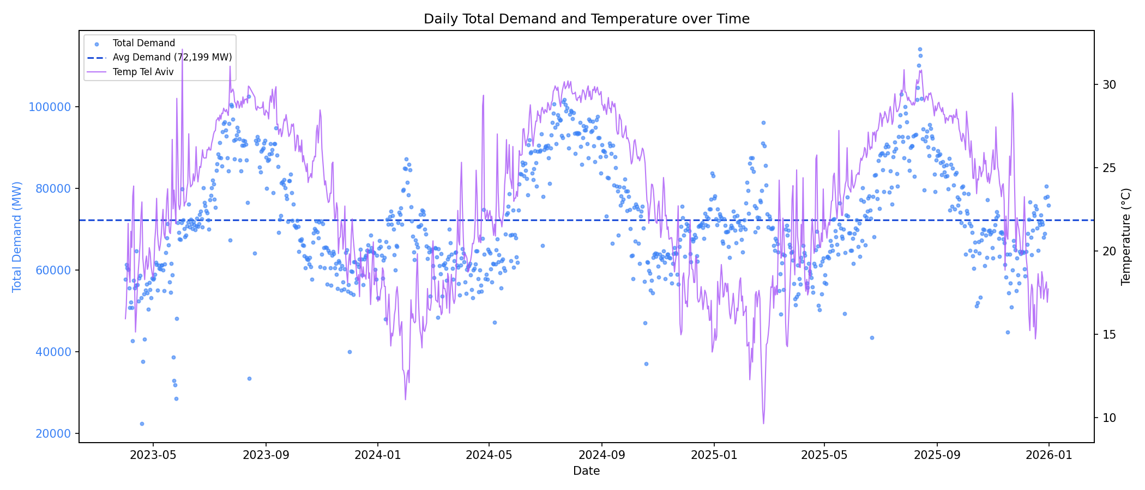
Daily electricity consumption (MWh) over the dataset period (March 2023–February 2026). Clear seasonal patterns are visible, with a summer peak (July–August) driven by air-conditioning loads and a secondary winter peak (January–February) driven by heating.
Figure 3 shows the relationship between daily electricity consumption and the daily average temperature in Tel Aviv.
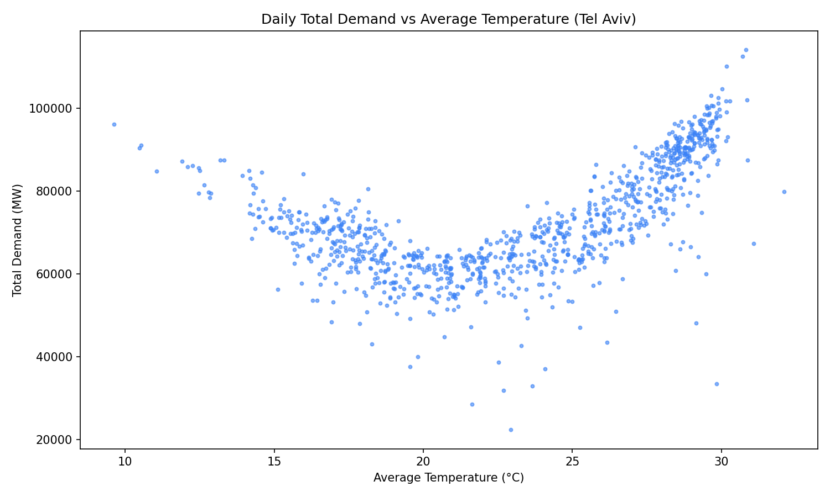
Daily electricity consumption vs. daily mean temperature in Tel Aviv. The characteristic U-shaped relationship is visible, with high demand at both high temperatures (cooling loads) and low temperatures (heating loads). The balance-point temperature is approximately 20 $​^{∘}$C.
Figure 4 shows the KDE histogram of the forecast error, i.e., the difference between the actual demand and the day-ahead forecast.
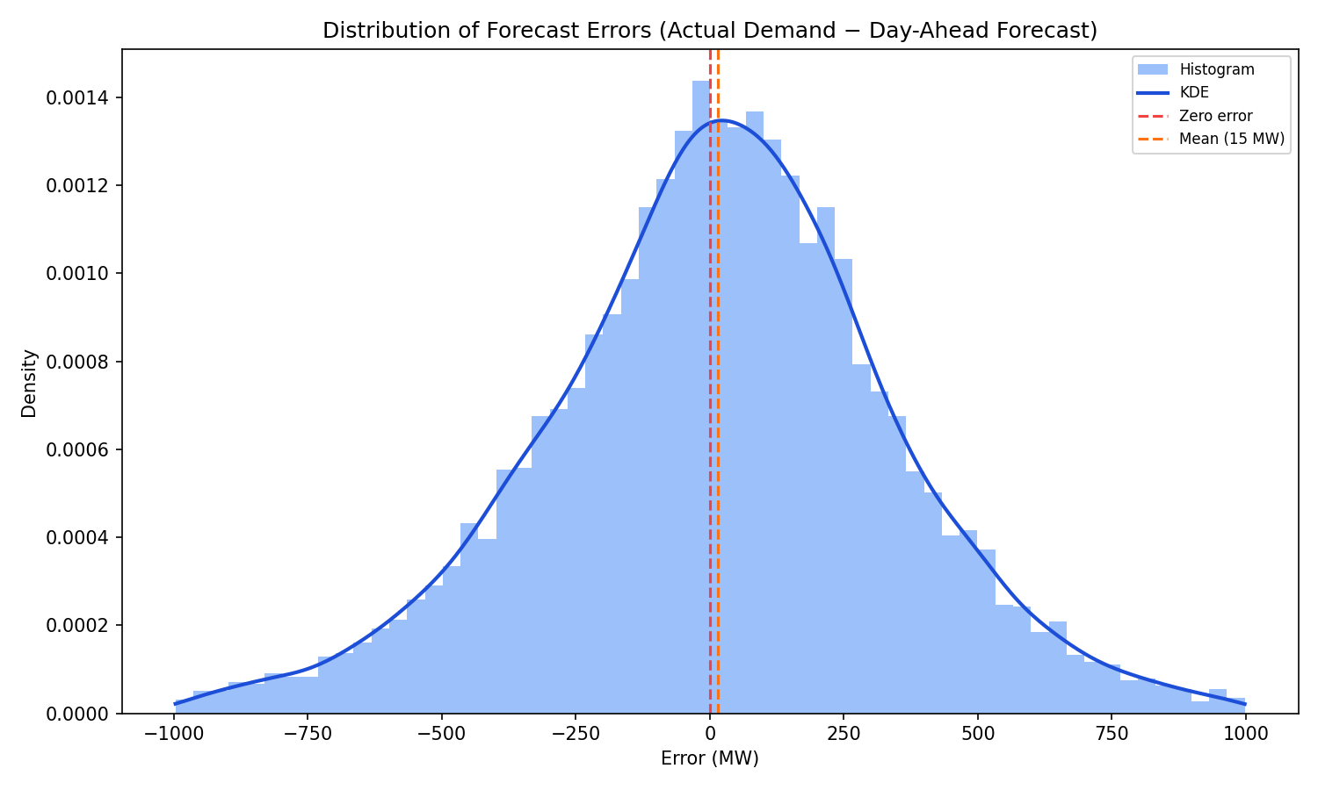
KDE histogram of the forecast error (actual demand minus day-ahead forecast). The distribution is approximately zero-mean with slightly heavier right tails, suggesting that large under-forecasts are marginally more frequent than large over-forecasts.
Table 1 reports summary statistics for the key variables in the daily dataset. The data span 1,096 days from 1 March 2023 to 28 February 2026.
Summary statistics for daily variables ($N=1,096$ days, March 2023–February 2026). $​^{*}$Three anomalous forecast values excluded from statistics; see text.
Variable | Mean | Std | Min | Median | Max
Total demand (MWh) | 73 421 | 14 852 | 19 742 | 70 435 | 114 103
Day-ahead forecast (MWh) | 73 109 | 14 680 | 2 400$​^{*}$ | 70 200 | 116 148
Forecast error (MWh) | $+312$ | 3 241 | $−12 300$ | $+284$ | $+11 543$
Temp. Tel Aviv ($​^{∘}$C) | 22.1 | 4.8 | 9.6 | 22.5 | 30.3
Temp. Jerusalem ($​^{∘}$C) | 18.9 | 6.4 | 2.3 | 19.8 | 36.5
Temp. Haifa ($​^{∘}$C) | 20.3 | 5.1 | 4.4 | 20.8 | 31.3

Forecast Error Distribution
As shown in Figure 4, the Noga day-ahead forecast errors (actual minus forecast) are strikingly close to zero-mean and nearly symmetric: the mean error is only $+312$ MWh against a standard deviation of $3,241$ MWh, and the KDE is approximately bell-shaped with modest skewness. In other words, the operational forecast is essentially unbiased, under-predicting and over-predicting with roughly equal frequency and magnitude.
From a pure accuracy standpoint this is a desirable property. From a cost-sensitive standpoint, however, it is a warning sign. As established in Section 2, when the costs of under-prediction substantially exceed those of over-prediction the cost-minimising forecast is not the conditional mean but a higher quantile — a deliberate upward bias proportional to the cost asymmetry. An approximately symmetric, zero-mean forecast therefore fails to account for the asymmetric cost structure of the market, and will systematically incur higher expected operational cost than a cost-aware alternative. This observation is central to the motivation of our approach and is quantified empirically in Section 4.
Figure 5 breaks down the Noga forecast error magnitude by hour of the day and day of the week. Each cell shows the mean percentage absolute error ($\left|actual−forecast\right|/actual$) for that hour-of-week slot over the entire dataset. The heatmap reveals that forecast accuracy varies substantially across the week: certain hour-of-day and day-of-week combinations are consistently harder to forecast than others, with notable differences between weekdays, Friday, and Saturday. This structured, non-uniform pattern has an important implication for post-hoc calibration: a global affine correction cannot account for the fact that errors are large in some slots and small in others. We return to this point in Section 4.
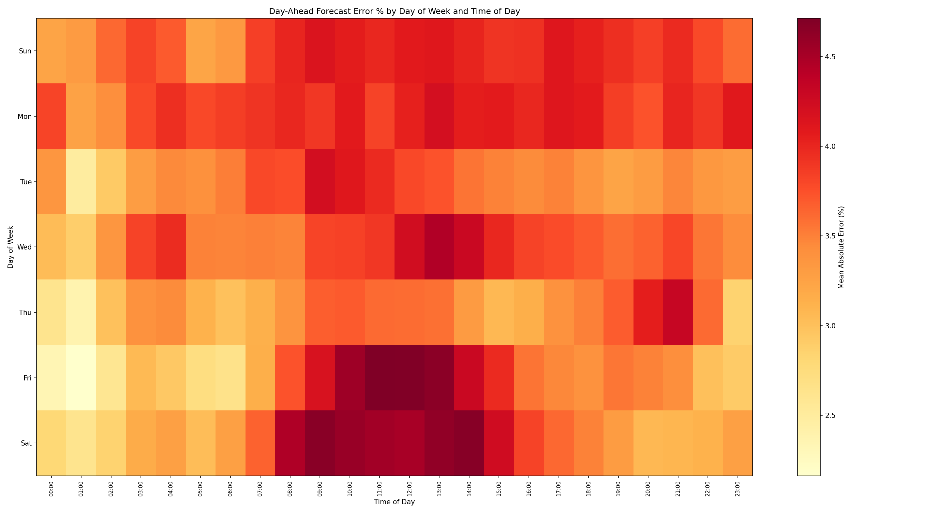
Heatmap of mean percentage absolute error ($\left|actual−forecast\right|/actual$) for Noga day-ahead forecasts, broken down by hour of the day (rows) and day of the week (columns). Each cell represents a specific hour-of-week slot. The non-uniform pattern demonstrates that forecast difficulty varies systematically across hours and days, and cannot be corrected by a single global offset.

Comparison with the Noga Operational Forecast
A distinctive feature of our dataset is the availability of the real day-ahead forecasts produced by Noga and used in the actual electricity market. This allows us to evaluate our learned models not merely against simple statistical baselines but against the operational forecast of an experienced system operator with access to proprietary data and domain expertise.
The Noga forecast achieves $R^{2}≈0.98$ against actual demand, confirming it is a strong accuracy baseline. Its error distribution is, as discussed in Section 3.1.2, nearly zero-mean and approximately symmetric. While this is impressive from an accuracy standpoint, it also reveals a limitation: the Noga forecast behaves as a conditional-mean estimator, making no explicit adjustment for cost asymmetry. A symmetric, unbiased forecast minimises mean squared error but, as we show empirically in Section 4, it does not minimize expected operational cost when under-prediction is substantially more costly than over-prediction. Its high $R^{2}$ is therefore a misleading indicator of operational performance under asymmetric costs — a point that motivates the cost-sensitive approach developed in this paper.

Model Training
All model variants share the same architecture: the prediction is expressed as a soft attention over a short window of recent historical demand values plus a learned additive correction. Weather conditions (temperature, wet-bulb temperature, and relative humidity at three meteorological stations) and temporal patterns (time of day, day of week, month of year) jointly determine both the attention weights and the correction term. Temporal features are encoded via learned embeddings; weather features enter as continuous inputs. The model operates at 5-minute granularity and produces a day-ahead forecast: given conditions at a target time $t$, it predicts demand exactly 24 hours earlier in the input window—making it a suitable testbed for isolating the effect of the training objective on cost-aware forecasting. The variants differ only in their training objective, so that any difference in cost performance can be attributed to that objective alone.

Data Splitting
The dataset is partitioned chronologically at 1 January 2025:
- Training set: March 2023 – December 2024 ($≈​672$ days).
- Test set: January 2025 – February 2026 ($≈​424$ days), held out for final evaluation.
The chronological split ensures no future information leaks into training.

Neural Network Architecture
For each target 5-minute slot $t$, the model receives three types of input:
- Historical demand. A window of $H=10$ consecutive 5-minute demand readings $h=\left(h_{1},…,h_{H}\right)$ ending exactly 24 hours before $t$ (i.e. the same time-of-day window from the previous day).
- Weather features. Nine continuous variables measured at time $t$: temperature, wet-bulb temperature, and relative humidity for three stations (Haifa, Jerusalem, Tel Aviv).
- Temporal embeddings. Learned embeddings for time of day (288 positions, dimension 16), day of week (7 positions, dimension 3), and month of year (12 positions, dimension 2).
These are concatenated into a vector of dimension $H+9+16+3+2=40$ and passed through a small MLP with two hidden layers of width 32 and LeakyReLU activations, producing an output vector $o∈R^{H+1}$. The first $H$ outputs are treated as attention logits over the history window; the last output is an additive correction scalar $δ$. The forecast is:
$$\hat{y} = \sum_{k=1}^{H}{softmax}{\left(o_{1:H}\right)}_{k} h_{k} + δ,$$
where all demand values are normalised by a constant scale factor $s=100$ during training and rescaled at inference time. The model thus learns to select which historical reading is most informative given the current conditions, and applies a weather- and calendar-conditioned correction. Both models (L1 and asymmetric) are trained with the Adam optimiser (Kingma and Ba 2014) at learning rate $2×{10}^{−4}$, batch size 10 000, and up to 500 epochs with early stopping (patience 20, evaluated every 10 epochs).

Training with L1 Loss
The symmetric neural network baseline is trained by minimising the mean absolute error (L1 loss):
$$L_{L1}\left(\hat{y},y\right)=\frac{1}{N}\sum_{i=1}^{N}{\left|{\hat{y}}_{i}−y_{i}\right|}$$
L1 loss treats over- and under-prediction symmetrically, and yields predictions that converge to the conditional median. As discussed in Section 2, this is suboptimal when costs are asymmetric.

Post-Hoc Cost-Optimised Baseline
To further isolate the benefit of end-to-end cost-aware training, we include an additional baseline in which predictions from the L1-trained neural network are adjusted after training by a learned affine transformation that minimises the expected operational cost on the training set. Concretely, we train a linear calibration model $g\left(z\right)=αz+β$ by minimising:
$$\left(α^{*},β^{*}\right)=arg\min_{α,β} \frac{1}{N_{train}}\sum_{i=1}^{N_{train}}{L_{asym}}​\left(α{\hat{y}}_{i}+β, y_{i}\right)$$
where ${\hat{y}}_{i}$ are the L1-trained predictions and $L_{asym}$ is the asymmetric loss (Section 2). The calibration is then applied uniformly to all test-set predictions.
This baseline tests whether a practitioner could recover most of the cost reduction by post-hoc rescaling a symmetric model, without modifying the training objective. Its key limitation is that it can only apply a global affine correction: it cannot adapt the shape of the predictive response to local input features, nor exploit the asymmetric cost structure during back-propagation. Cost-aware training, by contrast, reshapes the model’s response to every input pattern throughout optimisation, enabling feature-adaptive upward adjustments that are largest precisely when under-prediction risk is highest.

Training with Asymmetric Loss
The cost-aware neural network is trained by minimising the asymmetric cost function (Section 2) directly as the training objective. Because the loss is differentiable, it is incorporated into the standard gradient-based training loop with no additional computational overhead compared to L1 training.

Evaluation Protocol
Using the architecture and training loop above, we compare three training strategies, differing only in their objective:
- L1 (MAE) — trained with mean absolute error (symmetric baseline).
- Pinball 5:1 — trained with the pinball loss at a cost ratio of $5​:​1$ (under-prediction penalised 5$×$ more than over-prediction).
- Pinball 20:1 — trained with the pinball loss at a cost ratio of $20​:​1$.
To isolate the benefit of end-to-end cost-aware training, we additionally evaluate post-hoc calibrated variants of all three models (Section 3.2.4), in which an affine transformation $g\left(z\right)=αz+β$ is fitted on the training set to minimise the expected asymmetric cost.
Models are evaluated on three cost functions that reflect different assumptions about the cost of over- and under-prediction: the L1 cost, the Pinball 5:1 cost, and the Pinball 20:1 cost. The primary metrics are the Pinball 5:1 and Pinball 20:1 costs, which best reflect the asymmetric structure of real-world electricity procurement costs. Figure 6 illustrates these three cost functions: the Pinball 5:1 and Pinball 20:1 functions penalise under-predictions more heavily than over-predictions, reflecting the real-world asymmetry of electricity procurement costs, while L1 serves as a symmetric reference point.
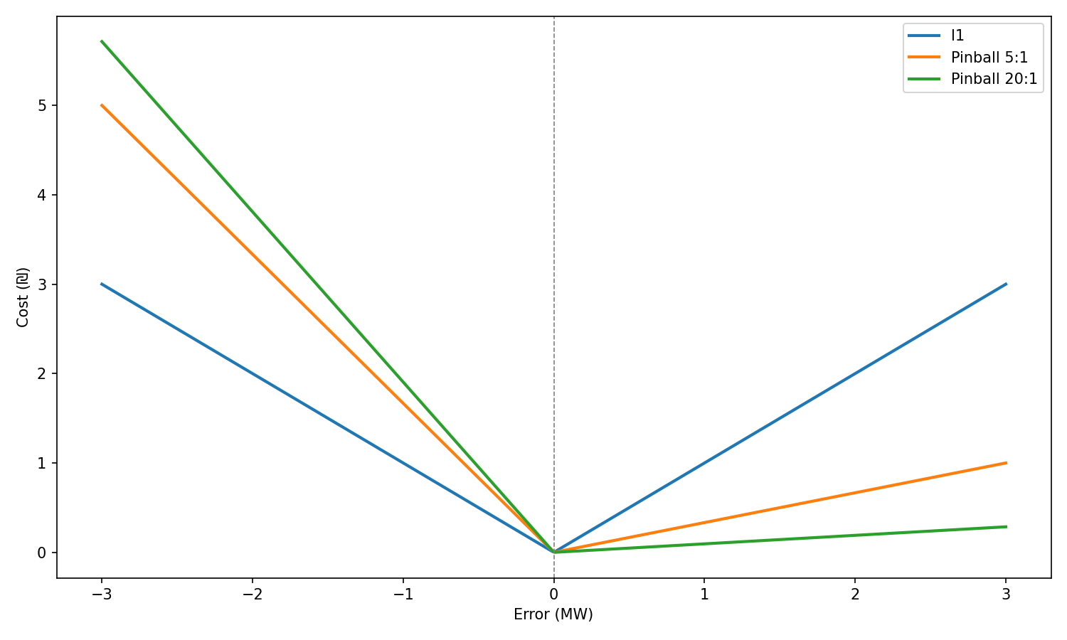
The three cost functions used for evaluation: L1 (MAE, symmetric baseline), Pinball 5:1, and Pinball 20:1. The pinball functions penalise under-predictions more heavily than over-predictions, with the 20:1 variant applying a much steeper penalty on the under-prediction side.

Results and Discussion
Table 2 reports the average test-set cost of each model under each evaluation cost function, before and after post-hoc calibration.
Test-set cost under three evaluation metrics. Lower is better. Bold marks the best value in each column. Top block: raw predictions; bottom block: after post-hoc affine calibration.
Model | L1 | Pinball 5:1 | Pinball 20:1
Without post-hoc calibration
L1 | 2.704 | 3.045 | 3.167
Pinball 5:1 | 3.652 | 1.820 | 1.166
Pinball 20:1 | 6.175 | 2.245 | 0.841
With post-hoc affine calibration
L1 + calibration | 2.704 | 1.979 | 1.022
Pinball 5:1 + calibration | 2.915 | 1.820 | 0.851
Pinball 20:1 + calibration | 3.424 | 1.964 | 0.841
Figure 7 visualises the same results as a colour-coded model $×$ loss matrix, making it easy to see at a glance which model wins on each metric and how calibration shifts the ranking.
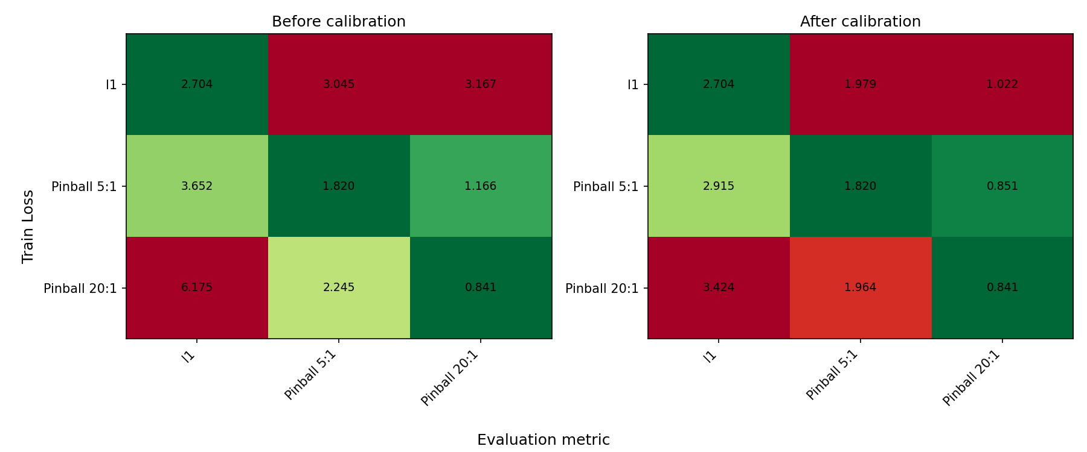
Train-loss $×$ evaluation-metric matrix for the three models (L1, Pinball 5:1, Pinball 20:1), before calibration (left) and after post-hoc affine calibration (right). Each cell shows the test-set cost; green marks the best value in each column and red the worst. The diagonal tendency — each model achieving its lowest cost on the metric it was trained with — is clearly visible. Calibration reduces off-diagonal costs substantially (e.g. L1 model under Pinball 20:1 drops from 3.167 to 1.022) while leaving the diagonal unchanged.

Each model excels on its own training metric.
Without calibration, a clear diagonal dominance is visible in Figure 7: each model achieves its lowest cost on the metric it was trained to minimise. The L1 model produces the lowest L1 cost ($2.704$), the Pinball 5:1 model the lowest Pinball 5:1 cost ($1.820$), and the Pinball 20:1 model the lowest Pinball 20:1 cost ($0.841$). This confirms that the training objective directly shapes the cost profile of the resulting forecast.

Asymmetric training substantially outperforms the symmetric baseline.
The advantage of cost-aware training grows with the asymmetry ratio. Under the Pinball 5:1 metric, the Pinball 5:1 model ($1.820$) outperforms the L1 baseline ($3.045$) by $40\%$. Under the more demanding Pinball 20:1 metric, the Pinball 20:1 model ($0.841$) outperforms L1 ($3.167$) by $73\%$. Figure 8 shows the mechanism: the Pinball 20:1 model produces a heavily right-skewed error distribution, deliberately over-predicting to avoid costly under-procurement events, while the L1 model is symmetric and centred near zero.

Post-hoc calibration narrows but does not close the gap.
Affine calibration substantially improves the L1 model on asymmetric metrics (Pinball 20:1: $3.167→1.022$; Pinball 5:1: $3.045→1.979$), confirming that a global bias correction captures much of the asymmetric signal. However, calibrated L1 still falls short of the dedicated pinball models (Pinball 5:1: $0.851$; Pinball 20:1: $0.841$), because a single affine shift cannot replicate the input-conditional upward bias that end-to-end cost-aware training achieves. Figure 5 (Section 3.1.2) illustrates exactly why: forecast error magnitude varies substantially by hour of the day and day of the week. A uniform global correction applies the same rescaling to every prediction regardless of context; only a model that conditions its output on time features can adapt its bias to each slot individually.

Error distributions reflect the targeted quantile.
Figure 8 shows the prediction error distributions on the test set for each model. The L1 model is symmetric and centred near zero, as expected for a mean-unbiased estimator. The Pinball 5:1 model is modestly right-shifted, and the Pinball 20:1 model exhibits a pronounced positive tail — each distribution directly reflecting the quantile targeted by its respective asymmetric loss.
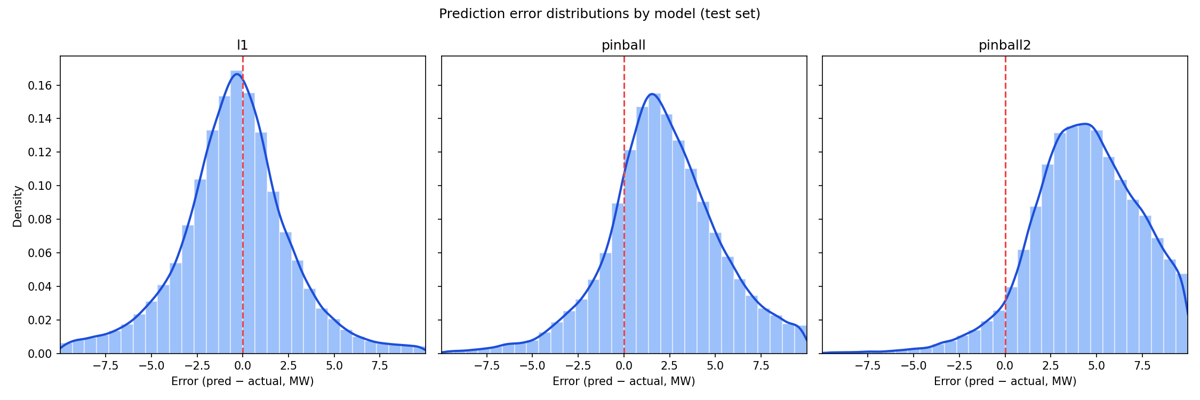
Distribution of test-set prediction errors (forecast minus actual, MW) for each model. The L1 model is symmetric and centred near zero. The Pinball 5:1 model shows a modest rightward shift, and the Pinball 20:1 model a pronounced positive tail, reflecting the increasingly aggressive upward bias required to minimise the cost under higher asymmetry ratios.

Conclusion and Future Work

Summary of Findings
This paper addressed day-ahead electricity demand forecasting under asymmetric operational costs. Our main findings are:
- Asymmetric costs are pervasive and substantial. In electricity markets the costs of under-predicting demand substantially exceed those of over-prediction. Empirically plausible cost ratios $c_{u}/c_{o}∈\left[5,20\right]$ have a large impact on the optimal forecasting strategy.
- The newsvendor framework provides a principled optimality condition. The cost-minimising procurement level corresponds to a specific quantile $τ^{*}=c_{u}/\left(c_{u}+c_{o}\right)$ of the conditional demand distribution. For a cost ratio of 5 this yields $τ^{*}≈0.833$, i.e. the 83.3rd percentile of demand — a systematic upward shift that is normatively desirable under asymmetric costs.
- Asymmetric loss training effectively targets the cost-minimising quantile. A feedforward neural network trained with a cost-sensitive asymmetric loss function (specifically, a non-linear variant of the pinball loss) at the appropriate quantile achieves lower expected operational cost than an L1-trained neural network baseline. The cost reduction is consistent across a wide range of synthetic cost function parameters.
- Symmetric loss is a misleading evaluation metric under asymmetric costs. The L1-trained neural network achieves lower MAE than the asymmetric-loss model yet incurs higher expected operational cost. Practitioners should adopt cost-sensitive metrics such as asymmetric loss or expected operational cost for model selection and evaluation.
- Post-hoc calibration helps but does not substitute for cost-aware training. A global affine correction fitted to the operational cost recovers much of the gap on asymmetric metrics, but cannot match a model trained end-to-end, because it cannot adapt the upward bias to the input-conditional structure of forecast error.
- The approach is practical and improves on the operational forecast. Our model is a small, open-source feedforward network that trains in minutes on commodity hardware. Even though predictive accuracy was not an objective of this work, it improves on the Noga operational forecast not only on cost-sensitive metrics but even under symmetric error metrics such as MSE — and we believe substantial further gains are readily achievable. Together with a demonstrated economic benefit, this makes the method realistic to adopt in practice.

Implications for Market Participants and Policymakers
For market participants (electricity retailers, large consumers, aggregators), the key takeaway is that standard forecasting tools optimised for MSE are likely to systematically under-procure electricity, exposing them to avoidable real-time market risk. Incorporating asymmetric cost modelling — through direct asymmetric-loss training or post-hoc quantile adjustment — can yield meaningful reductions in procurement costs with negligible additional computational overhead.
For grid operators (transmission system operators, independent system operators), the implication is that incentivising cost-sensitive forecasting among market participants could improve overall system reliability. If all participants systematically under-forecast demand, the system operator faces persistent shortfalls in committed reserves. Regulatory frameworks that reward forecast accuracy measured by cost-sensitive metrics, rather than MSE, would align private incentives with system reliability objectives.
For policymakers, our results support the inclusion of cost-sensitive forecasting requirements in market design rules. For example, mandatory reporting of asymmetric (pinball) loss at relevant quantiles, alongside MSE, would provide a richer picture of forecast quality that better reflects operational costs.

Limitations
- Synthetic cost functions. Since we do not have access to actual cost data from the Israeli electricity market, all cost evaluations rely on synthetic functions that satisfy qualitative constraints. The results may not precisely reflect actual market costs.
- Time-invariant cost asymmetry. Although our model operates at fine (5-minute) granularity, we treat the cost asymmetry as constant across the day. In practice, markets clear at sub-hourly intervals and the asymmetry of costs may vary significantly across hours of the day.
- Point forecasts only. Our neural network produces a single scalar forecast at the target quantile. A richer approach would estimate the full predictive distribution, enabling uncertainty quantification and adaptive quantile selection.
- Fixed cost ratio. We assume that $c_{u}/c_{o}$ is constant over time. In practice the relative costs may vary with fuel prices, demand levels, and seasonal reserve availability.

Directions for Future Research
- Distributional forecasting. Training models to output full predictive distributions (via normalising flows, conformal prediction, or Bayesian deep learning) would enable the optimal quantile to be selected adaptively as a function of current cost parameters. We regard this, rather than training against a fixed cost function, as the proper long-term formulation of the problem, for the reasons set out in the concluding remarks below.
- Nonlinear and non-smooth cost functions. Step-function or tiered cost structures require optimisation approaches beyond the pinball loss, such as distributionally robust optimisation or stochastic programming.
- Online and adaptive learning. Adaptive algorithms that update the forecasting model in real time as market conditions change would be valuable for practical deployment.
- Richer temporal modelling and time-varying cost asymmetry. Our model already operates at fine (5-minute) granularity but treats each target slot largely independently and assumes a constant cost ratio. Explicitly modelling intra-day and cross-day demand dynamics — for example with Transformer architectures (Vaswani et al. 2017) or temporal convolutional networks — together with a cost asymmetry that varies by hour of the day, could better exploit the structured hour-of-week error pattern documented in Section 3.1.2.
- Multi-product forecasting. In practice, electricity retailers must manage procurement across multiple products (day-ahead energy, reserves, ancillary services) with correlated costs and demands. A joint cost-sensitive forecasting framework would be a substantial extension.
- Real cost data. Collaboration with market participants or operators to obtain actual cost data would enable precise calibration and remove the need for synthetic cost functions.

Concluding Remarks
Electricity demand forecasting sits at the intersection of time series analysis, optimisation under uncertainty, and energy economics. As markets become more complex — driven by variable renewable energy, demand response, and distributed storage — the costs of forecast errors are likely to increase, making cost-sensitive forecasting ever more important.
This work demonstrates that a conceptually simple modification — replacing the MSE training objective with a cost-sensitive asymmetric loss function (specifically, a non-linear variant of the pinball loss at the cost-minimising quantile) — leads to meaningful improvements in operational performance without sacrificing computational tractability.
We stress, however, that training against a predefined, fixed cost function is not the solution we ultimately advocate. It couples the learned model to one particular cost structure, so that a change in the cost ratio — driven by fuel prices, reserve availability, or the time of day — in principle requires retraining, and it collapses the rich uncertainty in future demand into a single quantile chosen in advance. We view it as one useful step in the right direction rather than the destination. The desired formulation, in our view, is to decouple estimation from decision-making: first predict the full conditional distribution of demand given the available features, and then, at decision time, optimise the procurement quantity against whatever cost function currently prevails. This separation would let a single trained model serve any cost structure, adapt the optimal bias to the input-conditional uncertainty of each slot, and expose the full distribution for downstream risk-aware decisions. Realising it is the main direction of our future work.
We hope these findings contribute to a broader shift towards cost-aware forecasting practices in the electricity industry and stimulate further research at the intersection of machine learning and energy systems optimisation.
Arrow, Kenneth J., Theodore Harris, and Jacob Marschak. 1951. “Optimal Inventory Policy.” Econometrica 19 (3): 250–72. https://doi.org/10.2307/1906813.
Christoffersen, Peter F., and Francis X. Diebold. 1997. “Optimal Prediction Under Asymmetric Loss.” Econometric Theory 13 (6): 808–17. https://doi.org/10.1017/S0266466600006277.
Hong, Tao, and Shu Fan. 2016. “Probabilistic Electric Load Forecasting: A Tutorial Review.” International Journal of Forecasting 32 (3): 914–38. https://doi.org/10.1016/j.ijforecast.2015.11.011.
Hong, Tao, Pierre Pinson, Shu Fan, Hamidreza Zareipour, Alberto Troccoli, and Rob J. Hyndman. 2016. “Probabilistic Energy Forecasting: Global Energy Forecasting Competition 2014 and Beyond.” International Journal of Forecasting 32 (3): 896–913. https://doi.org/10.1016/j.ijforecast.2016.02.001.
“Israel Meteorological Service – Open Data Portal.” 2025. 2025. https://ims.gov.il/he/data_gov.
Kingma, Diederik P., and Jimmy Ba. 2014. “Adam: A Method for Stochastic Optimization.” arXiv Preprint arXiv:1412.6980.
Kirschen, Daniel S., and Goran Strbac. 2018. Fundamentals of Power System Economics. 2nd ed. Chichester, UK: Wiley. https://doi.org/10.1002/9781119213238.
Koenker, Roger, and Gilbert Bassett. 1978. “Regression Quantiles.” Econometrica 46 (1): 33–50. https://doi.org/10.2307/1913643.
Lin, Jun-Lin, Yiqing Zhang, Kunhuang Zhu, Binbin Chen, and Feng Zhang. 2020. “Asymmetric Loss Functions for Contract Capacity Optimization.” Energies 13 (12): 3123. https://doi.org/10.3390/en13123123.
Morales, Juan M., Antonio J. Conejo, Henrik Madsen, Pierre Pinson, and Marco Zugno. 2014. Integrating Renewables in Electricity Markets: Operational Problems. Vol. 205. International Series in Operations Research & Management Science. New York, NY: Springer. https://doi.org/10.1007/978-1-4614-9411-9.
“Noga – Israel Independent System Operator: Annual Hourly Consumption Data.” 2025. 2025. https://www.noga-iso.co.il/statistics/annual-hourly-consumption-data/.
Stoft, Steven. 2002. Power System Economics: Designing Markets for Electricity. Hoboken, NJ: Wiley-IEEE Press.
Vaswani, Ashish, Noam Shazeer, Niki Parmar, Jakob Uszkoreit, Llion Jones, Aidan N. Gomez, Łukasz Kaiser, and Illia Polosukhin. 2017. “Attention Is All You Need.” In Advances in Neural Information Processing Systems. Vol. 30.
Wang, Yi, Dahua Gan, Mingyang Sun, Ning Zhang, Zongxiang Lu, and Chongqing Kang. 2019. “Probabilistic Individual Load Forecasting Using Pinball Loss Guided LSTM.” Applied Energy 235: 10–20. https://doi.org/10.1016/j.apenergy.2018.10.078.
Weron, Rafał. 2014. “Electricity Price Forecasting: A Review of the State-of-the-Art with a Look into the Future.” International Journal of Forecasting 30 (4): 1030–81. https://doi.org/10.1016/j.ijforecast.2014.08.008.
Wu, Jinran, You-Gan Wang, Yu-Chu Tian, Kevin Burrage, and Taoyun Cao. 2021. “Support Vector Regression with Asymmetric Loss for Optimal Electric Load Forecasting.” Energy 223: 119969. https://doi.org/10.1016/j.energy.2021.119969.
Zhang, Jialun, Yi Wang, and Gabriela Hug. 2022. “Cost-Oriented Load Forecasting.” Electric Power Systems Research 205: 107723. https://doi.org/10.1016/j.epsr.2021.107723.

https://github.com/gkutiel/noga

