A Unified Price-and-Demand Model for Cost-Optimal Day-Ahead Electricity Demand Forecasting: Evidence from the Israeli Market
Abstract
Day-ahead electricity is bought before demand is known, and a shortfall is settled at a price several times higher than a surplus, by a factor that rises with the price. The cost-optimal forecast is therefore a quantile of demand that moves with the price, yet demand and prices are forecast separately and for accuracy. We propose a unified model: a small neural network that forecasts demand and prices from a shared representation and trains the demand forecast on the price-weighted procurement cost. On a new open dataset of the Israeli market, with real day-ahead and synthetic imbalance prices, the model lowers the excess cost of the test year to $49.5 million: 6% below a joint demand-and-price network trained for accuracy and corrected afterwards, and 19% below the operator’s corrected forecast. Replacing the operator’s published forecast would save about $27 million per year in Israel, roughly $1 billion at US scale.
Keywords: Load forecasting; Electricity price forecasting; Decision-focused learning; Newsvendor problem; Imbalance cost; Quantile forecasting; Neural networks

Introduction
Electricity for the next day is bought before the demand is known. Energy committed in the day-ahead market is paid at the day-ahead price; any shortfall must be bought in real time at a higher price, and any surplus is sold back at a lower one (Stoft 2002; Kirschen and Strbac 2018). A megawatt-hour short typically costs five to twenty times more than a megawatt-hour too much (J. Zhang, Wang, and Hug 2022), and the ratio is itself driven by the price: shortfalls are most expensive exactly when the system is tight and the day-ahead price is high. The cost-optimal forecast is therefore not the expected demand but a quantile of it, and the right quantile moves with the price from one settlement period to the next (Section 3).
Forecasting practice does not reflect this. Demand forecasts, including the operational forecast of the Israeli system operator studied here, are built for accuracy and are close to unbiased, so they fall short about half of the time. Price forecasts are also built for accuracy, separately. The cost-oriented load-forecasting literature trains demand models on an asymmetric loss, but with a fixed cost ratio that ignores prices; and the models that forecast load and price jointly are again trained only for accuracy (Section 2). No existing model lets the demand forecast follow the price.
We close this gap with a unified price-and-demand model. One small neural network reads only information available a day ahead—calendar, weather, yesterday’s demand and yesterday’s price—and computes a shared representation from which two heads forecast the demand and the three prices of the slot (day-ahead, shortfall and surplus). The demand forecast is trained on the realised procurement cost, priced at the realised prices, while the price head is trained to predict those prices. Because both heads read the same features, the demand head learns its safety margin from features that encode when prices—and hence shortfalls—will be expensive.

Contributions.
- The first unified price-and-demand model. To the best of our knowledge, this is the first model that forecasts electricity demand and prices together and trains the demand forecast on the price-weighted procurement cost. On the Israeli test year it has the lowest cost of all models we tested, $49.5 million: 6% below the strongest alternative, a joint load-and-price network with the same architecture trained for accuracy and corrected to the cost afterwards, and 19% below the operator’s forecast after the best correction ($p≤0.008$ in every comparison). Its safety margin rises with the price, as theory demands; the margin of a fixed-asymmetry model falls.
- Real money. Replacing the operator’s published forecast would save about $27 million per year in Israel—$2.65 per resident and 0.86% of the day-ahead energy bill—mostly by avoiding shortfalls. Projected to a market the size of the United States, the same improvement is worth roughly $1 billion per year.
- Small and cheap. The model has fewer than 2,000 parameters, trains in about five minutes on a standard laptop without a GPU, and needs only 21 months of training data.
- An open dataset and benchmark. We release a new dataset of the Israeli market that aligns 5-minute national demand, the operator’s real day-ahead forecast, real half-hourly day-ahead prices and weather (April 2023–December 2025), a generator of price-dependent imbalance prices, and the complete code.
Section 2 reviews related work, Section 3 formulates the problem, Section 4 presents the unified model, Section 5 describes the Israeli market, the data and the baselines, Section 6 reports the results and the savings, and Section 7 concludes.

Related Work

Cost-oriented load forecasting.
Quantile regression (Koenker and Bassett 1978) minimises the asymmetric pinball loss and estimates a conditional quantile, and under an asymmetric loss the optimal point forecast is biased (Christoffersen and Diebold 1997). The pinball loss became a standard in energy forecasting with GEFCom2014 (Hong et al. 2016; Hong and Fan 2016). Several works train load forecasters directly on an asymmetric cost: an LSTM trained on the pinball loss (Wang et al. 2019), LSTMs trained on losses derived from an asymmetric tariff, which cut electricity costs by 0.9–2.4% (Lin et al. 2020), an asymmetric support vector regression (Wu et al. 2021), and a cost-oriented formulation of load forecasting (J. Zhang, Wang, and Hug 2022). In all of them the asymmetry is fixed—one quantile, or the slopes of one tariff—and prices play no role in the model.

Joint forecasting of load and price.
Load and price are strongly coupled, and several models forecast them together: Shayeghi et al. (2015) with a multi-output least-squares SVM on the NYISO, NSW and PJM markets, and Li et al. (2024) with a multi-task network that shares layers across source, load and price. These models are trained for statistical accuracy: their demand forecast targets the conditional mean, and the predicted price plays no role in how the forecast trades shortfall against surplus. Price forecasting on its own has a large literature (Weron 2014), likewise accuracy-oriented.

Decision-focused learning.
Decision-focused or value-oriented learning trains predictors against the cost of a downstream decision rather than a statistical error (Donti, Amos, and Kolter 2017; Elmachtoub and Grigas 2022); the feature-based newsvendor (Ban and Rudin 2019) learns an order quantity directly from features under fixed costs. In power systems the idea has been applied to wind and solar forecasts traded in markets (Stratigakos et al. 2022; Y. Zhang et al. 2024) and to load forecasts for a downstream dispatch (Donti, Amos, and Kolter 2017; Han, Yan, and Li 2020). These works treat the cost parameters as given rather than predicting them, and none addresses national demand with real market prices or benchmarks against the forecast an operator actually uses.

The gap.
After a search of these three literatures we found no model that unifies them: one that forecasts the prices together with the demand and trains the demand forecast on the price-weighted cost, so that the decision follows the model’s own price expectations. We therefore compare against the strongest representative of each line: a joint load-and-price network trained for accuracy whose own price forecasts then set the margin, a fixed-asymmetry (pinball) model, and accuracy-trained models corrected to the cost after training.

Problem Formulation

Procurement Cost
A market participant commits to a quantity $p_{t}$ for every slot $t$ of the next day before observing the demand $y_{t}$. Let $π_{t}^{DA}$ be the day-ahead price, $π_{t}^{u}$ the price of each unit of shortfall and $π_{t}^{o}$ the value lost on each unit of surplus, with
$$π_{t}^{u} > π_{t}^{DA} > π_{t}^{o} > 0. (1)$$
The realised cost is $C_{t}=π_{t}^{DA}min(y_{t},p_{t})+π_{t}^{u}(y_{t}−p_{t})^{+}+π_{t}^{o}(p_{t}−y_{t})^{+}$. The consumed energy $π_{t}^{DA}y_{t}$ is paid whatever the forecast, so we work with the excess cost above a perfect forecast,
$$E_{t}(p_{t},y_{t})=C_{t}−π_{t}^{DA}y_{t}=\underset{c_{t}^{u}}{\underset{⏟}{(π_{t}^{u}−π_{t}^{DA})}} (y_{t}−p_{t})^{+}+\underset{c_{t}^{o}}{\underset{⏟}{π_{t}^{o}}} (p_{t}−y_{t})^{+}, (2)$$
a pinball loss whose two slopes are prices that change from slot to slot. We consider the uncertainty of demand only; production-side uncertainty, e.g. from renewables (Morales et al. 2014), is outside our scope.

Information.
The day-ahead price is set by the market after the purchase decision, so none of the slot’s prices $π_{t}^{DA},π_{t}^{u},π_{t}^{o}$ is known when $p_{t}$ is chosen. The forecaster sees only what is available a day ahead: demand and prices up to 24 hours before $t$, the weather forecast and the calendar. Historical prices are known after the fact and can be used for training.

The Optimal Forecast Is a Price-Dependent Quantile
For known prices, minimising Equation (2) is the newsvendor problem (Arrow, Harris, and Marschak 1951), whose solution is the critical fractile
$$p_{t}^{*}=F_{t}^{−1}(τ_{t}), τ_{t}=\frac{c_{t}^{u}}{c_{t}^{u}+c_{t}^{o}}=\frac{π_{t}^{u}−π_{t}^{DA}}{π_{t}^{u}−π_{t}^{DA}+π_{t}^{o}}, (3)$$
where $F_{t}$ is the conditional distribution of demand. When the prices are unknown, the optimum satisfies
$$E[c_{t}^{u} 1\{y_{t}>p_{t}^{*}\} \left| I_{t}\right]=E[c_{t}^{o} 1\{y_{t}<p_{t}^{*}\} \left| I_{t}\right], (4)$$
where $I_{t}$ is the information available a day ahead: a cost-weighted quantile of demand, in which each outcome is weighted by the price it would be settled at. Three consequences motivate the unified model. (i) The target quantile moves with the price, so no model that targets the mean or a fixed quantile can be optimal. (ii) High demand drives high prices, so shortfalls tend to happen when they are most expensive; Equation (4) accounts for this joint behaviour, a forecast shifted after training does not. (iii) A megawatt-hour of error during a price spike costs many times more than one at night, so a model should spend its capacity where prices are high. A model that predicts the prices and the demand from shared features and is trained on Equation (2) with the realised prices can learn all three.

Imbalance Prices
The day-ahead prices in our study are the real Israeli market prices (Section 5); imbalance prices are not published for the study period, so we generate them. Per 30-minute settlement period,
$$π_{t}^{o}=α (1+ε_{t}) π_{t}^{DA}, π_{t}^{u}=r_{t} π_{t}^{o}, (5)$$
$$r_{t}=clip​\left(\left(r_{min}+(r_{max}−r_{min}) u_{t}^{γ}\right) e^{η_{t}}, r_{min}, r_{max}\right), (6)$$
with $ε_{t}∼N(0,σ_{o}^{2})$, $η_{t}∼N(0,σ_{u}^{2})$, and $u_{t}∈[0,1]$ the position of $logπ_{t}^{DA}$ between its 5th and 99th percentiles. The surplus price is thus a fixed fraction of the day-ahead price, and the shortfall-to-surplus ratio lies in $[5,20]$ and rises convexly with it (J. Zhang, Wang, and Hug 2022). We use $α=0.3$, $γ=2$, $σ_{o}=0.03$, $σ_{u}=0.15$, $r_{min}=5$ and $r_{max}=20$; $αr_{min}>1$ guarantees the ordering (1). The resulting cost-optimal quantile (Figure 1) has a median of $0.78$ on the training set, $0.66$ in the cheapest fifth of the slots and $0.92$ in the most expensive fifth.
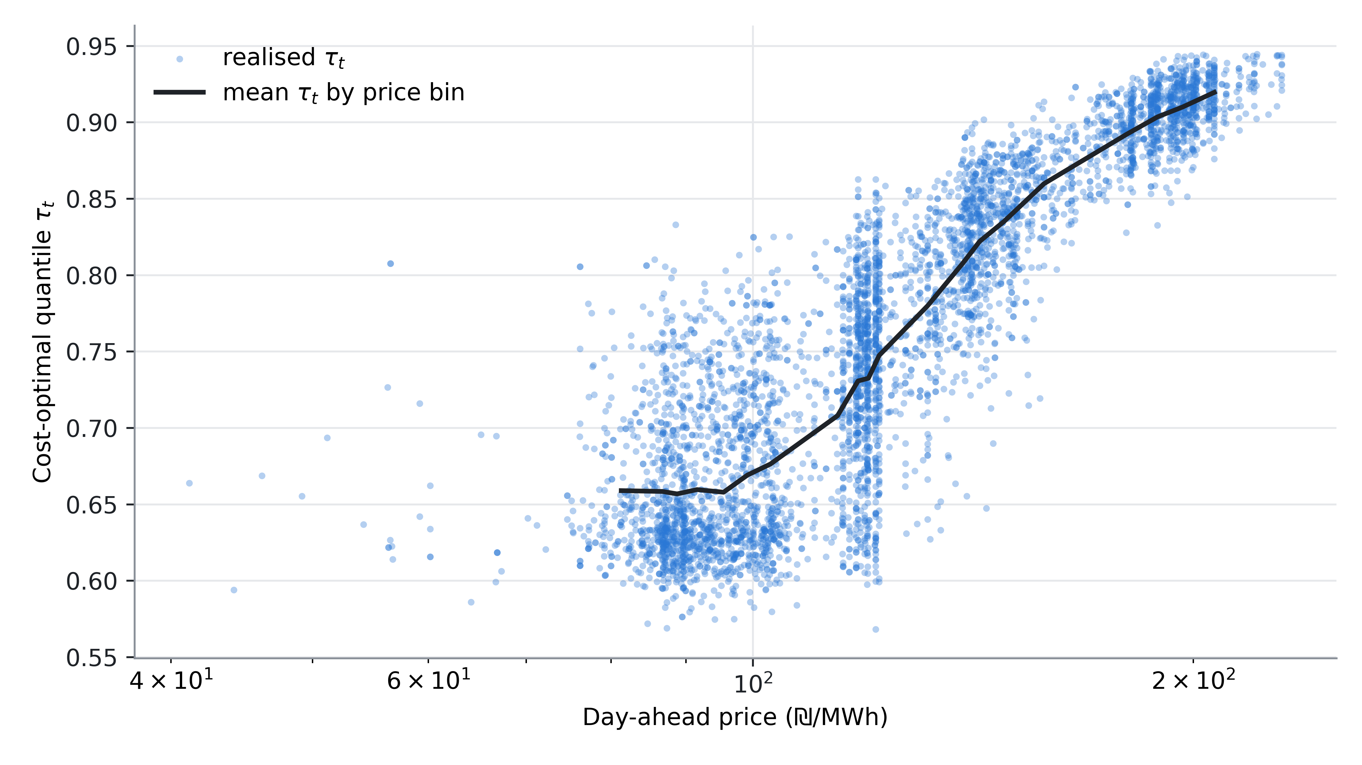
Figure 1: The cost-optimal quantile $τ_{t}$ (Equation (3)) rises with the real day-ahead price (test year). Points are realised values; the line is the mean in each of 20 price bins.

The Unified Model
Figure 2 shows the model. It forecasts the demand of a 5-minute slot $t$ of the next day, together with the slot’s three prices, from information available a day in advance.

Inputs.
(i) The demand history: the ten 5-minute readings ending exactly 24 hours before $t$. (ii) The calendar: month, day of week and 5-minute slot of the day, each a learned two-dimensional embedding with norm at most 1. (iii) The weather: temperature, wet-bulb temperature and relative humidity at Haifa, Jerusalem and Tel Aviv, for slot $t$ and for the same slot of the previous day. (iv) Yesterday’s day-ahead price of the same slot, $π_{t−24\text{h}}^{DA}$, which is public when the forecast is made. Weather and price are standardised with training-set statistics.

Shared representation.
One projection, $Linear(9→4)$ with a LeakyReLU, maps today’s and yesterday’s weather with the same weights, so the network can compare the same learned weather features on both days—which explains the change in demand since yesterday. The embeddings, both projected weather vectors and yesterday’s price (15 values) pass through three layers of width 16, each followed by a LeakyReLU, layer normalisation and dropout (0.1). The result is a vector of shared features $z∈R^{16}$, read by two heads.

Demand head.
A linear layer maps $z$ to ten attention logits $o$, a log-scale $s$ and a shift $\tilde{b}$:
$${\hat{y}}_{t} = a\sum_{k=1}^{10}{softmax}(o)_{k} h_{k} + b, a=e^{s}, b=\tilde{b} σ_{y}, (7)$$
where $h_{k}$ are the history readings and $σ_{y}$ is the training-set standard deviation of the day-over-day demand change. The attention picks the starting point from yesterday’s demand; $a$ and $b$ set the level, including the safety margin.

Price head.
A second linear layer maps the same features to the three prices, $({\hat{π}}_{t}^{DA},{\hat{π}}_{t}^{o},{\hat{π}}_{t}^{u})=\overset{‾}{π}⊙exp(Wz+c)$, with $\overset{‾}{π}$ the training-set mean prices. It has no other input: to predict the prices, $z$ itself must encode when prices—and hence shortfalls—will be expensive, and the demand head reads exactly these features. This is what makes the model unified.

Training.
The loss is the mean excess cost of the demand forecast (Equation (2)) at the realised prices plus the mean relative squared error of the three price forecasts, 13j​((πtj−πtj)/πtj)2, with equal weight. We use Adam (Kingma and Ba 2014) with learning rate $2×{10}^{−3}$, batches of 5,000 slots and a fixed budget of 500 epochs (the held-out cost is dominated by a few price spikes and is too noisy for early stopping).

Small and efficient.
The model has 1,805 parameters. On a standard laptop (Intel Core i5-1135G7, no GPU) a full training run over the 184,268 training slots takes about five minutes, and forecasting a year takes a fraction of a second, so the model can be retrained daily without special hardware.
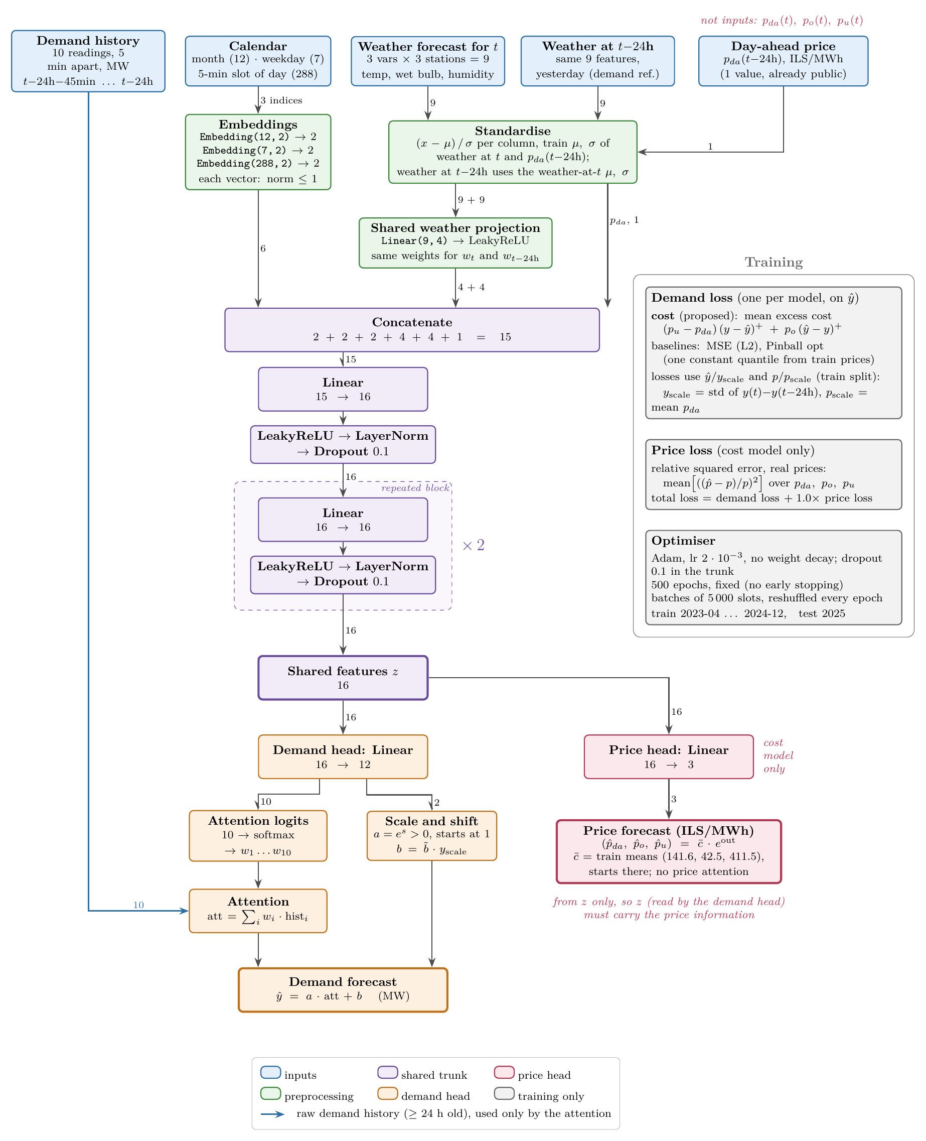
Figure 2: The unified model. Inputs (blue) are at least 24 hours old, except the weather forecast for $t$; the slot’s own prices are never inputs. A shared trunk produces features $z$ from which a demand head (orange) and a price head (red) are computed. The raw demand history enters only through the attention. The right panel lists the losses and the optimiser.

Data and Experimental Setup

The Israeli Electricity Market
Israel is a small country (about 22,000 km², 10.2 million people; (Israel Central Bureau of Statistics 2025)) whose population is highly concentrated: most of it lives on the narrow Mediterranean coastal plain, a strip of about 150 km from Haifa through the Tel Aviv metropolitan area to Ashdod, with Jerusalem the main inland centre (Figure 3). The weather at Haifa, Tel Aviv and Jerusalem therefore describes the conditions under which most of the electricity is consumed. The climate is hot in summer and mild in winter, and 96.5% of households have air conditioning, so demand is driven by cooling and, to a lesser extent, heating: it peaks in July–August, with a secondary peak in January–February. The working week runs from Sunday to Thursday; Friday and Saturday are the weekend.
The grid is an electricity island, with no significant interconnection to neighbouring countries, so every shortfall must be covered by domestic reserves. The market is centralised. The independent system operator, Noga, forecasts the national demand for every period of the next day; this day-ahead forecast, together with the resulting system marginal price (SMP), determines how much each producer is scheduled to generate. The day-ahead demand forecast is thus the pivotal quantity: it is fixed before the demand is known, and its errors are corrected in real time at a premium. With about 80 TWh per year and an average load of 9.2 GW, the market is small: a few percent of the US market.
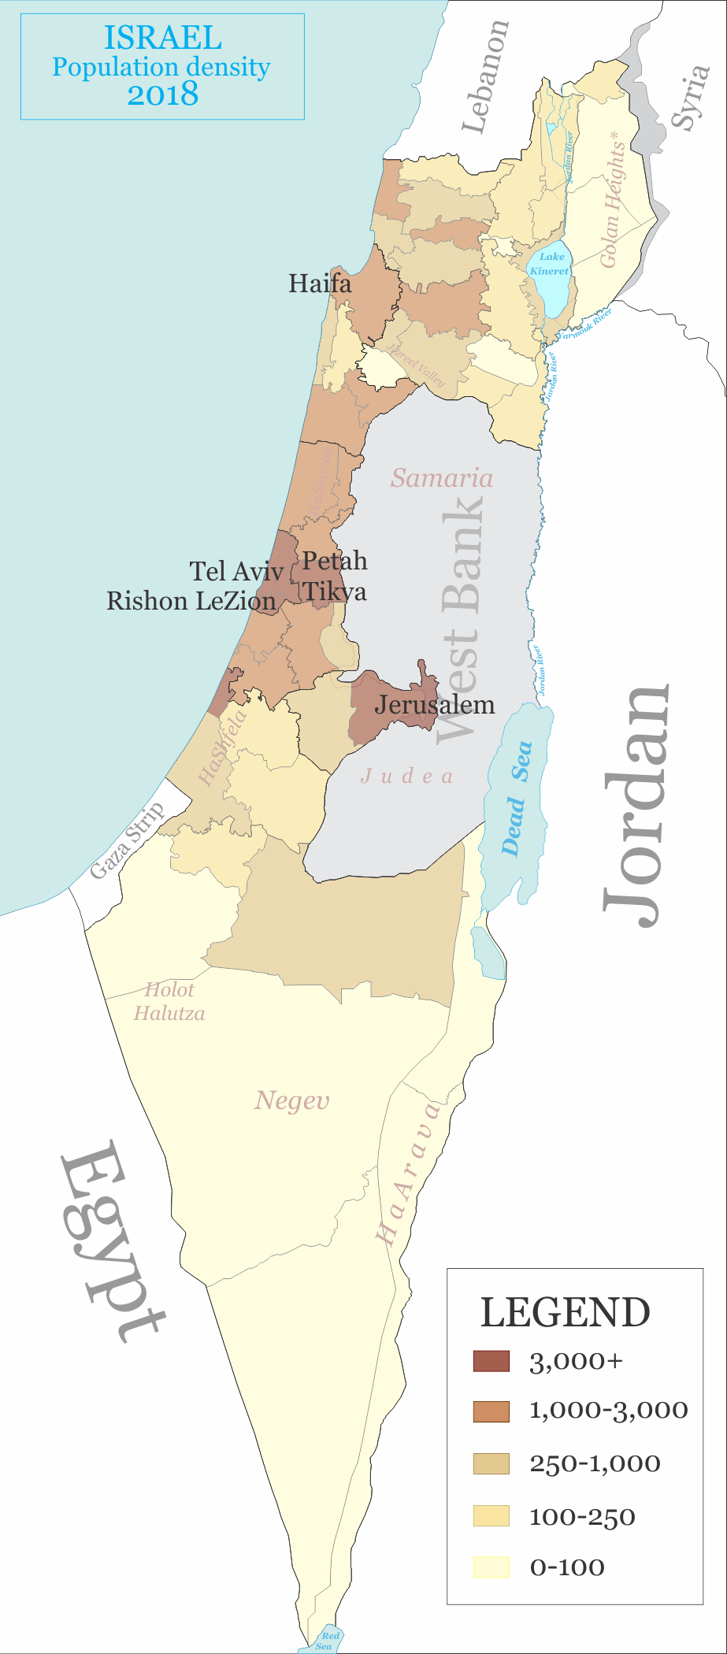
Figure 3: Population density of Israel (2018, people per km²). The coastal plain from Haifa to Ashdod holds most of the population; we use the weather at Haifa, Tel Aviv and Jerusalem. Map: Ynhockey (2021), CC BY-SA 4.0, based on data from the Israel Central Bureau of Statistics.

The Dataset
We combine three sources at a common 5-minute resolution, from 1 April 2023 to 31 December 2025; to our knowledge this is the first public dataset of the Israeli market that aligns them.
- Demand and the operator’s forecast (Noga, the Israeli system operator (“Noga – Israel Independent System Operator: Annual Hourly Consumption Data” 2025)): national demand every 5 minutes and the real day-ahead forecast Noga publishes and uses in the market—a strong, operational baseline.
- Day-ahead prices (Noga (“Noga – Israel Independent System Operator: System Marginal Price (SMP)” 2026)): the half-hourly unconstrained system marginal price (SMP), the market-clearing price $π_{t}^{DA}$; each 5-minute slot gets the price of its settlement period. (The constrained SMP adds redispatch spikes caused by local transmission limits, which a national forecast does not affect.) It averages 137.5 nis/MWh ($39.9/MWh) and ranges from 41 to 505.
- Weather (Israel Meteorological Service (“Israel Meteorological Service – Open Data Portal” 2025)): temperature, wet-bulb temperature and relative humidity at Haifa, Jerusalem and Tel Aviv (Figure 3).
Table 1 summarises the data. The average load is 9,167 MW (about 80 TWh per year).

The operator’s forecast is built for accuracy.
Noga’s forecast is accurate ($R^{2}≈0.98$) and, like a model trained on the squared error, unbiased and nearly symmetric (Figure 4): the mean error is $+25$ MW against a standard deviation of 436 MW, and demand exceeds the forecast in 53% of the slots. For accuracy this is ideal; for cost it is not. With shortfalls several times more expensive than surpluses, the cost-optimal forecast is a high quantile (Section 3.2), and a forecast centred on the mean falls short about half of the time.

The uncertainty is not uniform.
The cost-optimal margin $F_{t}^{−1}(τ_{t})−E[y_{t}]$ grows with the spread of the demand as well as with the price. This spread varies widely: the operator’s error ranges from 1.8% to 4.8% MAPE across the hours of the week (standard deviation 181 to 658 MW, Figure 5). It is highest on the weekend mornings, Friday and Saturday 8:00–15:00, and lowest at night. A single margin cannot fit both, and a correction per hour of the day (C2, Section 5.3) cannot tell a Friday from a Tuesday. A model that sees the calendar, the weather and yesterday’s price can set its margin from both the uncertainty and the price.
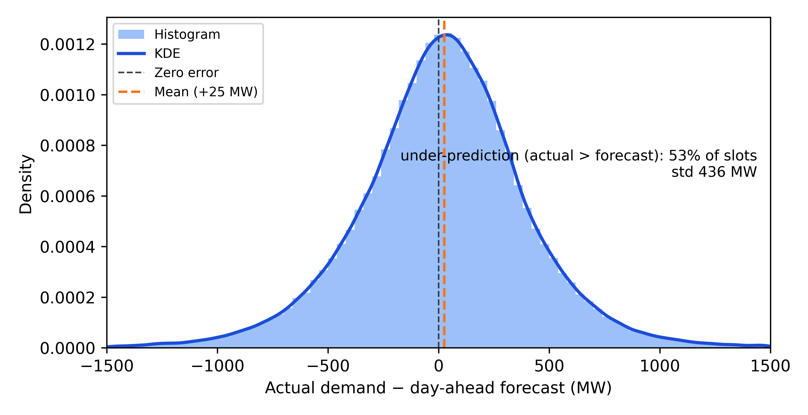
Figure 4: Error of the operator’s day-ahead forecast (actual minus forecast, 5-minute slots, April 2023–December 2025, shown within $±$1,500 MW). Like a forecast trained on the squared error, it is centred near zero and falls short in about half of the slots, far from the high quantile that the asymmetric cost calls for.
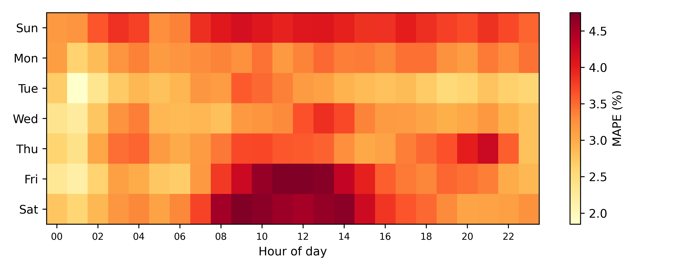
Figure 5: Mean absolute percentage error of the operator’s day-ahead forecast by day of week and hour of day. The uncertainty, and with it the cost-optimal margin, varies with the calendar: it is highest on the weekend (Friday–Saturday) mornings.
Table 1: Daily summary statistics (1,006 days). *Three days with an anomalous published forecast (17–19 June 2024) are excluded.
Variable | Mean | Std | Min | Median | Max
Demand (GWh/day) | 219.9 | 37.4 | 147.8 | 211.8 | 342.4
Operator forecast error (GWh/day)* | $+0.6$ | 6.3 | $−40.1$ | $+0.6$ | $+31.4$
Day-ahead price (nis/MWh) | 138 | 26 | 85 | 133 | 245
Temperature, Tel Aviv (°C) | 23.2 | 4.8 | 9.6 | 23.7 | 32.1

Compared Models
The data are split chronologically: training on April 2023–December 2024 (184,268 slots) and testing on 2025 (104,854 slots). All learned models share the network of Figure 2, so differences come from how demand and prices enter training, not from the architecture:
- MSE: demand only, trained on the squared error—the conventional accuracy-oriented forecaster.
- Pinball opt: demand only, trained on the pinball loss at the single best constant quantile, $τ^{*}=E[c^{u}]/(E[c^{u}]+E[c^{o}])=0.864$ from the training prices—the fixed-asymmetry approach of the cost-oriented literature.
- Joint MSE: the full network, with the price head, but with the demand trained on the squared error—a joint load-and-price forecaster trained for accuracy (Shayeghi et al. 2015; Li et al. 2024).
- Unified cost model (proposed): the full network trained on the excess cost and the price loss.
- Noga: the operator’s published forecast.

Post-hoc corrections.
To test whether the benefit can be had more cheaply, we correct the accuracy-trained forecasts to the cost after training, fitting each correction on the model’s own training-set forecasts at the realised prices: C1, a global affine map $a\hat{y}+b$; C2, an affine map per hour of the day, started from the exact cost-optimal shift of each hour (a cost-weighted quantile of its errors, Equation (4)); and, for Joint MSE, a $\hat{τ}$ shift, which uses the model’s own price forecasts: the training slots are split into deciles of the predicted quantile ${\hat{τ}}_{t}$ (Equation (3)), and each decile gets its own cost-optimal shift. This last baseline is the textbook forecast-then-optimise use of a joint load-and-price forecast. The proposed model is never corrected.

Evaluation.
The metric is the excess cost (Equation (2)) on the test year, split into its under- and over-prediction parts, in million US dollars per year at 3.45 nis/$ (the 2025 average). We also report MAE, RMSE and coverage $P(y_{t}≤p_{t})$. Each learned model is trained with three seeds (mean $±$ standard deviation), with one draw of the imbalance prices. Differences in daily cost (averaged over seeds) are tested with the Diebold–Mariano test (Diebold and Mariano 1995) with a Newey–West variance (lag 7 days).

Results

Main Results
Table 2 reports the test-year cost of every model. The unified model is the cheapest, at $49.5$±$1.4 million per year, and its advantage over every alternative is statistically significant. Each of its three seeds ($48.0, 50.7 and 49.9 million) is cheaper than every run of every baseline; the closest is a Joint MSE + C2 run at $52.2 million.
Table 2: Excess cost on the test year 2025 (million US$ per year; mean $±$ standard deviation over three seeds), split into under- and over-prediction. MAE and RMSE in MW; coverage $=P(y_{t}≤p_{t})$. $Δ$: cost of the unified model minus that of the row, with the Diebold–Mariano $p$-value.
Model | Cost | Under | Over | MAE | RMSE | Cov. | $Δ$ | $p$
Operator’s forecast
Noga | 76.5 | 61.0 | 15.5 | 294 | 416 | 0.51 | $−27.0$ | $<$0.001
Noga + C1 | 62.4 | 20.2 | 42.3 | 446 | 544 | 0.86 | $−12.9$ | 0.002
Noga + C2 | 61.1 | 20.8 | 40.4 | 434 | 536 | 0.86 | $−11.6$ | 0.008
Demand only, trained for accuracy
MSE | 100.9±9.3 | 90.8 | 10.1 | 265 | 398 | 0.44
MSE + C1 | 59.0±2.1 | 32.3 | 26.7 | 334 | 454 | 0.78 | $−9.5$ | $<$0.001
MSE + C2 | 56.2±2.6 | 30.3 | 25.9 | 323 | 447 | 0.76 | $−6.7$ | $<$0.001
Demand only, fixed cost asymmetry
Pinball opt | 54.8±2.1 | 21.9 | 32.9 | 379 | 518 | 0.85 | $−5.2$ | $<$0.001
Joint demand and price, trained for accuracy
Joint MSE | 96.0±15.3 | 86.4 | 9.6 | 259 | 384 | 0.42
Joint MSE + $\hat{τ}$ shift | 54.3±0.6 | 29.9 | 24.4 | 307 | 422 | 0.74 | $−4.8$ | $<$0.001
Joint MSE + C2 | 52.6±0.3 | 27.6 | 25.0 | 310 | 430 | 0.75 | $−3.1$ | 0.004
Joint demand and price, trained on the cost (proposed)
Unified cost model | 49.5±1.4 | 20.1 | 29.4 | 333 | 461 | 0.81

Accuracy is not value.
The accuracy-trained models are the most accurate—Joint MSE has the lowest MAE (259 MW), and even plain MSE beats the operator (265 vs. 294 MW)—but, used as they are, the most expensive ($96–101 million), because they fall short 56–58% of the time while a shortfall costs about six times more than a surplus. The same holds for the operator, whose forecast is centred like an accuracy-trained one (Figure 4): 80% of its cost comes from shortfalls.

Post-hoc correction is not enough.
Correcting the forecasts after training removes most of the shortfall cost, but the unified model is still 12% cheaper than MSE + C2 and 19% cheaper than Noga + C2. A correction that depends only on the hour cannot tell an expensive afternoon from a cheap one.

A fixed asymmetry is not enough.
Pinball opt knows that shortfalls are expensive and has the lowest shortfall cost of the learned baselines, but it buys the same 86% cover in every slot, pays for it with the highest surplus cost, and stays 10% more expensive than the unified model.

Joint forecasting for accuracy is not enough.
The strongest alternative is the joint load-and-price network trained for accuracy and then corrected, either by its own price forecasts ($\hat{τ}$ shift) or per hour (C2). With the same network, inputs and price head, the unified model is 6% cheaper ($p=0.004$). The only difference is that its demand head is trained on the price-weighted cost: knowing the price is not enough; the model must also learn how much cover each price buys, given how uncertain the demand is in that slot.

Why It Works: the Margin Follows the Price
The cost-optimal margin should grow with the price (Section 3.2). Table 3 shows that the unified model’s margin does, from 212 MW in the cheapest third of the slots to 281 MW in the most expensive third. The fixed-asymmetry model does the opposite, and the corrected accuracy models barely move. The unified model is the cheapest in every third, and it saves the most where it matters most: in the most expensive third, $7–15 million per year over the learned baselines and $24 million over Noga + C2.
Table 3: Mean safety margin (forecast minus demand, MW) and cost (million US$ per year) by thirds of the test slots sorted by day-ahead price (mean over seeds).
 | Margin (MW) |  |  | Cost (M$/year)
Model | Low | Mid | High | Low | Mid | High
Noga | $−141$ | $−9$ | 115 | 38.3 | 52.5 | 138.8
Noga + C2 | 264 | 362 | 421 | 31.4 | 46.1 | 105.9
MSE + C2 | 181 | 195 | 212 | 28.8 | 42.0 | 97.7
Pinball opt | 352 | 296 | 260 | 31.3 | 43.2 | 89.8
Joint MSE + C2 | 179 | 181 | 208 | 27.0 | 41.2 | 89.6
Unified cost model | 212 | 241 | 281 | 25.4 | 40.8 | 82.4

Price forecasts.
Table 4 compares the unified model’s price forecasts with those of Joint MSE and with a naive forecast, yesterday’s day-ahead price (scaled by the typical training-set ratios for the surplus and shortfall prices). On the relative squared error it is trained on, the unified model beats both on all three prices, and its forecast of the cost-optimal quantile correlates with the realised one at 0.71, where the naive forecast carries no information (0.00). On MAPE, yesterday’s price remains slightly better for the day-ahead price itself (13.5% vs. 14.5%); the price head is a single linear layer meant to inform the demand decision, not to compete with dedicated price models. A price head that starts from the naive forecast and learns only a correction lowered the MAPE by about one point but weakened the quantile forecast (correlation 0.62) and left the cost unchanged ($50.0 vs. $49.5 million, $p=0.60$), so we keep the simpler head.
Table 4: Price forecasts on the test year: MAPE, mean relative squared error (RSE, the price head’s training loss) and the correlation between the predicted and realised cost-optimal quantile (mean over three seeds).
 | MAPE (%) |  |  | RSE
Model | $π^{DA}$ | $π^{o}$ | $π^{u}$ | $π^{DA}$ | $π^{o}$ | $π^{u}$ | corr$(\hat{τ},τ)$
Naive (yesterday’s price) | 13.5 | 14.1 | 43.0 | 0.044 | 0.046 | 0.281 | 0.00
Joint MSE | 15.6 | 15.8 | 30.7 | 0.040 | 0.041 | 0.149 | 0.70
Unified cost model | 14.5 | 14.8 | 29.6 | 0.036 | 0.037 | 0.147 | 0.71

Savings: Israel and a US-Scale Projection
Table 5 translates the cost differences into annual savings. Replacing the operator’s published forecast with the unified model would save about $27 million per year in Israel: $41 million of avoided shortfall cost, in exchange for $14 million of extra surplus. This is 35% of the excess cost, 0.86% of the $3.1 billion day-ahead energy bill, $0.33 per MWh consumed and $2.65 per resident. Even against the operator’s forecast after the best correction (Noga + C2) the saving is $11.6 million per year, now mainly from buying less unnecessary surplus.
Table 5: Annual savings of the unified model on the test year (positive: the unified model is cheaper), split into under- and over-prediction, and normalised per MWh consumed (81 TWh) and per resident (10.2 million). The last column projects the saving per MWh to US consumption (about 4,100 TWh per year).
Compared with | M$/year | Under | Over | % of DA bill | $/MWh | $/resident | US, B$/year
Noga (as published) | 27.0 | 40.8 | $−13.9$ | 0.86% | 0.33 | 2.65 | 1.4
Noga + C2 | 11.6 | 0.6 | 11.0 | 0.37% | 0.14 | 1.14 | 0.6
MSE + C2 | 6.7 | 10.1 | $−3.5$ | 0.21% | 0.08 | 0.65 | 0.3
Pinball opt | 5.2 | 1.7 | 3.5 | 0.17% | 0.06 | 0.52 | 0.3
Joint MSE + C2 | 3.1 | 7.5 | $−4.4$ | 0.10% | 0.04 | 0.30 | 0.2

A US-scale projection.
Israel is a small market. The excess cost scales with the energy traded and with the price level, and the average US wholesale price, about $40/MWh in 2025 (U.S. Energy Information Administration 2025b), is close to the Israeli $39.9/MWh. Scaling the saving per MWh to US consumption of about 4,100 TWh per year (U.S. Energy Information Administration 2025a) gives roughly $1.4 billion per year against an uncorrected operator-style forecast and $0.6 billion against a corrected one; scaling per resident instead (about 342 million; (U.S. Census Bureau 2026)) gives $0.9 and $0.4 billion. The US market is fragmented into regional markets with their own designs, so these numbers only illustrate the order of magnitude: hundreds of millions to over a billion dollars per year.
All savings depend on the level of the synthetic imbalance prices (Section 3.3) and should be read as estimates under the stated cost model rather than measurements.

Conclusion
When forecast errors are settled at market prices, the cost-optimal demand forecast is a quantile that moves with the price. We proposed the first unified model that forecasts demand and prices from one shared representation and trains the demand forecast on the price-weighted procurement cost. On a new open dataset of the Israeli market it beats demand-only models trained for accuracy or with a fixed asymmetry, a joint demand-and-price network trained for accuracy, post-hoc corrections of all of them, and the operator’s own forecast—because its safety margin rises with the price. It would save about $27 million per year in Israel against the published operator forecast, roughly a billion dollars per year at US scale, and it does so with fewer than 2,000 parameters trained in five minutes on a laptop.

Limitations.
(i) The imbalance prices are synthetic, anchored on the real day-ahead price; the savings depend on their level. (ii) All results use one draw of these prices. (iii) The post-hoc corrections are fitted on training-set forecasts, whose errors are smaller than on the test set, so their margins may be slightly too small. (iv) We assume a price taker and ignore the effect of the forecast on the prices. (v) The model produces a point forecast, not a full predictive distribution.

Future work.
Real imbalance prices, from the operator or market participants, would turn the savings estimate into a measurement. Further directions are a scarcity variant of the price generator in which shortfalls are most expensive when the whole system is short, richer price inputs (fuel prices, renewable forecasts), distributional forecasts trained on price-weighted objectives, and applying the unified model to larger markets.

Declaration of generative AI and AI-assisted technologies in the manuscript preparation process
During the preparation of this work the authors used Claude (Anthropic) in order to improve the language and readability of the manuscript. The research itself—the problem formulation, the model, the experiments and the analysis—was conceived and carried out by the authors. After using this tool, the authors reviewed and edited the content as needed and take full responsibility for the content of the published article.
Arrow, Kenneth J., Theodore Harris, and Jacob Marschak. 1951. “Optimal Inventory Policy.” Econometrica 19 (3): 250–72. https://doi.org/10.2307/1906813.
Ban, Gah-Yi, and Cynthia Rudin. 2019. “The Big Data Newsvendor: Practical Insights from Machine Learning.” Operations Research 67 (1): 90–108.
Christoffersen, Peter F., and Francis X. Diebold. 1997. “Optimal Prediction Under Asymmetric Loss.” Econometric Theory 13 (6): 808–17. https://doi.org/10.1017/S0266466600006277.
Diebold, Francis X., and Roberto S. Mariano. 1995. “Comparing Predictive Accuracy.” Journal of Business & Economic Statistics 13 (3): 253–63. https://doi.org/10.1080/07350015.1995.10524599.
Donti, Priya L., Brandon Amos, and J. Zico Kolter. 2017. “Task-Based End-to-End Model Learning in Stochastic Optimization.” In Advances in Neural Information Processing Systems, 30:5484–94.
Elmachtoub, Adam N., and Paul Grigas. 2022. “Smart ‘Predict, Then Optimize’.” Management Science 68 (1): 9–26. https://doi.org/10.1287/mnsc.2020.3922.
Han, Jiayu, Lei Yan, and Zuyi Li. 2020. “LfEdNet: A Task-Based Day-Ahead Load Forecasting Model for Stochastic Economic Dispatch.” https://arxiv.org/abs/2008.07025.
Hong, Tao, and Shu Fan. 2016. “Probabilistic Electric Load Forecasting: A Tutorial Review.” International Journal of Forecasting 32 (3): 914–38. https://doi.org/10.1016/j.ijforecast.2015.11.011.
Hong, Tao, Pierre Pinson, Shu Fan, Hamidreza Zareipour, Alberto Troccoli, and Rob J. Hyndman. 2016. “Probabilistic Energy Forecasting: Global Energy Forecasting Competition 2014 and Beyond.” International Journal of Forecasting 32 (3): 896–913. https://doi.org/10.1016/j.ijforecast.2016.02.001.
Israel Central Bureau of Statistics. 2025. “Population of Israel at the End of 2025.” 2025. https://www.cbs.gov.il/en.
“Israel Meteorological Service – Open Data Portal.” 2025. 2025. https://ims.gov.il/he/data_gov.
Kingma, Diederik P., and Jimmy Ba. 2014. “Adam: A Method for Stochastic Optimization.” arXiv Preprint arXiv:1412.6980.
Kirschen, Daniel S., and Goran Strbac. 2018. Fundamentals of Power System Economics. 2nd ed. Chichester, UK: Wiley. https://doi.org/10.1002/9781119213238.
Koenker, Roger, and Gilbert Bassett. 1978. “Regression Quantiles.” Econometrica 46 (1): 33–50. https://doi.org/10.2307/1913643.
Li, Ke, Yuchen Mu, Fan Yang, Haiyang Wang, Yi Yan, and Chenghui Zhang. 2024. “Joint Forecasting of Source-Load-Price for Integrated Energy System Based on Multi-Task Learning and Hybrid Attention Mechanism.” Applied Energy 360.
Lin, Jun-Lin, Yiqing Zhang, Kunhuang Zhu, Binbin Chen, and Feng Zhang. 2020. “Asymmetric Loss Functions for Contract Capacity Optimization.” Energies 13 (12): 3123. https://doi.org/10.3390/en13123123.
Morales, Juan M., Antonio J. Conejo, Henrik Madsen, Pierre Pinson, and Marco Zugno. 2014. Integrating Renewables in Electricity Markets: Operational Problems. Vol. 205. International Series in Operations Research & Management Science. New York, NY: Springer. https://doi.org/10.1007/978-1-4614-9411-9.
“Noga – Israel Independent System Operator: Annual Hourly Consumption Data.” 2025. 2025. https://www.noga-iso.co.il/statistics/annual-hourly-consumption-data/.
“Noga – Israel Independent System Operator: System Marginal Price (SMP).” 2026. 2026. https://www.noga-iso.co.il/.
Shayeghi, H., A. Ghasemi, M. Moradzadeh, and M. Nooshyar. 2015. “Simultaneous Day-Ahead Forecasting of Electricity Price and Load in Smart Grids.” Energy Conversion and Management 95: 371–84.
Stoft, Steven. 2002. Power System Economics: Designing Markets for Electricity. Hoboken, NJ: Wiley-IEEE Press.
Stratigakos, Akylas, Simon Camal, Andrea Michiorri, and Georges Kariniotakis. 2022. “Prescriptive Trees for Integrated Forecasting and Optimization Applied in Trading of Renewable Energy.” IEEE Transactions on Power Systems. https://doi.org/10.1109/TPWRS.2022.3152667.
U.S. Census Bureau. 2026. “National Population Estimates, Vintage 2025.” 2026. https://www.census.gov/programs-surveys/popest.html.
U.S. Energy Information Administration. 2025a. “Short-Term Energy Outlook: U.s. Electricity Consumption.” 2025. https://www.eia.gov/outlooks/steo/.
———. 2025b. “Wholesale Electricity Prices Expected to Rise in 2025.” 2025. https://www.eia.gov/todayinenergy/detail.php?id=64384.
Wang, Yi, Dahua Gan, Mingyang Sun, Ning Zhang, Zongxiang Lu, and Chongqing Kang. 2019. “Probabilistic Individual Load Forecasting Using Pinball Loss Guided LSTM.” Applied Energy 235: 10–20. https://doi.org/10.1016/j.apenergy.2018.10.078.
Weron, Rafał. 2014. “Electricity Price Forecasting: A Review of the State-of-the-Art with a Look into the Future.” International Journal of Forecasting 30 (4): 1030–81. https://doi.org/10.1016/j.ijforecast.2014.08.008.
Wu, Jinran, You-Gan Wang, Yu-Chu Tian, Kevin Burrage, and Taoyun Cao. 2021. “Support Vector Regression with Asymmetric Loss for Optimal Electric Load Forecasting.” Energy 223: 119969. https://doi.org/10.1016/j.energy.2021.119969.
Ynhockey. 2021. “Israel Population Density 2018.” 2021. https://commons.wikimedia.org/wiki/File:Israel_population_density_2018.png.
Zhang, Jialun, Yi Wang, and Gabriela Hug. 2022. “Cost-Oriented Load Forecasting.” Electric Power Systems Research 205: 107723. https://doi.org/10.1016/j.epsr.2021.107723.
Zhang, Yufan, Honglin Wen, Yuexin Bian, and Yuanyuan Shi. 2024. “Improving Sequential Market Coordination via Value-Oriented Renewable Energy Forecasting.” https://arxiv.org/abs/2405.09004.

Repository link withheld for anonymous review; the code and data are provided as supplementary material.

