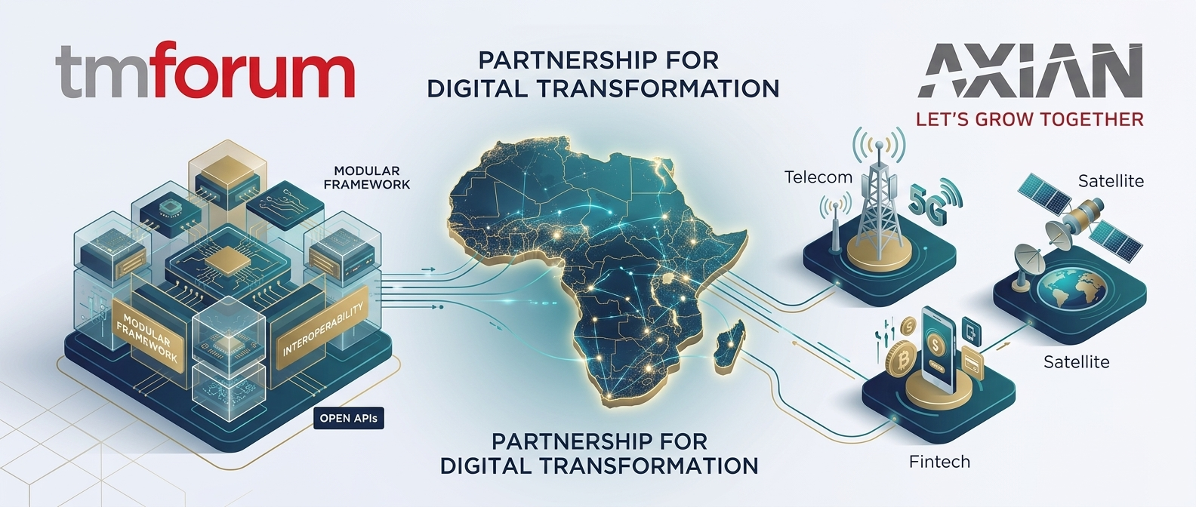
PREPARED EXCLUSIVELY FOR
Nik Willetts
CEO, TM Forum — ahead of your meeting with Hassan Jaber, CEO of Axian Telecom
A short briefing on Axian Group — its markets, its challenges today and tomorrow, and where TM Forum's Open Digital Architecture can help — to support the conversation about extending TM Forum membership from Axian Group to its individual OpCos.
“No single player can drive Africa’s digital future alone.” — Hassan Jaber, CEO, Axian Telecom
CLAIRE WATSON · ENGAGEMENT MANAGER · TM FORUM
PREPARED FOR  Nik Willetts, CEO, TM Forum | MEETING WITH  Hassan Jaber, CEO, Axian Telecom
SUBJECT  Axian Group — Growing OpCo Membership | PREPARED BY  Claire Watson, Engagement Manager

11  MARKETS ACROSS AFRICA & THE INDIAN OCEAN | 5  SECTORS — TELECOM, FINTECH, ENERGY, PROPERTY, DIGIBANK | 1 of 11  OPCOS CURRENTLY A TM FORUM MEMBER | 30  YEARS HASSAN'S TELECOM & DIGITAL LEADERSHIP

THE EXEC VIEW
Who Axian Is, And Where It Operates
A diversified pan-African group where telecom is the anchor — not the whole story.
A diversified group, not just an operator
Axian Group is a pan-African investment group founded in 2016, active across five sectors: Telecom, Financial Services & Digibank/Fintech, Energy, Properties, and (newest) a 2026 venture arm, "VIA". Its telecom arm — rebranded Yas in 2024 across several markets — operates in 11 countries: Madagascar, Tanzania, Togo, Uganda, Senegal, Comoros, DRC, Kenya, Malawi, Réunion and Mayotte.
Fintech is a genuine second engine, not a side project
MVola, launched in Madagascar in 2010, was the country's first mobile money service and became its first licensed digital bank in 2021. That model — rebranded Mixx in Senegal, Togo and Tanzania — is now expanding: Axian secured a licence for a decentralised digital financial institution from the Central Bank of Comoros in February 2026, with digitised credit products already live there and more markets flagged to follow.
KEY CHALLENGES — TODAY
CHALLENGE 01  Affordability against low ARPU  Hassan has been explicit that laying down 4G/5G infrastructure is "only half the battle" — the other half is making access affordable in underserved and rural markets where ARPU trails other continents, while still funding the rollout. | CHALLENGE 02  11 markets, 11 regulators  Hassan has publicly pushed for fair competition — running a consistent telecom and fintech proposition across 11 different regulatory regimes is a structural drag on speed and consistency.

CHALLENGE 03  Duplicated effort across OpCos  Each rebrand and each new fintech licence (Yas, Mixx, MVola, the new Comoros digital institution) risks being built and integrated separately per country, rather than once and reused. | CHALLENGE 04  Scaling the MVola model everywhere  Madagascar and Comoros are proof points; the real prize is making digital banking and credit a consistent, interoperable product across all 11 OpCos — not a series of one-off market launches.
KEY CHALLENGES — TOMORROW
CHALLENGE 05  Building for African-made AI  Hassan's stated ambition is data centres, fibre and subsea cable robust enough that Africa hosts and builds its own AI applications — not just imports them. | CHALLENGE 06  Partnership, not a solo effort  "No single player can drive Africa's digital future alone." That's precisely the case for standards-based, member-driven collaboration — not a bespoke build per OpCo.

HASSAN'S VISION — SHORT TO MEDIUM TERM
Leapfrogging Africa's Digital Divide
Three pillars, in Hassan's own framing: connectivity, financing, and innovation.
"Helping the continent leapfrog decades of digital underdevelopment — building a future where public institutions, businesses, and citizens are linked in a resilient, tech-driven ecosystem."

▸ Connectivity: extend and modernise network infrastructure (5G, fibre, subsea) across all 11 markets, anchored by strategic infrastructure partnerships.
▸ Financing: scale the MVola/Mixx digital banking and credit model from proof points (Madagascar, Comoros) into a group-wide proposition.
▸ Innovation: build the data centre and connectivity foundation for "made-in-Africa" AI, not imported AI.
▸ Publicly advocates for fair competition and for public-private partnership as the only realistic path to this vision.
WHERE TM FORUM'S ODA CAN HELP
Mapped directly to the challenges above — not a generic pitch
FOR CHALLENGE 03 & 04  One architecture, built once, reused across all 11 OpCos  ODA's Component Directory and TM Forum Open APIs give every OpCo a shared blueprint for telecom and fintech services — ending the need to design and integrate each market from scratch. | FOR CHALLENGE 01 & 04  Faster, cheaper time-to-market for new digital services  Standards-based interfaces cut integration cost and time — directly easing the affordability pressure Hassan has flagged, and speeding up scaling MVola/Mixx into new markets. | FOR CHALLENGE 06  A ready-made partner network, not a solo build  TM Forum's member community and Catalyst programme are exactly the "no single player can do this alone" model Hassan has already called for publicly — peers, not vendors, solving the same problems.
Today, TM Forum membership sits at Axian Group level — none of the 11 OpCos are members individually. Each one re-solves the same integration and interoperability problems alone. The conversation with Hassan is the opening to change that.
Axian doesn't need convincing that partnership is the answer — Hassan has said as much publicly. This conversation is about making TM Forum membership, and ODA, the concrete form that partnership takes for every one of Axian's 11 OpCos, not just the Group.

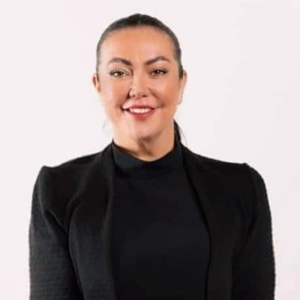 | Claire Watson  ENGAGEMENT MANAGER · TM FORUM · PREPARED AHEAD OF YOUR MEETING WITH HASSAN JABER

