**Philippine Investment Management Group (PHINMA GROUP)**

USER MANUAL

# Human Resource Management System

# Overtime (4 of 4)

For Employee and Supervisor Only

**Prepared By**

Softweb Consulting, Inc.

2011

Contents

Human Resource Management System 1

Overtime (4 of 4) 1

Overtime 3

Overview 3

Objective 3

I. User Interface 4

II. Log in 5

III. Home 5

1. Creating Overtime Request 5

2. Saving Overtime Request as Draft 5

3. Submitting the Overtime Request 5

4. Viewing Overtime Request Sorted by Overtime Date 5

5. Viewing Overtime Request Sorted by Status 5

6. Viewing Overtime Request Sorted by Approver 5

7. Viewing For My Approvals 5

8. Approving Overtime Request 5

9. Disapproving Overtime Request 6

IV. Reports 6

1. Generating Overtime Requests per Employees (for Requestor) Reports 6

2. Generating Overtime Requests For My Action (for Approval) Reports 6

# Overtime

## Overview

Overtime module is the fourth from the four modules of Philippine Investment Management Group’s Human Resource Management System. It is integrated to the other three modules such as employee profile, daily time record and leave. It is responsible monitoring employee overtime.

## Objective

The module primarily aims to enhance the employee overtime management of the company’s Human Resource Department. It accommodates the general and the distinct processes of PHINMA Group’s seven companies: (1) PHINMA Corp., (2) PHINMA Inc., (3) Trans Asia Oil & Energy Development Corp., (4) Trans Asia Power Generation Corp., (5) T-O Insurance Brokers Inc., (6) PHINMA Property Holdings Corp. and (7) Microtel. It increases efficiency, boosts productivity and dramatically reduces operational costs of the group.

## User Interface

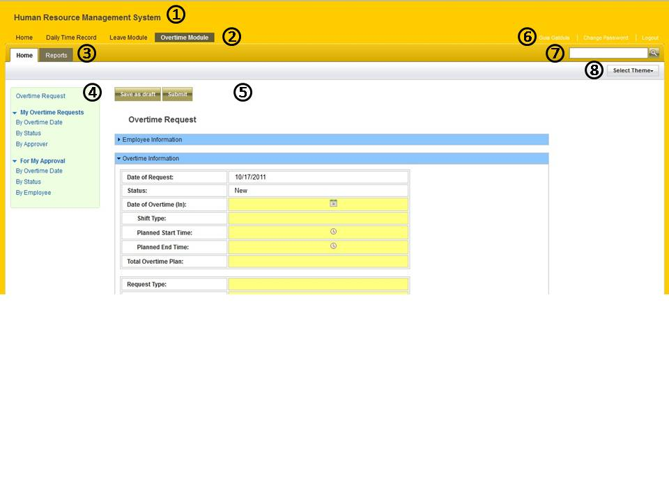

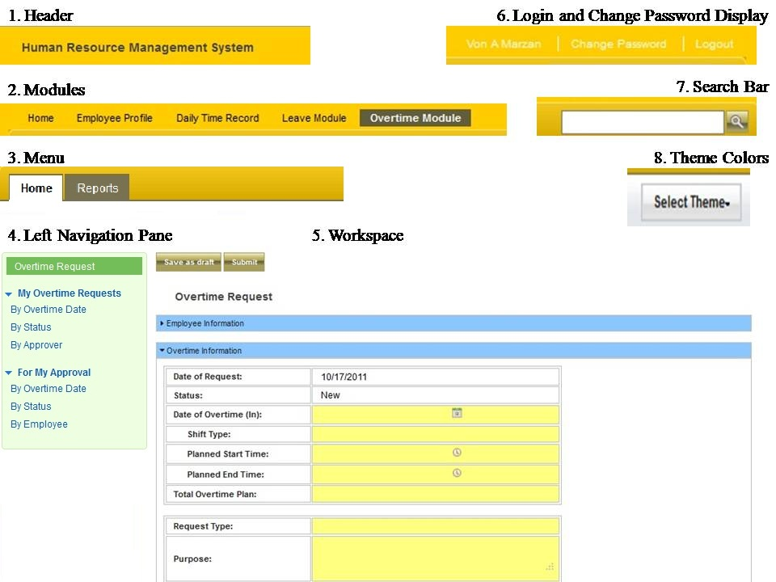

## Log in

* Accessing the daily Time Record module.

##### To Access DTR

1. Type your login ID and your password.
2. Click login button.

## Home

### Creating Overtime Request

* This process allows the user to create, save and submit overtime request.

#### To Create Overtime Request

1. Go to “Create Overtime Request” to launch the overtime request form.
2. Input the required fields.

### Saving Overtime Request as Draft

* This process allows the user to save the overtime request as draft.

#### To Save the Overtime Request as Draft

1. Go to “Create Over time Request”.
2. Click the “Save as Draft” button.

### Submitting the Overtime Request

* This process allows the user to submit the overtime request for approval.

#### To Submit Overtime Request

1. Go to “Create Overtime Request”.
2. Complete the required fields.
3. Click the “Submit” button to pass the request for approval.

### Viewing Overtime Request Sorted by Overtime Date

* Allows the user to display the entire overtime request sorted to date.

### Viewing Overtime Request Sorted by Status

* Allows the user to display the list of entire overtime request sorted by status.

### Viewing Overtime Request Sorted by Approver

* Allows the user to display the entire overtime request sorted by approver.

### Viewing For My Approvals

* Allows the user to display the list of entire overtime request needed for user’s approval.

### Approving Overtime Request

* This process allows the user to approve the submitted overtime request.

#### To Approve Overtime Request

1. Go to “For My Approval”.
2. Open the overtime request.
3. Click the “Approve” button.
4. A message box will appear, click “OK”.

### Disapproving Overtime Request

* This process allows the user to disapprove the submitted overtime request.

#### To Disapprove Overtime Request

1. Go to “For My Approval”.
2. Open the overtime request.
3. Click the “Disapprove” button.
4. A message box will appear, click “OK”.
5. A comment box will display, write your comment and click “OK”.

## Reports

### Generating Overtime Requests per Employees (for Requestor) Reports

* Allows the user to generate reports.

#### To Generate Report

1. At the Report type, select the ‘Overtime Requests per Employees (for Requestor)’ and choose the category.
2. Click the “Generate Report Button”.
3. Choose among ‘Open with’ and ‘Save File’, click “OK”.

### Generating Overtime Requests For My Action (for Approval) Reports

* Allows the user to generate reports.

#### To Generate Report

1. At the Report type, select the ‘Overtime Requests For My Action (for Approval)’ and choose the category.
2. Click the “Generate Report Button”.
3. Choose among ‘Open with’ and ‘Save File’, click “OK”.