Philippine Investment Management Group (PHINMA GROUP)

USER MANUAL

Human Resource Management System

Leave (3 of 4)
For Employees

Prepared By
Softweb Consulting, Inc.
2011

Table of Contents
Human Resource Management System 1
Leave (3 of 4) 1
LEAVE APPLICATION MODULE 4
Overview 4
Objective 4
I. User Interface 5
II. Log in 5
III. Home 5
1. Creating Leave Request 5
2. Saving Leave Request as Draft 5
3. Submitting Leave Request 6
4. Viewing Users Leave Request Sorted By Leave Date 7
5. Generating Users Leave Request Sorted By Leave Date 7
6. Viewing Users Leave Request Sorted By Leave Type 7
7. Generating Users Leave Request Sorted By Leave Type 8
8. Viewing Users Leave Request Sorted By Status 8
9. Generating Users Leave Request Sorted By Status 8
10. Cancelling Users Leave Request 8
11. Withdrawing Users Leave Request 9
12. Viewing For Users Approval Leave Request Sorted By Employee 10
13. Generating For Users Approval Leave Request Sorted By Employee 10
14. Viewing For Users Approval Leave Request Sorted By Leave Date 10
15. Generating For Users Approval Leave Request Sorted By Leave Date 11
16. Viewing For Users Approval Leave Request Sorted By Leave Type 11
17. Generating For Users Approval Leave Request Sorted By Leave Type 11
18. Approving Leave Request 11
19. Disapproving Leave Request 12
20. Approving Withdrawal Leave Request 13
21. Disapproving Withdrawal Leave Request 14

LEAVE APPLICATION MODULE

Overview
Leave module is the third from the four modules of Philippine Investment Management Group’s Human Resource Management System. It is integrated to the other three modules such as employee profile, daily time record and overtime. It is responsible monitoring employee leaves. The module focuses on the creation, submission, approval, archiving and reporting processes of employee leaves.
The module handles 11 types of leaves: (1) vacation leave, (2) sick leave, (3) maternity leave, (4) paternity leave, (5) official business, (6) accumulated day off, (7) incentive leave, (8) birthday leave, (9) paternal leave for solo parent, (10) leave for victims of violence and (11) 4 + 1.

Objective
The module primarily aims to enhance the employee leave management of the company’s Human Resource Department. It accommodates the general and the distinct processes of PHINMA Group’s seven companies: (1) PHINMA Corp., (2) PHINMA Inc., (3) Trans Asia Oil & Energy Development Corp., (4) Trans Asia Power Generation Corp., (5) T-O Insurance Brokers Inc., (6) PHINMA Property Holdings Corp. and (7) Microtel. It increases efficiency, boosts productivity and dramatically reduces operational costs of the group.

User Interface
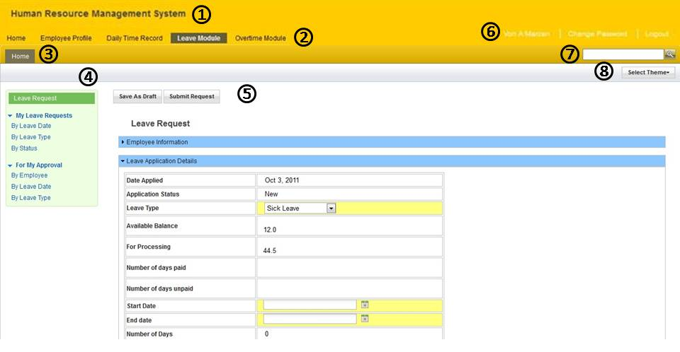
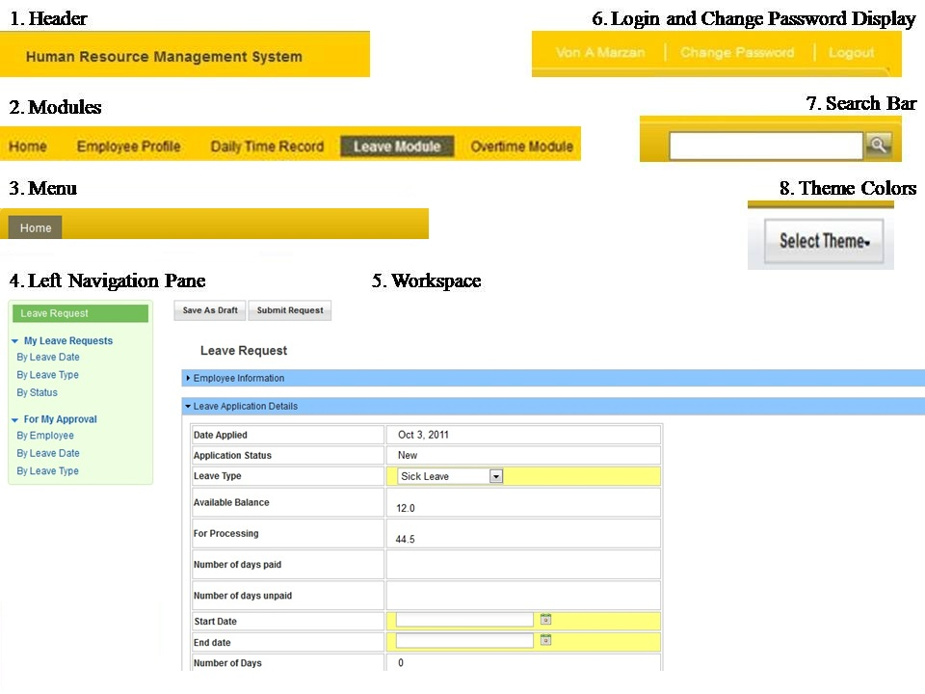

Log in
- Accessing the Leave Application Module.

To Access Leave Module
- Type your login ID and your password.
- Click login button.

Home

Creating Leave Request
- This process allows the user to create leave request.

To Create Leave Request
- Click the “Leave Request” to launch the leave form.
- Input the necessary details.
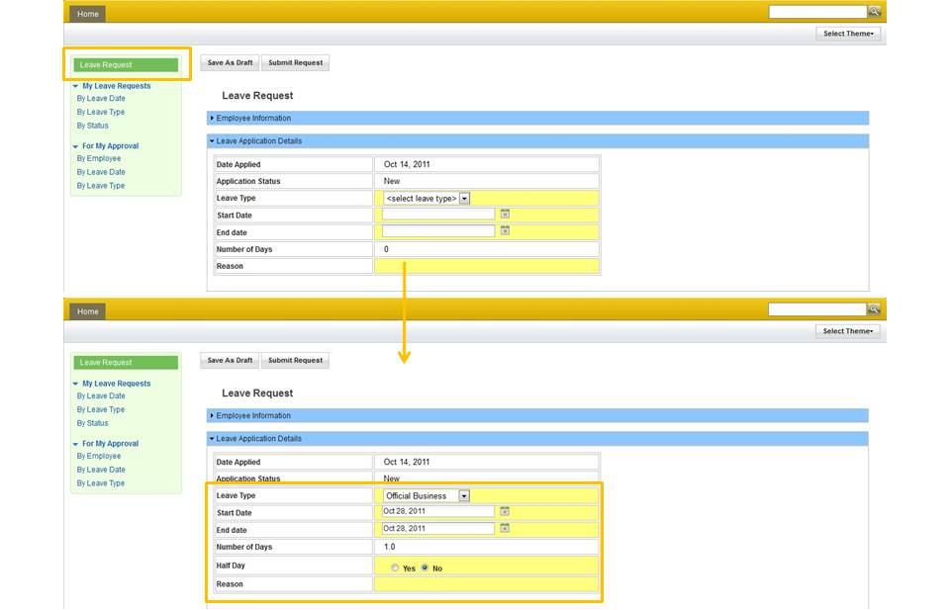

Saving Leave Request as Draft
- This process allows the user to save the created leave request as draft.

To Save Leave Request as Draft
- Click the “Save as Draft” button to save the leave request.
- A message box will appear, click “Ok”.
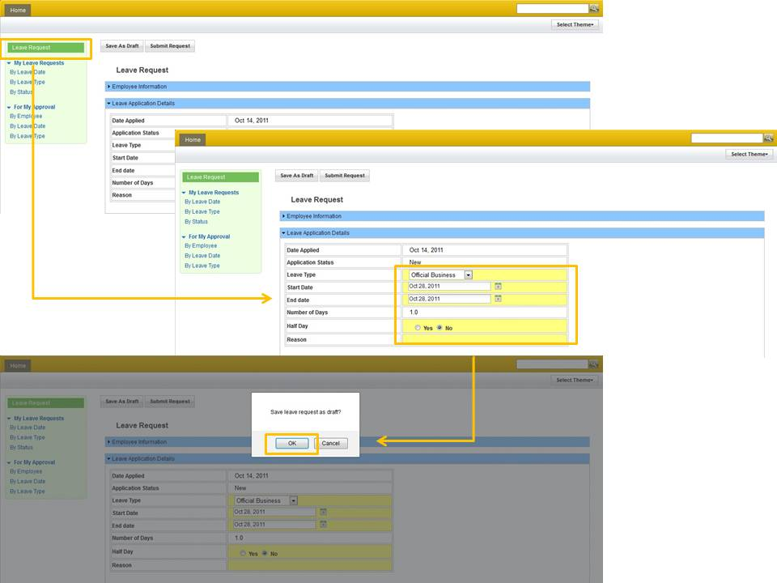

Submitting Leave Request
- This process allows the user to save the created leave request for approval.

To Submit Leave Request
- Upon completing the necessary details, click the “Submit Request” button to submit the request for approval.
- A message box will display, click “Ok”.
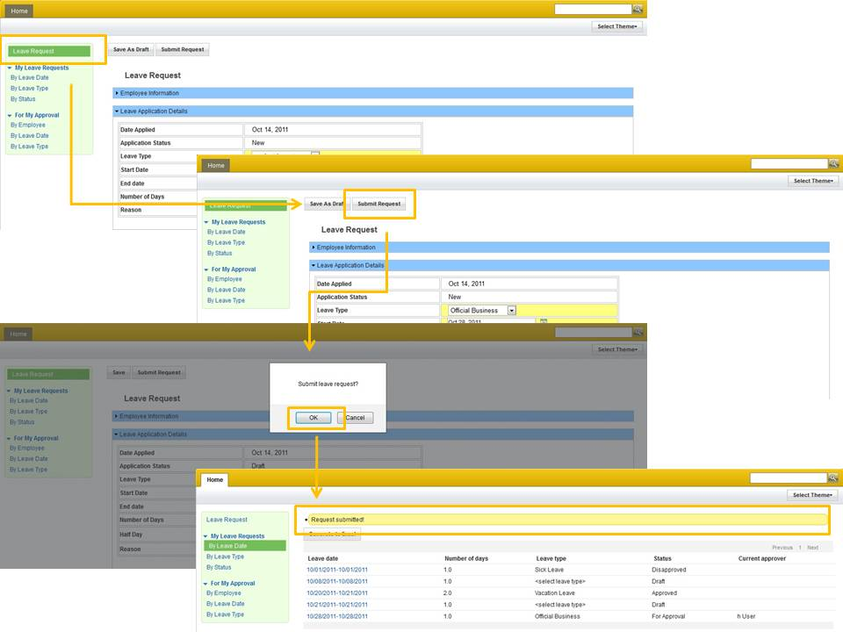

Viewing Users Leave Request Sorted By Leave Date
- Allows the user to view the users leave request sorted by leave date.

Generating Users Leave Request Sorted By Leave Date
- This process allows the user to generate the users leave request in excel format sorted by leave date.

To Generate Users Leave Request Sorted By Leave Date
- From the “My Leave Request”, select the ‘By Leave Date’ view.
- Upon clicking the “Generate to Excel” button, a message box will display asking if you really want to generate to excel, click “Ok”.
- A new message box will display, choose among ‘Open with’ and ‘Save File’, and click “Ok”.

Viewing Users Leave Request Sorted By Leave Type
- Allows the user to view the users leave request in sorted by leave type.

Generating Users Leave Request Sorted By Leave Type
- This process allows the user to generate the users leave request in excel format sorted by leave type.

To Generate Users Leave Request Sorted By Leave Type
- From the “My Leave Request”, select the ‘By Leave Type’ view.
- Upon clicking the “Generate to Excel” button, a message box will display asking if you really want to generate to excel, click “Ok”.
- A new message box will display, choose among ‘Open with’ and ‘Save File’, and click “Ok”.

Viewing Users Leave Request Sorted By Status
- Allows the user to view the users leave request in sorted by leave status.

Generating Users Leave Request Sorted By Status
- This process allows the user to generate the users leave request in excel format sorted by status.

To Generate Users Leave Request Sorted By Status
- From the “My Leave Request”, select the ‘By Leave Date’ view.
- Upon clicking the “Generate to Excel” button, a message box will display asking if you really want to generate to excel, click “Ok”.
- A new message box will display, choose among ‘Open with’ and ‘Save File’, and click “Ok”.

Cancelling Users Leave Request
- This process allows the user to cancel the leave request.
- Cancelling leave request can only be done if the leave request is not yet approved.

To Cancel Leave Request
- Select the ‘For Approval’ leave request from the “My Leave Request” view.
- Click the “Cancel” button.
- A message box will display, click “Ok”.
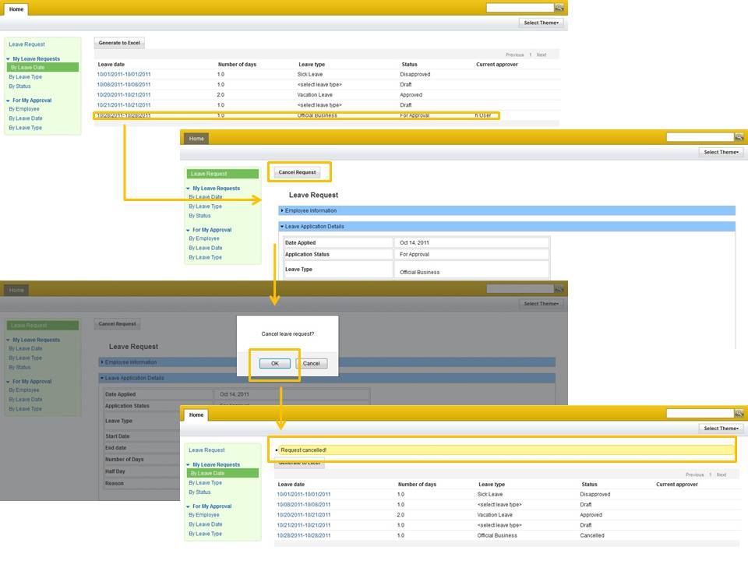

Withdrawing Users Leave Request
- This process allows the user to withdraw the leave request.
- Withdrawal of leave request is only available for those approved leave request.

To Withdraw Users Leave Request
- Open the ‘approved’ leave request from the ‘My Leave Request’ view.
- Click the “Withdraw” button.
- A message box will appear, click “Ok”.
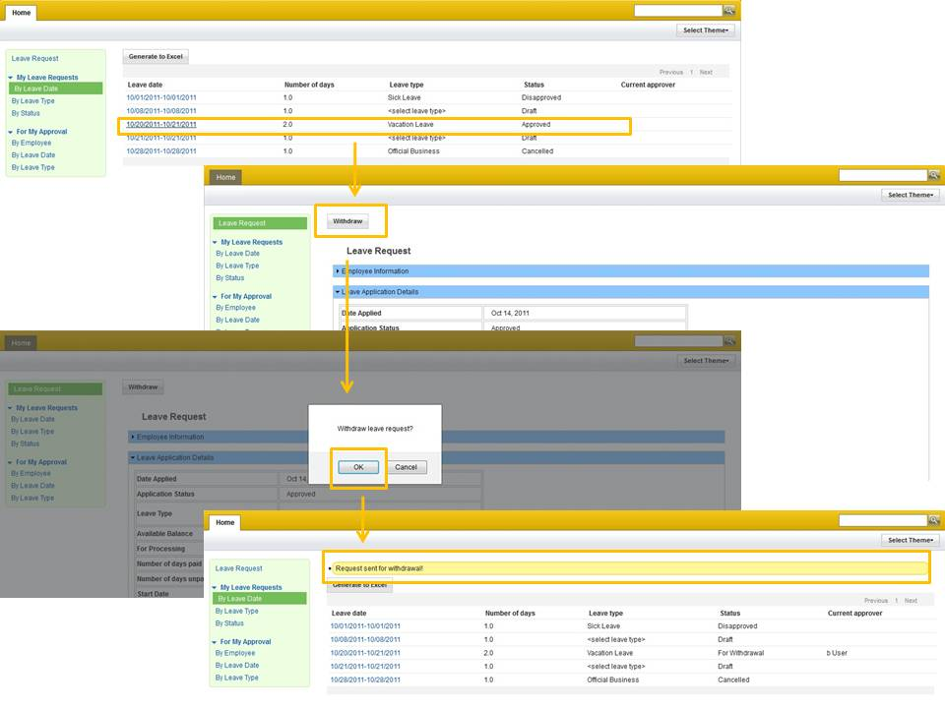

Viewing For Users Approval Leave Request Sorted By Employee
- Allows the user to view the list of ‘For Approval Leave Request’ that needs user’s approval sorted by employee.

Generating For Users Approval Leave Request Sorted By Employee
- This process allows the user to generate report in an excel file sorted by employee.

To Generate For Users Approval Leave Request Sorted By Employee
- From the “For My Approval”, select the ‘By Employee’ view.
- Upon clicking the “Generate to Excel” button, a message box will display asking if you really want to generate to excel, click “Ok”.
- A new message box will display, choose among ‘Open with’ and ‘Save File’, and click “Ok”.

Viewing For Users Approval Leave Request Sorted By Leave Date
- Allows the user to view the list of ‘For Approval Leave Request’ that needs user’s approval sorted by leave date.

Generating For Users Approval Leave Request Sorted By Leave Date
- This process allows the user to generate report in an excel file sorted by leave date.

To Generate For Users Approval Leave Request Sorted By Employee
- From the “For My Approval”, select the ‘By Employee’ view.
- Upon clicking the “Generate to Excel” button, a message box will display asking if you really want to generate to excel, click “Ok”.
- A new message box will display, choose among ‘Open with’ and ‘Save File’, and click “Ok”.

Viewing For Users Approval Leave Request Sorted By Leave Type
- Allows the user to view the list of ‘For Approval Leave Request’ that needs user’s approval sorted by leave type.

Generating For Users Approval Leave Request Sorted By Leave Type
- This process allows the user to generate report in an excel file sorted by leave type.

To Generate For Users Approval Leave Request Sorted By Employee
- From the “For My Approval”, select the ‘By Employee’ view.
- Upon clicking the “Generate to Excel” button, a message box will display asking if you really want to generate to excel, click “Ok”.
- A new message box will display, choose among ‘Open with’ and ‘Save File’, and click “Ok”.

Approving Leave Request
- This process allows the user to approve the leave request.

To Approve Leave Request
- Open the leave request from the ‘For Approval’ view list.
- Click the “Approve” button.
- A message box will display, click “Ok”.
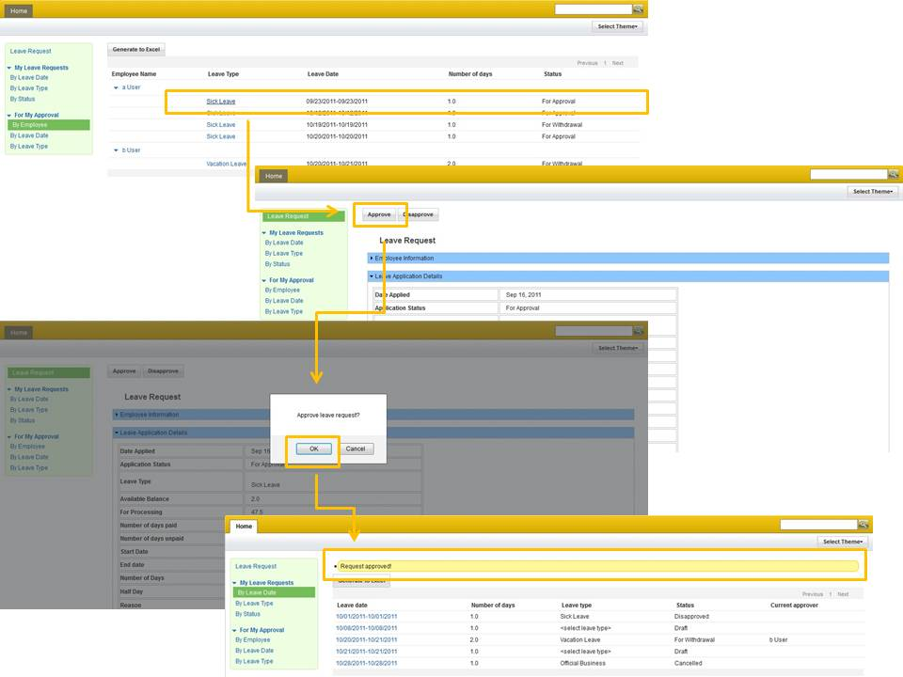

Disapproving Leave Request
- This process allows the user to disapprove the leave request.

To Disapprove Leave Request
- Open the leave request from the ‘For Approval’ view list.
- Click the “Disapprove” button.
- A message box will display, click “Ok”.
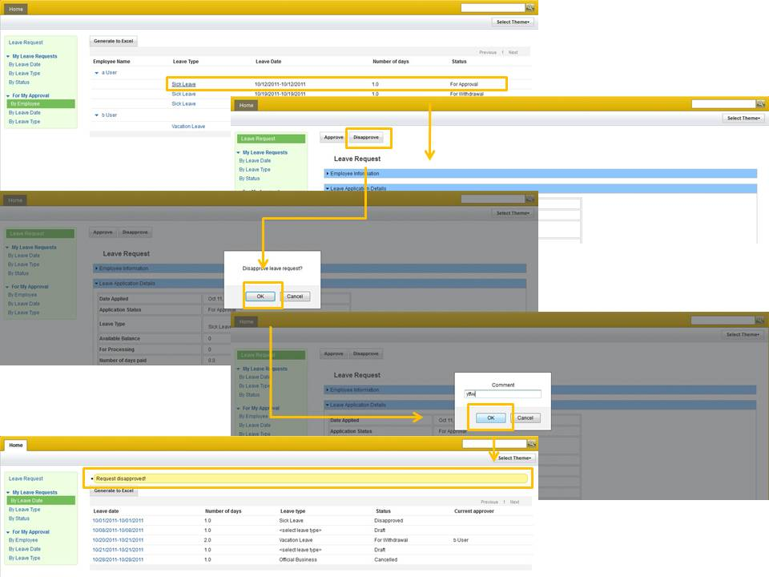

Approving Withdrawal Leave Request
- This process allows the HR to approve the withdrawal of leave request.

To Approve Withdrawal Request
- Open the leave request with the status of ‘for withdrawal’ from the “For Approval” view list.
- Click the “Approve Withdrawal” button.
- A message box will display, click “Ok”.
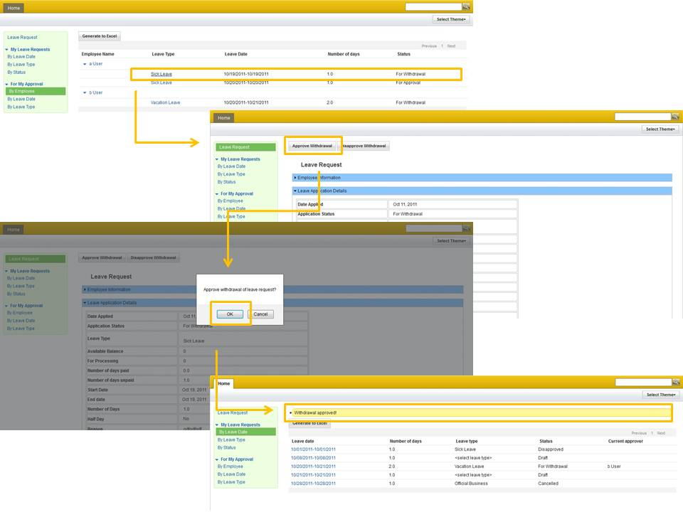

Disapproving Withdrawal Leave Request
- This process allows the HR to disapprove the withdrawal of leave request.

To Approve Withdrawal Request
- Open the leave request with the status of ‘for withdrawal’ from the “For Approval” view list.
- Click the “Disapprove Withdrawal” button.
- A message box will display, click “Ok”.
