PHINMA VPN Client Installation

- Open the Phinma VPN Website in your browser (https://122.2.3.76:8443)
- Once the page is loaded, type in your username and password.

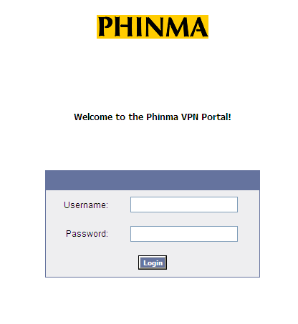
- Click on the SSL VPN Client (Tunnel access mode) to drop down all options.

For Windows (Windows XP, Windows 7, Windows 8) users, click on Download Client to download the installer. (Continues to page 2)

For MAC OS (Apple devices) users, continue to page 5.

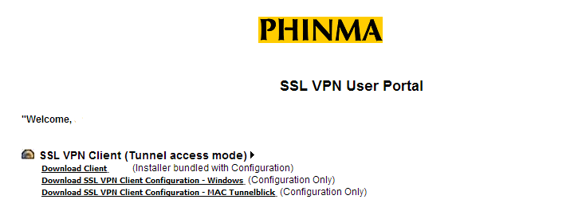

For Windows Users

After clicking the download link:

  - Save the file

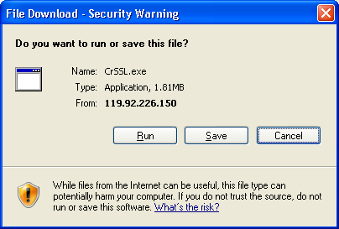

  - Install the file in your computer by double-clicking or right-click, then select Open.

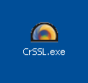

  - Select Run

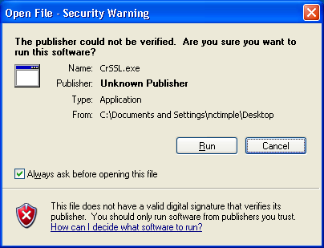

  - Choose destination folder (the default is recommended) and click Install

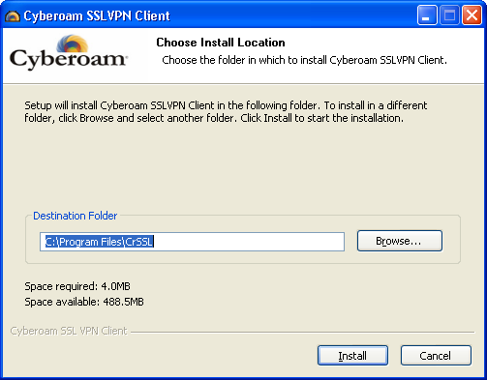

  - After finishing the installation, you will see the Cyberoam VPN icon on the notification area in the lower right section of the task bar

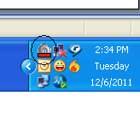
  - Right-click the icon and click Login

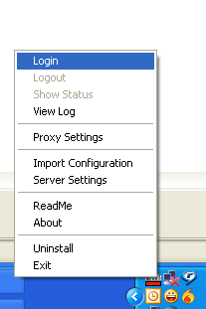

  - Type in your username and password (the same one you retrieved from the document and used to enter the download site). You can also “tick” the “Save username and password” option to be able to store the credentials and login much quicker, bearing in mind that the laptop is secured and not accessible to unknown personnel.

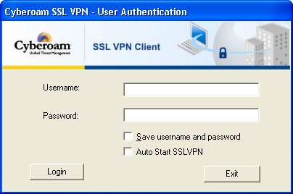

  - Once connected, you will notice a green Cyberoam icon. You can now use your browser to access the VPN sites, such as HRMS.

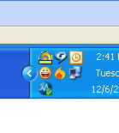
  - To disconnect and return to normal browsing, just right-click on the icon again and select Logout.

For MAC OS (Apple Device users)

- MAC users will need to install the Tunnelblick Client first before installing the Cyberoam VPN client. Download Tunnelblick Client from http://tunnelblick.googlecode.com/files/Tunnelblick_3.2.3.dmg
- Locate the .dmg file and double-click on it. A new finder window showing its contents should appear (a) or you might be prompted to confirm that you want to install the application, then click Open (b).

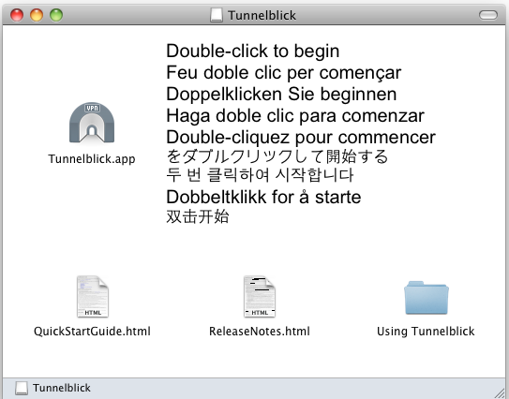

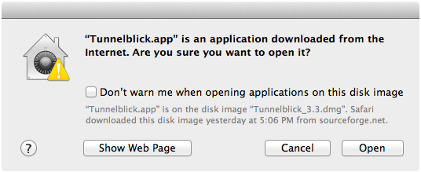

- Confirm by clicking Install when prompted and enter your computer administrator/user credentials if needed. This should save your credentials as well so you don’t have to enter them every time. Click OK after entering the credentials.

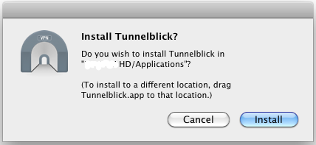

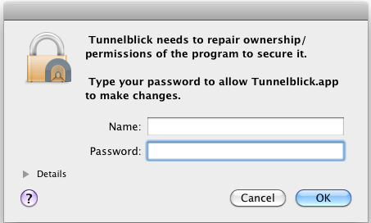

- When done, a new will appear. Click on Quit for the mean time.

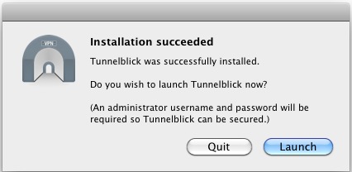

- Go back to the PHINMA VPN website, https://122.2.3.67:8443 (login again if session has ended)
- Click on the SSL VPN Client (Tunnel access mode) to drop down all options.
- Click on Download SSL VPN Client Configuration – MAC Tunnelblick to download the configuration.

- After clicking, a compressed file will be downloaded, clientbundle.tgz
- Double click on the compressed file, CRSSLconfig.tblk. (.tblk is the file extension for the Tunnelblick application) This should launch Tunnelblick.
- After double-clicking the .tblk file, a prompt like the one below should appear. You can choose to allow the application to be used by all users or choose “Only Me” to restrict it.

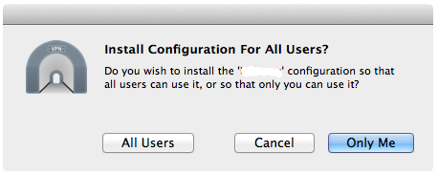

- Tunnelblick might ask for your computer administrator credentials again to confirm. This should also save your credentials as well so you don’t have to enter them every time. Click OK after entering the credentials.

- The installation of the VPN configuration should be finished and you can now access the VPN on your top toolbar with the following icon:


- Click on the icon and click Connect CRSSLconfig.

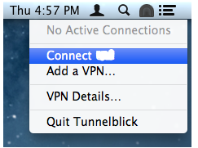

- When prompted, enter the credentials you used to access the Phinma VPN Website as the username and password. Tick “Save in Keychain” to save the credentials so you don’t have to enter them every time.

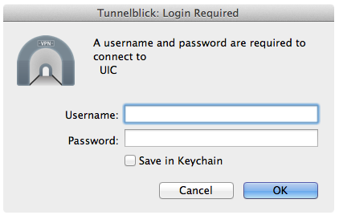

- When you have successfully connected, the Tunnelblick icon should light up. You can now use your browser to access the VPN sites, such as HRMS.



- To disconnect and return to normal browsing, just click on the icon again and select Disconnect CRSSLconfig.

