Philippine Investment Management Group (PHINMA GROUP)

USER MANUAL

Human Resource Management System

Daily Time Record (2 of 4)
For Employees and Supervisor Only

Prepared By
Softweb Consulting, Inc.
2011

Contents
Human Resource Management System 1
Daily Time Record (2 of 4) 1
DAILY TIME RECORD MODULE 2
Overview 3
Objective 3
I. User Interface 3
II. Login 4
III. My DTR 5
1. Viewing My Daily Time Record 5
2. Viewing for My Correction 5
3. Correcting Invalid DTR 5
4. Submitting DTR to Supervisor for Correction 5
5. Viewing For My Approval (for Supervisor only) 5
6. Approving DTR 5
7. Disapproving DTR 7
8. Viewing of My Approved DTR 9
9. Viewing of My Disapproved DTR 9

DAILY TIME RECORD MODULE

Overview
Daily time record module is the second from the four modules of Philippine Investment Management Group’s Human Resource Management System. It is integrated to the other three modules such as employee profile, leave and overtime. It is responsible in monitoring employee’s daily time record. The main module allows the user to upload, create, validate, process cut-off and report generation.

Objective
The module primarily aims to enhance the attendance management of the company’s Human Resource Department. It accommodates the general and the distinct processes of PHINMA Group’s seven companies: (1) PHINMA Corp., (2) PHINMA Inc., (3) Trans Asia Oil & Energy Development Corp., (4) Trans Asia Power Generation Corp., (5) T-O Insurance Brokers Inc., (6) PHINMA Property Holdings Corp. and (7) Microtel. It increases efficiency, boosts productivity and dramatically reduces operational costs of the group.

User Interface

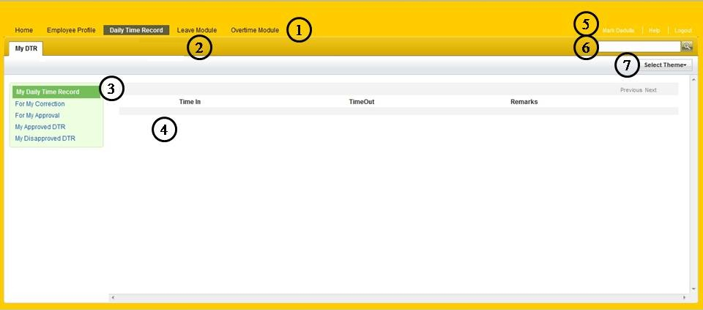

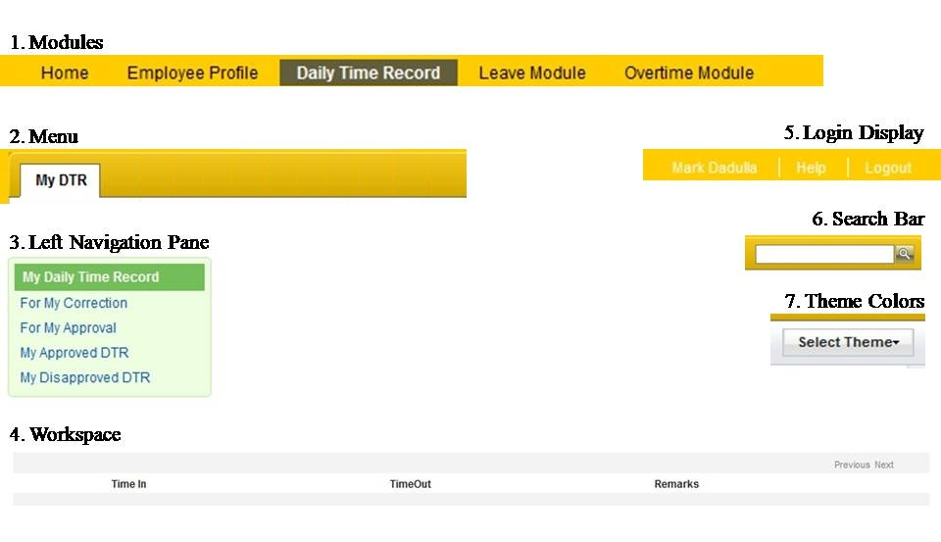

Login
- Accessing the daily Time Record module.

To Access DTR
- Type your login ID and your password.
- Click login button.

My DTR

Viewing My Daily Time Record
- Allows the user to view the daily time record.

Viewing for My Correction
- Allows the user to view the list of invalid DTR.

Correcting Invalid DTR
- Allows the user to correct the invalid DTR.

To Correct Invalid DTR
- Go to “For My Correction” to view the list of invalid DTR.
- Open the DTR.
- Click the “Switch Time In/Time Out” button to switch or edit the field to correct the invalid DTR.

Submitting DTR to Supervisor for Correction
- Allows the user to send the corrected DTR to the supervisor for approval.

To Submit DTR to Supervisor for Correction
- Go to “For My Correction”.
- Open the invalid DTR and perform the corrections.
- Click the “Submit” button.

Viewing For My Approval (for Supervisor only)
- Allows the Supervisor to view the submitted invalid DTR.

Approving DTR
- This process allows the user to approve the corrected DTR.

Two Ways of Approving DTR

Batch Approval
- Go to “For My Approval” to view the list of DTR that requires approval.
- Mark the Checkbox “All” to select all the DTR.
- Click the “Approve” button.
- A message box will appear, click “OK”.
- The user will notify the system that the DTR has been ‘Approved’.
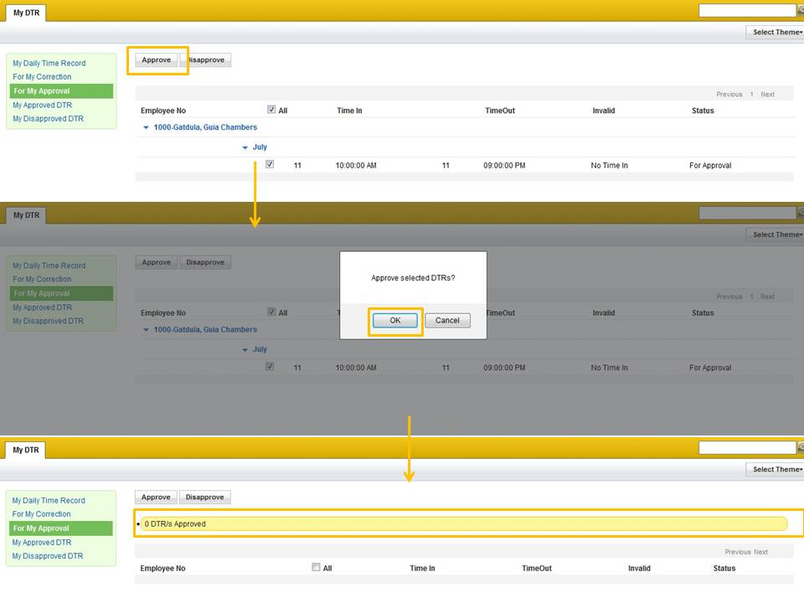

Individual Approval
- Go to “For My Approval” to view the list of DTR that requires approval.
- Open the document for approval.
- Click the “Approve” button.
- A message box will appear, click “OK”.
- The user will notify the system that the DTR has been ‘Approved’.
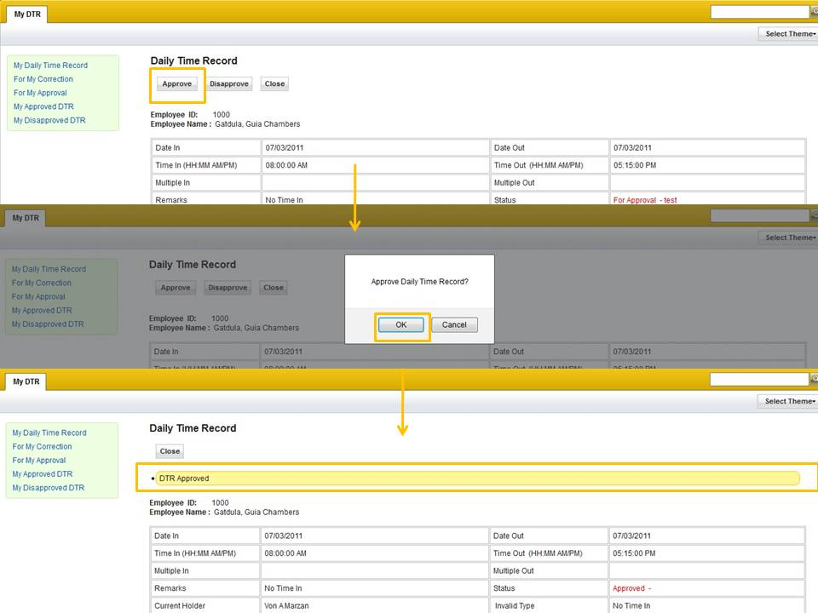

Disapproving DTR
- This process allows the user to reject the corrected DTR.

Two Ways of Disapproving DTR

Batch Disapproval
- Go to “For My Approval” to view the list of DTR that requires approval.
- Mark the Checkbox “All” to select all the DTR.
- Click the “Disapprove” button.
- A comment box will appear asking for the comment as the reason of disapproval.
- Click “OK”.
- The user will notify the system that the DTR has been ‘Disapproved’.
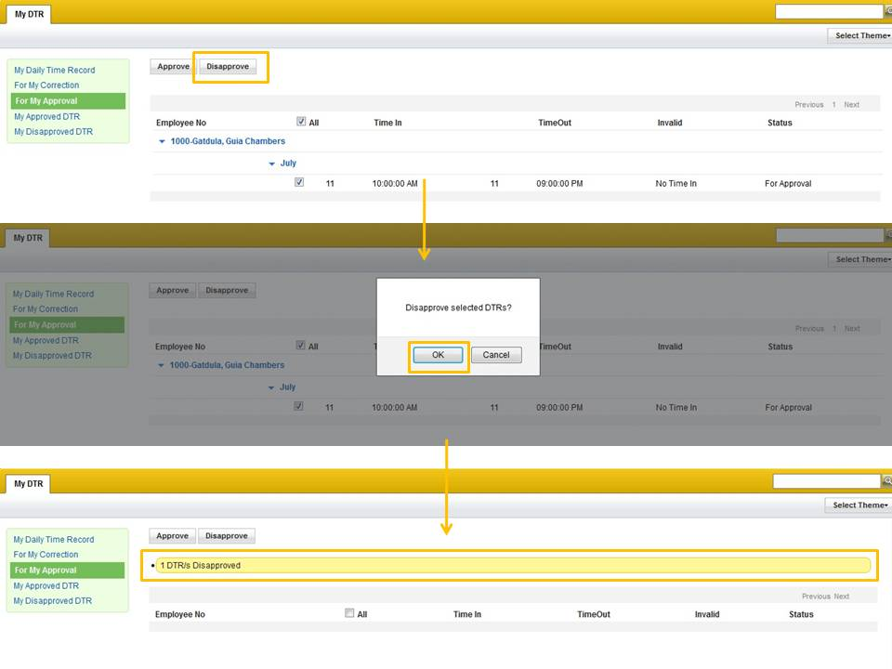

Individual Disapproval
- Go to “For My Approval” to view the list of DTR that requires approval.
- Open the document for approval.
- Click the “Disapprove” button.
- A comment box will appear asking for the comment as the reason of disapproval.
- Click “OK”.
- The user will notify the system that the DTR has been ‘Disapproved’.
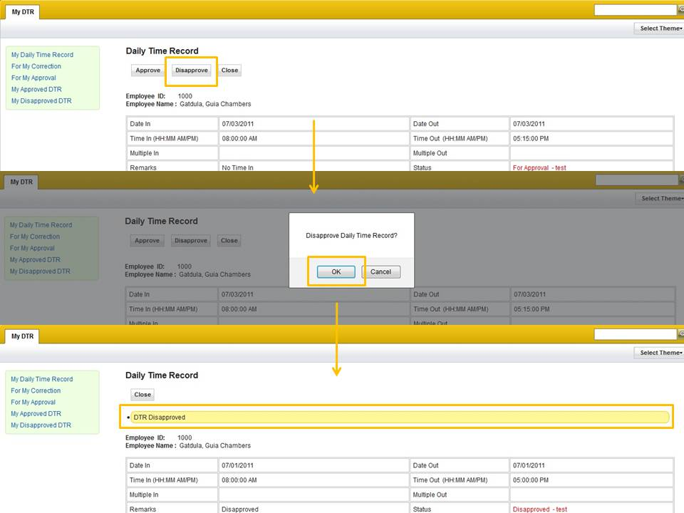

Viewing of My Approved DTR
- Allows the user to view the list of approved DTR.

Viewing of My Disapproved DTR
- Allows the user to view the list of disapproved DTR.

