IALA Guideline

GXXXX
MArine Aids To Navigation (ATON): Technical Specification for the provision of AtoN information to End-Users

Edition 1.0
March 2026

urn:mrn:iala:pub:gXXXX:ed.1.0
Revisions to this document are to be noted in the table prior to the issue of a revised document.
Date | Details | Approval
September 2025 | First edition
March 2026 | Revision

No table of contents entries found.
List of Tables
No table of figures entries found.
List of Figures
No table of figures entries found.

Marine Aids to Navigation (AtoN) Service Specification
Service Specification for the Provision of AtoN information to End-Users

Introduction
This document is a specification for the technical service of provision of Marine Aids to Navigation (AtoN) information, following the IALA guideline G1128 [1]. In the context of e-navigation there is a number of maritime services, and each of these make reference to a number of associated technical services. The technical services themselves are described on three levels;
- Service specification (this document)
- Service design (one or more)
- Service instance (one or more)
All the above documents are part of G1128 and are explained in that guideline.
The AtoN information provision makes use of the IHO S-125 data model, which is outlined in the S-125 product specification. According to the International Hydrographic Office, S-125 - Marine Aids to Navigation (AtoN) describes navigational features including lights and other navigation aids, both physical and virtual; temporary and seasonal marks; and local AIS application-specific messages. Navigational services information may be considered supplementary additional information that complements the ENC. This specific technical service may be referenced in other S-1xx product specifications and maritime services including MS12 - Nautical Publications and MS02 - AtoN.
This service specification may be used with the Maritime Connectivity Platform (MCP), where the MCP would provide means of authentication of service providers and service consumers as well as means of service discoverability.

Purpose of the Document
The purpose of this service specification document is to provide a holistic overview of the service and its building blocks in a technology-independent way, according to the G1128 guideline. It describes a well-defined baseline of the service by clearly identifying the service version.
The aim is to document the key aspects of the service at the logical level:
- the operational and business context of the service
  - requirements for the service (e.g., information exchange requirements)
  - involved nodes: which operational components provide/consume the service
  - operational activities supported by the service
  - relation of the service to other services
- the service description
  - service operations
  - service operation parameters
  - service payload definition
  - service dynamic behaviour description
- service provision and validation aspects

Intended Readership
This service specification is intended to be read by service architects, system engineers and developers in charge of designing and developing an instance of the service.
Furthermore, this service specification is intended to be read by enterprise architects, service architects, information architects, system engineers and developers in pursuing architecting, design and development activities of other related services.

Definitions
The following definitions describe terms used in this specification:
- Aid to Navigation (AtoN) - A device, system or service, external to vessels, designed and operated to enhance safe and efficient navigation.
- Navigational Warning (NW) - A broadcast message containing urgent information relevant to safe navigation.
- Maritime Safety Information (MSI) - Navigational and meteorological warnings, meteorological forecasts and other urgent safety-related messages.
- Navaid - An instrument, device or nautical publication carried on board a vessel for the purpose of assisting navigation.
- NAVAREA - A geographical sea area, as shown in the appendix (IMO A.706(17) established for the purpose of co-ordinating the transmission of radio navigational warnings. Where appropriate, the term NAVAREA followed by an identifying roman numeral may be used as a short title. The delimitation of such areas is not related to and shall not prejudice the delimitation of any boundaries between States.
- NAVAREA Co-ordinator - The authority charged with co-ordinating, collating and issuing long-range navigational warnings and NAVAREA warnings bulletins to cover the whole of the NAVAREA
- NAVTEX - Single frequency time-shared broadcast system with automated reception and message rejection/selection facilities. Use of NAVTEX is regulated by the IMO NAVTEX Manual (IMO publication 951).
- SafetyNET Service – Dedicated international satellite broadcast system with automated reception and message rejection/selection facilities.
- SafetyCast Service – Dedicated international mobile satellite service in the Global Maritime Distress and Safety System (GMDSS) for broadcasting navigational warnings, meteorological warnings and forecasts, and Search and Rescue (SAR) related information.

Service Identification
The purpose of this chapter is to provide a unique identification of the service and describe where the service is in terms of the engineering lifecycle.
- Service Identification Information.
Information Field | Information Value
Name | TBD
ID | MRN assigned by IALA (ex: urn:mrn:iala:techsvc:ss:arm:atoninfo:1.0)
Version | 1.0
Description
Keywords | Marine Aids to Navigation, S-125
Architect(s)
Status | Provisional

Operational Context
This section describes the context of the service from an operational perspective.

Pre S-125 Operational Context {sec:pres_125_operational_context}
From a practical perspective, the List of Lights is intended for use by mariners as a compendium to the navigational chart for AtoN information. In accordance with IHO S-12, The List of Lights and Fog Signals describe maritime signal installations on land or afloat producing light or sound signals (fog signals). In addition, these volumes contain information relating to certain other navigational aids: buoyage (day and night); signals (port signals, rescue signals, tide signals, etc.), radio-based aids (radio beacons, radar, radio navigation systems), etc.
IHO S-53, is concerned with drafting navigational warnings or with the issuance of meteorological forecasts and warnings under the Global Maritime Distress and Safety System (GMDSS). Maritime Safety Information (MSI) is promulgated in accordance with the requirements of IMO resolution A.705(17), as amended. Navigational Warnings are issued under the auspices of the IMO/International Hydrographic Organization (IHO) World-Wide Navigational Warning Service (WWNWS) in accordance with the requirements of IMO resolution A.706(17), as amended. Navigational Warnings (NW), including ATON casualties or changes which may impact navigational safety, are part of the Maritime Safety Information (MSI) system. This includes casualties to lights, fog signals, buoys and other aids to navigation affecting main shipping lanes as well as establishment of major new aids to navigation or significant changes to existing ones, when such establishment or change might be misleading to shipping. Currently, NW are promulgated as a radio broadcast and then printed in text format. The messages are standardized as SafetyNET, SafetyCast, NAVTEX broadcasts, and are in some countries accessible on the WWW or as voice broadcasts via coastal radio stations. System interfaces between NW publishers, NAVAREA (or Sub-Area) coordinator and broadcast service are not standardized, and may rely on manual processes involving e-mail, telephone, voice radio transmissions, fax, telex and manual re-entering of information from one system to another, or much more advanced solutions. Provision of NW via web is not standardized. NAVTEX, SafetyCast and SafetyNET cannot transport structured data formats for a joint NW-NM solution.
The pre-S-125 “present day” operational context of promulgation at the component level, is depicted below. A generalize assumption is made that information management systems are unique to each ATON Administration.
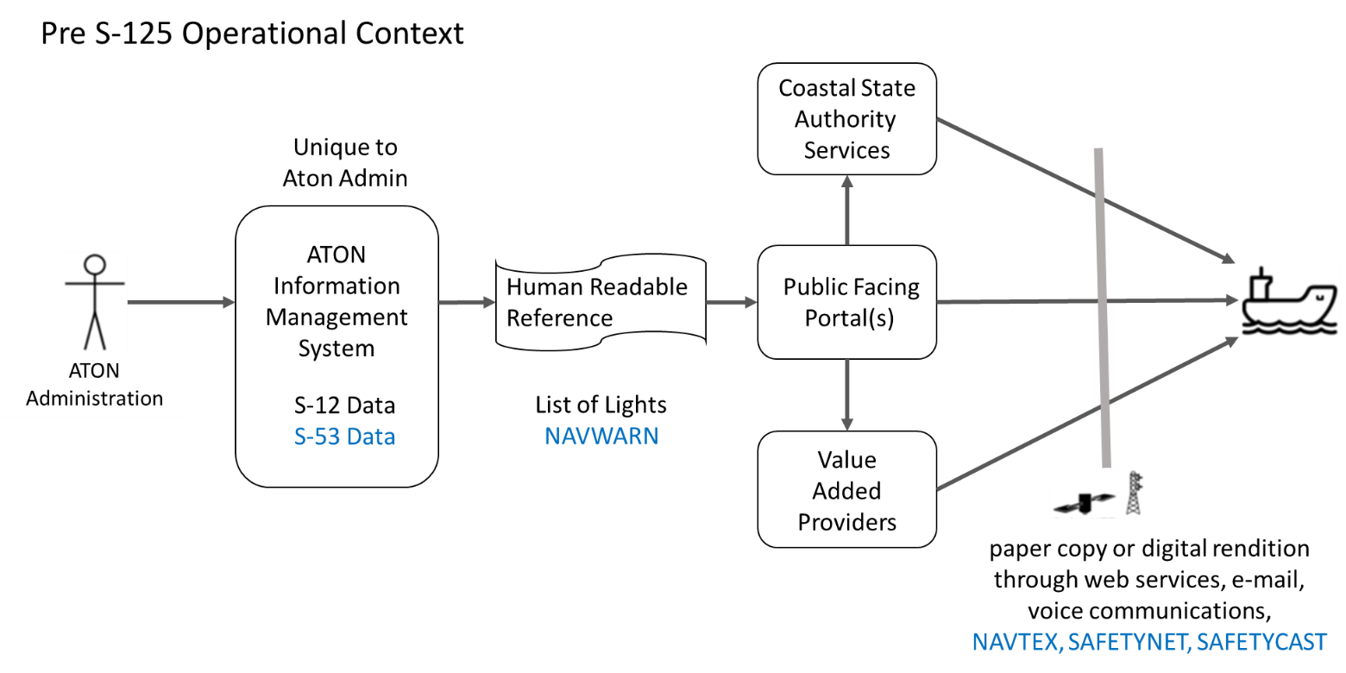
- Pre S-125 “Present Day” Operational Context.
System interfaces between AtoN Administrations, Hydrographic Officers, Nautical Publication Publishers, and dissemination methods are unique, and may rely on manual processes involving carriage of paper print copies or human readable digital renditions obtained via web services or email. Provision of the AtoN information included within the List of Lights via web services is not standardized.

Envisioned Operational Context
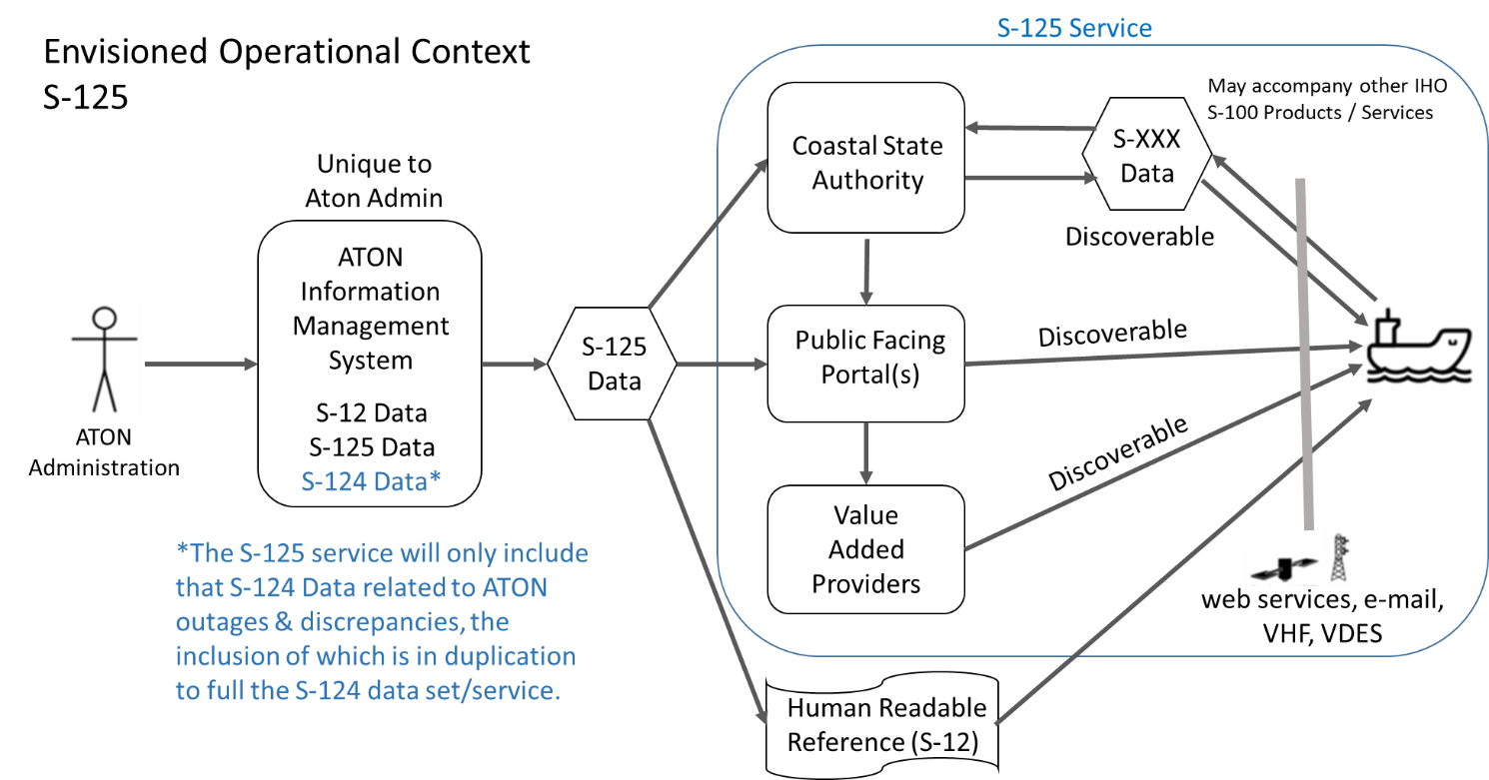
- Envisioned S-125 Operational Context
This scenario depicts an envisaged future of S-125 data exchange. Based on a standardized structured AtoN information (List of Lights) format, compatible systems will be able to exchange AtoN Data seamlessly. As depicted, each AtoN Administration may have a unique AtoN Information Management System. This system should automatically promulgate S-125 Data from the authoritative source for use by national and local authorities (e.g. Coastal State Authorities, Harbor and Port Authorities), the mariner public, as well as being available for use by commercial value-added services providers. The provision of an “S-125 Service” described in this document, is depicted as those activities after production of the S-125 data by AtoN administrations in the above diagram. It is envisioned that the legacy IHO S-12 data is a subcomponent and replaced by S-125. Administrations may desire to continue providing S-12 format human readable “paper reference” List of Lights in addition to the S-125 Marine Navigation Services, either transitionally, or indefinitely.
AtoN Administrations will administer and publish local S-125 Data for their area of responsibility, typically this includes areas within that state’s exclusive economic zone. Where appropriate they should coordinate with adjacent or overlapping AtoN administrations who share responsibility within the same waterway. (e.g. Both the U.S. Coast Guard and Canadian Coast Guard maintain aids to navigation within the waterways comprising the Great Lakes.) The instance descriptions will provide detailed information of coverage area available to users.
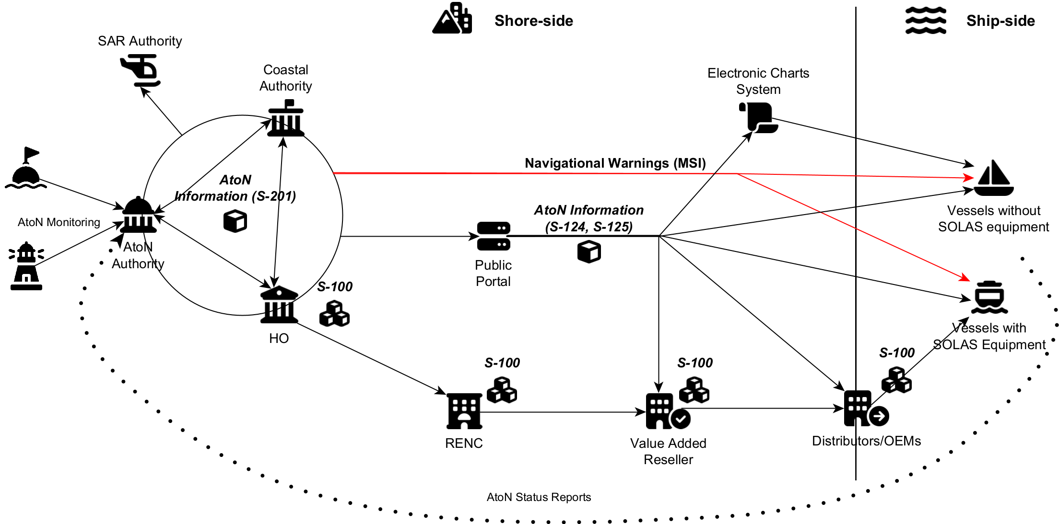
- Example of the AtoN information flow, as per [2].
The service described in this specification defines the exchange of AtoN information between a service provider and the end user of such a service. In the most common case, the end user will use an ECDIS to receive and display the information onboard a ship. However, as illustrated in the IALA interperation of the IMO MS-2 Aids to Navigation maritime service [2], seen in Figure 3, the application of this service specification is not limited to the exchange of information from shore to ship. It may also be used to harmonise the exchange of AtoN information between other stakeholders in the data distribution chain before it is received by the end user on a ship. This includes the data exchange between AtoN Authorities, coastal authorities, Regional Electronic Navigational Chart Coordination Centre (RENCs), Value Added Providers, public portals, and other entities. Depending on the specific requirements, the service usage patterns may differ. For example, A Value-Added Provider could pull all available data and subscribe to updates from a data producer (e.g., national AtoN authority) and redistribute the data to the end user via its own implementation of this service (after applying validation checks or optimising the data for a specific group of end users). The orchestration of multiple AtoN information services in the distribution chain, however, is not in the scope of this document and lies within the responsibility of the service provider(s).

Relationship of S-124 to S-125
MSI Providers (National and NAVAREA Co-ordinators) are the recognised authorities for promulgating and cancelling Navigational Warnings. An AtoN outage, or discrepancy as further defined within the IHO S-53 standard, is reported as a Navigational Warning and immediately communicated by the S-124 service. Upon confirmation of the discrepancy, the responsible ATON authority will include the report of outage in the S-125 dataset. The inclusion of the reported outage as part of S-125 will be in duplication to warnings provided as part of S-124. MSI providers are responsible for the removal of any Navigational Warnings from applicable S-124, and the AtoN authority is responsible for withdrawing the outage report from S-125. A Navigational Warning in S-124 will remain in force and continue to be promulgated by GMDSS broadcast services, since adding the information to the S-125 database will not, on its own, be sufficient to cancel the warning from GMDSS broadcast.
Whereas Navigation Warnings are disseminated as soon as possible via S-124, the S-125 dataset is updated on a routine cyclical basis. In this manner, time-critical Navigational Warnings regarding AtoN are rapidly disseminated to users via S-124 to provide awareness until the S-125 data set is updated. The duplication of long-term S-124 “temporary information” regarding AtoN Outages within S-125 will help lower the chance the mariner overlooks older critical navigation safety information. All in-force NAVAREA warnings should remain in S-124. The NAVAREA coordinators should be the only agency responsible for cancelling these warnings.

Relationship of S-125 to S-201
S-201 is a standard for compiling all data related to any AtoN including maintenance schedules, equipment types (such as battery and bulb types). S-201 is intended to be the means of communicating and exchanging such information with its main partners such as hydrographic offices, and in certain circumstances with IALA, within an AtoN organization or between AtoN organizations. The S-201 dataset, as a whole, is not intended for portrayal on navigation systems, like ECDIS. S-201 includes additional cartographic information to inform about AtoN services that would not be appropriate in a navigation system, such as positioning source confidence.
The S-125 product is derived from S-201 data. The S-125 service provides the machine-to-machine exchange of information for use in ECDIS/ECS and public distribution. S-125 is the digital equivalent of the extended list of lights in order to meet IMO SOLAS Chapter V requirements of having list of lights on board and serve as a continually updated list of AtoN and navaids. The organizational structure of Coastal State Authorities and Hydrographic Offices vary between nations. The authoritative source of S-201 data, including S-125, may also vary between nations. Therefore, it is recommended all coastal state authorities should establish an appropriate organizational structure and designated authoritative source for S-201 and S-125 data.

Relationship of S-101 to S-125
The AtoN data presented in the layers of the S-101 Electronic Navigation Chart (ENC) represents the design state of the aid. Information S-125 data serves as the AtoN compendium for charts, facilitating voyage monitoring and planning functions by providing emergent data related to discrepancies, temporary changes, proposed and advanced notice of changes to AtoN not represented in the S-101 data.

Discoverability and Dissemination
The S-125 data should be made available to public facing portals and be discoverable to mariners, Coastal State Authorities, and commercial value-added providers. S-125 data should enhance S-124 NW and ENC S-101 services, especially by reducing the effort in the transformation of data, with the harmonization of data models. This could be accomplished by introducing efficient data exchange mechanism between authorities. It is envisioned that upon complying with applicable ship reporting requirements to Coastal State Authorities, a vessel would then receive available S-xxx data supporting Maritime Services (e.g. latest ENC S-101 updates, S-125 Marine ATON, S-127 Marine Traffic Management, S-129 Under Keel Clearance, etc.) appropriate for their respective route.
The S-125 Data received by ships will thus depend on the promulgation method of choice. If, say, a ship targets the website of a specific port or Coastal State authority; it may see only that data provided by the corresponding AtoN Administration. If, however, the ship queries for S-125 data via other non-governmental public portals, it may receive S-125 data from various national and local authorities who have made their S-125 data available through that portal. The S-125 Service detailed in this specification only caters for a small part of this promulgation regime. It exposes multiple service operations for machine-to-machine consumptions of all current Aton Information from the targeted authority. It may be used by any client, such as a ship, a website or an app.
An S-125 service enables a system (ECDIS/ECS, or other route planning system) to retrieve S-125 dataset(s). Generally speaking, information regarding AtoN along a planned route is requested by the user from the service. In cases where the requested information is provided by multiple authoritative sources, the S-125 data may need to be retrieved from multiple service instances. The S-125 service instance(s) is known to the system, or the system has access to a service registry in which the service instance can be discovered.
Ordinary Sequence:
- The route is planned on the system by the mariner.
- The system requests AtoN status information from the service based on one of various means, including geometry of the route (all AtoN along the route) possibly defined by S-421 route exchange, geographic area defined by the mariner in the form of a point geometry with a search radius or a polygon, or by selection of predefined data subset(s) as provided by the authoritative source. The system could also request the complete S-125 dataset available from the authoritative source/service provider. Data requests can result in a singular response, or recurring response based upon subscription parameters such as geographical area, or time duration.
- The service directly answers the request with the appropriate data. This includes all relevant datasets to the user’s request. To ensure that all relevant safety information is presented to the mariner, datasets may not be broken or divided from what it provided by the authoritative source.
- The data is rendered and displayed to the user.

ECDIS Compatibility
Since S-125 is intended for ECDIS, it is required that S-125 comply with requirements of S-98, the Interoperability Catalogue Specification for ECDIS. This standard will govern how the various product layers will interact within an ECDIS. Within the IHO, S-98 is developed and maintained by S-100WG.

Functional and Non-functional Requirements
The table below defines the functional requirements, as there are defined in the IALA documentation for the IMO MS-2 Aids to Navigation Maritime Service [2]. Please note that the feature identifiers referenced in Table 2, are also referring to service features identified in the IALA MS-2 specification document.
- Functional Requirements for the MS-2 – Aids to Navigation Service.
Requirement Type | Requirement ID | Requirement Name | Requirement Text | Feature Identifier
Functional | MS2-FR001 | Provision of dataset(s) | The service provides S-100 compliant dataset(s) with all current and valid AtoN Information assigned to that dataset(s). | F001, F005
Functional | MS2-FR002 | Request for dataset(s) | The end users can receive on demand S-100 compliant dataset(s). Service providers will respond with current data relevant to the request but will not subdivide datasets to less than that defined by the authoritative source of the data. | F001, F005
Functional | MS2-FR003 | Filter AtoN Information | The end-users can filter the AtoN information based on a point, line, polygon geometry, AtoN type, AtoN status etc. | F001, F008
Functional | MS2-FR004 | Retrieve AtoN Status Updates | The end-users are able to request and filter out only the AtoN which have associated status changes. | F001, F008
Functional | MS2-FR005 | Subscribe to dataset(s) | The end users can subscribe to receive S-100 compliant dataset(s) and their respective updates. Subscription requests should be able to include the start and stop time of the subscription. | F002, F004, F005
Functional | MS2-FR006 | Status of Subscription | The service provides a subscription status notification. This could indicate termination of subscription from the service provider side. | F002, F003
Functional | MS2-FR007 | Data Update Status | The service must be able to provide the users with the status of their respective subscriptions and whether the current dataset is the latest one, along with other relevant information. | F002, F006
Functional | MS2-FR008 | Cancellation of Subscription | The service provides a facility to cancel the subscription. | F004
Functional | MS2-FR009 | Data Validation Certificate | The service can provide on demand the security certificate that was used to secure the data transmission. | F006, F009
Functional | MS2-FR012 | Information Filtering | The end users can filter the relevant AtoN information by name or based on a point, line, polygon geometry, or receive the complete service content. | F008
Functional | MS2-FR013 | Delivery Acknowledgement Request | The service is able to request a data delivery acknowledgement for any end-user. The requested acknowledgement should support multiple levels (receiving, reading etc.) | F011
Functional | MS2-FR014 | Delivery Acknowledgement Confirmation | The service provides a common but secure facility for all end-users to acknowledge the successful updates of AtoN information if requested. | F011
Functional | MS2-FR015 | Subscription Updates | The service is able to identify and contact the subscribed end-users to push updates on the requested dataset(s). | F012
Functional | MS2-FR016 | Input Automation | The service updates the advertised datasets, based on the AtoN status updates received. | F013
Functional | MS2-FR017 | End-User Precision Tailoring | The service is able to supply AtoN information with certain details (e.g. precision of decimal points) tailored to the corresponding end-user. | F010, F018
Functional | MS2-FR018 | Change Log | The service allows data producers to track the record of changes to the advertised dataset(s) for any time interval required. | F015
Functional | MS2-FR019 | Change Log State | The service allows data producers to view the full state of the AtoN Information as provided to consumers at any past point in time. | F015
The table below defines non-functional requirements for the S-125 service, as these are defined in the IALA documentation for the IMO MS-2 Aids to Navigation Maritime Service [2]. Please note that the feature identifiers referenced in Table 3, are also referring to service features identified in the IALA MS-2 specification document.
- Non-Functional Requirements for the MS-2 – Aids to Navigation Service.
Requirement Type | Requirement ID | Requirement Name | Requirement Text | Feature Identifier
Non-functional | MS2-NFR001 | Authorization | Service consumers are authorized by the provider for reception of data by the service. This may be public authorization (everyone has access), or limited authorization associated with a transactional service | F010, F016, F017
Non-functional | MS2-NFR002 | Authenticity | Service consumers can verify independently the authenticity of the AtoN information transmitted to them. | F006, F009
Non-functional | MS2-NFR003 | Integrity | It is clear to both service provider and consumer whether changes have been made to the AtoN information after this was created. | F006, F009
Non-functional | MS2-NFR004 | Availability | The service is consistently available in its ability to deliver AtoN Information to its consumers. (i.e. Service should have a high availability) | F001, F002, F004, F005, F011, F013
Non-functional | MS2-NFR005 | Responsiveness | The service provides a response to a service consumer’s request without delay, and the data provided should be (near) real time. | F001, F002, F011, F016
Non-functional | MS2-NFR006 | Performance | The service can handle multiple requests simultaneously (e.g. 1000/sec). | F001, F010, F012
Non-functional | MS2-NFR007 | Portability | The service makes the data available in portable machine-readable formats (e.g. XML/JSON) | F014
Non-functional | MS2-NFR008 | Compression | The service is able transmit the data in compressed format, with the compression method (e.g., gzip) clearly indicated. | F001. F005, F008
Non-functional | MS2-NFR009 | Accessibility | The AtoN information is accessible as much as possible and modern APIs should be supported for machine-to-machine communication. | F005, F010, F013, F014
Non-functional | MS2-NFR010 | Compatibility | The service is compatible with as many end-user devices as possible and conforms to the latest relevant maritime standards (e.g. IEC 63173-2 (SECOM), S-100 (S-124, S-125, S-201, S-240)) | F005, F010, F013, F014

Other Constraints

Relevant Industrial Standards
Not Applicable

Operational Nodes
The following tables describe the operational nodes of the service.
- Operational Nodes providing the S-125 service.
Operational Node | Remarks
AtoN Administration – AtoN Information Management System | The AtoN Information Management System collects all AtoN Information available from its Authoritative Source (AtoN Administration).
Coastal State Authority | Governmental Agency responsible for overseeing vessel arrival within a respective area. Should facilitate dissemination of S-125.
Discoverable Service | S-125 services must be discoverable and may be operated by public or private entities.
Service Consumer | Consumers of S-125 service. This must include the ECDIS/ECS on vessels operating within coverage area. This may include intermediary service providers.

Operational Activities
The following tables describe the operational activities of the service.
- Operational Activities supported by the S-125 service.
Operational Activity | Remarks
Identify S-125 Dataset(s) | The service consumer is able to identify the availability of S-125 dataset(s) for a given area. This includes identification of the authoritative source for the dataset(s).
Get S-125 Dataset(s) | The service consumer is able to retrieve S-125 dataset(s) from the service provider. This includes retrieving archived dataset(s).
Subscribe | The service consumer is able to subscribe to receive S-125 dataset(s) from the service provider for a given timeframe and area.
Version Designation | Service provider needs to track the current version of S-125 dataset(s) and make this discoverable to service consumers.
Record of Changes | Service provider needs to log changes between versions of S-125 dataset(s).
Dissemination of Changes | The “delta” compilation of changes made to a dataset(s) since the last version was issued may be made available to service consumer before the release of a new dataset version.

Use Cases

Use-case #1
Name: Retrieve complete S-125 AtoN information from a service provider.
Description: All AtoN information from a S-125 service provider is requested by the user. System is ECDIS/ECS, or other route planning system.
Actors: Shore-based user (e.g. VTS), AtoN information service, Mariner, ECDIS/ECS or other route planning system
Frequency of Use: Typically triggered once when a user request information
Pre-conditions: The service instance is known to the system, or the system has access to a service registry in which the service instance can be discovered.
Ordinary Sequence::
- User sends request to the service.
- The service directly answers the request with all of the AtoN dataset(s) in the service.
- The data is rendered and displayed to the user.
Post-conditions:: The correct AtoN information is received by the user

Use-case #2
Name: Retrieve AtoN information for a specific area, geographically defined waterway, predefined by authoritative source as S-125 dataset(s).
Description: Complete dataset(s) of AtoNs located in the area covered by the chart or defined by the user is requested by the system, including information such as ATON casualties or changes which may impact navigational safety; notification of temporary changes, advanced notice of changes, and proposed changes to ATON. System is ECDIS/ECS, or other route planning system.
Actors: Mariner, System, AtoN information service
Frequency of Use: Typically triggered once when new updates are available or when user needs information for a (serviced defined) area.
Pre-conditions: The service instance is known to the user, or the system has access to a service registry in which the service instance can be discovered.
Ordinary Sequence:
- The end user software sends request to get information of all datasets with the specified area(s) covered by the service, provided as summary functionality as defined under SECOM.
- The end user software receives information of all areas covered by the service.
- The user selects the dataset(s) for the desired area or waterway(s).
- The end user software sends request to receive information on all AtoNs that are located inside the coverage area.
- The service answers by providing the most recent data. This includes all relevant datasets to the user’s request. To ensure that all relevant safety information is presented to the mariner, datasets may not be broken or divided from what it provided by the authoritative source.
- The data is rendered and displayed to the user.
Post-conditions: The correct AtoN information is received by the user

Use-case #3
Name: Retrieve updates on the AtoN information through subscription service.
Description: ATON information and its changes, including status, within the user’s subscription parameters as made available by the service provider. Parameters may include a geographical area, or time duration for the subscription. Includes navigation safety information such as AtoN casualties or changes which may impact navigational safety: discrepancies, notification of temporary changes, advanced notice of changes, and proposed changes to AtoN. System is ECDIS/ECS, or other route planning system.
Actors: Mariner, System, AtoN information service
Frequency of Use: Triggered by the needs of the subscriber, when they want to receive updates for dataset(s) they have previously received.
Pre-conditions: The service instance is known to the system, or the system has access to a service registry in which the service instance can be discovered.
Ordinary Sequence:
- The system subscribes to receive AtoN information.
- The service answers the request with the most recent data. This includes all relevant datasets to the user’s subscription. To ensure that all relevant safety information is presented to the mariner, datasets may not be broken or divided from what it provided by the authoritative source
- The data is rendered and displayed to the user.
- Indication of the changes is highlighted to the user.
Post-conditions: The correct AtoN status information is displayed

Use-case #4
Name: Retrieve information on the status of a single AtoN based on its MRN [3] or location.
Description: Includes navigation safety information such as AtoN casualties or changes which may impact navigational safety; notification of temporary changes, advanced notice of changes, and proposed changes to AtoN. System is non-ECDIS, but other route planning system.
Actors: Researcher, ATON Administrator, AtoN information service
Frequency of Use: Adhoc.
Pre-conditions: The service instance is known to the relevant system or has access to a service registry in which the service instance can be discovered. Data is packaged in S-125 datasets with MRN attributes populated. S-125 datasets cannot be broken apart into division beyond those established by the authoritative source for liability reasons.
Ordinary Sequence:
- The AtoN status information is requested from the service.
- The service directly answers the request with the appropriate data. This includes the S-125 data for the ATON identified as well as all additional ATON contained within the predefined S-125 dataset.
- The data is rendered and displayed to the user.
Post-conditions: The correct AtoN status information is displayed.

Service Overview
This section aims at providing an overview of the main elements of the service. Architectural elements applicable for this description are:
- Service - the element representing the service, as a whole
- Service Operations - describe the logical operations used to access the service. Actual technical designs may rename some of the operations or ignore some of the operations if the operation is triggered in a different way e.g. API-based designs require more operations than an event-based design. Multiple service operations may also be implemented by a single API endpoint with e.g. different HTTP methods differentiating between operations.
- Service Operations Parameter Definitions - identify logical data structures being exchanged via Service Operations. These parameters must not be an exhaustive list but describe the parameters that are required for the business logic to work.

The AtoN Information Service
In Figure 4, below, an overview of the operations of the AtoN Information service is shown.
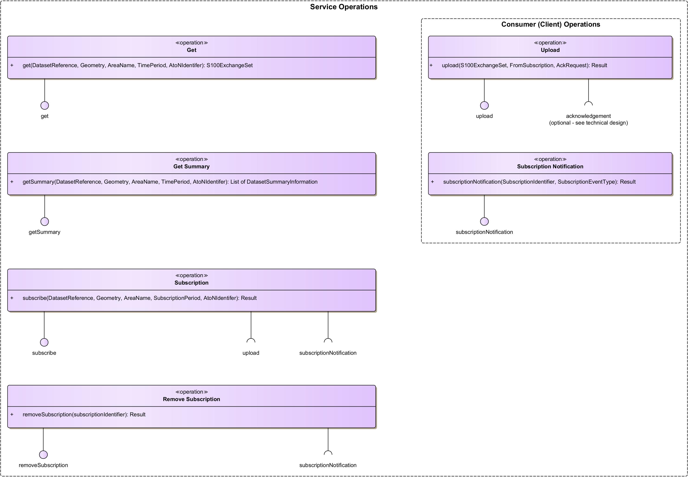
- S-125 Service Operations Definition diagram.
- Service Operations Overview.
 | Service Operation | Exchange Pattern | Definition
PULL | Get | REQUEST_RESPONSE | Operation to (pull) ask for AtoN datasets from the producer.
PULL | Get Summary | REQUEST_RESPONSE | Operation to (pull) ask for a list of summary information on the AtoN datasets made available by producer.
SUBSCRIPTION | Subscription | REQUEST_CALLBACK | Operation to create subscriptions on specific AtoN datasets. Relevant Client operations:  - Subscription Notification  - Upload
SUBSCRIPTION | Remove Subscription | REQUEST_CALLBACK | Operation to remove existing subscriptions. Relevant Client operations:  - Subscription Notification

- Consumer (Client) Operations Overview.
 | Client Operation | Exchange Pattern | Definition
PUSH | Upload | ONE_WAY or REQUEST_CALLBACK | Operation for (pushing) uploading information to consumer. An acknowledgement whether the data have been successfully received and/or processed can optionally be requested.
SUBSCRIPTION | Subscription | ONE_WAY | Operation for notification from subscription events. The implementation of a separate subscription notification operation on the AtoN Service clients is not necessarily required, depending on the choice of the underlying technology. When the subscription status information can be embedded onto the data upload operation, this operation may be omitted.

Service Operations
This section describes the details of each service operation, along with the relevant parameter definitions. To establish a service for the exchange of AtoN information, information is mainly provided by the service provider and is requested from the service consumer via the interfaces of the service provider. However, requirement S-125R009 states that a consumer must also be able to subscribe to updates of the service information. On the technical level, this may be realized in different ways. For example, the SECOM standard [4] requires the consumer to expose interfaces, to which new information can be pushed directly. Other technical designs may use a message broker as a middleware between consumer and provider, such that the consumer must not expose any public interfaces. For this reason, the respective consumer operations are modelled separately at the end of this section and may be implemented by other technical means as the service provider’s operations.
To ensure the integrity of the transmitted information, responses or requests from the service provider must be signed digitally by the service provider independently from the signature that is applied to the S-125 dataset itself. The transmitted data may also be encrypted for transport. The authentication mechanism for service consumers is left as an implementation decision to the service provider.
Furthermore, operations that are used internally by an AtoN information service provider to transfer AtoN information datasets from an internal information management system to the specified service are not discussed, as they are specific to those systems and not relevant for consumers of the service.
This section covers only the static design description, while the dynamic design (behaviour) is described in Section 7. The operations are designed to be compliant to the SECOM standard on a basic level. However, the SECOM standard explicitly prescribes the usage of certain technologies (such as REST). Therefore, this service specification provides an abstraction layer above SECOM that makes it possible to also realize the operations with different technology stacks.

Get Operation
The Get operation is used by service consumers for filtering and retrieving AtoN information from a service provider, e.g. S-125 datasets that are applicable for a specified geographical area. The consumer can also filter the requested S-125 dataset results by a specific dataset reference identifier, a time period, an area name etc.
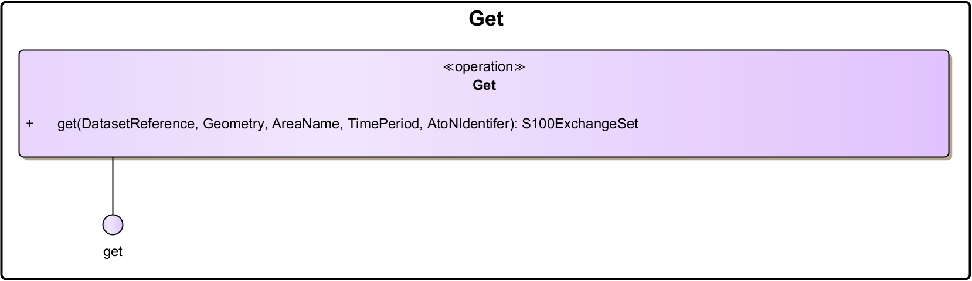
- Get operation.

Operation Functionality
This operation can be used for filtering and retrieving S-125 datasets from a service provider. It follows a request-response paradigm (REQUEST_RESPONSE), where a client queries the server, and based on a set of filtering criteria, receives an appropriate response back. The service response must be packaged as an S-100 Exchange Set, which contains all applicable S-125 datasets that match all the provided operation parameters, alongside any necessary metadata and support information. Other packaging formats are not supported by ECDIS and therefore are not included in this service specification. Each S-125 dataset contained in the response should include all AtoN entries allocated to it, not just the ones matching the operation parameters.
If multiple operation parameters are provided, only the results matching all requested filters are to be returned. If no operation parameters are provided, the response should include all datasets currently available in the service provider. A service provider may offer different encodings of AtoN information in accordance with the S-100 standard, which can be specified as an enumeration (XML/GML or binary). A service provider is required to offer at least one of the available encodings.
All instances of services providing AtoN information are required to support all operation parameters presented in the following sub-section Section 4.2.1.2, apart from the <TimePeriod> which is optional. The specific encodings are left to be decided by the service technical design specification. In most cases the parameter description provides an adequate definition.

Operation Parameters
- The Get Operation Parameters.
Parameters (in) | Encoding | Mult. | Descriptions
DatasetReference | See technical design | 0..1 | The dataset identifier of a specific S-125 dataset. A list of all supported references can be retrieved via Get Summary operation. If no references are provided, it’s up to the service to decide what to return.
Geometry | See technical design | 0..1 | Geometry condition for geolocated information objects. This can be used to filter on geometric shapes (e.g. filter AtoN information S-125 datasets by a bounding box).
unlocode | See technical design | 0..1 | UN/LOCODE (United Nations Code for Trade and Transport Locations) of a defined object (e.g., “CN” for China).
TimePeriod (Optional) | See technical design | 0..1 | An optional parameter denoting the time period (ValidFrom, ValidTo) in which a dataset is valid and becomes subject to changes. The service response is expected to encompass all modifications that occurred within the specified interval and should be provided in the form of complete datasets or delta files, adhering to the specifications outlined in the S-100 data model specification.

Get Summary Operation
The Get Summary operation is used by service consumers for retrieving a list of summary information (without the actual dataset contents), in order to discover which S-125 datasets are being currently made available (and are accessible) by a service provider. The service provider will respond by listing the available (and accessible) S-125 datasets that are of interest to the consumer. This list should only contain summary information on each dataset, not the dataset content itself. The dataset reference identifiers can be used to retrieve the full S-125 datasets via the Get operation. The consumer can filter the requested S-125 dataset summary results by a specific dataset identifier reference, a geometry, a time period, an area name etc.
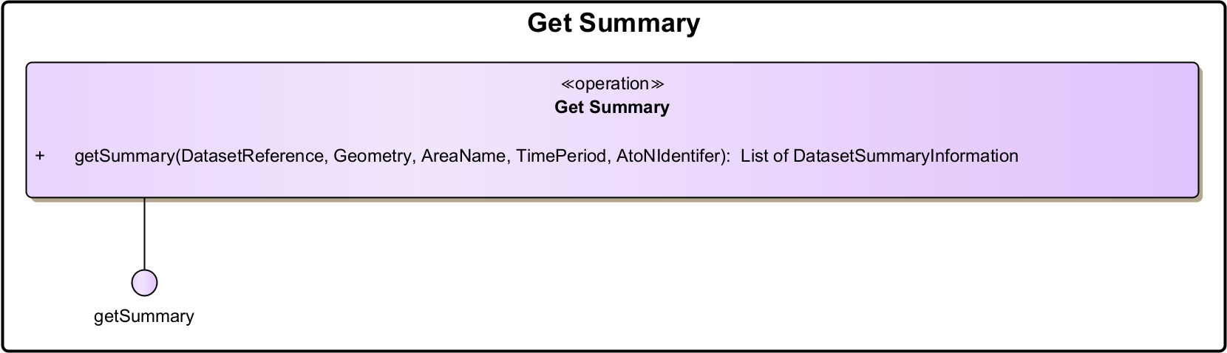
- Get Summary operation.

Operation Functionality
The operation can be used for filtering and retrieving the summary information regarding the S-125 datasets that are currently made available and accessible by the service provider. This operation is typically used to conserve bandwidth and make the query process faster, by initially retrieving only the summary information, and then only querying specific datasets from the service provider via the Get operation. It follows a request-response paradigm (REQUEST_RESPONSE), where a client queries the server, and based on a set of filtering criteria receives an appropriate response back. The server response should be formatted as a list of dataset summary objects. Each object contained in the list should only include summary information on the corresponding S-125 dataset, such as the data reference identifier, the status, a short description and the dataset size.
If multiple operation parameters are provided, only the results that match all requested filters should be included. If no parameters are given, the return should include all available datasets.
All instances of services providing AtoN information are required to support all operation parameters presented in the following sub-section Section 4.2.2.2, apart from the <TimePeriod> which is optional. The specific encodings are left to be decided by the respective service technical design specification. In most cases the parameter description provides an adequate definition.

Operation Parameters
- The Get Summary Operation Parameters.
Parameters (in) | Encoding | Mult. | Descriptions
DatasetReference | See technical design | 0..1 | The dataset identifier of a specific S-125 dataset. If no references are provided, it’s up to the service to decide what to return.
Geometry | See technical design | 0..1 | Geometry condition for geolocated information objects. This can be used to filter on geometric shapes (e.g. filter AtoN information by a bounding box).
unlocode | See technical design | 0..1 | UN/LOCODE (United Nations Code for Trade and Transport Locations) of a defined object (e.g., “CN” for China).
TimePeriod (Optional) | See technical design | 0..1 | An optional parameter denoting the time period (ValidFrom, ValidTo) in which a dataset is valid and becomes subject to changes. The service response should only include the S-125 datasets for which modifications occurred within the specified interval.

- The Get Summary Operation Return Types.
ReturnType (out) | Encoding | Mult. | Descriptions
List of Dataset Summary Information | List of dataset summary information objects. See technical design. | 0..* | Metadata of available AtoN information, that match the search parameters.

Subscription Operation
The purpose of this operation is to facilitate subscriptions initiated by service consumers on specific AtoN information. The information a service consumer subscribes to, can either determined by the provided operation parameters, or decided upon by the service provider.
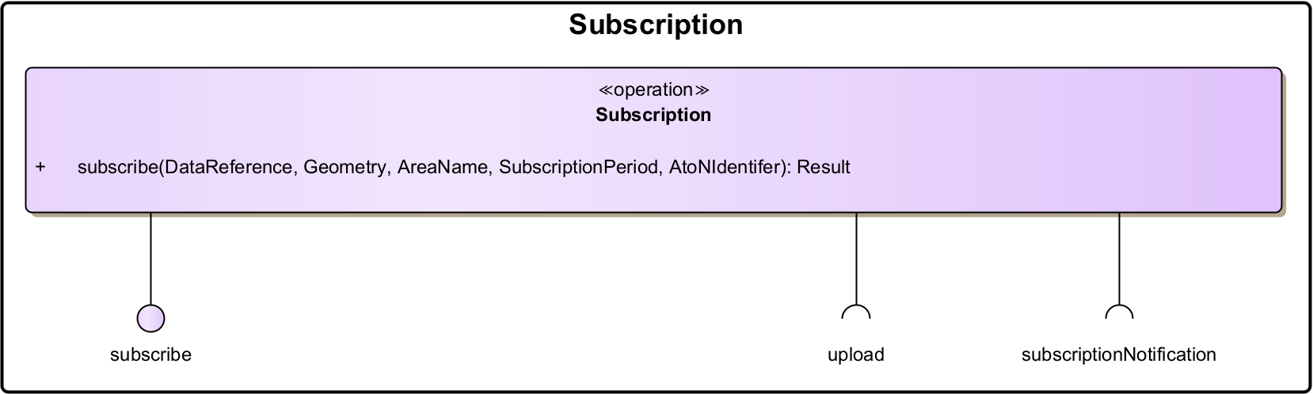
- Subscription operation.

Operation Functionality
The Subscription operation can be used by service consumers to subscribe to a specific set of S-125 datasets. The datasets that are covered by each subscription, are limited by the provided operation parameters, which include the dataset reference identifier. Note that the dataset reference identifiers of the S-125 datasets can be retrieved by the Get Summary operation. If no operational parameters are specified, the consumer is assumed to subscribe to updates on all available and valid datasets.
The operation follows a request-callback paradigm (REQUEST_CALLBACK), in which the consumers register their interest in a set of AtoN information and receive updates whenever one of the corresponding S-125 datasets change. The subscription can be cancelled through the Remove Subscription operation or can be limited by specifying a subscription period.
While on an active subscription, the service consumers will receive AtoN information packaged as an S-100 Exchange Set, which includes either the complete S-125 datasets for which updates exist, or just the incurred changes in the form of delta files, as these are defined in the S-100 data model specification [5]. In the latter case, it is recommended that before a consumer subscribes to updates, it initially requests all applicable S-125 datasets via the Get operation.
This operation consumes the following consumer operations:
- Upload
- Subscription Notification
The Upload consumer operation is utilised by the service provider to push the incurred S-125 dataset changes to the subscribed service consumer. The Subscription Notification operation on the other hand, is used to inform the consumer that on the status of the subscription, i.e. when it has been successfully activated or removed. More information on this operation can be found in the Section 7, describing the dynamic behaviour of the Subscription operation. Note that for each new subscription, a subscription identifier should be made available to the consumer.
All instances of services providing AtoN information are required to support all operation parameters presented in the following sub-section Section 4.2.3.2, although the specific encodings are left to be decided by the service technical design specification. In most cases the parameter description provides an adequate definition.

Operation Parameters
- The Subscription Operation Parameters.
Parameters (in) | Encoding | Mult. | Descriptions
DatasetReference | See technical design | 0..1 | The dataset identifier of a specific S-125 dataset. A list of all supported references can be retrieved via Get Summary operation. If no references are provided, it’s up to the service to decide what to return.
Geometry | See technical design | 0..1 | Geometry condition for geolocated information objects. This can be used to filter on geometric shapes (e.g. filter AtoN information by a bounding box).
unlocode | See technical design | 0..1 | UN/LOCODE (United Nations Code for Trade and Transport Locations) of a defined object (e.g., “CN” for China).
SubscriptionPeriod | See technical design | 0..1 | The period for which the subscription is active (start and end date/time).

- The Subscription Operation Return Types.
ReturnType (out) | Encoding | Mult. | Descriptions
Result | List of dataset summary information objects. See technical design. | 0..1 | Confirmation or error message. On confirmation, it must include a Subscription Identifier for the created subscription, which can then be used to remove the subscription. If the subscription corresponds to more than one information object, all information objects will be part of one subscription.

Remove Subscription Operation
Subscriptions are removed either internally by the service provider, or externally by the service consumer. This operation can be used by the consumer to request the removal of an active subscription.
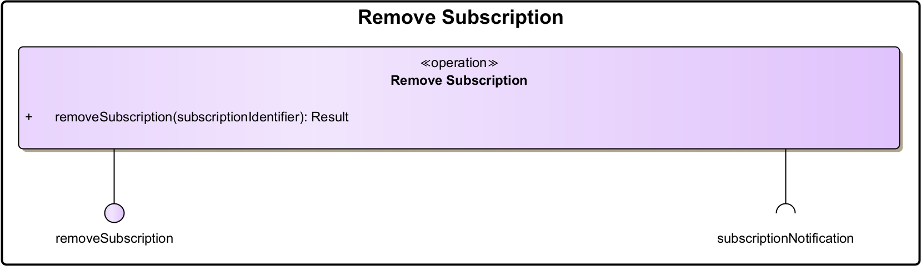
- Remove Subscription operation.

Operation Functionality
The Remove Subscription operation should be used to remove subscriptions that were created earlier through the Subscription operation. The operation follows a request-callback paradigm (REQUEST_CALLBACK), where a client expects a subscription notification to be sent back asynchronously, in order to confirm the successful removal of the requested subscriptions. In this operation, the consumer can optionally provide the subscription identifier, acquired through the Subscription operation response, to select the individual subscription to be removed. Alternatively, if no subscription identifier is provided, all active subscriptions for this consumer will be removed.
This operation consumes the following operations:
- Subscription Notification
The Subscription Notification operation is used to inform the consumer that on the status of the subscription, i.e. when it has been successfully removed.

Operation Parameters
- The Remove Subscription Operation Parameters.
Parameters (in) | Encoding | Mult. | Descriptions
SubscriptionIdentifier | See technical design | 0..1 | A specific identifier of the information object to remove the subscription for. If no subscription identifier is provided, all subscriptions for the consumer are removed.

- The Remove Subscription Operation Return Types.
ReturnType (out) | Encoding | Mult. | Descriptions
Result | List of dataset summary information objects. See technical design. | 0..1 | Confirmation or error message.

Upload Operation
The purpose of this operation is to allow service providers to upload (push) AtoN information to a service consumer. Hence, a consumer needs to implement this functionality as a separate operation or support it through the technology selected for the subscription operation, in order to receive S-125 datasets from a subscription or a unicast/broadcast operation.
Note: This may not be implemented as a separate interface as different technologies already implement this functionality on other levels (e.g., by using a message-oriented middleware like the MCP MMS, RabbitMQ or Kafka).
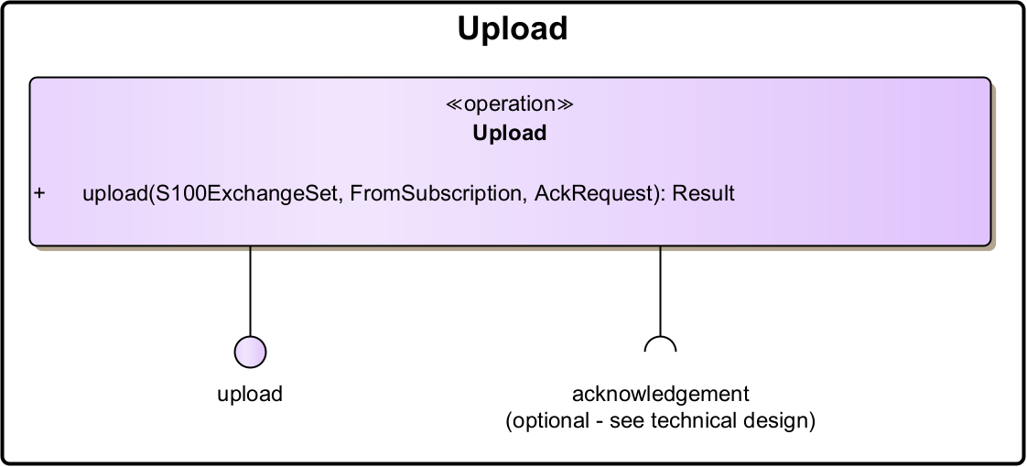
- Upload operation.

Operation Functionality
This operation allows service consumers to be directly informed about new or updated S-125 datasets made available. The operation may follow two types of exchange patterns. The first one is a one-way paradigm (ONE_WAY), where a service sends data to the consumer without expecting information back, other than a technical response. Alternatively, a request-callback paradigm (REQUEST_CALLBACK) can be employed, where uploads are expected to result in an acknowledgement message sent asynchronously back. This acknowledgement should be directed to an Acknowledgement operation of the service provider. This mechanism however, as well as the operation specification, is left to be defined at the service design level, as it is considered to be implementation specific.
This operation can be used both in single uploads and uploads under a subscription. The parameter <FromSubscription> indicates whether the upload took place within or outside a subscription by the consumer.
As stated previously, this operation may optionally consume the following operations:
- Acknowledgement
When uploading an AtoN information message and if this functionality is actually supported by the service provider, the acknowledgement can be requested through the <AckRequest> operational parameter. The encoding of this parameter is left to be defined by the technical service specification, as it is implementation specific. For example, in SECOM this would be represented by a simple Boolean value, while other technologies may require to a more complex structure that defines the location of the provider service endpoint, as well as authentication information.
The acknowledgement message may be expected to be received when the uploaded message has been delivered to end system (technical acknowledgement), and/or if supported, when the message has been opened (read) by the end user (operational acknowledgement). More information on this operation can be found in Section 6.2, describing the dynamic behavior description of the subscription on AtoN information.

Operation Parameters
- The Upload Operation Parameters.
Parameters (in) | Encoding | Mult. | Descriptions
S100ExchangeSet | S100ExchangeSet | 1 | S-125 datasets which conform to the data product specification including the service metadata (see Section 5).
FromSubscription (Optional) | See technical design | 0..1 | Flag to indicate whether the payload has been uploaded within an active subscription or not.
AckRequest (Optional) | See technical design | 0..1 | Flag to indicate that acknowledgement is expected when delivered, and an acknowledgement when message has been opened (read) by end user.

- The Upload Operation Return Types.
ReturnType (out) | Encoding | Mult. | Descriptions
Result | See technical design | 1 | Confirmation or error message.

Subscription Notification Operation (Consumer Operation - Optional)
This operation is used by service consumers to receive notifications by a service provider, when a subscription is created or removed.
Note: This may not be implemented as a separate operation as different technologies already implement this functionality on other levels (e.g., by using a message-oriented middleware like the MCP MMS, RabbitMQ or Kafka).
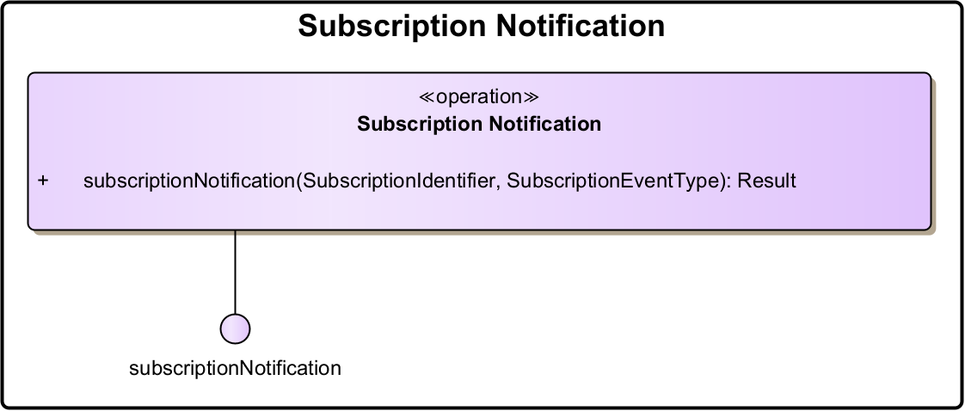
- Subscription Notification operation.

Operation Functionality
The operation receives notifications by the service provider, when a subscription is created or removed, either internally by information owner, or externally on request. This operation follows a one-way paradigm (ONE_WAY), where a service sends data to consumer without expecting information back, other than a technical response. More information on this operation can be found in Section Section 7, describing the dynamic behavior description of the subscription on AtoN information.

Operation Parameters
- The Subscription Notification Operation Parameters.
Parameters (in) | Encoding | Mult. | Descriptions
SubscriptionIdentifier (Optional) | See technical design | 1 | Specific identifier of the subscription for which the status has being updated.
SubscriptionEvent | See technical design | 1 | Type of subscription status update event; Created or Deleted/Removed.

- The Subscription Notification Operation Return Types.
ReturnType (out) | Encoding | Mult. | Descriptions
Result | See technical design | 1 | Confirmation or error message.

Service Data Model
This section describes the logical data structures to be exchanged between providers and consumers of the service. The service data model is bound by the current definition of the IHO S-125. For complete and updated documentation refer to the latest S-125 Product Specification which can be found at:
https://iho.int/en/nipwg-product-specifications.
Included in the service data model is a full description followed by specific extracts for;
- AtoN Information Features and Information types
- Enumerations
- Complex Attributes
Note that the S-100 specification [5] describes in Appendix 9-B how S-100 based data models shall be formulated in XML schema format.
Since the main purpose of the discussed service is to provide AtoN information to ECDIS, the S-125 information should be packaged as S-100 datasets, alongside any necessary metadata and other support information. The S-100 data model specification [5] in Appendix 4aS-100 Part 17, introduces the Exchange Set data structure, precisely for supporting this functionality. To indicate that S-125 datasets are coupled with additional service metadata, we refer to the type S100ExchangeSet (see Figure 11).
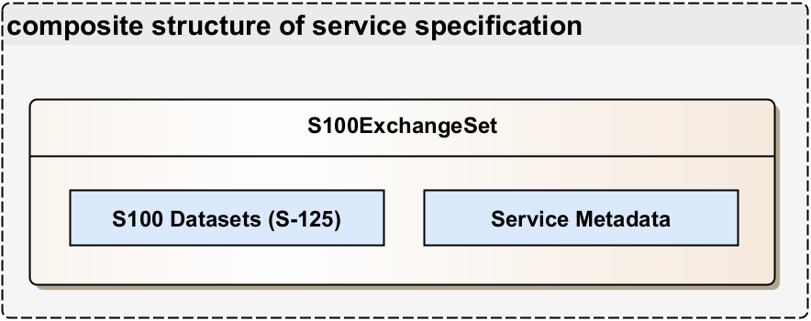
- S-125 dataset coupled with service metadata in an S-100 Exchange Set.

Service Internal Data Model
As the S-125 data model, used to represent the transmitted data, is developed independently from this service specification, the internal data model of the service should be adequate to generate the required S-125 datasets. In addition, a way to store service metadata that are not directly related to the data model (internal service identifies, signatures, etc.) is required. For further information, refer to IALA Guideline 1157. However, these metadata are mostly implementation specific and therefore are not discussed in this service specification. Examples on how to implement this functionality can also be found in the IMO’s S-100 data model specification [5], as well as the SECOM standard [4].

Service Dynamic Behaviour
This section describes the interactive behaviour of the operations between the service provider and the service consumers. The AtoN Information service supports two different types of operations, namely the client-initiated retrieval of AtoN information, and the subscription-based AtoN information propagation. Both are discussed in the following sections respectively.
Note: The description of the behaviour of the aforementioned operations, is provided in an abstract manner, where generic actions are performed on technology-agnostic endpoints. The implementation of each of these operations is left to be decided by any extending service design documents. In addition, any specific authentication procedure that is being applied is out of scope of the service specification and is described in the service designs of this service.

Client-initiated Retrieval of AtoN Information
The client-initiated retrieval is triggered by the service consumer, when it issues request on the appropriate service provider operations (i.e. Get and Get Summary). This operation covers Use Case #1, Use Case #2 and Use Case #4, as outlined in Section Section 3.4.4. All three use cases can be achieved by two methods; either by directly requesting specific S-125 datasets, using the operation parameters of the Get operation, or by first requesting the S-125 dataset summary information through the Get Summary operation, and then using the provided dataset reference identifiers, to retrieve the corresponding S-125 datasets.
The first method is presented in Figure 12, where the service consumer contacts directly the Get operation of the service provider. By utilising the available operation parameters such as the geometry, area name, time-period and AtoN identifier, only specific S-125 datasets matching the specified criteria and/or have updates on the specified time-period interval, will be retrieved, packaged into an S-100 Exchange Set, and returned as a response.
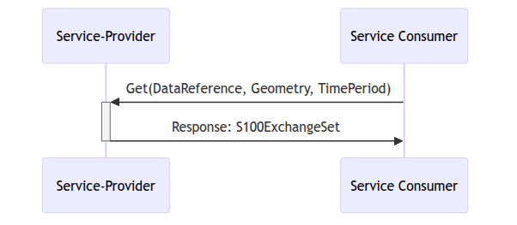
- Client-Initiated AtoN Information Retrieval through the Get operation.
In cases where the service consumer requires more information, before making a decision on which datasets should be downloaded, the latter “Client-initiated AtoN Information Retrieval” method can be utilised, by contacting the Get Summary operation beforehand. This is demonstrated in Figure 13, where the service consumer requests the list of the available S-125 dataset metadata via the summary operation and directly receives a response from the service provider. The service consumer can then select a dataset reference identifier from the returned list and request the detailed information (i.e. the complete S-125 dataset) back, through the Get operation of the service provider. The corresponding S-125 dataset (and/or its corresponding updates) will be packaged as an S-100 Exchange Set and then get sent back to the service consumer as direct response.
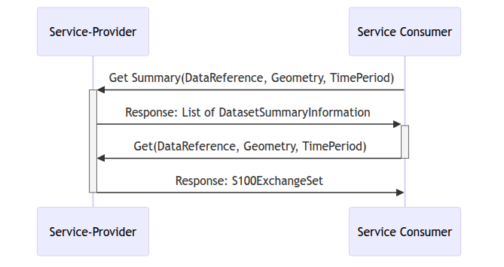
- Client-Initiated AtoN Information Retrieval through the Get Summary operation.
As demonstrated in Figure 13, the Get Summary operation accepts similar operation parameters as the Get operation, which can be employed to filter the summary response list. This feature improves the flexibility of the whole operation as for example, even if a provided geometry operation parameter matches more than one S-125 datasets, only the required dataset will eventually be retrieved by the service consumer, by using its respective dataset reference identifier.

Subscription-based AtoN Information Propagation
The subscription on AtoN Information is an alternative method of data propagation, in which a service consumer actively registers its interest to receive updates either on a specific set or alternatively, on all available S-125 datasets. This operation covers Use Case #3, as outlined in Section Section 3.4.4.
Figure 14 illustrates the typical behaviour the subscription operation. Initially, the service consumer is required to initiate the subscription through the Subscription operation of the service provider. By utilising the available operation parameters such as the geometry, the area name and the subscription period, only the specific S-125 datasets matching the specified criteria and have updates during the specified subscription interval will be covered. Once the subscription request has been received, processed and accepted by the service provider, a notification should be sent back to the service consumer, using its Subscription Notification operation. This notification will indicate that the requested subscription has commenced and should include the identifier reference of the established subscription.
Whenever an update is made available on the set of S-125 datasets covered by a subscription, the service consumer Upload operation is used to deliver these updates, packaged as S-100 Exchange Sets, to the service consumer. Depending on the implementation of the service, the consumer may be required to respond to this operation by sending an acknowledgement message back to the service provider. This is an optional operation, depending on the implementing technology. Therefore, it is not covered as an operation in this service specification.
The subscription updates will continue to be provided until one of the following conditions are met:
- The subscription period initially set by the service consumer has expired.
- The service consumer requests an end to the active subscription, using the Remove Subscription operation of the service provider.
- The service provider removes the information objects covered by the subscription.
- An expected incident/unexpected error forces the service provider to terminate the subscription.
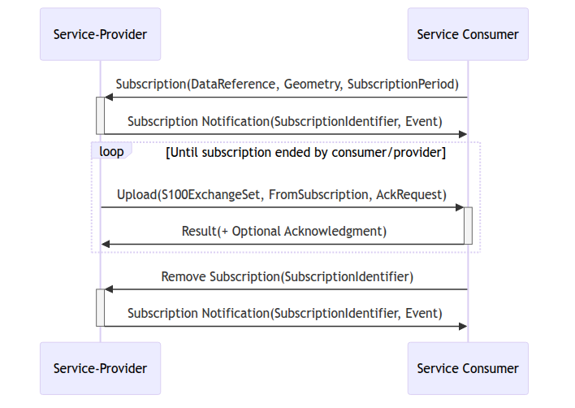
- Subscription requested by external service.
In the sequence diagram presented in Figure 14, the established subscription is terminated though a service consumer request. This should include the identifier reference of the subscription to be terminated, otherwise the service provider will terminate all active subscriptions for the service consumer performing the request. Once the service consumer’s request has been received, processed, and accepted by the service provider, another notification will be sent back to the service consumer’s Subscription Notification operation, to terminate the subscription process.
Note that the full contents of the S-125 datasets covered by a subscription, are not send back to the service consumer, unless a new dataset is created within the active period of an existing subscription that covers it. In all other cases, only the S-125 dataset changes will be transferred, in order to conserve bandwidth. Therefore, service consumer needs to utilise the Get (and Get Summary) operations, if the full contents of the S-125 datasets are required.

References
[1] International Organization for Marine Aids to Navigation (IALA), “The specification of e-navigation technical services,” Guideline 1128. Available: https://www.iala.int/product/g1128/
[2] International Organization for Marine Aids to Navigation (IALA), “MS-2 – aids to navigation maritime service – IALA g-1155 maritime service description,” Guideline XXXX. Available: https://www.iala.int/product/gXXXX/
[3] International Organization for Marine Aids to Navigation (IALA), “Unique identifiers for maritime resources,” Guideline 1143. Available: https://www.iala.int/product/g1143/
[4] International Electrotechnical Commission (IEC), “Maritime navigation and radiocommunication equipment and systems - data interfaces - part 2: Secure communication between ship and shore (SECOM),” Guideline 63173-2. Available: https://webstore.iec.ch/en/publication/64543
[5] International Hydrographic Organization (IHO), “S-100 – universal hydrographic data model,” Standard 5.2.0. Available: https://iho.int/uploads/user/pubs/standards/s-100/S-100_5.2.0_Final_Clean.pdf

Acronyms and Terminology

Acronyms
- List of Acronyms
Term | Definition
API | Application Programming Interface
MC | Maritime Cloud
MEP | Message Exchange Pattern
MRN | Maritime Resource Name
NAF | NATO Architectural Framework
REST | Representational State Transfer
SOA | Service Oriented Architecture
SOAP | Simple Object Access Protocol
SSD | Service Specification Document
UML | Unified Modelling Language
URL | Uniform Resource Locator
VTS | Vessel Traffic Service
WSDL | Web Service Definition Language
XML | Extendible Mark-up Language
XSD | XML Schema Definition

- List of Terms
Term | Definition
External Data Model | Describes the semantics of the “maritime world” (or a significant part thereof) by defining data structures and their relations. This could be at logical level (e.g., in UML) or at physical level (e.g., in XSD schema definitions), as for example standard data models, or S-100 based data produce specifications.
Message Exchange Pattern | Describes the principles how two different parts of a message passing system (in our case: the service provider and the service consumer) interact and communicate with each other. Examples: 1) In the Request/Response MEP, the service consumer sends a request to the service provider in order to obtain certain information; the service provider provides the requested information in a dedicated response. 2) In the Publish/Subscribe MEP, the service consumer establishes a subscription with the service provider in order to obtain certain information; the service provider publishes information (either in regular intervals or upon change) to all subscribed service consumers.
Operational Activity | An activity performed by an operational node. Examples of operational activities in the maritime context are: Route Planning, Route Optimization, Logistics, Safety, Weather Forecast Provision, …
Operational Model | A structure of operational nodes and associated operational activities and their inter-relations in a process model.
Operational Node | A logical entity that performs activities. Note: nodes are specified independently of any physical realisation. Examples of operational nodes in the maritime context are: Maritime Control Center, Maritime Authority, Ship, Port, Weather Information Provider, …
Service | The provision of something (a non-physical object), by one, for the use of one or more others, regulated by formal definitions and mutual agreements. Services involve interactions between providers and consumers, which may be performed in a digital form (data exchanges) or through voice communication or written processes and procedures.
Service Consumer | A service consumer uses service instances provided by service providers. All users within the maritime domain can be service customers, e.g., ships and their crew, authorities, VTS stations, organizations (e.g., meteorological), commercial service providers, etc.
Service Data Model | Formal description of one dedicated service at logical level. The service data model is part of the service specification. Is typically defined in UML and/or XSD. If an external data model exists (e.g., a standard data model), then the service data model shall refer to it: each data item of the service data model shall be mapped to a data item defined in the external data model.
Service Design Description | Documents the details of a service technical design (most likely documented by the service implementer). The service design description includes (but is not limited to) a service physical data model and describes the used technology, transport mechanism, quality of service, etc.
Service Implementation | The provider side implementation of a dedicated service technical design (i.e., implementation of a dedicated service in a dedicated technology).
Service Implementer | Implementers of services from the service provider side and/or the service consumer side. Anybody can be a service implementer but mainly this will be commercial companies implementing solutions for shore and ship.
Service Instance | One service implementation may be deployed at several places by same or different service providers; each such deployment represents a different service instance, being accessible via different URLs.
Service Instance Description | Documents the details of a service implementation (most likely documented by the service implementer) and deployment (most likely documented by the service provider). The service instance description includes (but is not limited to) service technical design reference, service provider reference, service access information, service coverage information, etc.
Service Interface | The communication mechanism of the service, i.e., interaction mechanism between service provider and service consumer. A service interface is characterised by a message exchange pattern and consists of service operations that are either allocated to the provider or the consumer of the service.
Service Operation | Functions or procedure which enables programmatic communication with a service via a service interface.
Service Physical Data Model | Describes the realisation of a dedicated service data model in a dedicated technology. This includes a detailed description of the data S-124 to be exchanged using the chosen technology. The actual format of the service physical data model depends on the chosen technology. Examples may be WSDL and XSD files (e.g., for SOAP services) or swagger (Open API) specifications (e.g., for REST services). If an external data model exists (e.g., a standard data model), then the service physical data model shall refer to it: each data item of the service physical data model shall be mapped to a data item defined in the external data model. In order to prove correct implementation of the service specification, there shall exist a mapping between the service physical data model and the service data model. This means, each data item used in the service physical data model shall be mapped to a corresponding data item of the service data model. (In case of existing mappings to a common external (standard) data model from both the service data model and the service physical data model, such a mapping is implicitly given.)
Service Provider | A service provider provides instances of services according to a service specification and service instance description. All users within the maritime domain can be service providers, e.g., authorities, VTS stations, organizations (e.g., meteorological), commercial service providers, etc.
Service Specification | Describes one dedicated service at logical level. The Service Specification is technology-agnostic. The Service Specification includes (but is not limited to) a description of the Service Interfaces and Service Operations with their data S-124. The data S-124 description may be formally defined by a Service Data Model.
Service Specification Producer | Producers of service specifications in accordance with the service documentation guidelines.
Service Technical Design | The technical design of a dedicated service in a dedicated technology. One service specification may result in several technical service designs, realising the service with different or same technologies.
Service Technology Catalogue | List and specifications of allowed technologies for service implementations. Currently, SOAP and REST are envisaged to be allowed service technologies. The service technology catalogue shall describe in detail the allowed service profiles, e.g., by listing communication standards, security standards, stacks, bindings, etc.
Spatial Exclusiveness | A service specification is characterised as “spatially exclusive”, if in any geographical region just one service instance of that specification is allowed to be registered per technology. The decision, which service instance (out of a number of available spatially exclusive services) shall be registered for a certain geographical region, is a governance issue.

