**FAQ**

1. **Difference between Margin, Balance, Equity**

Reference: <http://www.fxcm.com/support/faq/margin-requirements/>

**Trading on Margin (Trading with Leverage)** is a common attraction of the forex market. It allows you to open trades that are larger than the capital in your account.

**Example**

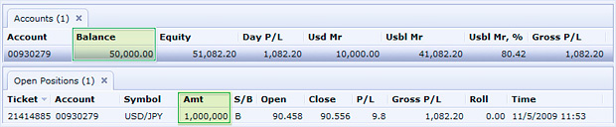

In the example above, $1,000,000 have been purchased through a long USD/JPY position with a $50,000 account balance (20:1 Leverage).

**Trading on margin can both positively and negatively affect your trading experience as both profits and losses can be dramatically amplified. Trading foreign exchange with any level of leverage may not be suitable for all investors.**

1. **Margin Requirements for FXCM LTD Standard Accounts Using a 1K Lot Size**

Reference: <http://www.fxcm.co.uk/products/forex/margin-requirements/>

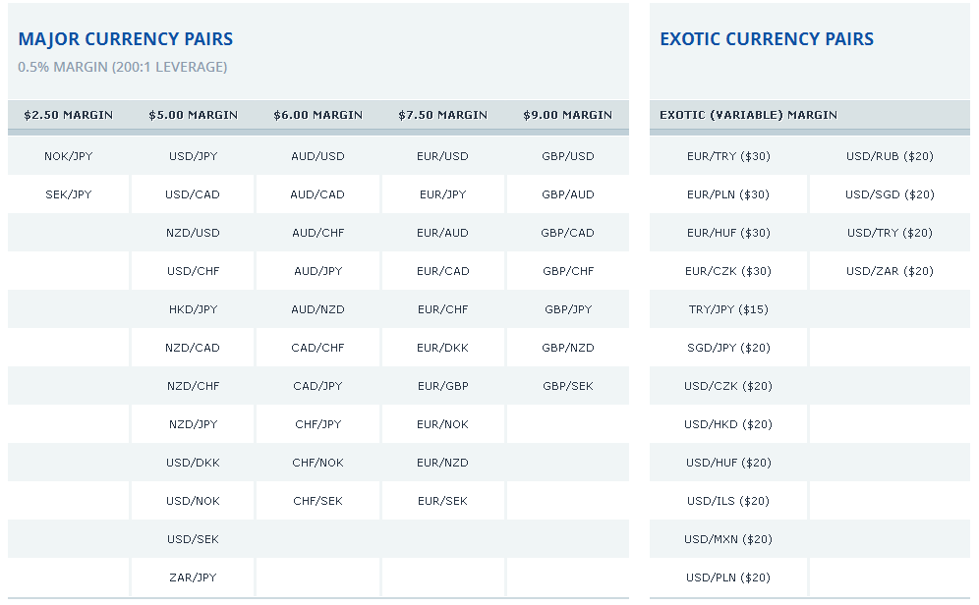

1. **How does FXCM calculate margin?**

By default FXCM LTD offers approximately 200:11 leverage (or 0.5% margin) on its forex trading accounts. Margin requirements (per 1K lot) at FXCM are determined by taking a percentage of the notional trade size plus a small cushion. A cushion is added to help alleviate daily/weekly fluctuations.

Please note that margin requirements are subject to change without notice based on price fluctuations and will be adjusted up or down in increments of $1. We believe that margin requirements will not change more than once a month. Up-to-date margin requirements are displayed in the "Simplified Dealing Rates" window of the Trading Platform by currency pair. To learn more about margin and leverage, please visit our Frequently Asked Questions (FAQs).