1. **Idea**

Following the success of E-learning, M-learning becomes a trend that every institute needs to adapt to attract the learners. We aim at generation Y and Z, who were born in the era of technology. They are creative and familiar with technology as well as social media. However, they are the ones who are easily distracted, especially by online games or social media. Utilizing this special property, we have come up with an idea of creating a mobile game as an innovative approach to language teaching, aim at improving students’ motivation in English classes, and more important is triggering their autonomy or life-long study.

1. **Features**

Powerlish provided 3 ways for students to interact with the application

First is Arena Mode. In this mode, students will compete with others student to fight for the top position in the leaderboard. As a reward, top 5 of each week will be proposed to higher rank which indicated by a different fish. Each win match will give the student 5 points and the points will be reset at the start of next week. There are three consecutive rounds in each match, first round is about vocabulary, second is listening and the last is grammar, who got the higher total score will win the match. The game was designed to pick a question from the most recent learned unit in class more frequently than others.

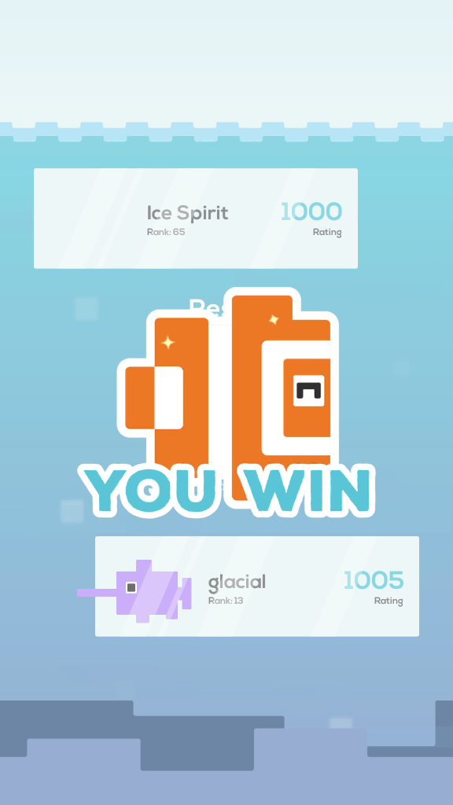

Second is Practice Mode. In this mode, students will choose a particular game and at the start of the game, they can choose a unit they want to practice specifically. The answer of the question will be shown if the student answers it correctly. Students will be counted as practice one time only if they have finished the game by answering 10 questions.



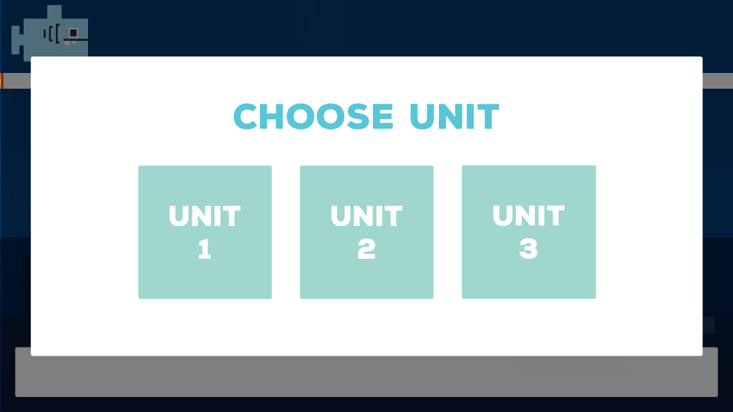

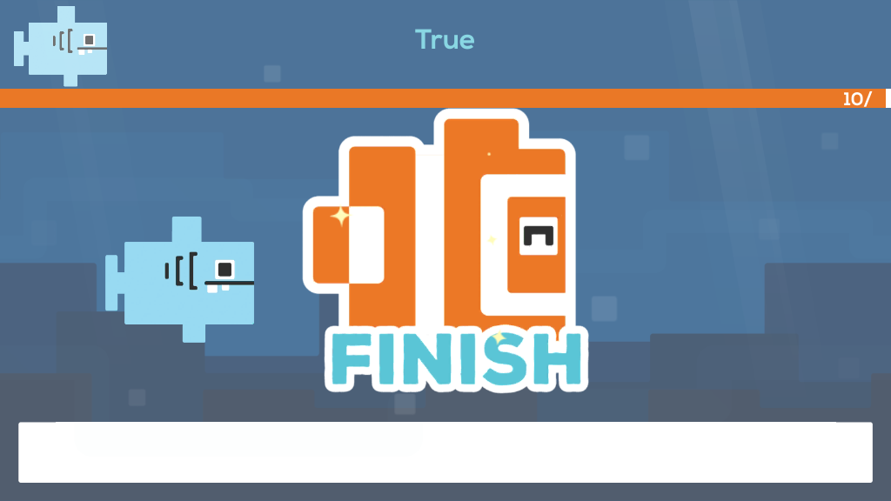

Third is Library Mode. In this mode, students can review the vocabulary in particular unit and its grammar which is a slide provided from the course.

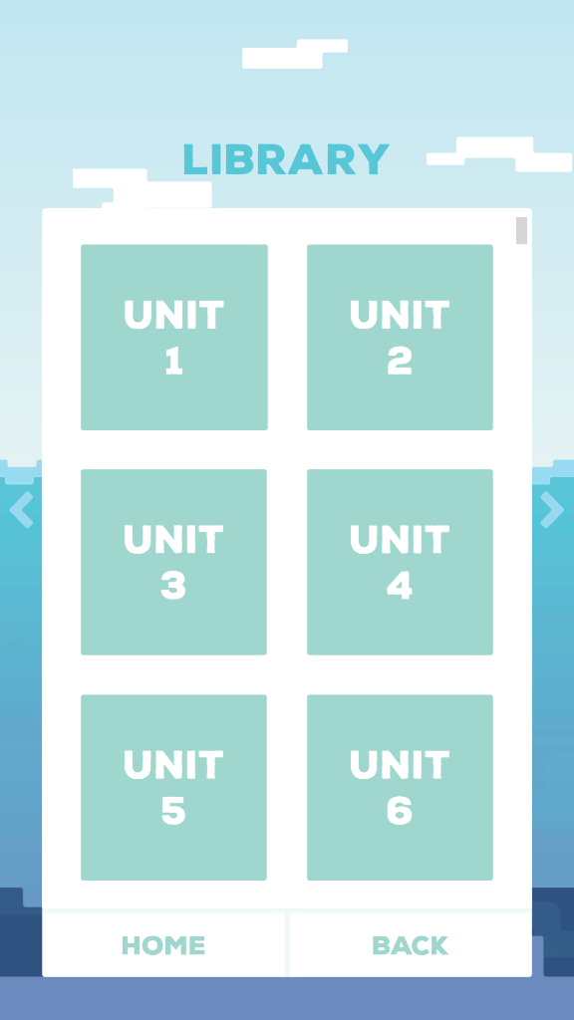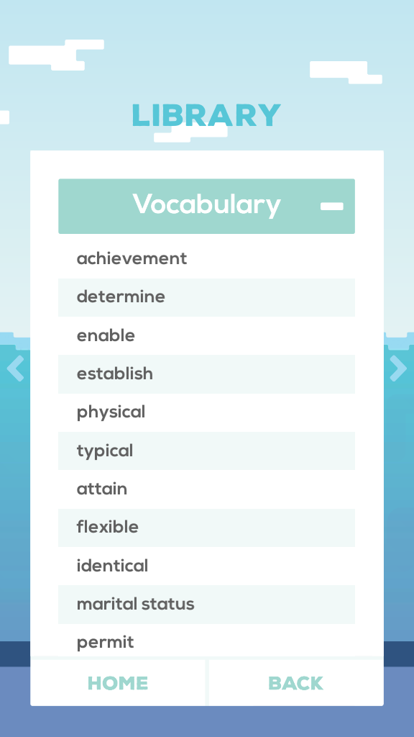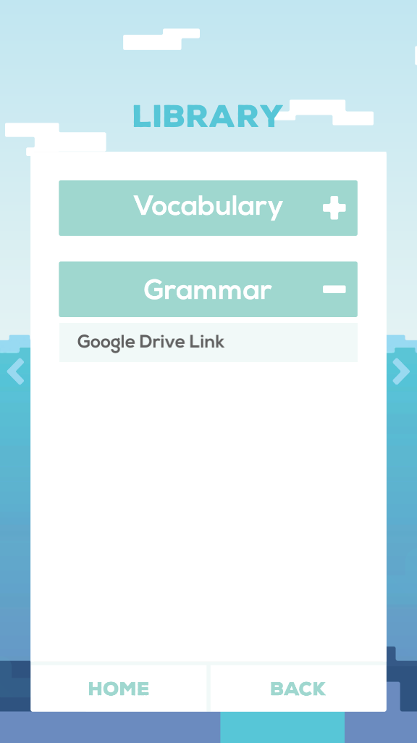

At the main screen, we provide a chart to show how students were performing in each section. It is calculated by the ratio between the correct answered question and total question they have met. The questions in the game are designed to be selected randomly, in order to create a unique experience every time the game is played.

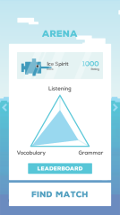

1. **Special Techniques**

* Having seperate server to serve login function and store user data
* Using unity multiplayer Unet to serve online functions
* Cross-platform which means PC user can play with mobile user