

Protocol and infrastructure agnostic
message exchange

Bruno Costa
Licensiado

Trabalho de Projeto para obtenção do grau de Mestre em Engenharia Informática e de Computadores

ORIENTADOR
Professor José Simão

Junho de 2026

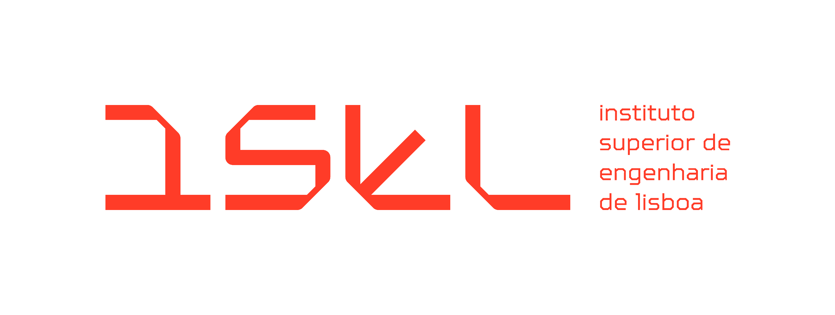
Protocol and infrastructure agnostic
message exchange

Bruno Costa
Licensiado

Trabalho de Projeto para obtenção do grau de Mestre em Engenharia Informática e de Computadores

ORIENTADOR
Professor José Simão

JÚRI [Verdana, 9p, centrado]
Presidente [Verdana, 9p, centrado]
Grau Título Nome, Afiliação [Verdana, 9p, centrado]

Vogais
Grau Título Nome, Afiliação [Verdana, 9p, centrado]
Grau Título Nome, Afiliação
Grau Título Nome, Afiliação
Grau Título Nome, Afiliação

Junho de 2026

Agradecimentos

Agradeço ao Professor José Simão pelo seu zelo, critica e prontidão no acompanhamento da realização deste trabalho. Agradeço também a todo staff do ISEL, docente e não docente. Só com a particapação de todos foi possível ter frequentado um curso de qualidade, com as instalações devidamente cuidadas, com atendimento diferenciado e também com hospitalidade.

Statement of integrity

I declare that this dissertation / project work / internship report is the result of my personal and independent research. Its content is original, and all sources listed in the bibliographic references were consulted and are duly mentioned in the text. I further declare that all scientific and technical references relevant to the development of the work are duly cited and included in the bibliographic references.

The author

_____________________

Lisbon, ………………., ……

Protocol and infrastructure agnostic message
exchange

Resumo

Em sistemas distribuidos e também no contexto de microserviços é frequentemente necessário trocar mensagens. Essas mensagens podem ser encaminhadas com a utilização de uma diversidade de protocolos e sistemas de comunicação assincronos, como queues. O processamento através de envio de mensagens também é comum em arquiteturas Event-Driven, devido ao desacolamento entre o processamento e a mensagem que representa o pedido de processamento.

Existem assim três contextos onde mensagens podem ser trocadas: dentro do mesmo processo, entre processos diferentes (IPC) e entre máquinas diferentes (RPC).

O âmbito deste projeto consiste em implementar uma biblioteca que permite de forma simples configurar o mecanismo de troca de mensagens que pode ser utilizado em qualquer tipo de contexto.

Este projeto surgiu porque foi identificado uma lacuna em algumas bibliotecas existentes que têm funcionalidade limitada a queues e não permitem outro tipo de comunicação. Este pode ser um fator limitador porque discarta a possibilidade de utilizar meios de comunicação eficientes consoante o contexto.

Palavras-chave: Protocolos, Queues, Message oriented middle-ware, Event-Driven

Protocol and infrastructure agnostic message
exchange

Abstract

In distributed systems and in microservices it is usually necessary to exchange messages. Those messages can be exchanged through a diversity of protocols and asynchronous communication system such as queues. In Event-Driven architecture it is also typical to design the application so it responds to messages, with the aim to increase the decoupling between processing and exchanged data.

There are three contexts where messages can be exchanged: within the same process, between processes (IPC) and between machines (RPC).

The scope of this project is to implement a library that allows to configure the mechanism used to exchange those messages and can be used in any context while being easy configure a different mechanism if necessary.

This project emerged because it was identified a gap in some existing libraries which have functionality limited to queues and do not allow other type of communication. This can be a limiting factor since it discards the possibility of using communication mechanisms that are more efficient for a given context.

Keywords: Protocols, Queues, Message oriented middle-ware, Event-Driven

Índice
2.1 Request Response Pattern 3
2.2 Publish-Subscribe Pattern 4
2.3 Queue Pattern 6
3.1 Mediator – Abstracting a broker
7
3.2 Trabalho futuro 8

Índice de figuras
Figura 2.1 – Lorem ipsum dolor sit amet, consectetur adipiscing elit. 2

Índice de tabelas
Tabela 1.1 – Suspendisse congue, ipsum tempus u. 2

Lista de Símbolos e de Siglas
ALFABETO ROMANO
E energia de compactação
E_{GG} módulo de deformabilidade (geogauge)
k_{GG} rigidez medida pelo geogauge
r raio externo do anel rígido (geogauge)
S_{r} grau de saturação
w teor em água gravimétrico
w_{opt} teor em água ótimo

ALFABETO GREGO
δ deslocamento no centro da placa
■ coeficiente de Poisson
τ coeficiente de tortuosidade do meio
ω(n) função da relação entre o raio interno e externo do anel rígido (geogauge)
γ_{d} peso volúmico seco
γ_{d máx} peso volúmico seco máximo

SIGLAS
EDD Event-Driven Design
IPC Inter Process Communication
RPC Remote Procedure Call
CSG Cloud Software Group

Introduction
On the 2nd and 3rd of April 2025, MediatR (Bogard 2025) and MassTransit (Patterson 2025) libraries in .NET transitioned from open-source products to commercial products.
This event motivated me to conduct in-depth research on the core functionalities and design principles set by those remarkable libraries, as they have been downloaded hundreds of millions of times from NuGet. Moreover, I wanted to learn more about message exchange services, as I had never had the opportunity to work with them.
Therefore, I set an ambitious goal of writing a simple library that would be capable of exchanging messages independently of protocols and infrastructure. This goal was purposefully set as broadly as possible in order to design the library with the correct abstractions and to allow for multiple integrations with diverse characteristics.
The goal was to develop a library that would support the following message exchange methods: in-process, between processes, between machines, through UDP, TCP, SSL, Domain Sockets, WebSockets, supporting Kafka, RabbitMQ, AWS SQS, Azure Queues, ZeroMQ, and Google Pub/Sub while providing an interface similar to MediatR.
This article provides an in-depth explanation of the common characteristics of these services and how they can be abstracted into a compact framework.

Communication Patterns
I start exploring how a message exchange library can be built by identifying the commonalities of communication patterns and their components.
A communication pattern describes how machines can communicate with each other. Usually, there are at least two participants and a mechanism that allows the communication to happen. This mechanism is usually through the use of networks and protocols such as UDP, TCP, HTTP, and many others. Depending on the communication Pattern the participants can have different roles, though commonly they are referred to as client and server. Usually, the client takes the initiative by sending a request to the server, and the server then processes the request and replies to the client.
"Understanding this architecture thoroughly requires the three basic elements of the system to be well defined. The Client is the one who actively makes the requests and is usually in charge of the user interface and presentation logic. On the other hand, the Server is the one that passively listens and is he mainstay of resource, data, and business logic management. The Network here is the layer that connects. It sends out the requests and accepts the responses. This is how the client-server model works." (Ramagiri 2025)

Request Response Pattern
One application of the Client to Server pattern is the Request Response pattern. As described, one limitation of this pattern is that the initiative of the Request always starts from the client. The server cannot send messages to the client without receiving a request first.
Another limitation relates to long-running requests, due to timeout or throughput concerns. To circumvent long-running requests, the server should process the request in the background, outside of the context of the request. One identifier can be assigned to the operation and returned in the response immediately. The client can then poll for the operation to see if it has been completed. This process can cause more stress on the network due to the need to poll the operations. Because polling can add extra load, other patterns are often preferable for this scenario. The following image describes this pattern.
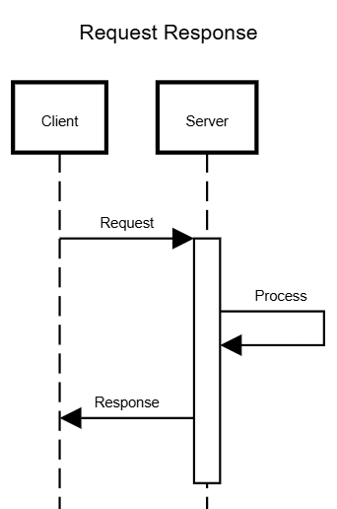

Publish-Subscribe Pattern
Another pattern is the publish-subscribe pattern. In this pattern, clients can subscribe to topics, and the server will publish messages regarding that topic. This pattern allows clients to be up to date regarding a topic and overcomes the poll behavior present on Request Response Pattern for long-running operations.
This pattern is well-suited for use cases where there is a stream of data that needs to be sent to the clients. Imagine, for instance, that clients could subscribe to the Fibonacci Topic, and the server would keep publishing messages regarding the
next number in the Fibonacci sequence. However, for this scenario, the server needs to know which number to send next for each client. It would also be necessary to define the behavior of what should happen when a client becomes unavailable and subscribes to the topic again. Should it start from the beginning or from the point it was? This pattern is very limited by the interactions from clients, since the only operation allowed is to subscribe to a topic. The following image describes this pattern.

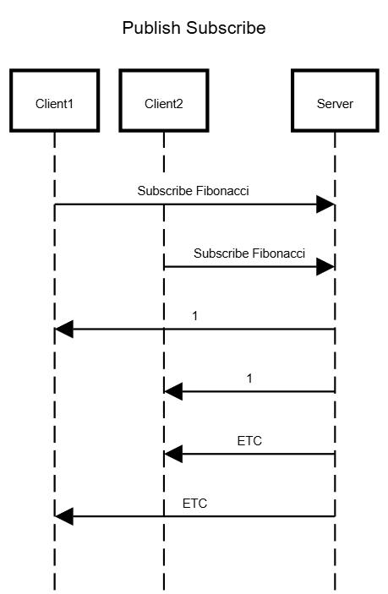

Queue Pattern

Another possibility is the queue pattern. In this pattern, messages are sent to a queue by a producer and then read from the queue by a consumer. This pattern is more versatile than the publish-subscribe pattern since it allows the participants to exchange arbitrary messages. Messages can be delivered to the consumer in two main ways. One way is push-based, where messages are delivered to consumers as they arrive. Another possibility is pull-based, where consumers poll for messages.
While this pattern is very versatile, it increases the latency of the communication since the message needs to be inserted into the queue itself. It also adds another point of failure, since queues are often deployed on a different machine. The following image describes this pattern

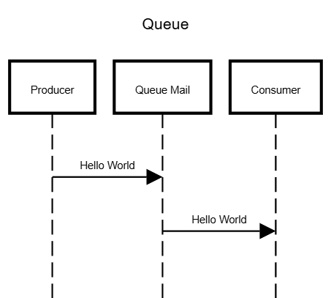

Event-Driven Architecture
In the Communication patterns, I presented three important elements: client, server, and network. I now want to draw a parallel between those elements to event-driven-architecture. In event-driven architecture, there are three components: producer, consumer, and broker.
There is a one-to-one element mapping between the Queue communication pattern and event-driven architecture. And a similar relationship can be established for the other presented patterns. Where the producer can be described as a client capable of sending messages to the broker. The consumer is the server capable of processing client messages. And the broker is the layer that knows how to exchange the message between the producer and consumer.
"The components of an event-driven architecture can include three parts: producer, consumer, and broker. The broker can be optional, particularly when you have a single producer and a single consumer that are in direct communication with each other, and the producer just sends the events to the consumer."
(CSG 2024)
Similarly, in an agnostic message exchange, the broker is optional for scenarios where there is no communication or where communication occurs directly between the producer and consumer.

Mediator – Abstracting a broker
Since the broker is optional and can have different implementations depending on the context, it is important to abstract the concept of broker. The broker can be the network, a queue, or not exist. A mediator will be able to choose the
adequate broker depending on the context. This abstraction can be achieved through the Mediator pattern.
"The goal of this pattern is to decouple modules or objects by constraining their interactions within a single Mediator. Instead of having objects interact with each other directly, the Mediator is responsible for coordinating the interactions between objects. Colleague objects know about the Mediator, but do not know about each other. The Mediator manages all interactions among Colleague objects."
(Johnston 2020)
This pattern will also allow the clients be unaware of where a service exists. Imagine there are two services: sum service and the multiply service. Instead of communicating with each service directly, the client will send the messages to the mediator, and the mediator then relays the request to the correct service.
The figure 4 presents the Mediator Pattern UML Diagram

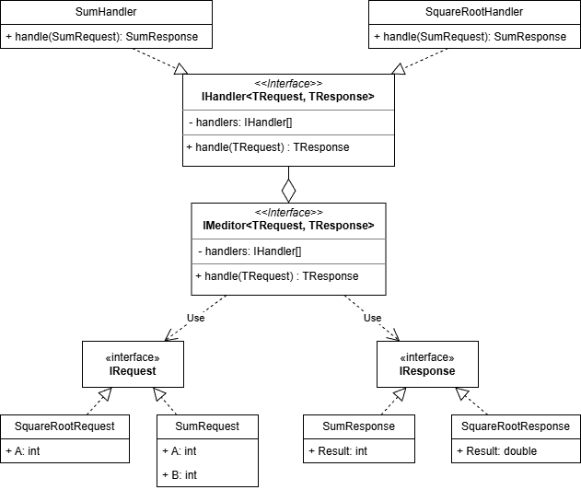

Agnostic Message Exchange
Depending on the context where a message is being exchanged, there are different considerations to be accounted for. For Instance:
• If the message is being exchanged within the process, no serialization and no networking resources are required.
• If the message is exchanged between different processes, only serialization is required.
• If the message needs to be sent through the network, both are required.
Therefore, it is necessary to provide an interface that abstracts serialization and networking constraints while minimizing to the maximum extent possible any work by users of this type of library.
This requirement raises concerns about how two different machines can agree on how to identify a specific type. To be more concrete, lets imagine requests Sum Request and Multiply Request. Both requests can be represented with the same properties. There is no discernible way to distinguish those requests unless the client and broker can agree on an ID that is attached to each request and response type. Furthermore, that ID should be consistent across different executions, allowing brokers and clients to restart if necessary.

Message Framing
In most restrictive and complex scenarios, messages are exchanged between separate machines. This scenario requires both serialization and networking to work correctly. I envisioned that if the library were capable of exchanging messages using its own protocol, it would be a matter of adapting the protocol to support different scenarios, such as in-process, between processes, and between machines, while being extensible for message queues.
In order to exchange arbitrary messages between two participants, it is crucial that both participants agree on the format of the message. The representation and the process of exchanging a message is called Message Framing(Cleary 2009).
Stephen Cleary identifies two common approaches used in message framing: delimiters and length prefixing. An exampleof a protocol that uses delimiters is the HTTP protocol, where the message is separated by lines. However, delimiter message framing often comes with the caveat that the character used to delimit the message components cannot always be used outside of the scope where the delimiter is expected. In other words, delimiter-based message framing is more complex.
"Delimiters are more complex to get right. When sending, any delimiter characters in the data must be replaced, usually with an escaping function. The
receiving code cannot predict the incoming message size, so it must append all received data onto the end of a receiving buffer, growing the buffer as necessary. When a delimiter is found, the receiving side can apply an unescaping function to the receiving buffer to get the message. If the messages will never contain delimiters, then one may skip the escaping/unescaping functions."
(Cleary 2009)
Therefore, I chose a length-based message framing. However, as mentioned in chapter IV, the length is not sufficient to identify any arbitrary message. Let’s imagine client Alice and Bob. Alice wants to send a Sum Request while Bob wants
to send a Multiply request. The server needs to distinguish between the requests and return the result of the operation to the correct client. In other words, requests are correlated to the client that initiated them. It is also necessary to distinguish request types as previously discussed.
Network protocols such as TCP often already support this correlation process by being able to identify the incoming Socket that established the connection and allowing the server to use the same connection to send messages back to the client that initiated the request. While this capability facilitates correlation, it often increases the coupling between message exchange and message processing. On a simpler implementation, the server could read the request, process it, and reply to the client all within the same scope or similar level of abstraction. This kind of implementation is often error-prone and increases the complexity of the software.
So, besides message framing, another characteristic of a well-designed message exchange library is that the request processing should be decoupled from the message exchange mechanism, allowing requests to be processed within a different scope and preferably asynchronously. This characteristic llows the server to keep receiving requests while, at the same time, processing any previous requests.
This loosely coupling between message exchange and message processing introduces new requirements to the message framing, since the server may lose context of the client that sent the request, and this context needs to be capable of being restored. This context can be restored if a UUID is attached to each request.
To resume, I identified and explained which elements are necessary to be within the message frame. They are the length, ID of request, and ID of message type, which are represented in the following picture.

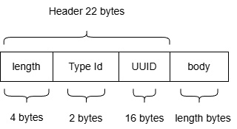

Agnostic Message Serialization
Serialization is the process that transforms a message intoa representation of that message. While deserialisation is the process that transforms the representation of the message into the message. To ensure that message serialization behaves correctly, it must follow some simple rules:
• Both the serializer and de-serializer must agree on the exchanged format.
• The serialization must be deterministic, always producing the same representation for the same message.
• The serialization must be bijective, allowing for rebuilding of the message from the representation.
As noted before, one advantage of choosing length-prefixed framing is that the body of the message will never contain characters that need to be handled in special cases. This is particularly useful since it allows for any arbitrary payload to be exchanged without escaping the message. The choice of this type of framing increases the flexibility in the choice of the format of the body.
The choice of a serialization format is relevant since each message needs to be serialized and deserialized, contributing to a sizable overhead in the message exchange process. Formats that minimize the number of bytes needed to represent the object and minimize serialization and deserialization times should therefore be preferred.
Otherwise, other characteristics can be taken into account when choosing a serialization format, such as verbosity, readability, as in human-readable (text) or machine-readable (binary), adoption, and ease of integration and implementation. Given the importance of serialization in message exchange, it
should be considered as an extensibility point of the library.

Protocol Independence
There are many protocol options when it comes to sending messages through the network, each offering different guarantees. Thankfully, there is a programming primitive that abstracts the networking details, named Berkley Sockets, invented in 1983. Using this primitive, it should be possible to abstract any given Protocol such as UDP, TCP or SSL.
During my experimentation, I concluded that there are only a few details that change during the creation of the sockets and when establishing connections, since UDP does not establish connections. Therefore, it should be possible to support different protocols by applying the Factory Design Pattern that knows how to create the socket for each protocol.
I also found out that sending and receiving messages correctly is not so simple due to the communication details of exchanging messages. The sender can send 1 byte at a time while the receiver receives 1000 bytes at a time. The opposite can also be true. Therefore, one send may not correspond to a single receive (Cleary 2009). While Stephen Cleary tried to explain this behavior in his article, I think there is a point that needs to be stressed.
Previously, I proposed a Message Frame that had a header of 22 bytes and a body. So, for the receiver to read the whole message frame, it should therefore read 22 bytes, parse the header, get the length inside the body, and read that many more bytes to read that whole message frame. This is easier said than done!
The reading process cannot be implemented this way be cause there is no telling if the 22 bytes we wanted to read related to the header will correspond to a header in the first place. Instead, the reader needs to keep reading from the network while trying to keep the context of the reading state.
Is it reading the header? Is it reading the body? Does it need to read more bytes to complete the current frame? Has it finished reading the frame, but other bytes started the next frame? Indeed, while the message exchange seems simple when discussed in high level, the implementation will require a lot of attention to detail so it does not misread messages.

Infrastructure Indepedence
A message exchange library should be extensible to allow integration with any existing Queue platform. This can be achieved through the application of the Strategy Pattern, as it allows us to take advantage of polymorphic behavior. A public interface should be provided for extensibility, and the integrator should be able to implement the interface with the desired Queue platform.
One consideration to take into account is that this interface should be at the correct level of abstraction. It should not expose too complex or too low-level details, while also not being too restrictive. It would be a plus if extensibility for protocols, queues, and in-memory message exchange could all be abstracted with the same interfaces.
This approach should allow the core library to be separate from integrations, allowing integrations to be plugin-based and removing the need to have many dependencies in the core library.

Service Discovery
As previously noted, it is necessary to enable requests with different types. Moreover, it is also necessary that all participants agree on the types exchanged. To do so, there is a requirement of having 2 bytes in the Message Frame to identify the type being sent. This ID should also be consistent across different executions.
To achieve this, I propose a Service Discovery request that needs to be initiated by all clients whenever they need to connect. This request should be responsible for keeping request IDs consistent between all participants. Only after sending this request, clients be able to identify which ID needs to be assigned to a specific request type.
To an attentive reader, this poses a dilemma, as the client and the server still need to agree on the ID of the Service Discovery request and Response. While this is true, at least, all the other requests and responses are treated as if they were dynamic. More features can be added to the server at any moment, and the clients will be able to use them automatically. Clients are not required to know all IDs beforehand. This might prevent features from being removed from the server, as the ID should not be freed to be used for other requests. On the other hand, request compatibility will always be preserved.

Transceiver Library
Transceiver is my implementation of the Agnostic message exchange library described in the previous chapter. This implementation was done using the .NET platform and C#. The goal of this chapter is to revisit some of the previously discussed concerns and the solution I implemented for each of them.

Transceiver
The Transceiver class acts as the Broker and implements the mediator pattern previously described. It implements methods that are fully asynchronous, allowing messages to be sent to the correct Processor. It allows sending a message and getting one reply, many replies, or publishing a message in a fire-and-forget style. It also implements a pipeline of request processing, allowing the implementation of crosscutting concerns such as logging, metrics, exception handling, and others. This class acts as a decorator of the described components to allow a smaller and easier-to-use interface.

Transceiver Protocol
The majority of logic is handled by the Transceiver Protocol classes. Those classes know how to deliver messages to a message processor. It’s within those two classes that Transceiver becomes aware of the context of where messages are exchanged. As previously described, messages can be exchanged within the same process, within the same machine, through a network, or through a queue provider. Each context is optimized to perform Serialization only when necessary.
When a server starts listening for requests, it can handle any request Id. As such, the Id of the request within a server is only relevant to deliver the response to the correct client. The message processor is the mechanism that allows for registering a request and, when the server finishes processing it, delivers the message back to the client. This mechanism allows for implementing loosely coupled protocol handling, message delivery, and processing.

Component Discovery
Component discovery is implemented through the correct setup of dependencies via dependency injection. It allows the Transceiver library to be correctly configured as well as being highly customizable, allowing different components to be used for different contexts. The following setup is done within component discovery:
• Setup a Transceiver implementation for each Request-Response tuple
• For each Transceiver, set up a Processor, pipeline, protocol, and message processor
• Setup the Serializer
• Runs Service Discovery on startup
• If the setup is within a server, it starts listening for requests on startup

Service Discovery
Service discovery is implemented through one Transceiver Service. This service does introspection within Transceiver, discovers the available services, assigns an id for each Request and Response type, and allows the exchange of this information with the client.

UDP, TCP, SSL, Domain Sockets and Websockets protocols
Most Socket Protocols were able to be abstracted through the implementation of a Socket factory, which is able to return the socket correctly configured for each protocol type.
For SSL, since it deals with a slightly different abstraction from sockets, and also requires more implementation details, such as certificate configuration and client-server authentication.
For Websockets it was implemented a Kestrel webserver that listens to HTTP requests and upgrades the requests to Websockets. This avoided the use of HTTP Listener which requires HTTP.sys which is a Windows specific library.

Queues
All queue providers were implemented by creating a class that derives from Message Processor. Queue plugins are responsible for creating and deleting the queues. Usually, they will create a queue for each request and response type.
Through testing, I found out this is a good compromise between the number of queues created, their scope, and resource usage. Another alternative would be to create a queue for each request and response. However, some queue services, such as Amazon, can take as long as one second to create a queue, which makes the operation too computationally expensive.

Conclusion

Building an agnostic message exchange that is capable of exchanging messages within different contexts can be very challenging. In this paper, I explored communication patterns, allowing me to have an overview of their characteristics. With this broader perspective, I got a better grasp of how machines can interact with each other and therefore know about the three main elements of communication: client, server, and network.
With this understanding, I then drew some parallels with event-driven architecture, which allowed me to be aware of useful abstractions and design patterns, such as the mediator design pattern, and others.
Equipped with this information, I then detail each of the contexts where messages can be exchanged, the serialization process, and the need to define a message frame that would allow for the reading of messages correctly.
Finally, I described the project I implemented, its components and features, and how they relate to the investigation I conducted. This project is fully available on Nuget and GitHub, and I intend to keep it open source and with GPLv3 license for the foreseeable future. I also intend to spend some of my free time addressing any issues that I might be able to find and provide maintenance or add new queue providers as I see fit.

Referências bibliográficas
Lenke, L. R., McKeen, R. G., & Grush, M. P. (2003). Laboratory Evaluation of GeoGauge for Compaction Control. Transportation Research Record, 1849, 20–30. https://doi.org/10.3141/1849-03

Anexos

