Analysis model_experiments.py

*run_many_models_in_parallel* will write the configs into a pkl file, and the following *fit_and_save_one_model* will select one config from teh pkl file according to the config idx.



1. Read the arguments

set necessary arguments



Psi is what?

fit_disease_model_on_real_data()

init_exogenous_variables():

initial_conditions: ['E', 'I', 'R']

num_seeds: seems the iteration times of simulation.

Different daily rates:

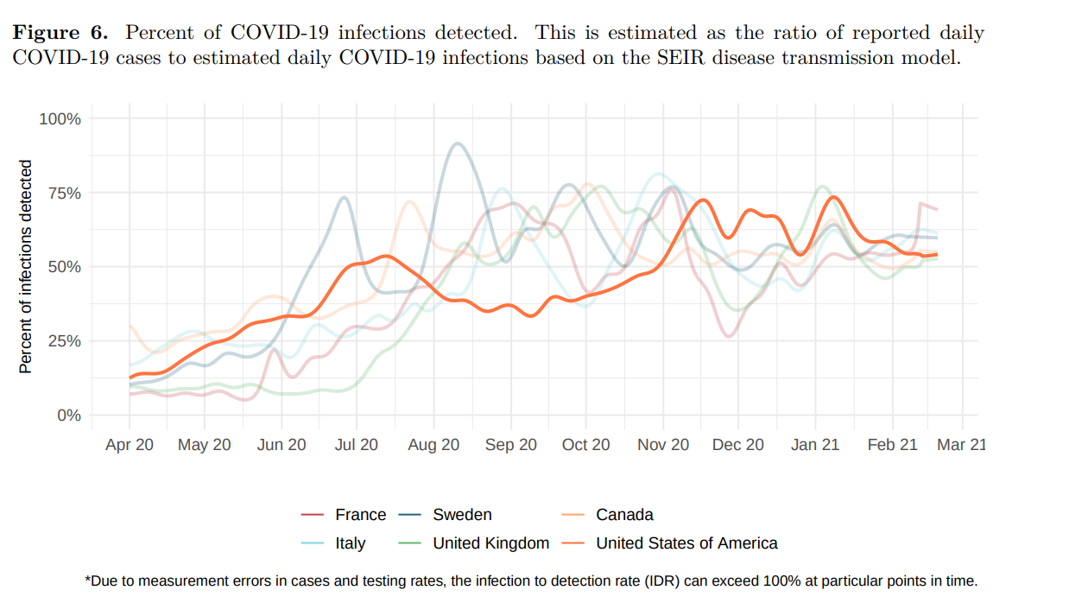

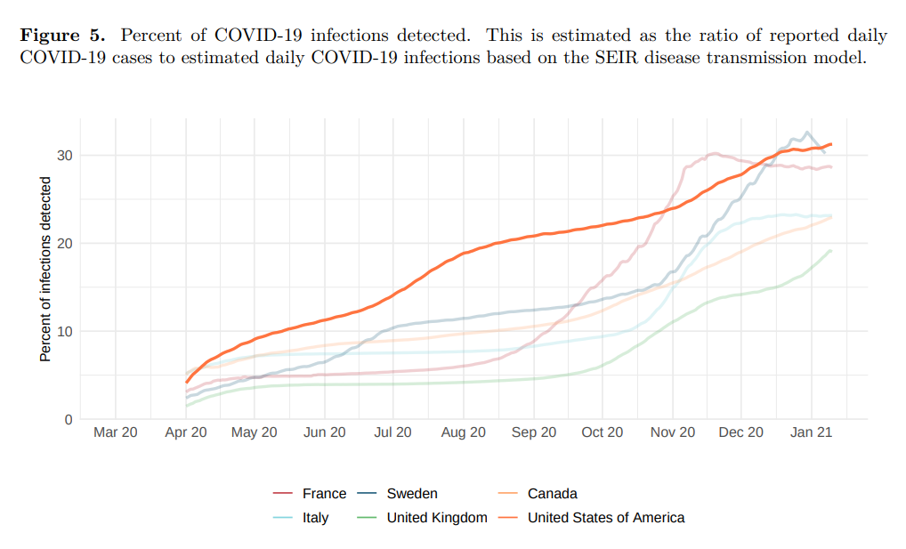

http://www.healthdata.org/sites/default/files/files/Projects/COVID/2021/briefing_US_20210114.pdf

<http://www.healthdata.org/sites/default/files/files/Projects/COVID/2021/102_briefing_United_States_of_America_2.pdf>

daily_E_to_I = smoothed_daily_counts / rate_over_time

hourly_E_to_I[t] = daily_E_to_I[d] / 24

I_s = E[s_index - latency_period]

R_s = np.sum(hourly_E_to_I[:s_index - infectious_period])

S_s = total_pop - E_s - I_s - R_s

total_pop = np.sum(pop_sizes)

conda run python model_experiments.py run_many_models_in_parallel calibrate_r0

conda run python model_experiments.py run_many_models_in_parallel normal_grid_search

conda run python model_experiments.py run_many_models_in_parallel test_retrospective_counterfactuals

conda run python model_experiments.py run_many_models_in_parallel rerun_best_models_and_save_cases_per_poi

#### PARAMETERS FOR 2021 EXPERIMENTS #### # Huan: for: python model_experiments.py run_many_models_in_parallel calibrate_r0  
# MIN_DATETIME = datetime.datetime(2020, 12, 28, 0) # the acutall data date.  
MIN_DATETIME = datetime.datetime(2021, 1, 1, 0) # the acutall data date.  
  
MAX_DATETIME = datetime.datetime(2021, 1, 17, 23) # the acutall data date.