Analysis model_experiments.py

*run_many_models_in_parallel* will write the configs into a pkl file, and the following *fit_and_save_one_model* will select one config from teh pkl file according to the config idx.



1. Read the arguments

set necessary arguments



Psi is what?

fit_disease_model_on_real_data()

init_exogenous_variables():

initial_conditions: ['E', 'I', 'R']

num_seeds: seems the iteration times of simulation.

Different daily rates:

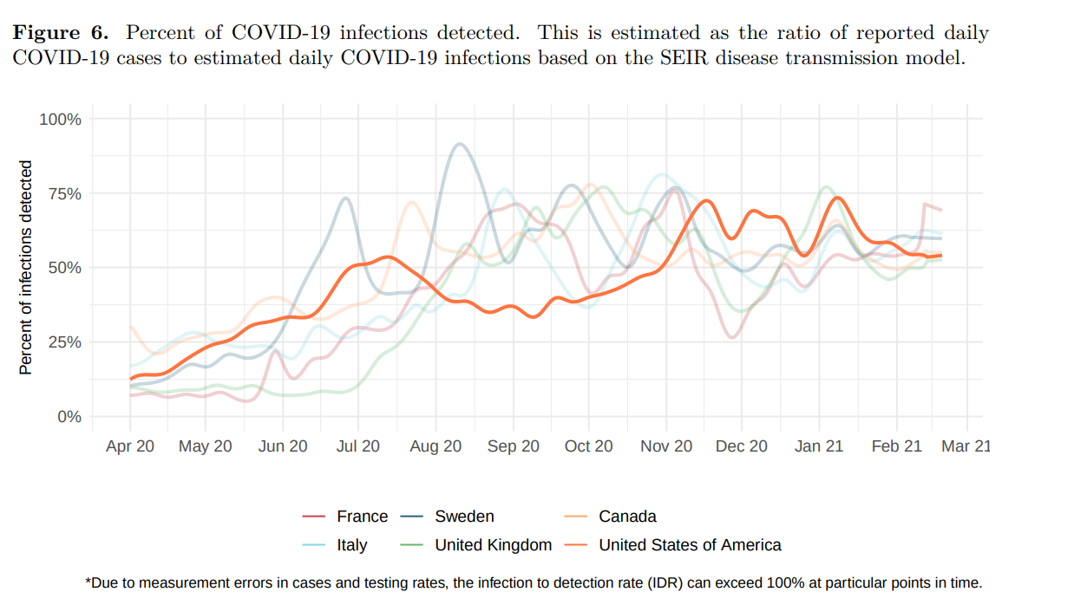

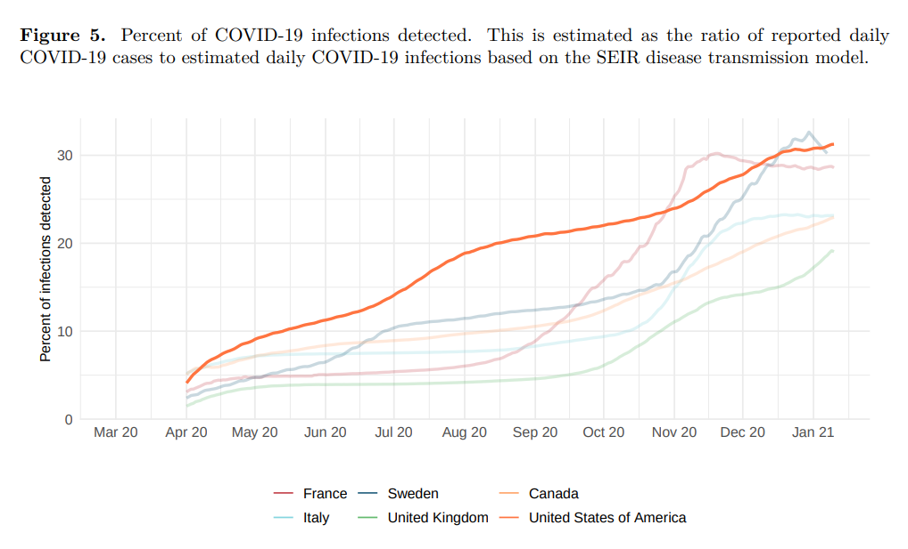

<https://www.cdc.gov/coronavirus/2019-ncov/cases-updates/burden.html>

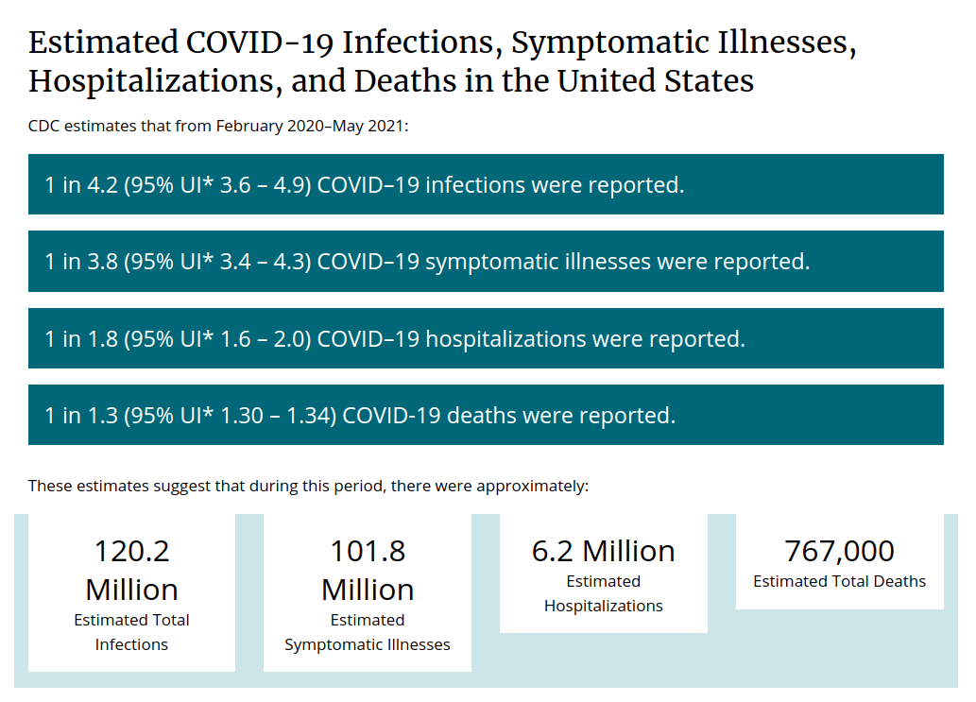

http://www.healthdata.org/sites/default/files/files/Projects/COVID/2021/briefing_US_20210114.pdf

<http://www.healthdata.org/sites/default/files/files/Projects/COVID/2021/102_briefing_United_States_of_America_2.pdf>

ISSUE: detected rate is not sure: 0.25 ~ 0.3 ~ 0.6

daily_E_to_I = smoothed_daily_counts / rate_over_time

hourly_E_to_I[t] = daily_E_to_I[d] / 24

I_s = E[s_index - latency_period]

R_s = np.sum(hourly_E_to_I[:s_index - infectious_period])

S_s = total_pop - E_s - I_s - R_s

total_pop = np.sum(pop_sizes)

conda run python model_experiments.py run_many_models_in_parallel calibrate_r0

conda run python model_experiments.py run_many_models_in_parallel normal_grid_search

conda run python model_experiments.py run_many_models_in_parallel test_retrospective_counterfactuals

conda run python model_experiments.py run_many_models_in_parallel rerun_best_models_and_save_cases_per_poi

conda run python -u model_experiments.py fit_and_save_one_model calibrate_r0 --timestring Huan_R0_only --config_idx 29

fit_and_save_one_model normal_grid_search --timestring Huan_normal_grid_search --config_idx 15

#### PARAMETERS FOR 2021 EXPERIMENTS #### # Huan: for: python model_experiments.py run_many_models_in_parallel calibrate_r0  
# MIN_DATETIME = datetime.datetime(2020, 12, 28, 0) # the acutall data date.  
MIN_DATETIME = datetime.datetime(2021, 1, 1, 0) # the acutall data date.  
  
MAX_DATETIME = datetime.datetime(2021, 1, 17, 23) # the acutall data date.

N: CBG_count:

M: POI_count

# Huan modified  
for home_beta in home_betas:  
 configs_with_changing_params.append({'home_beta':home_beta, 'poi_psi':2500, 'p_sick_at_t0':1e-4})  
for poi_psi in poi_psis:  
 configs_with_changing_params.append({'home_beta':0.001, 'poi_psi':poi_psi, 'p_sick_at_t0':1e-4})

BETA_AND_PSI_PLAUSIBLE_RANGE = {"min_home_beta": 0.0001,  
 "max_home_beta": 0.02,  
 "min_poi_psi": 100,  
 "max_poi_psi": 500}

R0: 2.838

self.HOME_BETA: 0.02 PSI: 250

R0: 2.473

self.HOME_BETA: 0.0002 PSI: 500R0: 1.233

self.HOME_BETA: 0.0001 PSI: 250

R0: 2.898

self.HOME_BETA: 0.005 PSI: 500

R0: 0.503

self.HOME_BETA: 0.0002 PSI: 100R0: 1.240

self.HOME_BETA: 0.0002 PSI: 250R0: 1.264

self.HOME_BETA: 0.0005 PSI: 250

R0: 2.534

self.HOME_BETA: 0.001 PSI: 500

R0: 0.525

self.HOME_BETA: 0.0005 PSI: 100

R0: 2.037

self.HOME_BETA: 0.01 PSI: 250

R0: 2.067

self.HOME_BETA: 0.02 PSI: 100

R0: 0.564

self.HOME_BETA: 0.001 PSI: 100R0: 1.396

self.HOME_BETA: 0.002 PSI: 250

R0: 0.492

self.HOME_BETA: 0.0001 PSI: 100

R0: 2.468

self.HOME_BETA: 0.0001 PSI: 500

R0: 0.879

self.HOME_BETA: 0.005 PSI: 100

R0: 2.493

self.HOME_BETA: 0.0005 PSI: 500R0: 1.314

self.HOME_BETA: 0.001 PSI: 250

R0: 2.613

self.HOME_BETA: 0.002 PSI: 500

R0: 0.644

self.HOME_BETA: 0.002 PSI: 100R0: 1.654

self.HOME_BETA: 0.005 PSI: 250R0: 1.288

self.HOME_BETA: 0.01 PSI: 100

# Imprtant dates

# Imprtant initial variables

# ??????????????

BETA_PLAUSIBLE_RANGE = (0.7, 1.3)

# use to normal grid search

After clipping, 10262 POIs

After dropping for missing CBG home data, 9924 POIs

After dropping for missing avg_median_dwell, 9924 POIs

After dropping for missing area, 9924 POIs

After dropping for missing any hours, 6550 POIs; kept 94.70% of visits

After dropping CBGs that appear in < 100 POIs, 910 CBGs (2.3%)

After dropping CBGs with population size 0 in ACS data, 904 CBGs

FINAL: number of CBGs (N) = 904, number of POIs (M) = 6550

Num connected POI-CBG pairs (E) = 522762, network density (E/N) = 578.277

Dwell time correction factors: mean = 0.16, min = 0.01, max = 0.73

Change the correction factor.

# use South Carolina population to obtain the correction factor.  
state_population = 5149000  
state_unique_visitors = 415034 # 2021-02-03  
correction_factor = state_population / state_unique_visitors  
print(  
 "Total state population of South Carolina: %i; total safegraph visitor count in South Carolina: %i; correction factor for POI visits is %2.3f" %  
 (total_us_population_in_50_states_plus_dc,  
 safegraph_visitor_count,  
 correction_factor))

Population

|  |  |
| --- | --- |
| [Richland County](https://www.southcarolina-demographics.com/richland-county-demographics) | 416,147 |
| [Lexington County](https://www.southcarolina-demographics.com/lexington-county-demographics) | 293,991 |
| [Kershaw County](https://www.southcarolina-demographics.com/kershaw-county-demographics) | 65,403 |
| [Fairfield County](https://www.southcarolina-demographics.com/fairfield-county-demographics) | 20,948 |
| [Saluda County](https://www.southcarolina-demographics.com/saluda-county-demographics) | 18,862 |
| [Calhoun County](https://www.southcarolina-demographics.com/calhoun-county-demographics) | 14,119 |

After dropping CBGs that appear in < 100 POIs, 910 CBGs (2.3%)

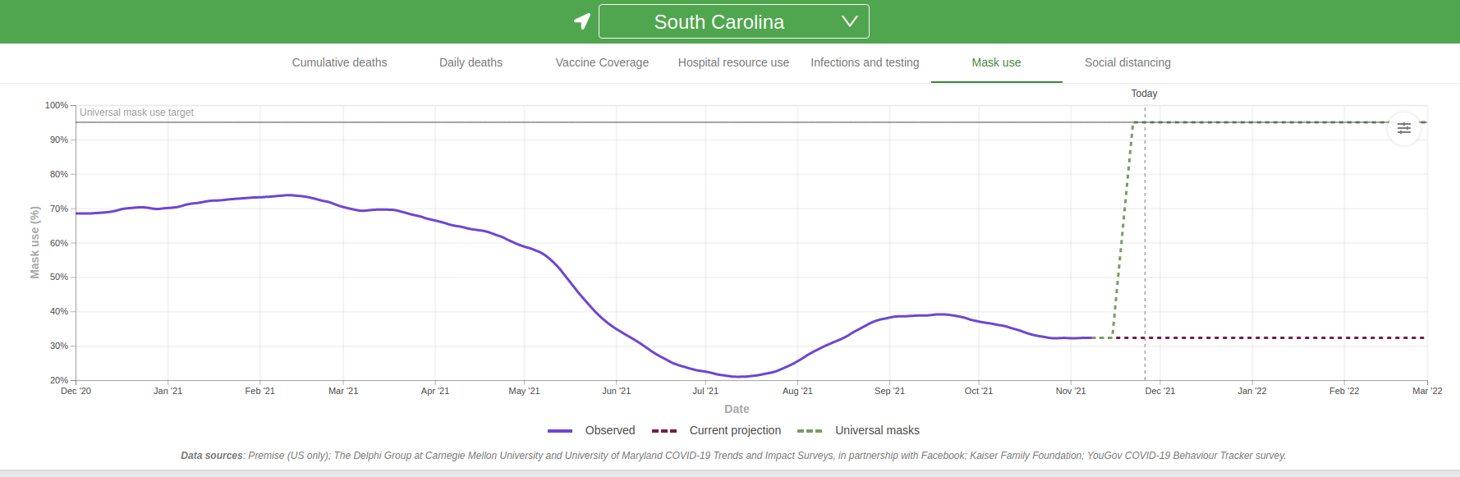

https://covid19.healthdata.org/united-states-of-america/south-carolina?view=mask-use&tab=trend

