What becomes more difficult…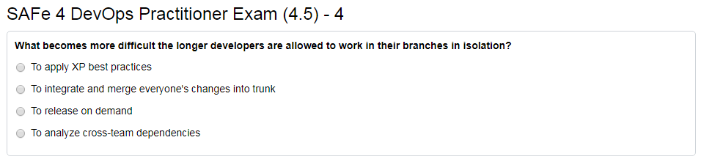What marks the beginning…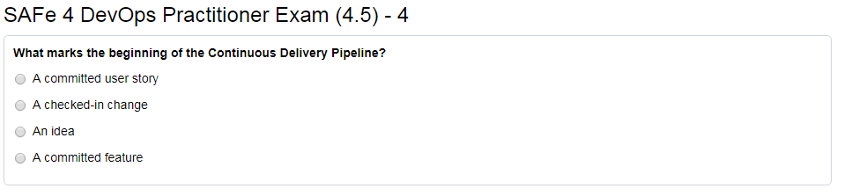What are two parts…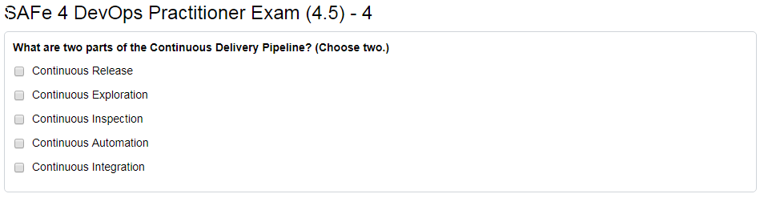Continous deployment enables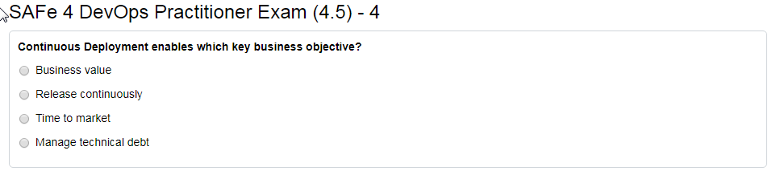Why is hypothesis evalusation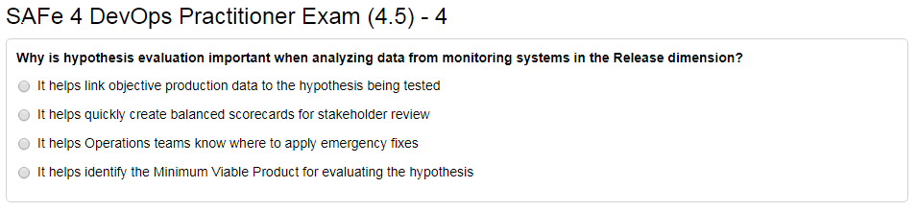What organizational anti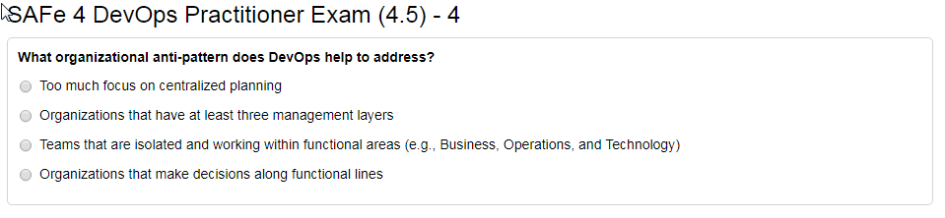What are two benefits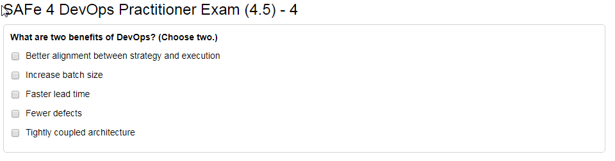What identifies potential changes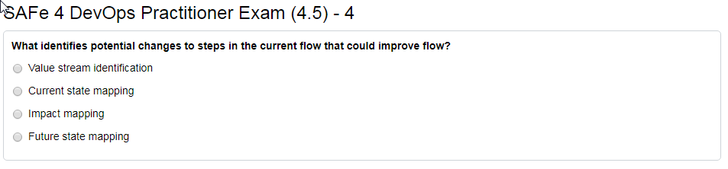which two competencies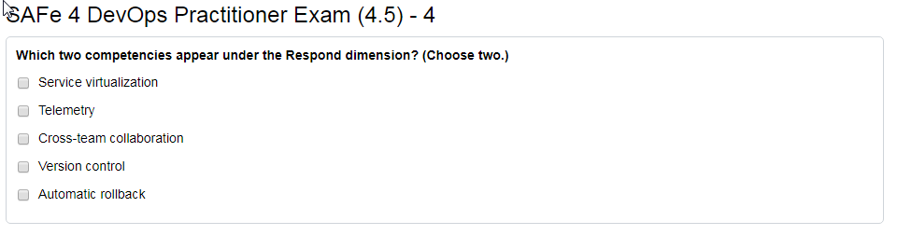What is the main result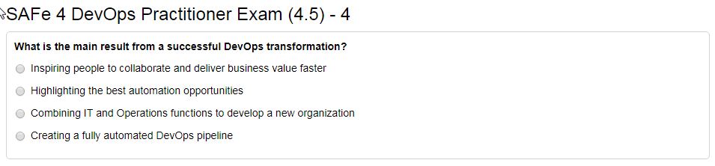When should security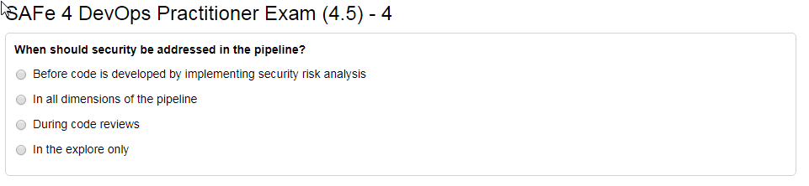The Explore dimension primarily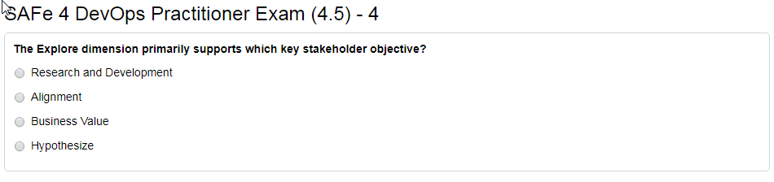When does the continuous integration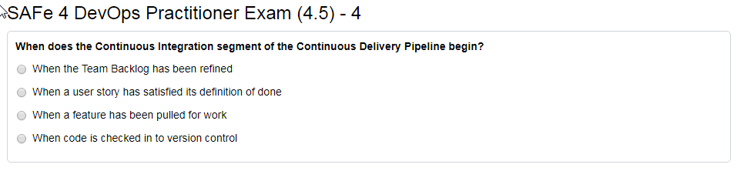What is one potential outcome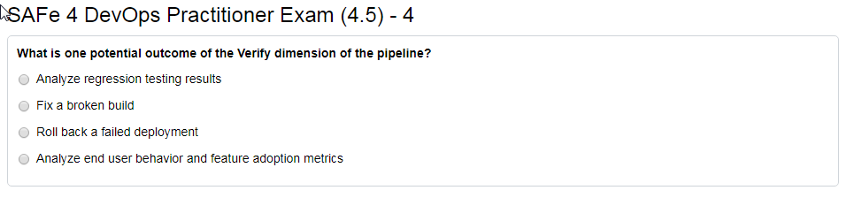Which statement describes what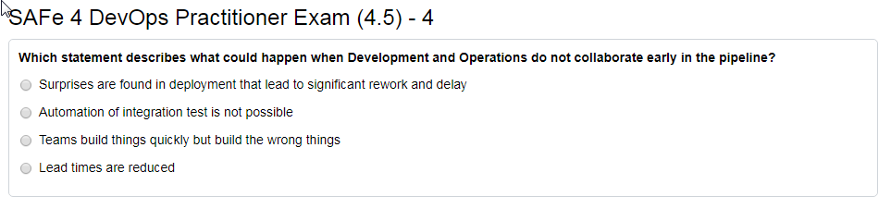the devops radar aligns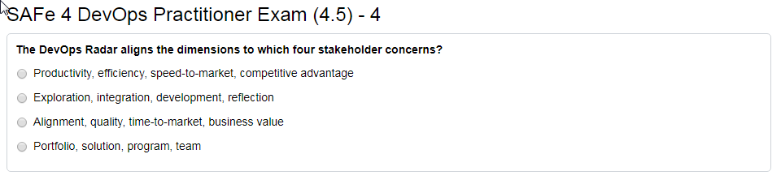What are the top two advantages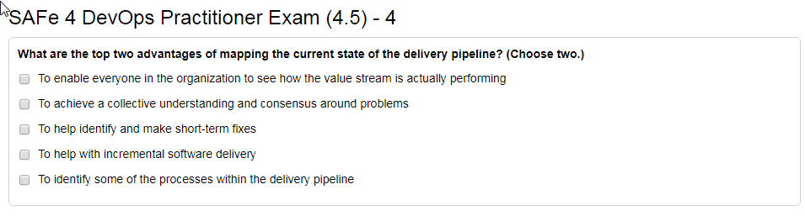How shoul developers integrate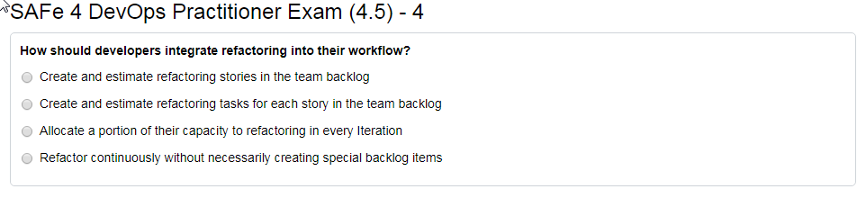A canary release involves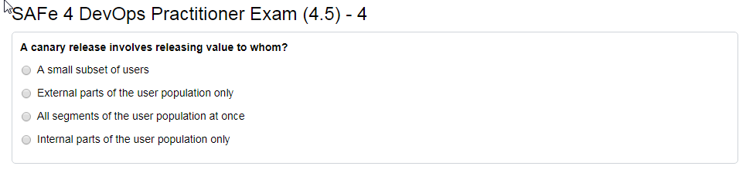Which two statements describe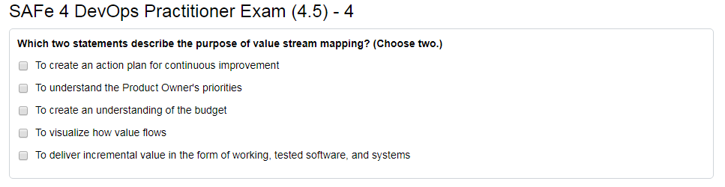What are tiwo reasons for test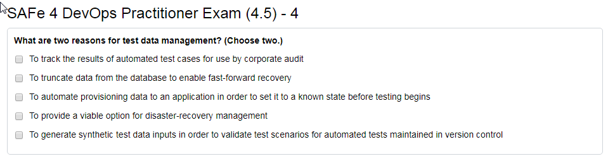Which statement illustrates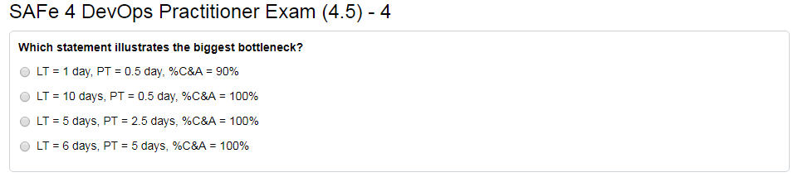What is the recommended way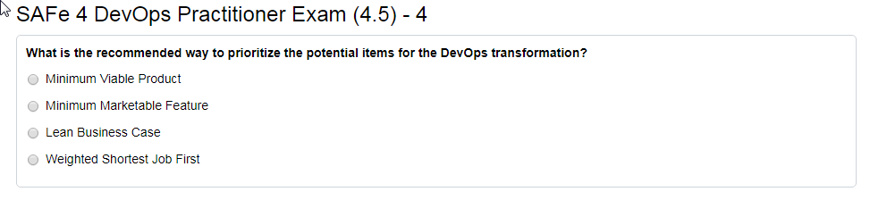Feature toggles are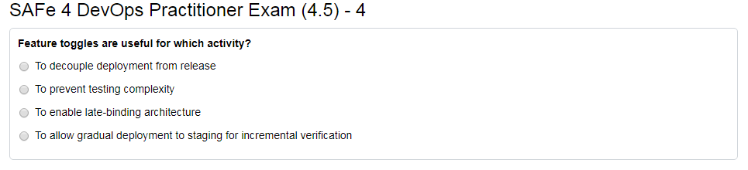Which technical practice incorporates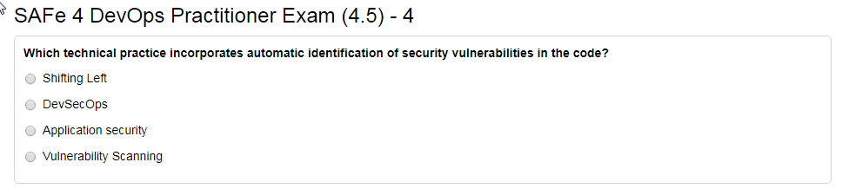How is Lean UX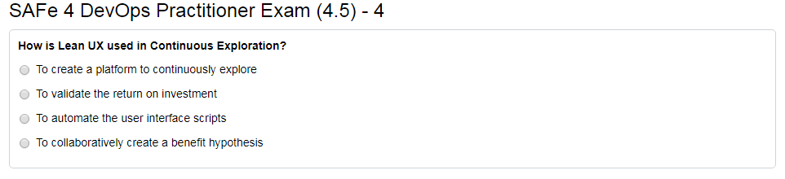What does value stream mapping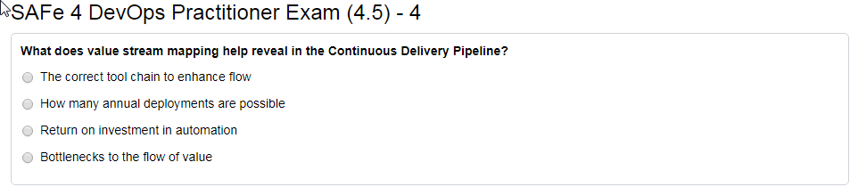Weighted shortest job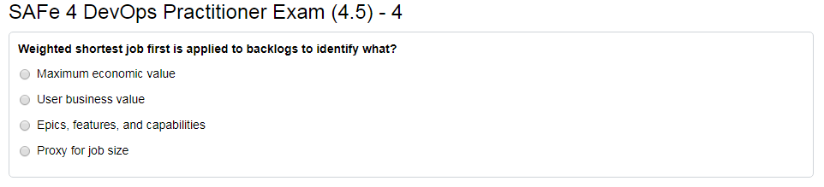Ensuring that security controls such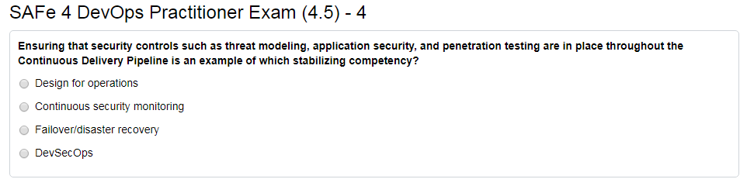What should be measured in 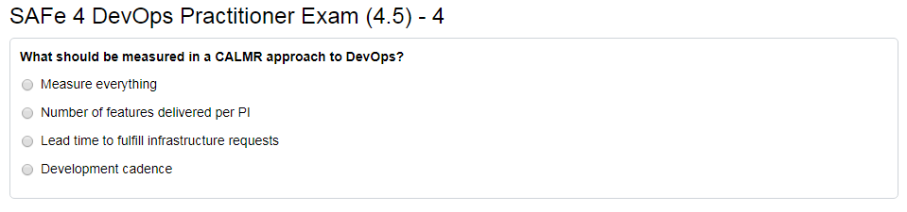What is an output of the release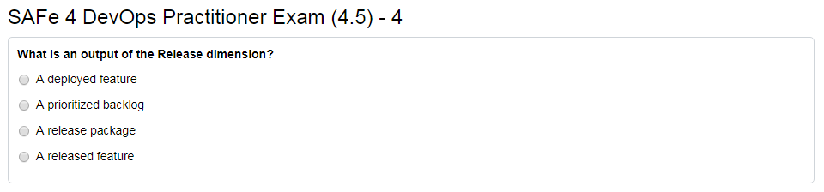Which metric reflects the quality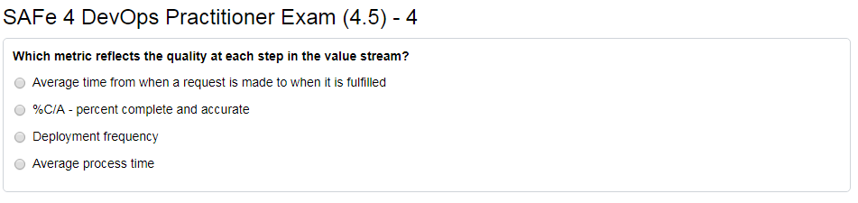Gemba walks are an important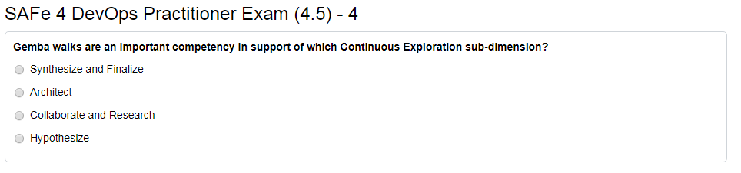Which activity is performed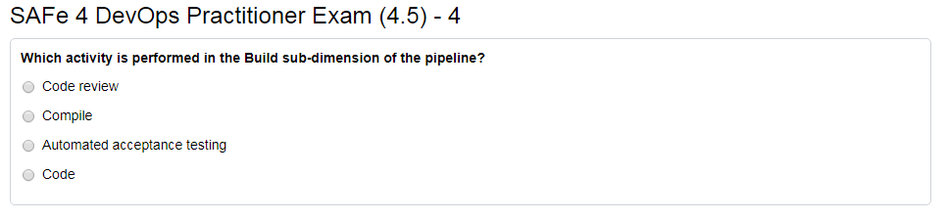Which incident response practise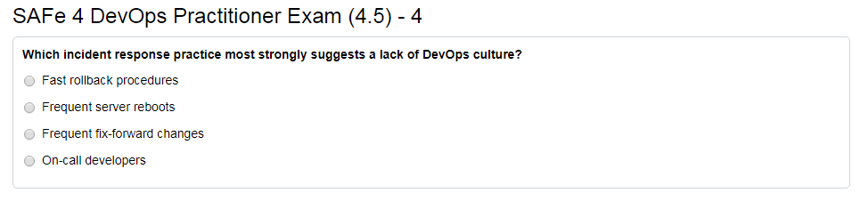What triggers the release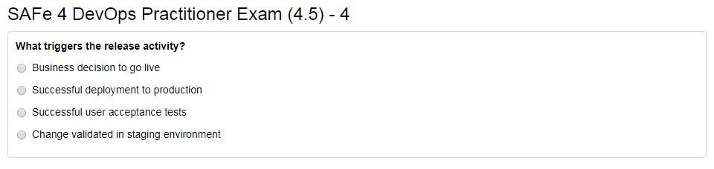What can impede the progress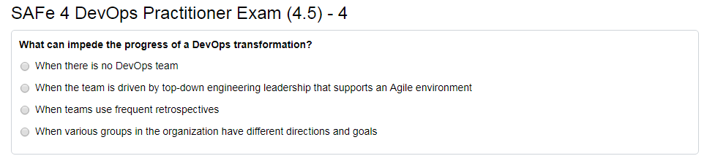Which steps in the value stream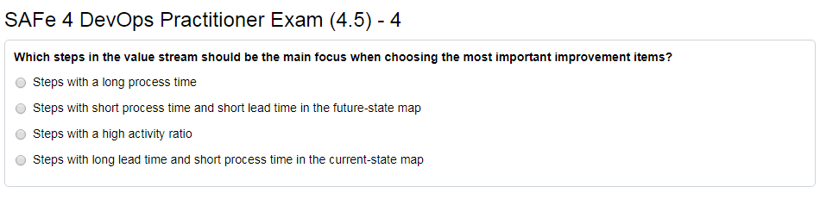When full deployment automation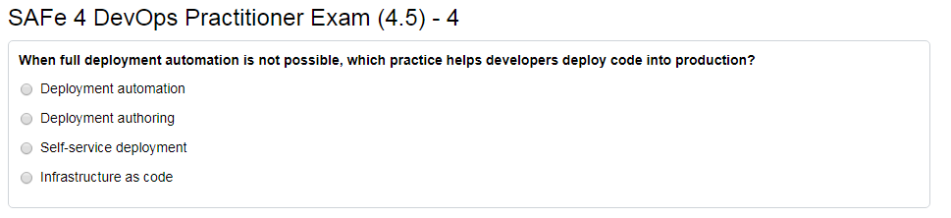When should teams use root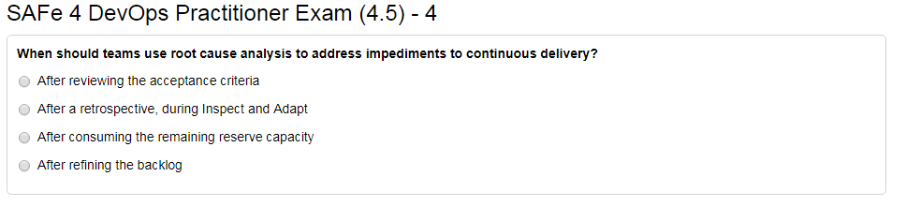What are the first two areas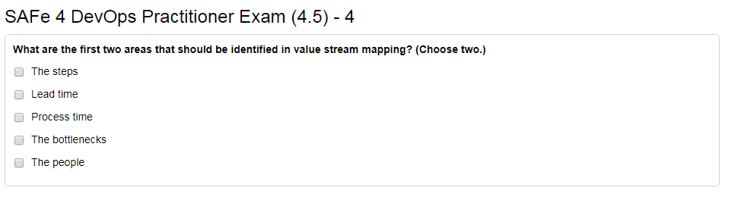Where do features go after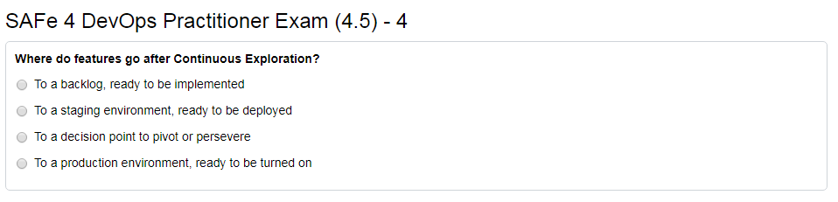What should the team be able to do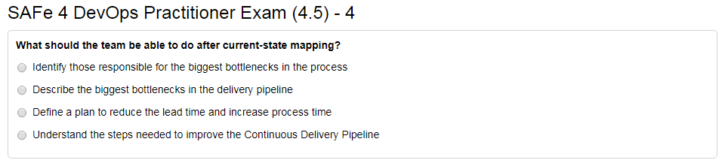What differentiates deployment and release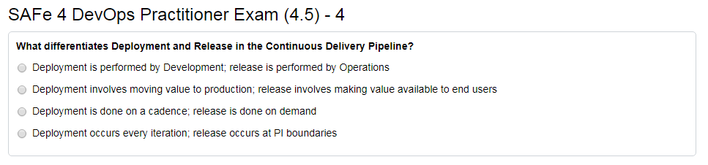What does the activity ratio