General Setup
- Start in Joule Studio dashboard SAP Build
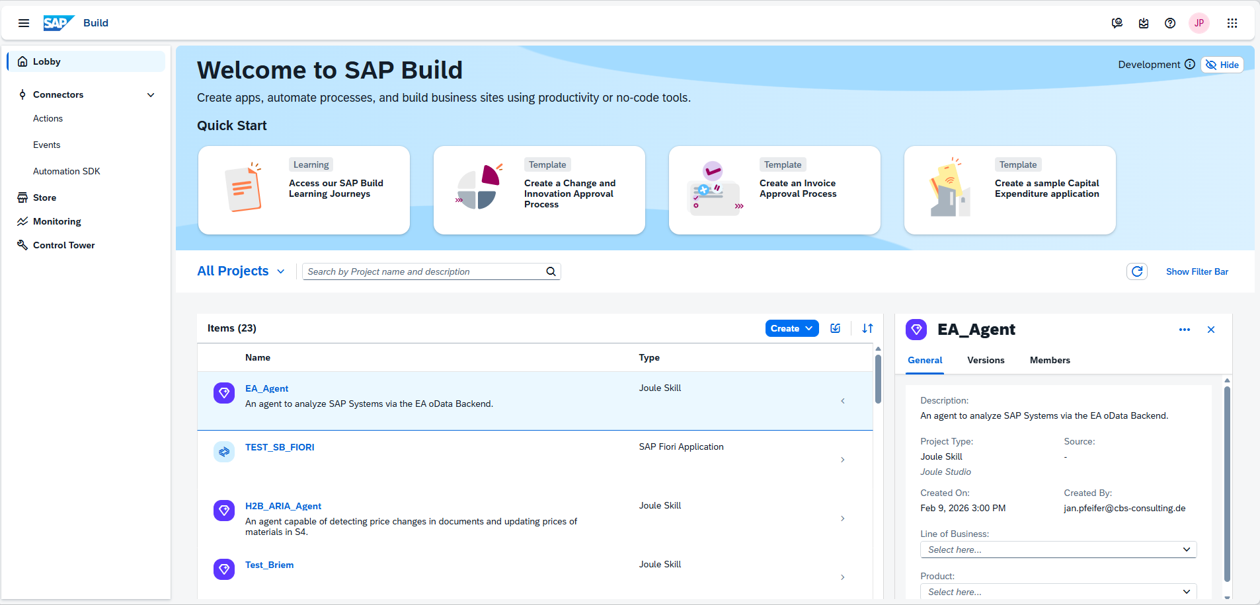
- Create already setip Action Project (then continue with “Recreate Get Bug” chapter) or setup new Action Project
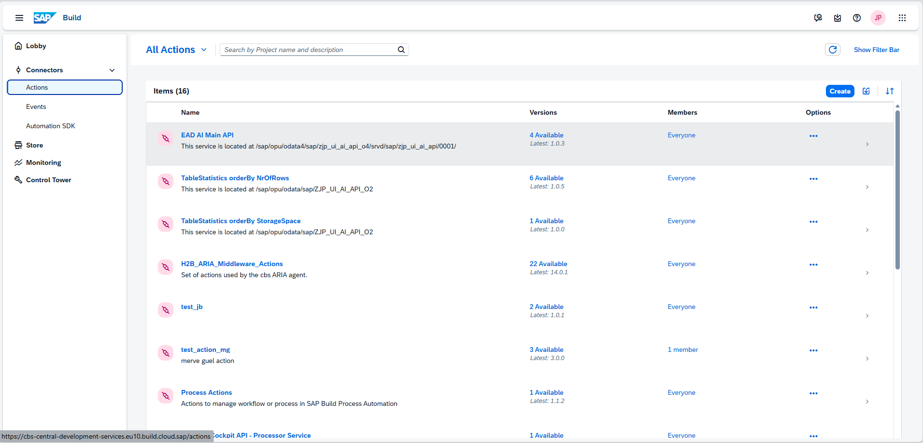
- Choose ABAP Restful Application Programming Model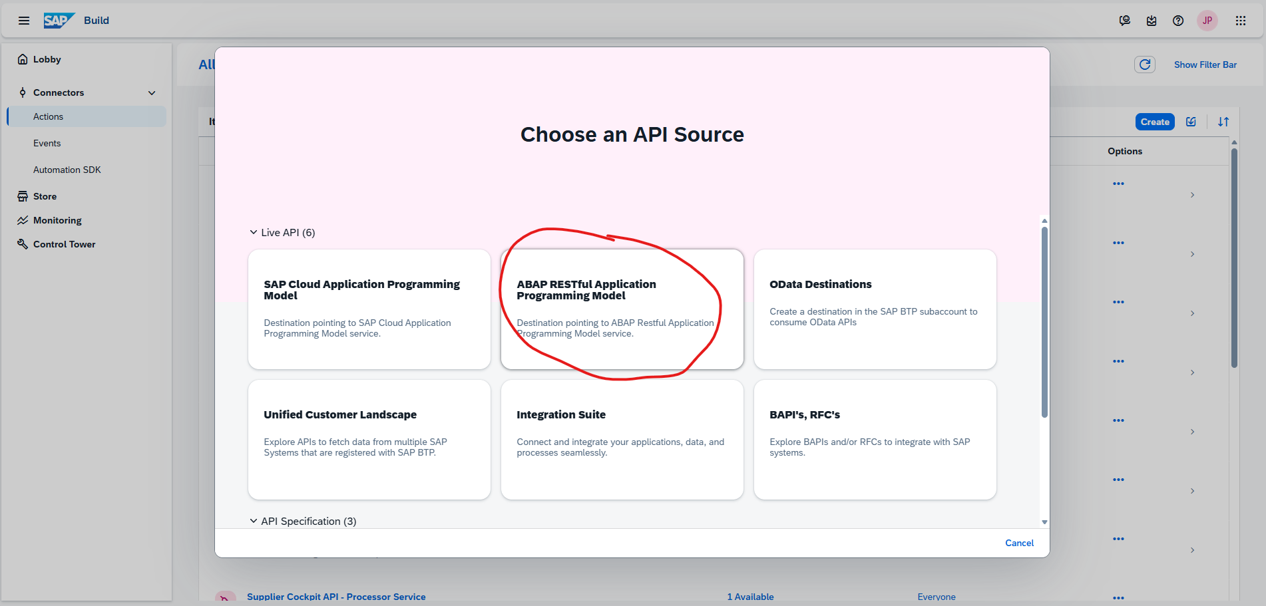
- Select the destination pointing at our system (for more info look up chapter “Destination Setup”)
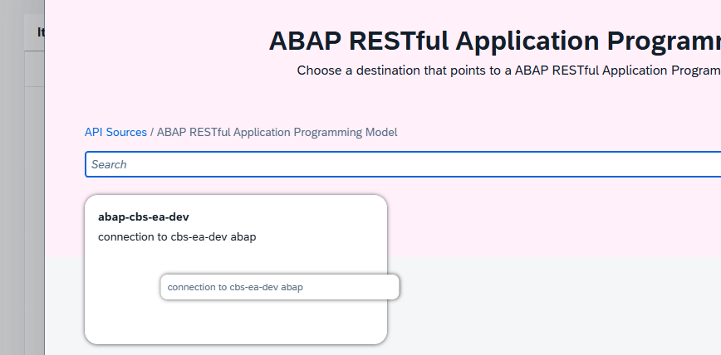

- Any type in the o4 service /sap/opu/odata4/sap/zjp_ui_ai_api_o4/srvd/sap/zjp_ui_ai_api/0001/
Or the o2 service
/sap/opu/odata/sap/ZJP_UI_AI_API_O2
The bug is odata version independent.

- Now create a GET or POST for any EntitySet since the bug is entityset and GET or POST independent.

Recreate Get Bug
First we are in any action which creates an API call to our backend.
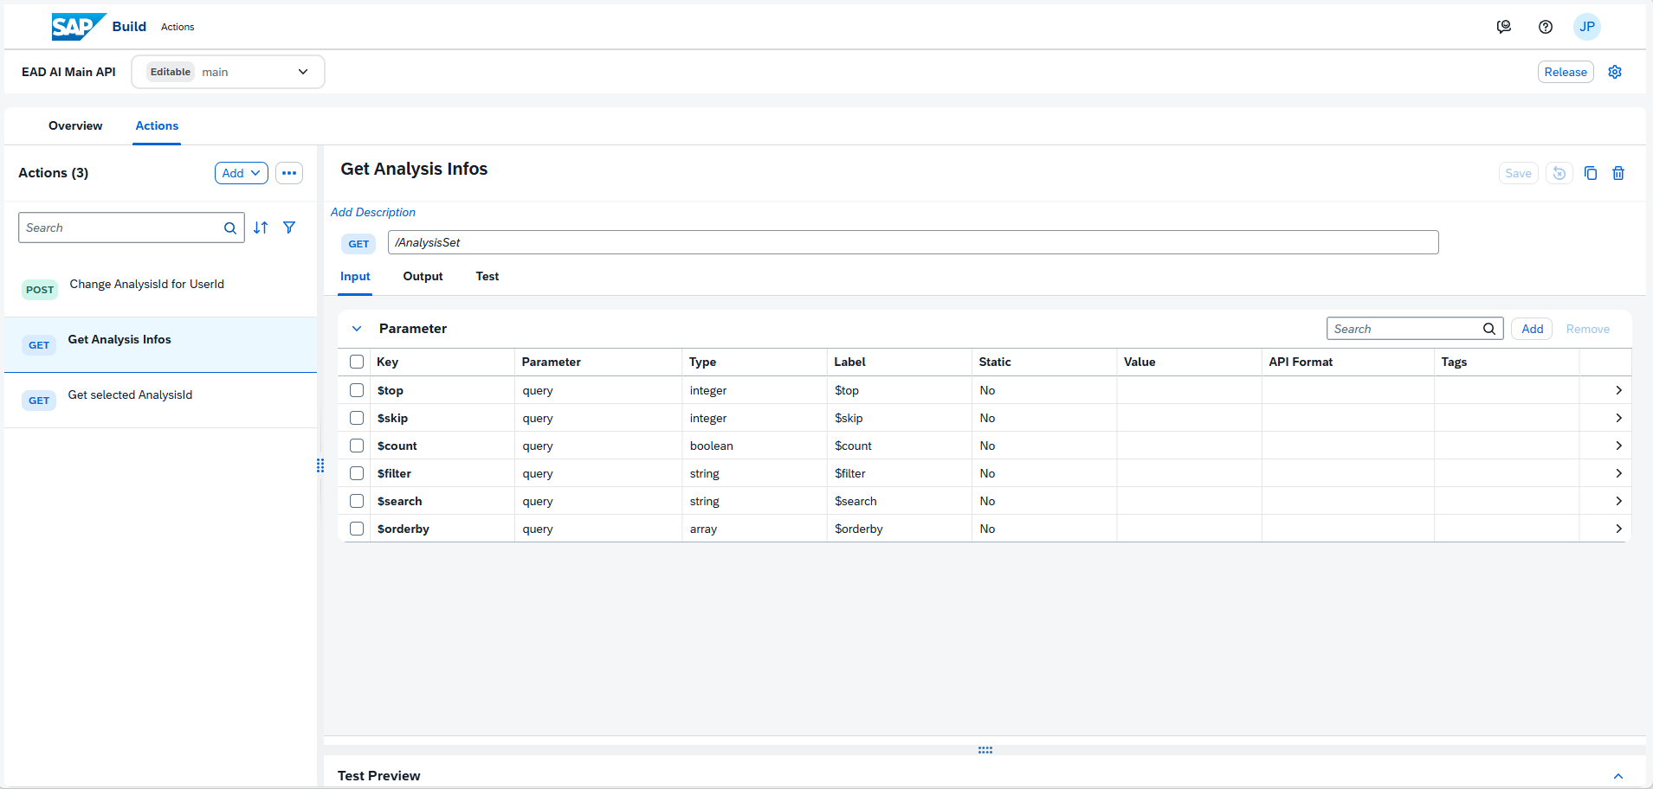
When testing the call it always works the first time.
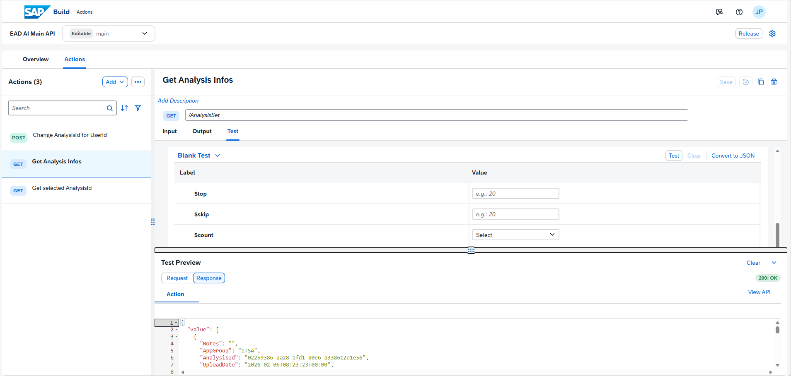
But fails in subsequent calls an undefined amount of times until working again for one call
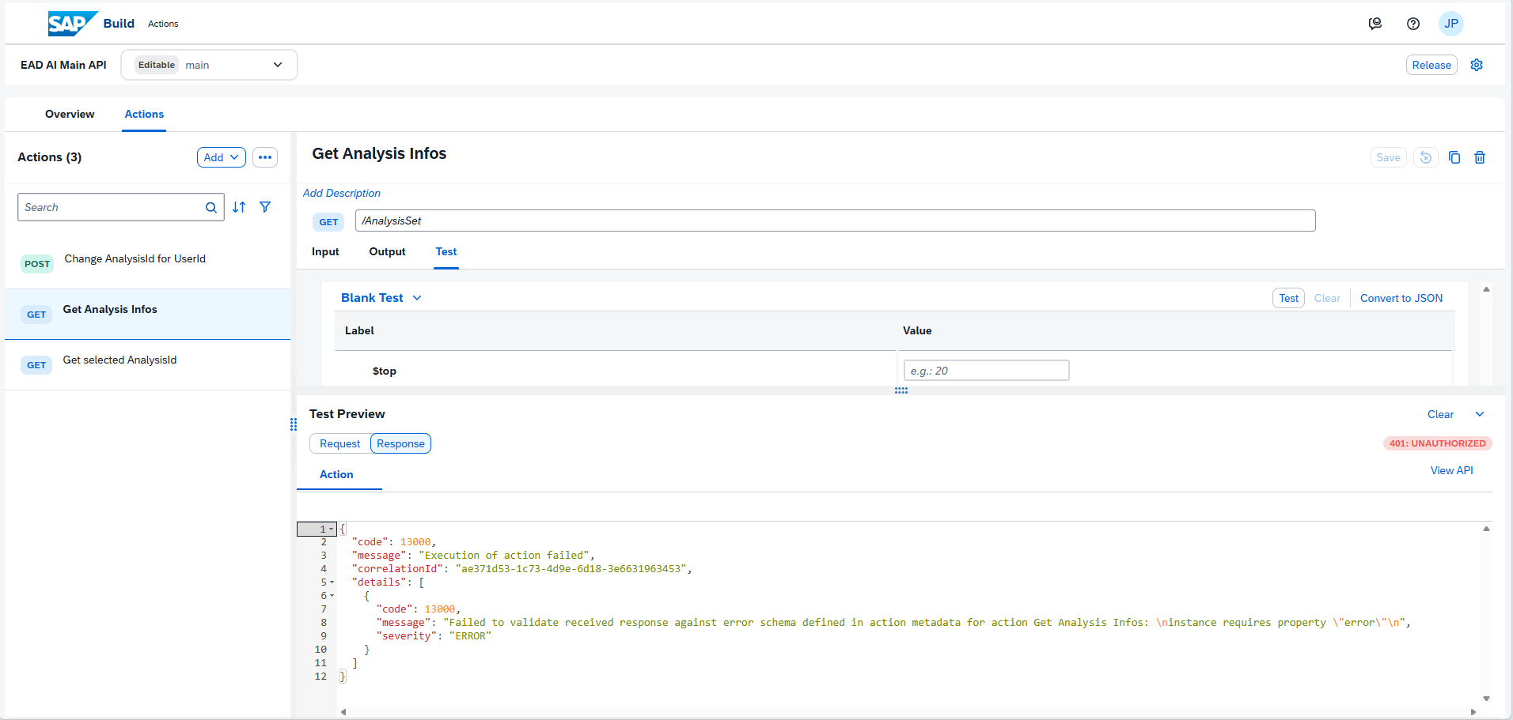
Request URL: abap-cbs-ea-dev + /sap/opu/odata4/sap/zjp_ui_ai_api_o4/srvd/sap/zjp_ui_ai_api/0001/AnalysisSet
Request Header: {
"accept": "application/json; IEEE754Compatible=true",
"Content-Type": "application/json; IEEE754Compatible=true"
}
Request Body : Empty
Response Header: {
"set-cookie": "sap-usercontext=sap-client=100; path=/",
"content-type": "text/html; charset=utf-8",
"content-length": "6356",
"sap-authenticated": "false",
"sap-system": "EAD",
"www-authenticate": "Basic realm=\"SAP NetWeaver Application Server [EAD/100][alias]\"",
"sap-server": "true",
"sap-perf-fesrec": "70533.000000",
"connection": "close"
}

In our connectivity trace a unauthorized issue gets shown
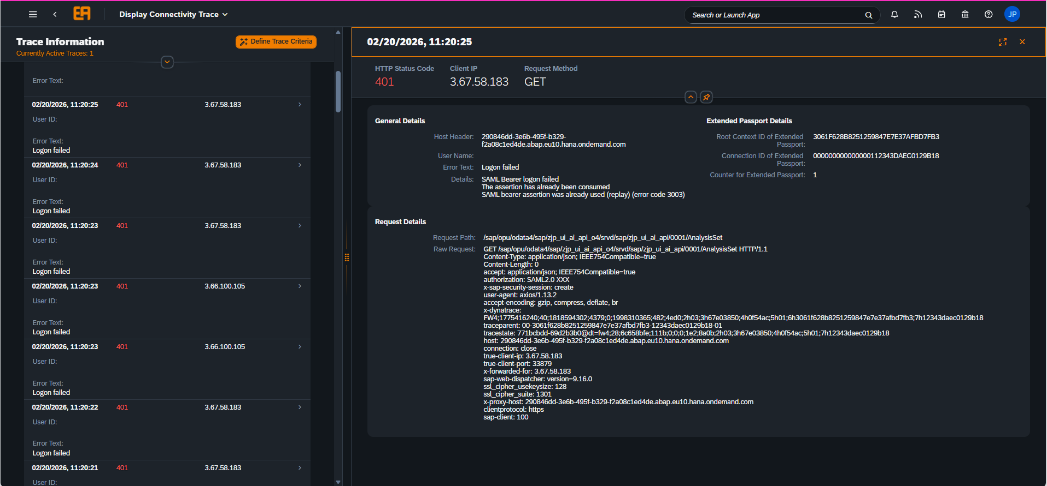

Recreate Post Bug
For post requests we have a similar issue. The first time everything works fine, most of the time the second time too.
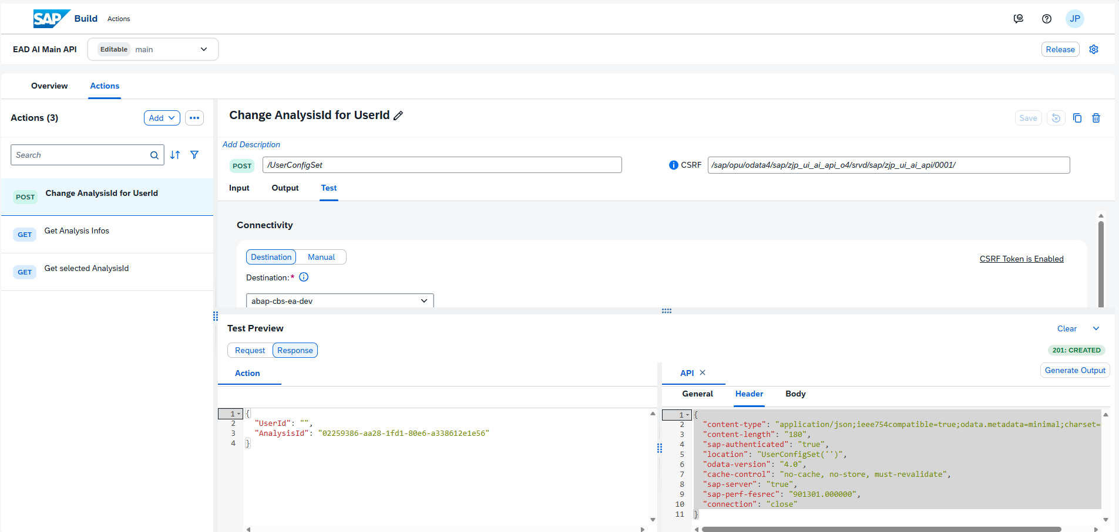
But at least in the third test a X-CSRF issue occurs.
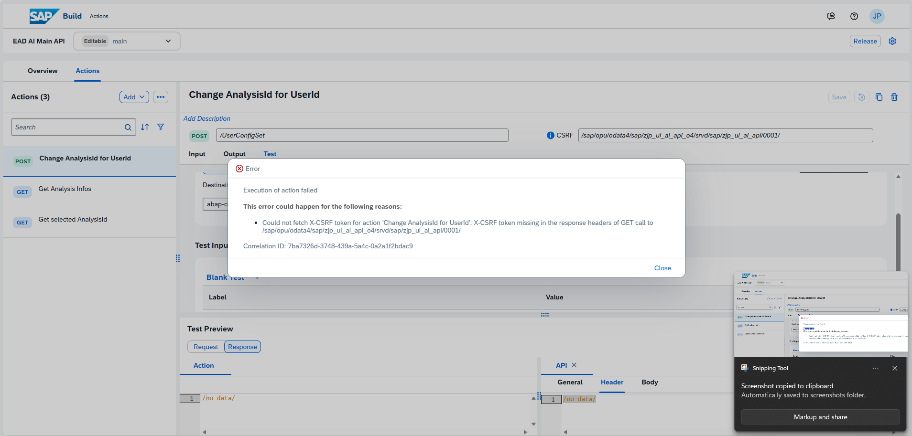
Request and Response Body / Header are all empty here.
Most likely because the HEAD / GET request to get the token CSRF token fails too
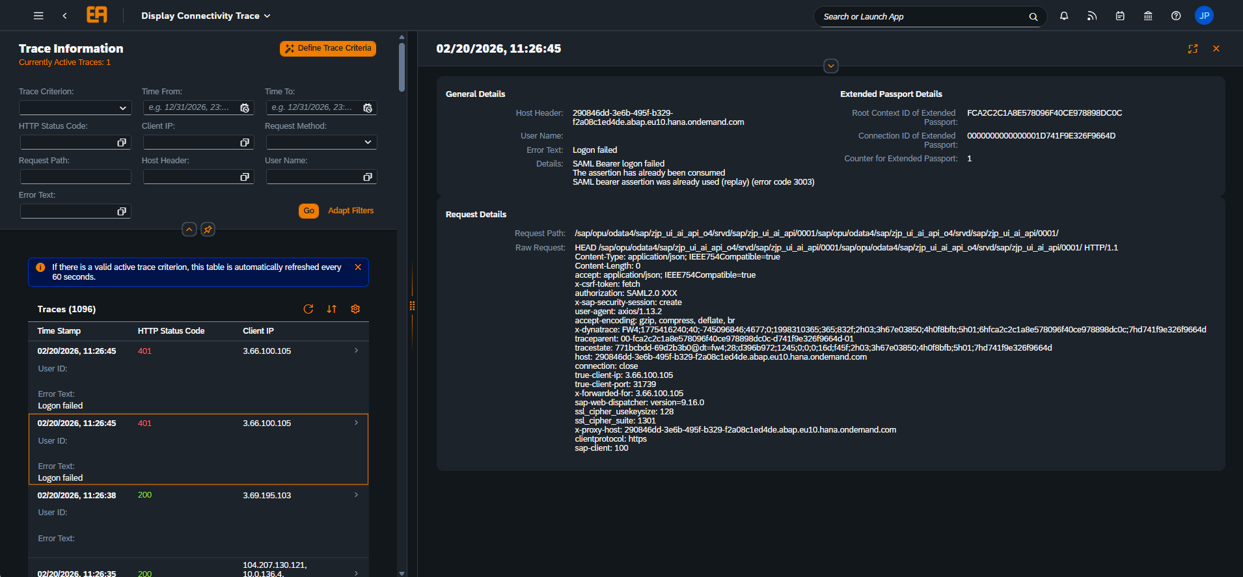

Why do these 401 Authentification errors occur, beginning on the 2. Or 3. Request?

