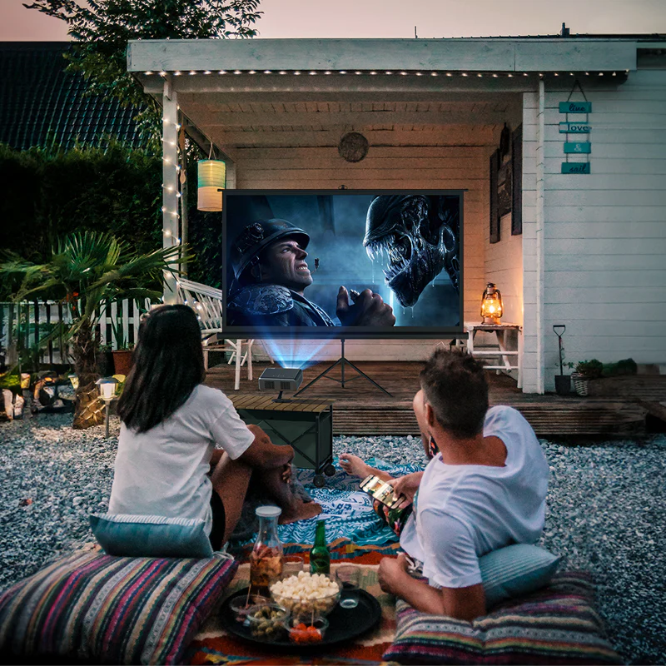
1. Christmas Trivia Challenge
What you need:
- Laptop (PowerPoint, Google Slides, or simple quiz website)
- Projector
How it works:
- Divide into teams (Families, Cousins, Adults vs Kids)
- Categories:
  - Bible & Christmas Story
  - Jamaican Christmas traditions
  - Christmas movies & songs
  - Family history questions (very fun!)
Extra fun:
- Small prizes: candy canes, chocolate, or bragging rights 😄

🎶 2. Christmas Karaoke Night
What you need:
- Laptop with YouTube karaoke videos
- Projector + speakers
How it works:
- Display lyrics on the projector
- Let families perform together
Song ideas:
- Traditional carols
- Gospel Christmas songs
- Fun upbeat tunes for the kids
💡 You don’t need microphones—group singing keeps it relaxed.

🎬 3. Family Christmas Movie + Interactive Quiz
What you need:
- One Christmas movie
- Short quiz afterward
How it works:
- Watch the movie together
- Pause occasionally for:
  - “What happens next?”
  - “Who said this line?”
- After the movie, run a 5–10 question quiz
🎁 Perfect for winding down the evening.

🧠 4. Guess the Christmas Song (Audio or Lyrics)
What you need:
- Short audio clips or lyric slides
How it works:
- Play 5–10 seconds of a song OR show part of the lyrics
- Teams guess:
  - Song title
  - Artist
  - Complete the next line
🔥 Add speed rounds for excitement.

📸 5. Family Photo Slideshow + Story Time
What you need:
- Old family photos or recent ones
- Projector
How it works:
- Display photos and let people:
  - Guess the year
  - Identify who’s in the photo
  - Share short memories
❤️ This often becomes the most meaningful moment of the night.

🎄 6. Christmas “Would You Rather?” (Projector Version)
What you need:
- Simple slides with choices
Examples:
- Would you rather no Christmas cake or no sorrel?
- Would you rather sing a solo or tell a joke?
- Would you rather Christmas in July or Christmas twice a year?
👨‍👩‍👧‍👦 Great for laughs and participation.

🎁 7. Digital Christmas Pictionary
What you need:
- Laptop + simple drawing app (Paint, Whiteboard, PowerPoint draw tools)
How it works:
- One person draws using the laptop
- Everyone guesses from the projector screen
- Use Christmas-themed words:
  - Angel, manger, star, reindeer, shepherd, gift

🎤 8. “Minute to Win It” – Projected Challenges
What you need:
- Timer on projector
- Simple household items
Examples:
- Name 10 Christmas foods in 60 seconds
- Recite a Bible verse about Jesus’ birth
- Sing 3 carols back-to-back
⏱️ Projected countdown adds excitement!

🙏 9. Christmas Devotional + Interactive Reflection
Since faith is important in your family, this fits beautifully.
How it works:
- Project a short scripture (Luke 2, Isaiah 9:6)
- Follow with questions:
  - “What does Christmas mean to you this year?”
  - “What are we thankful for as a family?”
🌟 Calm, meaningful, and unifying.

🎅 Suggested Flow for the Evening
- Icebreaker game
- Trivia or Karaoke
- Meal
- Movie + Quiz
- Slideshow & Devotional
- Light games + prizes

