**generate an example of children’s book style cartoon character**

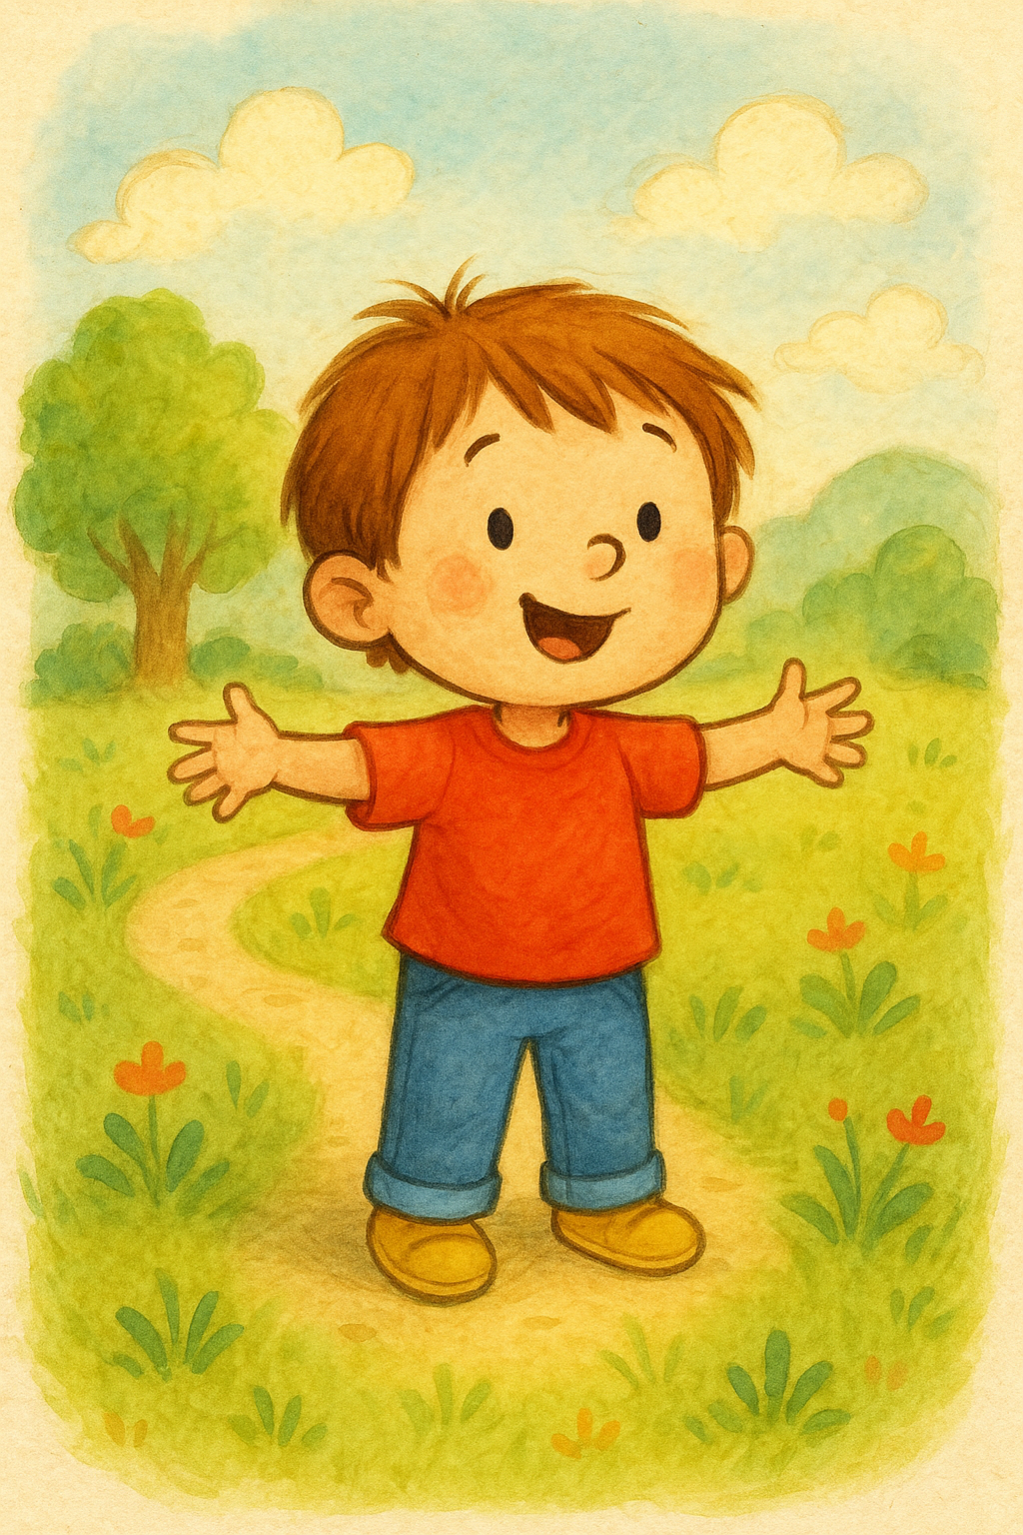

Example