ISO #####-#:####(X)
ISO/TC 296/SC ##/WG 2
Date: YYYY-MM-DD
Bamboo mat

WD/CD/DIS/FDIS stage

Warning for WDs and CDs
This document is not an ISO International Standard. It is distributed for review and comment. It is subject to change without notice and may not be referred to as an International Standard.
Recipients of this draft are invited to submit, with their comments, notification of any relevant patent rights of which they are aware and to provide supporting documentation.

A model document of an International Standard (the Model International Standard) is available at:
https://www.iso.org/drafting-standards.html
© ISO 20XX
All rights reserved. Unless otherwise specified, or required in the context of its implementation, no part of this publication may be reproduced or utilized otherwise in any form or by any means, electronic or mechanical, including photocopying, or posting on the internet or an intranet, without prior written permission. Permission can be requested from either ISO at the address below or ISO’s member body in the country of the requester.
ISO copyright office
CP 401 • Ch. de Blandonnet 8
CH-1214 Vernier, Geneva
Phone: +41 22 749 01 11
Email: copyright@iso.org
Website: www.iso.org
Published in Switzerland
Contents
This template allows you to work with default MS Word functions and styles. You can use these if you want to maintain the Table of Contents automatically and apply auto-numbering if this is your preference. Delete this Table of Contents if not required.
Foreword V
1 Scope 1
2 Normative references 1
3 Terms and definitions 1
4 Classification 2
4.1 Categorized based on the main components 2
4.2 Categorized based on the application 2
5 Requirements 3
5.1 Materials 3
5.1.1 Age of bamboo 3
5.1.2 Mechanical properties of woven rop 3
5.2 Size and Tolerance 3
5.2.1 Size 3
5.2.2 Tolerances on the length and width 3
5.3 Appearance 3
5.3.1 Classification 3
5.3.2 Requirements 3
5.4 Physical, mechanical, and chemical property 4
5.5 Other Requirements 5
6 Test samples 5
6.1 Sampling 5
6.2 Size and number 5
6.3 Conformance 6
7 Handling, storage, packing and marking 6
7.1 Handling, storage and packaging 6
7.2 Marking 6
Annex A (normative) Test method for toughness of bamboo stick 8
A.1 Measuring Tools 8
A.2 Method 8
A.3 Expression of results 8

Foreword
ISO (the International Organization for Standardization) is a worldwide federation of national standards bodies (ISO member bodies). The work of preparing International Standards is normally carried out through ISO technical committees. Each member body interested in a subject for which a technical committee has been established has the right to be represented on that committee. International organizations, governmental and non-governmental, in liaison with ISO, also take part in the work. ISO collaborates closely with the International Electrotechnical Commission (IEC) on all matters of electrotechnical standardization.
The procedures used to develop this document and those intended for its further maintenance are described in the ISO/IEC Directives, Part 1. In particular, the different approval criteria needed for the different types of ISO documents should be noted. This document was drafted in accordance with the editorial rules of the ISO/IEC Directives, Part 2 (see www.iso.org/directives).
ISO draws attention to the possibility that the implementation of this document may involve the use of (a) patent(s). ISO takes no position concerning the evidence, validity or applicability of any claimed patent rights in respect thereof. As of the date of publication of this document, ISO [had/had not] received notice of (a) patent(s) which may be required to implement this document. However, implementers are cautioned that this may not represent the latest information, which may be obtained from the patent database available at www.iso.org/patents. ISO shall not be held responsible for identifying any or all such patent rights.
Any trade name used in this document is information given for the convenience of users and does not constitute an endorsement.
For an explanation of the voluntary nature of standards, the meaning of ISO specific terms and expressions related to conformity assessment, as well as information about ISO's adherence to the World Trade Organization (WTO) principles in the Technical Barriers to Trade (TBT), see www.iso.org/iso/foreword.html.
This document was prepared by Technical Committee [or Project Committee] ISO/TC [or ISO/PC] 296, [Bamboo and rattan], Subcommittee SC ##, [name of subcommittee].
This second/third/… edition cancels and replaces the first/second/… edition (ISO #####:####), which has been technically revised.
The main changes are as follows:
— xxx xxxxxxx xxx xxxx
A list of all parts in the ISO ##### series can be found on the ISO website.
Any feedback or questions on this document should be directed to the user’s national standards body. A complete listing of these bodies can be found at www.iso.org/members.html.

Bamboo mat

Scope
This document specifies the terms and definitions, technical requirements, test methods and requirements for handling, storage, packaging and marking of bamboo mat.
This document applies to both painted and unpainted bamboo mats for use as beds, cushions, pillows, and carpets. These mats are made of bamboo sticks, bamboo slivers and bamboo blocks as the main components.

Normative references
The following documents are referred to in the text in such a way that some or all of their content constitutes requirements of this document. For dated references, only the edition cited applies. For undated references, the latest edition of the referenced document (including any amendments) applies.
ISO105-X12, Textiles - Tests for colour fastness - Part X12: Colour fastness to rubbing
ISO 3856-1, Paints and varnishes - Determination of "soluble" metal content - Part 1: Determination of lead content
ISO 3856-4, Paints and varnishes - Determination of "soluble" metal content - Part 4: Determination of cadmium content - Flame atomic absorption spectroscopic method and polarographic method
ISO 3856-6, Paints and varnishes - Determination of "soluble" metal content; - Part 6: Determination of total chromium content of the liquid portion of the paint - Flame atomic absorption spectrometric method
ISO 3856-7, Paints and varnishes - Determination of "soluble" metal content - Part 7: Determination of mercury content of the pigment portion of the paint and of the liquid portion of water - dilatable paints - Flameless atomic absorption spectrometric method
ISO 9426, Wood-based panels - Determination of dimensions of panels
ISO 12460-1: 2007, Wood-based panels - Determination of formaldehyde release - Part 1: Formaldehyde emission by the 1-cubic-metre chamber method
ISO 16979, Wood-based panels - Determination of moisture content
ISO 21629-1, Bamboo floorings - Part 1: Indoor use
ISO 21625, Vocabulary related to bamboo and bamboo products
ISO 14362-1: 2017, Textiles - Methods for determination of certain aromatic amines derived from azo colorants - Part 1: Detection of the use of certain azo colorants accessible with and without extracting the fibres
ISO 14362-3: 2017, Textiles - Methods for determination of certain aromatic amines derived from azo colorants - Part 3: Detection of the use of certainazo colorants, which may release 4-aminoazobenzene

Terms and definitions
ISO and IEC maintain terminology databases for use in standardization at the following addresses:
- ISO Online browsing platform: available at https://www.iso.org/obp
- IEC Electropedia: available at https://www.electropedia.org/
3.1
bamboo block
short-cube piece processed from bamboo strip or stick
3.2
bamboo stick
long, thin bamboo strip with or without sharp pointed ends and of uniform dimension along its length
[SOURCE: ISO 21625: 2020, 3.2.10]
3.3
bamboo sliver
long, thin, and narrow piece cut from bamboo strip or split
[SOURCE: ISO 21625: 2020, 3.2.4]
3.4
bamboo mat
mat made of bamboo sticks, bamboo slivers, and bamboo blocks as the main elements through weaving processing, and its back can be covered with gauze, cellulose fiber, regenerated cellulose fiber or other backing materials, and its edges can be wrapped and sewn with fabric
3.5
bamboo stick mat
mat made of bamboo sticks as the main elements through weaving processing, and its back can be covered with gauze, cellulose fiber, regenerated cellulose fiber or other backing materials, and its edges can be wrapped and sewn fabric
3.6
bamboo woven mat
mat made of bamboo slivers as the main elements through weaving processing, and its edges can be wrapped and sewn with fabric
3.7
bamboo mahjong mat
mat made of bamboo blocks through weaving processing with string or other materials, and its edges can be wrapped and sewn with fabric
3.8
bamboo thorn
needle-like protrusions on the bamboo surface prone to pierce the skin caused by the tearing of bamboo fibre bundles

Classification

Categorized based on the main components
— Bamboo stick mat
— Bamboo woven mat
— Bamboo mahjong mat

Categorized based on the application
— Bamboo mat for bed
— Bamboo mat for cushion
— Bamboo mat for pillow
— Bamboo mats for carpet

Requirements

Materials

Age of bamboo
The age of the bamboo used to make the mats shall be over 4 years.

Mechanical properties of woven rop
The breaking force of woven rope shall be not less than 2 000 cN.

Size and Tolerance

Size
The common sizes are indicated in Table 1.
- Common size
Parameter | Test method | Size
Parameter | Test method | Bamboo mat for bed | Bamboo mat for seat cushion | Bamboo mat for pillow | Bamboo mat for carpet
Length (mm) | ISO 9426 | 1950~2000 | 450~900 | 500~700 | 900~1800
Width (mm) | ISO 9426 | 1200~1800 | 450~900 | 300~500 | 450~900
NOTE Other specific sizes of bamboo mats are permitted upon agreement between producer and buyer.

Tolerances on the length and width
Length and width tolerances are indicated in Table 2.
- Tolerances on the length and width
Nominal size |  | Test method | Requirements
 |  | Test method | Bamboo sliver mat | Bamboo woven mat | Bamboo mahjong mat
Length(mm) | ≤1000 | ISO 9426 | ±5 | ±5 | ±10
Length(mm) | 1000~1500 | ISO 9426 | ±10 | ±10 | ±15
Length(mm) | >1500 | ISO 9426 | ±20 | ±10 | ±20
Width(mm) | ≤1000 | ISO 9426 | 0  -5 | 0  -5 | 0  -10
Width(mm) | 1000~1500 | ISO 9426 | 0  -10 | 0  -10 | 0  -10
Width(mm) | >1500 | ISO 9426 | 0  -15 | 0  -10 | 0  -10

Appearance

Classification
Bamboo mats can be classified into Grade 1 and Grade 2 according to the quality of appearance, if their size, size tolerances, physical and chemical properties comply with this standard.

Requirements
The requirements for appearance quality are indicated in Table 3.
- Appearance quality
Type of defects |  | Requirements
 |  | Grade 1 | Grade 2
Bamboo thorn |  | Not permitted
Pattern |  | Complete and clear
Chromatic aberration |  | Not obvious
Crack |  | Not permitted | Not obvious
Scratches |  | Not permitted | Not obvious
Glue delamination ª |  | Not permitted for backing material | Not obvious for backing material
Bamboo stick breakage |  | Not permitted | The maximum width of single bamboo stick does not exceed 1/4 of the stick and length≤20 mm; Permitted up to 3 per m²
Mildew |  | Not permitted | Not obvious
Wormhole |  | Not permitted
Decay |  | Not permitted
Stain |  | Not permitted | Not obvious
Sewing quality ^{b} | Edging fabric | Smooth, firm, wrinkle-free; the tightness is suitable; and the width of the hemming is evenly sewn | Firm, no obvious wrinkling; the tightness is suitable; and the sewing width of the hemming is basically uniform
Sewing quality ^{b} | Stitch | No less than 8 pins/50 mm | No less than 6 pins/50 mm
Sewing quality ^{b} | Skipping stitch | Not permitted
Sewing quality ^{b} | Missing stitch
Sewing quality ^{b} | Broken stitch
NOTE Unobvious: It means that it is not easy to be discerned by normal eyesight under natural light and when observed with the naked eye at a distance of 0.4m from the bamboo mat.
ª Glue delamination shall be tested only for bamboo mat with backing materials.
^{b} Sewing quality shall be tested only for wrapped bamboo mat.

Physical, mechanical, and chemical property
The physical, mechanical, and chemical properties of bamboo mats shall comply with Table 4.
- Property requirements
Property |  | Test method | Requirement
Moisture content (%) |  | ISO 16979 | 3.0 ≤ w_{M} ≤ w_{EM}
Bonding quality ª |  | ISO 21629-1  Annex C | The cumulative delamination length in each separate individual glueline shall not exceed 25mm. At least 5 of the 6 test specimens meet the above requirement.
Bamboo stick toughness ^{b} |  | Annex A | No less than 5 of the 6 specimens shall not be broken
Colour fastness ^{c}  (Grade) | Dry rubbing  (Stain) | ISO 105-X12 | ≥4
Colour fastness ^{c}  (Grade) | Wet rubbing  (Stain) | ISO 105-X12 | ≥3
Formaldehyde emission ª  (mg/m³) |  | ISO 12460-1 | ≤0.124
4-aminoazobenzene and Banned azo colourants (mg/kg) |  | ISO 14362-1 and ISO 14362-3 | Not permitted
Soluble metal content ^{d}  (mg/kg) | lead | ISO 3856-1 | ≤45
Soluble metal content ^{d}  (mg/kg) | cadmium | ISO 3856-4 | ≤35
Soluble metal content ^{d}  (mg/kg) | chromium | ISO 3856-6 | ≤20
Soluble metal content ^{d}  (mg/kg) | mercury | ISO 3856-7 | ≤20
Key
w_{M} = moisture content
w_{EM} = equilibrium moisture content
ª Bonding quality and formaldehyde emission shall be tested only for bamboo mat with backing materials.
^{b} Bamboo stick toughness shall be tested only for bamboo stick mat.
^{c} Color fastness shall be tested only for dyed bamboo mat.
^{d} Soluble metal content shall be tested only for painted or dyed bamboo mat.

Other Requirements
Where applicable, and where required by regulations, the following may be required: flame retardant, heat resistance, biological durability.

Test samples

Sampling
The test sample shall be taken from the bamboo mats stored for more than 24 hours after production.

Size and number
The specimens shall be prepared according to Table 5 and Figure 1.
- Size and number of test specimens
Property | Size  (mm) | number  (piece) | Location of specimen
Moisture content | 75×75 | 3 | Take 1 piece of specimen at any position from workpiece samples 1 to 3
Bonding quality | 75×75 | 6 | Take 2 pieces of each one in any position from Sample No. 1 to No. 3
Bamboo stick toughness | Appropriate length | 6 | Take 2 pieces of each one in any position from Sample No. 1 to No. 3
Color fastness | Length≥140;  Width≥50 | 4 | Take 1 piece in the length and width direction of Sample 1 and Sample 3, respectively
Formaldehyde emission | 500×500 | 2 | Sample No. 4 and No. 5
4-aminoazobenzene and Banned azo colourants | — | About 1.0 g | Edging fabric: 5 mm × 5 mm;  Dyed bamboo stick: 5 mm (length) × width of bamboo stick
Soluble metal content | — | About 0.2 g | Scrape the coating materials from the surface of painted or dyed bamboo strips
NOTE If the size and number of specimens cannot be achieved due to the small size of the bamboo mats, they can be taken randomly from the same batch of mats until all the required specimens have been prepared.
Unit: mm
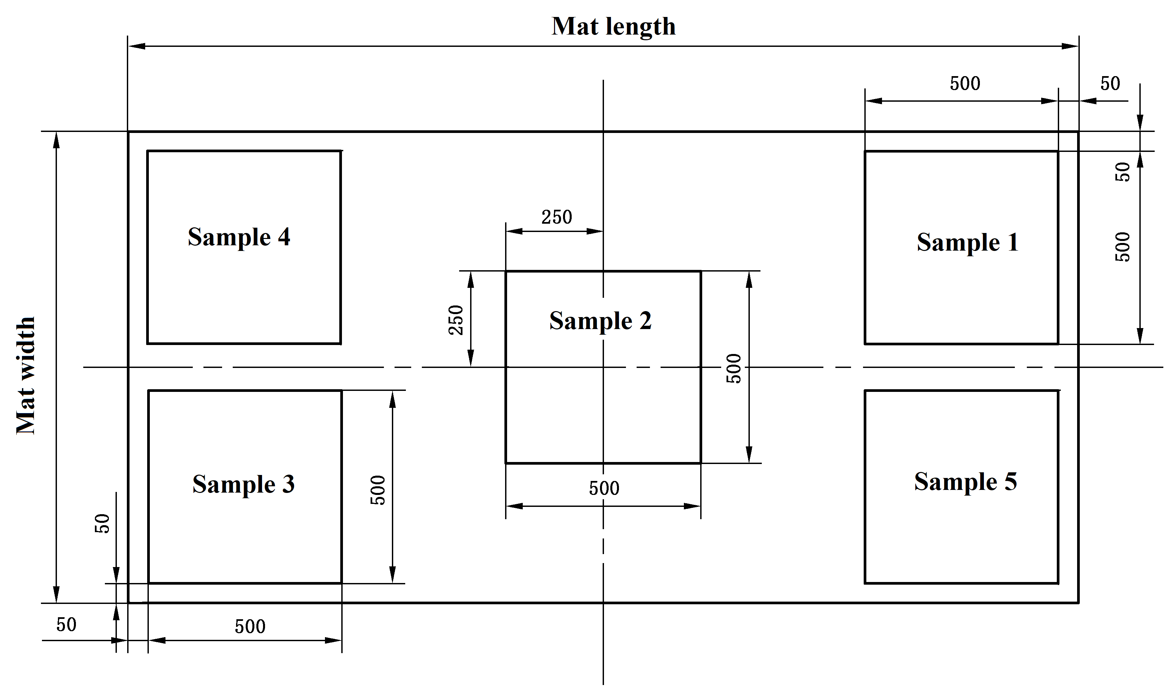
Figure 1 — Example of cutting for test pieces preparation

Conformance
Bamboo veneer conforming to this international Standard shall be manufactured undera quality system which
- includes factory production and quality-control with internal auditing and
- Includes external auditing of the factory quality control.
When the quality control system is certified, the bodies performing certification should operate in accordance with ISO/IEC 17065.

Handling, storage, packing and marking

Handling, storage and packaging
The manufacturer shall have procedures providing methods of product handling, packaging and shall provide suitable storage areas to prevent damage or deterioration.

Marking
By agreement between buyer and supplier, the package shall be clearly marked with the following information as a minimum:
— name of manufacturer or supplier;
— tradename;
— a reference to this document, i.e. ISO ***;
— dimensions;
— bamboo species;
— date of production and/or batch number;
— quantity of products and/or covered surface;
— when there are special requirements, instructions for use shall be attached.
- (normative) Test method for toughness of bamboo stick
  - Measuring Tools
A round steel drum with a diameter of 100 mm.
  - Method
- Total 6 pieces of bamboo sticks are obtained from Sample No.1 to No.3 at intervals of 2 to 3 bamboo sticks.
- Removing the backing material from the specimens and numbering them;
- Identify the right and back sides of the specimen. The right side faces inward immediately and bends close to the outer circle of the round steel drum to make the specimen bend into a circle.
  - Expression of results
Observing whether there is fracture phenomenon, and recording the numbers of fractured specimens.

