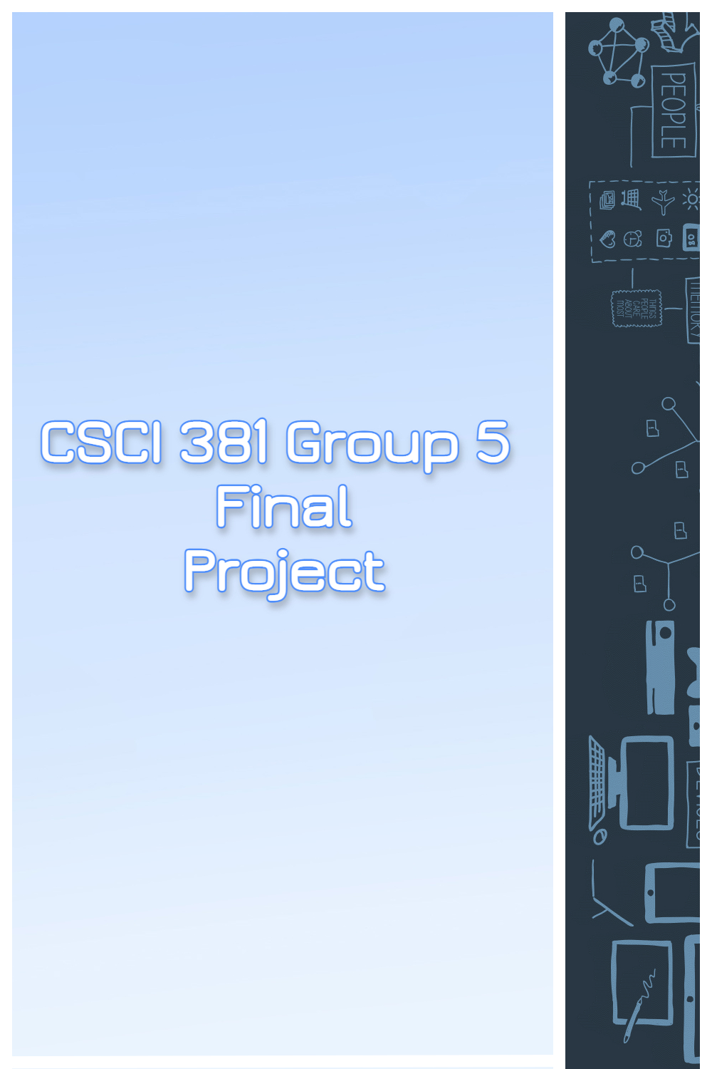

Contents

Overview 2

1. Project Background and Description (Executive Overview) 2

2. Project Scope 2

3. High-Level Requirements 2

4. Deliverables and Affected Parties 2

5. Specific Exclusions from Scope 3

6. Implementation Plan 3

7. High-Level Timeline/Schedule 3

8. Approval and Authority to Proceed 3

# **Overview**

## **Project Background and Description (Executive Overview)**

The Final Project serves as a model on how to improve and modernize an existing database using techniques and methods we have discussed over the entire course. This would elevate the model to be more robust and a better representative example of what is considered good practice for building and using a database. The target audience for this project will be developers and, at a greater level, the rest of the corporation that interacts with the database. The primary goal is to improve a system to better facilitate database interaction and as such, improve business operations.

## **Project Scope**

The scope of the project entails incorporating all aspects of the course, spanning early discussions on entities and relationships to triggers and model database adaptability. This project will be the most open in scope so far, as we have all the tools and concepts acquired through the course and can let our creativity be the driving force for what is implemented. Ultimately, the project is a showcase of what we have interpreted through the semester and will use the EuropeanCarManufacturer data model as a canvas.

## **High-Level Requirements**

The Final Project database should have the following implementations…

* Conceptual, Logical, and Physical Data Models
* Heavy incorporation of domains, indexing, constraints, and validations
* Full definitions for domains and entities
* Table normalization where appropriate
* Fully qualified objects including appropriate uniform naming conventions
* Business rule template validations
* Create User Authorization table
* Audit Table Triggers
* Archetype color coded themes for entity/tables
* GitHub implementation

## **Deliverables and Affected Parties**

The stakeholders that will be impacted by this project are the data scientist, programmers and the corporation as a whole:

* The Data Scientists will benefit from this because it will make data collection and data organization easier. This makes getting information easier as well as being able to present the data to the executives at the corporation.
* Programmers will benefit from this as data collection and organization will become more actionable and applicable to projects. Utility of the database may become more streamlined and straightforward.
* The corporations will benefit from this because it will allow more data to be organized and be better utilized. Since data is critical when it comes to day-to-day operations, this will facilitate that at the database level with modern intuitive database conventions.

Deliverables will include…

* Project plan and different models
* Project directory structured to specification
* Project tracking documentation
* Separate videos to present different aspects of the project (i.e., Domain taxonomy, Triggers, etc.)

## **Specific Exclusions from Scope**

The project will be implemented in an incremental order as following:

1st Step – Review requirements and plan schedule

2nd Step – Create first objects, definitions, models

3rd Step – Implement domains, constraints, defaults, and indexes

4th Step – Additional tables, triggers, and normalization

5th Step – Color coding and smaller additions

6th Step – Database migration

7th Step – Create presentation outline and record videos

8th Step – Finishing touches and submission

## **Implementation Plan**

The implementation plan is to flesh out the model requirements early on and begin to incorporate the basics first: relationships, definitions, domains, etc. Most of these requirements can be done concurrently by different teams. As we get to the more complex requirements, we can establish priority and designate responsibilities accordingly. After achieving an initial final model, we can begin to refine details and check off requirements. Lastly, we must prepare the required documentation, directory, and presentations. Communication will be critical to each stage of the plan to ensure smooth transition between phases.

## **High-Level Timeline/Schedule**

|  |  |  |
| --- | --- | --- |
| **TASK NAME** | **START  DATE** | **END  DATE** |
| Initial meeting to review initiate planning | 12-2-2022 | 12-2-2022 |
| Relationships, definitions, entities | 12-3-2022 | 12-5-2022 |
| CDM, LDM, PDM | 12-4-2022 | 12-6-2022 |
| Domains, constraints, indexes, defaults | 12-6-2022 | 12-7-2022 |
| Additional table, triggers, normalization | 12-4-2022 | 12-11-2022 |
| Color Coding Themes | 12-9-2022 | 12-10-2022 |
| Database final refinement | 12-11-2022 | 12-13-2022 |
| Postgres, MySQL Migration | 12-13-2022 | 12-14-2022 |
| Presentation, Video, Documentation | 12-14-2022 | 12-15-2022 |
| Submission | 12-13-2022 | 12-15-2022 |

# **Approval and Authority to Proceed**

We approve the project as described above, and authorize the team to proceed.

|  |  |  |
| --- | --- | --- |
| Name | Title | Date |
|  |  |  |