Hospital Drug Supply Risk & Inventory Planner
A Data Pipeline, Risk Model, and Power BI Dashboard — Case Study
Glad Wong | August 2026 | Portfolio Project
Most hospitals learn about a drug shortage only after it starts affecting care. This project builds a composite risk score for every drug and therapeutic category a hospital stocks, by combining real FDA shortage data, real CDC seasonal illness surveillance, and real de-identified hospital prescription data, then surfaces it in an interactive Power BI dashboard. No synthetic or placeholder data appears anywhere in the final pipeline.
1,581  real FDA shortage records | 59,525  CDC seasonal surveillance rows | 71  real per-drug demand rows (MIMIC-IV) | 81.8  top composite risk score

The Dashboard
Filter by therapeutic category and see the highest-risk drugs, active shortage count, and quarterly shortage trend update together — built on a relational model with a category table as the hub.
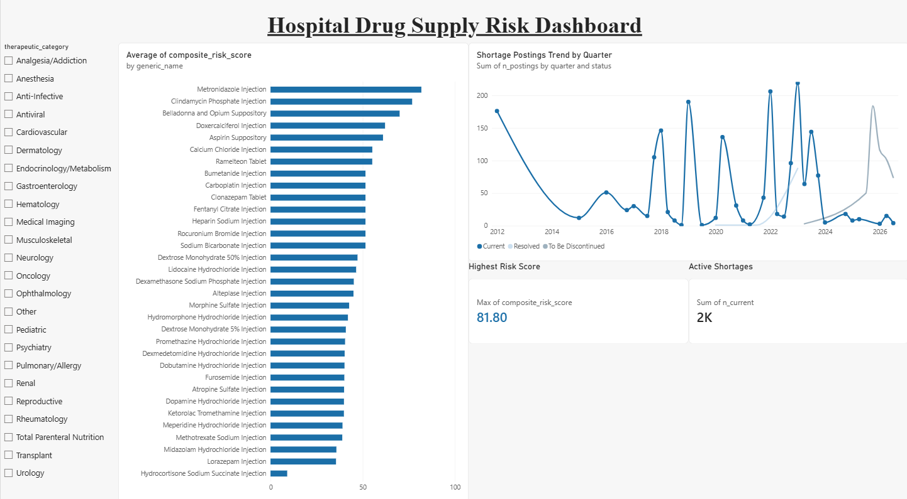
Hospital Drug Supply Risk dashboard in Power BI Desktop: category slicer, composite risk score by drug, quarterly shortage trend by status, and two KPI cards.
Data Sources
Source | What it provides | Volume
openFDA Drug Shortages | Active / resolved / discontinuing shortage records | 1,581 records, 24 categories
CDC RESP-NET | Seasonal respiratory illness surveillance | 59,525 rows, 4 networks, 2018–2026
FDA NDC Directory | Backfills proprietary drug names | 1,676 rows; 1,369/1,581 matched
MIMIC-IV Clinical Database Demo | Real per-drug hospital demand (Beth Israel Deaconess / Harvard Medical School, via MIT) | 71 demand rows from 1,374/18,087 matched prescriptions

Approach
Why MIMIC-IV
- eICU-CRD has more admissions (200k+) but anonymizes hospital identity and uses proprietary HICL/GTC medication codes, not NDC — would need a paid crosswalk.
- AmsterdamUMCdb and HiRID are prestigious academic-hospital datasets but European, coded in ATC, not NDC.
- MIMIC-IV (Beth Israel Deaconess, via MIT) uses real NDC codes that join directly to the shortage table — no crosswalk needed.
The NDC matching problem
openFDA's package NDC field uses three different dash layouts (4-4-2, 5-3-2, 5-4-1). Naively zero-padding the digit string produces the wrong 11-digit code for two of the three layouts. A segment-aware normalizer (Appendix A) fixes this by padding the correct segment based on where the dashes actually fall.
A real bug, caught by validating against live data
The seasonal view filtered CDC records where sex and race_ethnicity equal “Overall,” matching the documented schema used for age_group and site. CDC's live data actually labels those two fields “All.” This silently zeroed every seasonal number for four categories (Antiviral, Anti-Infective, Pulmonary/Allergy, Pediatric), which scored a flat 60.0 baseline. After the fix, those categories scored 84–98 — correctly outranking categories with no seasonal driver.
Key Findings
Metronidazole Injection ranks highest (risk score 81.8) — active shortage plus Anti-Infective seasonal amplification.
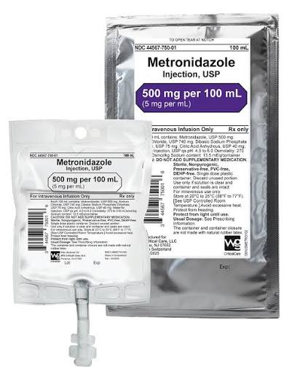
Metronidazole Injection, USP — 500 mg/100 mL
Clindamycin Phosphate Injection follows at 76.8, same drivers.
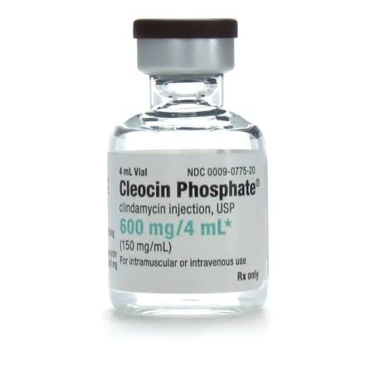
Clindamycin Phosphate Injection, USP (Cleocin Phosphate®) — 600 mg/4 mL
A cluster of “To Be Discontinued” drugs score high on discontinuation risk even at low volume — a signal a purely volume-based model would miss.
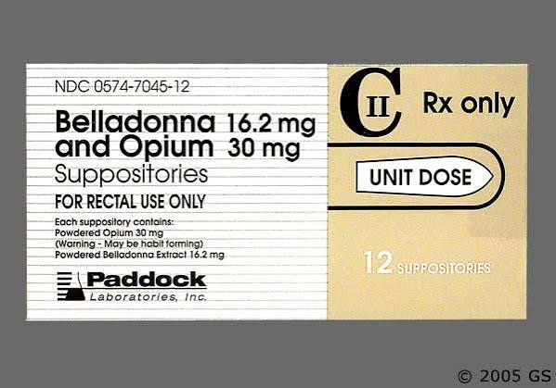  Belladonna 16.2 mg and Opium 30 mg Suppositories | 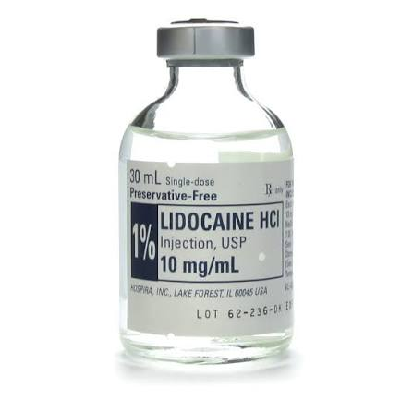  Lidocaine HCl Injection, USP 1% | 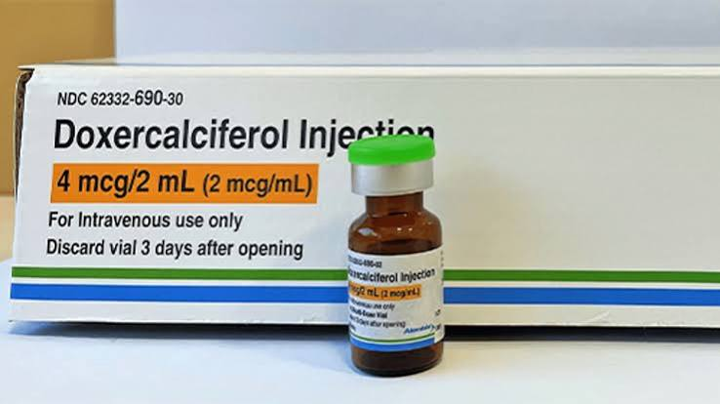  Doxercalciferol Injection 4 mcg/2 mL
Image sources:
Metronidazole — WG Critical Care | Clindamycin — McGuff Medical | Belladonna/Opium — GoodRx
Lidocaine — McGuff Medical | Doxercalciferol — Drug Store News
Tech Stack
Python (pandas, duckdb) · DuckDB · SQL · Power BI Desktop
Limitations & Next Steps
- Demand data currently comes from the free 100-patient MIMIC-IV demo. Full credentialed access (364,627 patients) is pending through PhysioNet — the pipeline swaps in with zero code changes once granted.
- Rankings may shift once demand is calculated from the full patient population instead of the 100-patient sample.

Technical Appendix
A. NDC Normalization
Converts a dashed openFDA package NDC (any of the three real segment layouts) to the standard 11-digit form by zero-padding the correct segment.
def normalize_dashed_ndc(package_ndc: str):
"""
Convert a DASHED openFDA package_ndc (4-4-2, 5-3-2, or 5-4-1)
to the standard 11-digit (5-4-2) form by zero-padding whichever
segment is short -- using the real segment boundaries from the
dashes, not a naive whole-string pad (only correct for 4-4-2).
"""
if not package_ndc:
return None
parts = package_ndc.strip().split("-")
if len(parts) != 3:
return None
labeler, product, pkg = parts
if not (labeler.isdigit() and product.isdigit() and pkg.isdigit()):
return None
labeler = labeler.zfill(5)
product = product.zfill(4)
pkg = pkg.zfill(2)
return labeler + product + pkg

B. Composite Risk Score
Derives safety stock, reorder point, and the final composite risk score once demand, seasonal, and supply-status data are joined for a drug.
z = norm_ppf(d["service_level"])
d_avg, d_std = d["avg_weekly_demand_units"], d["demand_std_units"]
lt_avg, lt_std = d["lead_time_weeks"], d["lead_time_std_weeks"]

base_ss = z * math.sqrt(lt_avg * d_std**2 + d_avg**2 * lt_std**2)
base_rop = d_avg * lt_avg + base_ss

seasonal_amp = (1.0 + seasonal_cv) if (network and seasonal_cv is not None) else 1.0
supply = SUPPLY_RISK_PARAMS.get(shortage_status, DEFAULT_SUPPLY_RISK)

d_std_eff = d_std * seasonal_amp
lt_avg_eff = lt_avg * supply["lt_mean_mult"]
lt_std_eff = lt_std * supply["lt_std_mult"]

vol_ss = z * math.sqrt(lt_avg_eff * d_std_eff**2 + d_avg**2 * lt_std_eff**2)
vol_rop = d_avg * lt_avg_eff + vol_ss

ss_inflation_norm = min(max((vol_ss / base_ss - 1.0) if base_ss > 0 else 0.0, 0.0), 1.0)
seasonal_norm = min(max(seasonal_amp - 1.0, 0.0), 1.0)
composite = 100.0 * (0.45 * supply["risk_component"]
+ 0.30 * seasonal_norm
+ 0.25 * ss_inflation_norm)

