AI Adoption in Developing Countries: Lessons from the Adoption of other Advanced Digital

Technologies

Xavier Cirera¹, Diego Comin², Marcio Cruz¹, and Kyungmin Lee¹ ¹The World Bank

²Dartmouth College July 31, 2026

Abstract
This paper examines how firms in developing countries adopt and productively use ar-tificial intelligence (AI) based technologies. It draws on evidence from the FAT (Firm Adoption of Technology) survey on the diffusion of earlier advanced digital technolo-gies, which covers more than 20,000 firms across countries at different income levels, together with new evidence on AI adoption among firms in Romania. The cross-country evidence shows that advanced digital technologies diffuse more slowly and are used less intensively in lower-income countries, with intensive use more strongly asso-ciated with productivity than adoption alone. The evidence from Romania shows that AI adoption remains limited and concentrated among larger, more productive, better-managed, and technologically advanced firms, providing little evidence of technological leapfrogging. AI adoption is associated primarily with worker reassignment rather than displacement or net employment reduction. The findings highlight the need to narrow the dual gap—adoption and use—with measures that support building complementary digital, managerial, organizational, and workforce capabilities to accelerate the diffu-sion of AI technologies. Not addressing these gaps will prevent developing countries from capturing the anticipated productivity gains from AI.
∗

What we know about the diffusion of technologies in developing countries and the technology gap
The potential benefits from AI described in the previous section are conditional to the suc-cessful adoption of AI based technologies. However, the adoption and use of advanced tech-nologies in developing countries is lagging significantly compared to high income countries. Specifically:

The diffusion of digital technology in developing countries

The speed of diffusion of digital technologies in developing coun-tries is slower than in higher income countries
There are long adoption lags for advanced digital technologies, especially in low-income countries. Adoption of off-the-shelf digital technologies is lower and slower in low income countries, and these are mature technologies with a reasonable availability of suppliers to support diffusion, even in low income countries. The diffusion gap is most significant for ERP where less than 10% of firms in low income countries have adopted this technology (Figure 2).

⁴See Cirera et al. (2026) for the details of the survey design and method.
Figure 2: Diffusion Curve by Income Group
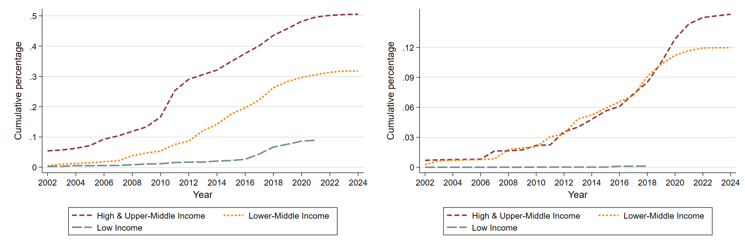
(a) ERP (b) SRM
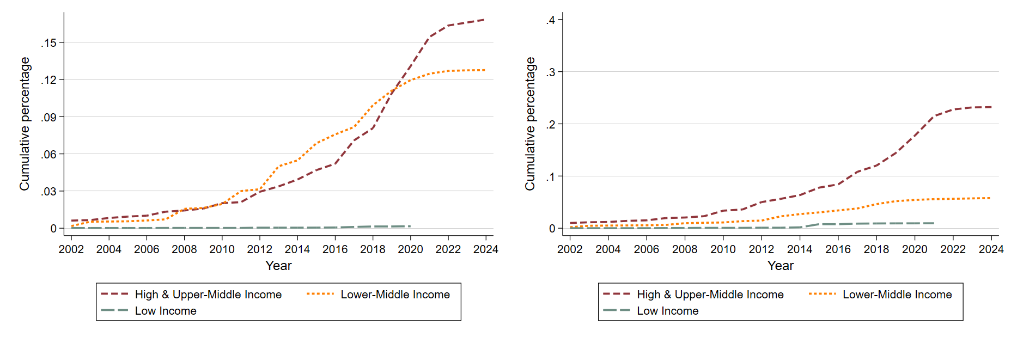
(c) CRM (d) Advanced Quality Control
Note: This figure shows the diffusion of advanced technologies—Enterprise Resource Planning (ERP), Supplier Relationship Management (SRM), Customer Relationship Management (CRM), and Advanced Quality Control (AQC)—by country income groups. The X-axis indicates the years of adoption of advanced technology while the y-axis presents the cumulative share of firms that had adopted the technology by each year. All estimates are weighted using sampling weights.

While slow diffusion is the result of different factors, Cruz et al. (2024) suggests that digital technologies are disproportionately expensive in developing countries. Examining item-level price data from the International Comparison Program (ICP) to identify digi-tal versus nondigital goods in the machinery and equipment and other products categories enables a more detailed understanding of digital goods prices. Figure 3 shows a negative relationship between the price of software and per capita gross domestic product (GDP). A similar picture emerges in panel (b) when using a web scrapping methodology. Although these higher prices are not the only binding constraint, they play a role in slowing diffusion. When thinking about accelerating the adoption of AI technologies in developing countries it is important to ensure that the costs are not much larger than in developed economies. In addition to import costs, country specific costs that can be large. For example, most
standard ERP packages in Cambodia are not translated to Khmer, which increases the costs of using the technology since firms require hiring workers that can manage the software in english.
Figure 3: Correlation cost of software and income per capita
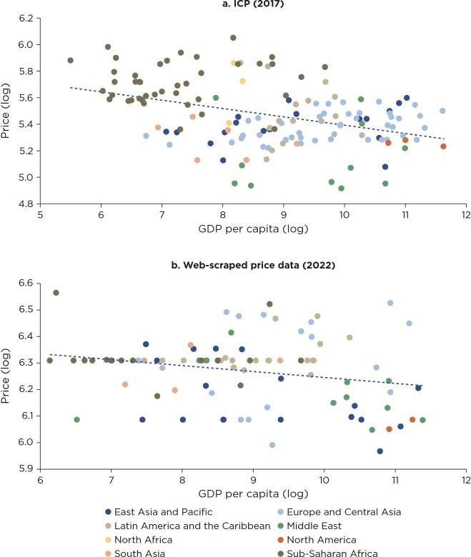
Source: Cruz et al. (2024) Note: Estimates based on 2017 ICP data on software, 2022 web-scraped software price data from Microsoft online store, and World Bank data on GDP per capita for 2017 and 2022. The 2022 web-scraped software price data are obtained for 91 countries, which include 16 in Sub-Saharan Africa. The 2017 ICP software price data are obtained for 147 countries, which include 42 Sub-Saharan African countries. Prices are in US dollars at market prices. GDP = gross domestic product; ICP = International Comparison Program; IFC = International Finance Corporation.

Intensive use of advanced digital technology

In addition to slow diffusion, a key technology gap relates to the lack of intensive use of advanced digital technologies
The technology more intensively used in a business function is not necessarily the most sophisticated technology that has been adopted. Even in cases where firms have incurred in the costs of investing in these technologies, they are often underutilized. These gaps between adoption and use - MAX-MOST gaps (Cirera et al., 2026) - are persistent and strongly associated with productivity both across establishments and countries. Figure 4, Figure 5 and Figure 6 show graphically these gaps by income region and for four different business functions. The first bar represents the gap to access to digital infrastructure - connection to internet and having computers - and it is almost universal for high-income and upper middle incomes, but with significant gaps in low income countries. The second bar show the gap in adoption of advanced digital technologies, which increases at lower income per capita. The third and final bar is the gap in use of advanced digital technologies that have been already adopted. In some cases, this gap in intensive use of firms that have adopted and incurred some of the costs of adoption can be significant. Adoption does not ensure that firms use advanced technologies productively.

Figure 4: Digitalization Gap in Core General Business Functions, High and Upper-Middle Income Countries
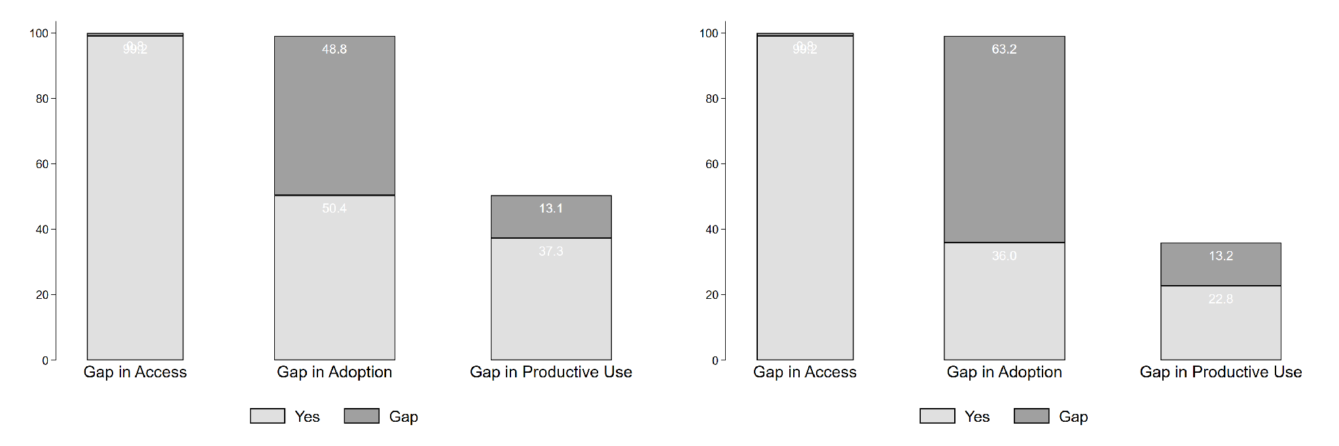
    - Business Administration (b) Production Planning
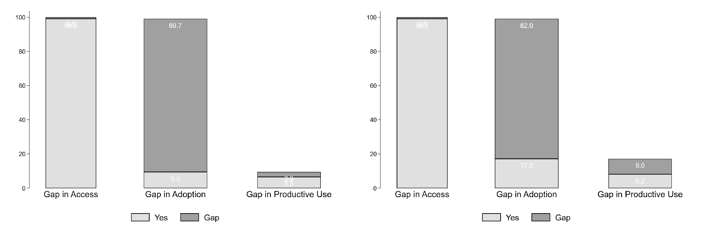
(c) Supply Chain Management (d) Quality Control
Note: This figure shows the share of firms with access to basic digital technologies, those adopting advanced digital technologies, and those intensively using advanced digital technologies across four core business functions in high-income and upper-middle-income countries. The four core general business functions include Business Administration, Production Planning, Supply Chain Management, and Quality Control Inspection. All estimates are weighted using sampling weights.

Figure 5: Digitalization Gap in Core General Business Functions, Lower-Middle Income Countries
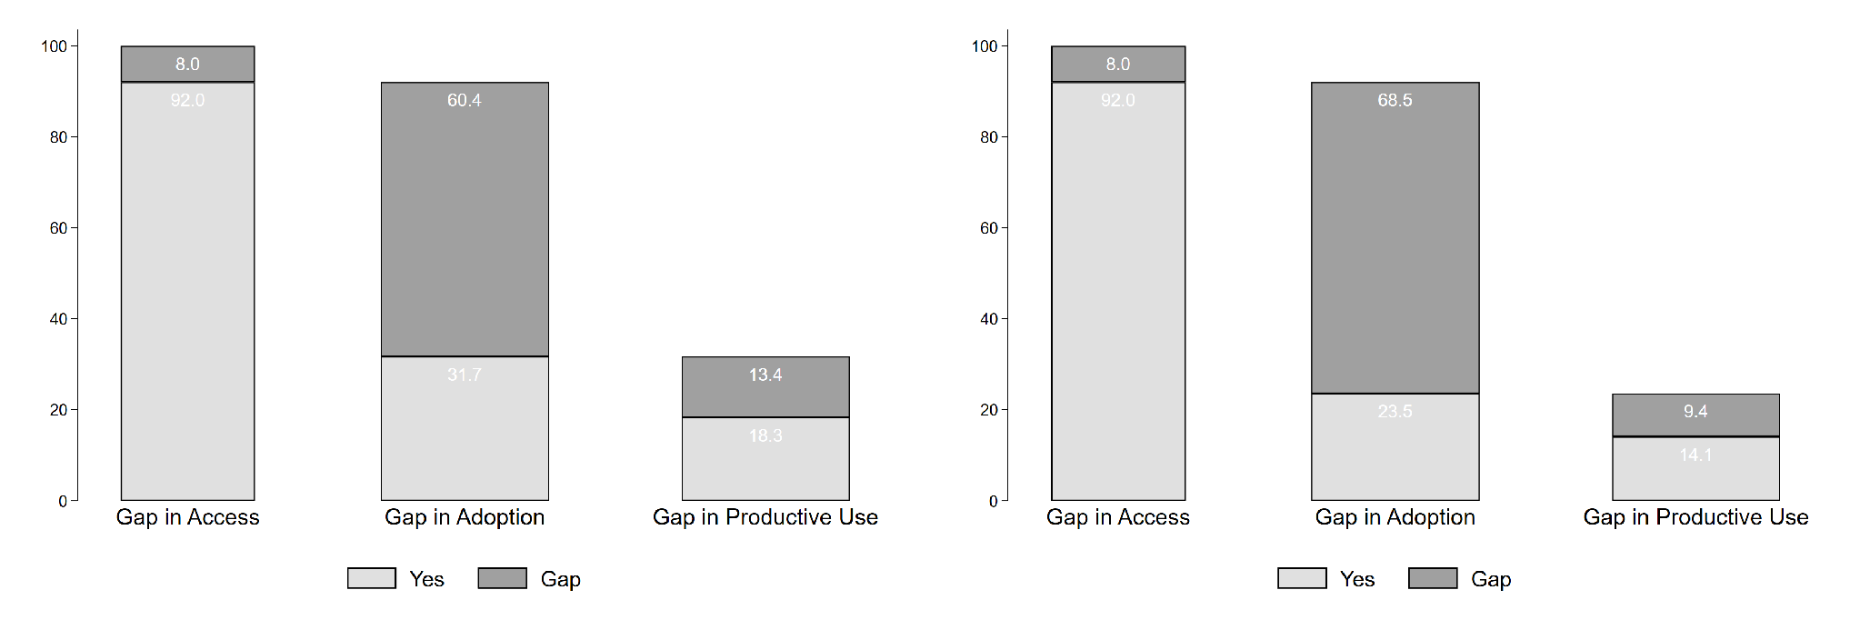
(a) Business Administration (b) Production Planning
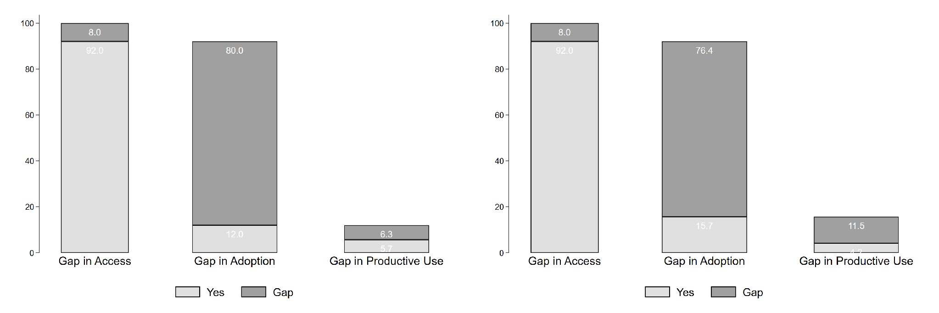
(c) Supply Chain Management (d) Quality Control
Note: This figure shows the share of firms with access to basic digital technologies, those adopting advanced digital technologies, and those intensively using advanced digital technologies across four core business functions in lower-middle income countries. The four core general business functions include Business Administration, Production Planning, Supply Chain Management, and Quality Control Inspection. All estimates are weighted using sampling weights.
Figure 6: Digitalization Gap in Core General Business Functions, Low Income Countries
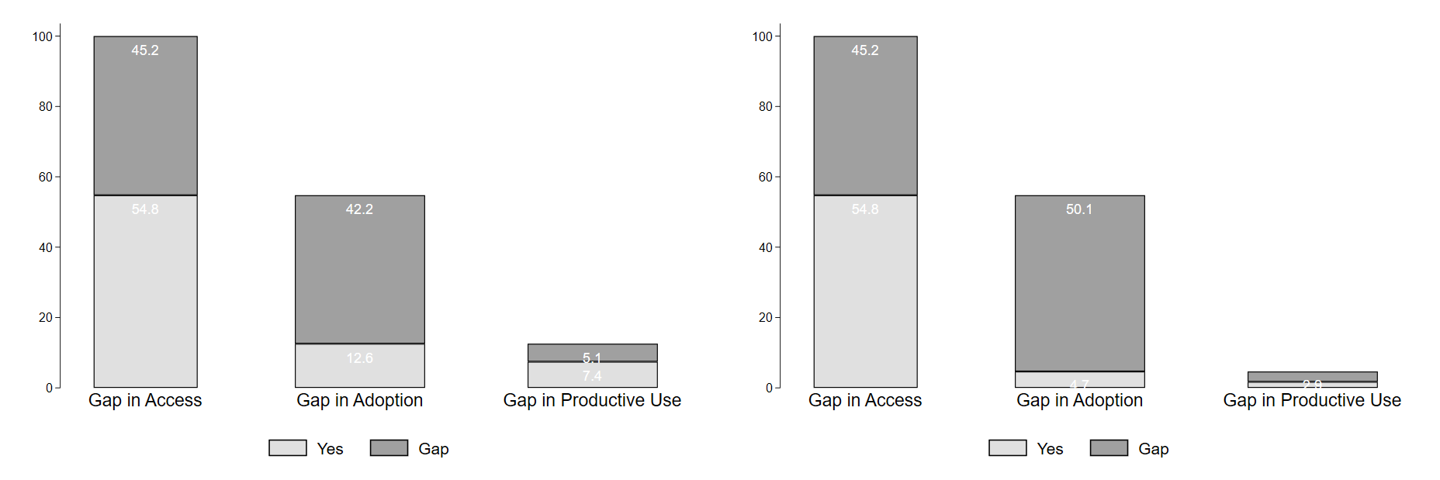
(a) Business Administration (b) Production Planning
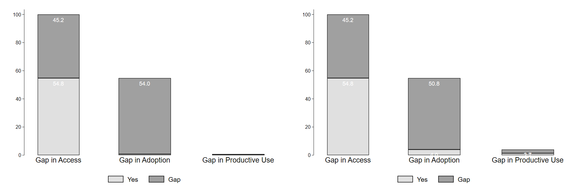
(c) Supply Chain Management (d) Quality Control
Note: This figure shows the share of firms with access to basic digital technologies, those adopting advanced digital technologies, and those intensively using advanced digital technologies across four core business functions in low-income countries. The four core general business functions include Business Administration, Production Planning, Supply Chain Management, and Quality Control Inspection. All estimates are weighted using sampling weights.

