

Automatic Ticket Assignment

Interim Report

# Team Details

|  |  |
| --- | --- |
| Anand Sethurathinam KamalRaj M Praveen Galav Priya Rama G Vaibhav Kulkarni Vinayak Gokuldas Kudva | [anand.sethurathinam@gmail.com](mailto:anand.sethurathinam@gmail.com)  [kamalraj.m@gmail.com](mailto:kamalraj.m@gmail.com)  [pgalav@gmail.com](mailto:pgalav@gmail.com)  [ancpriya73@gmail.com](mailto:ancpriya73@gmail.com)  [ramag80@gmail.com](mailto:ramag80@gmail.com)  [vaibhavkulkarni9@gmail.com](mailto:vaibhavkulkarni9@gmail.com)  [vinayak.kudva@gmail.com](mailto:vinayak.kudva@gmail.com) |

# Index

Team Details 2

Index 3

Summary of the problem statement, Data and findings 4

Problem Statement 4

Data & Findings 4

Summary of the approach to EDA and Pre-Processing 5

Visualization 5

Word Cloud 5

Charts 5

Decide Model and Model building 6

Model performance - Approaches to improve model 7

Code Snippet 8

Finalized results 9

Link to code and references 10

# Summary of the problem statement, Data and findings

## Problem Statement

Manual assignment of incidents is time consuming and requires human efforts. There may be mistakes due to human errors and resource consumption is carried out ineffectively because of the misaddressing. On the other hand, manual assignment increases the response and resolution times which result in user satisfaction deterioration / poor customer service.

## Abstract

Applying traditional machine learning and neural network-based NLP to automatically classify tickets and assign them to the right owner in a timely manner to save effort, increase user satisfaction and improve throughput in the ticketing pipeline of an organization.

## Data & Findings

### Data provided in format

CSV

### Total Records

8500

### Data Fields

|  |  |
| --- | --- |
| Short description | A summary of the issue faced by the user |
| Description | Detailed description of the issue |
| Assignment group | GRP_0 ~ GRP_73 (total 74 classes of Assignment group) |

### Sample data

| **Short description** | **Description** | **Assignment group** |
| --- | --- | --- |
| login issue | -verified user details.(employee# & manager na... | GRP_0 |
| outlook | \r\n\r\nreceived from: hmjdrvpb.komuaywn@gmail... | GRP_0 |
| cant log in to vpn | \r\n\r\nreceived from: eylqgodm.ybqkwiam@gmail... | GRP_0 |

### Distribution of classes

1. High imbalance seen in data with GRP_0 having <TODO> percent of representation
2. Many classes with very little representation. Percentage representation <TODO>
3. Null values:

Short description 8

Description 1

Assignment group 0

1. Observed certain Short descriptions are same as Description
2. Observed almost <TODO> percentage of Non-English ticket descriptions

# Summary of the approach to EDA and Pre-Processing

### Cleaning processes applied

1. Removal of trailing spaces
2. Removal of line breaks and tabs (\r\n\t)
3. Removal of special characters
4. Removal of extra spaces
5. Missing value imputation: NLP keyword extraction with Rake < TODO >

## Visualization

### Word Association

### Collapsible tree

## Word Cloud of entire data and top 3 categories

### Entire Data

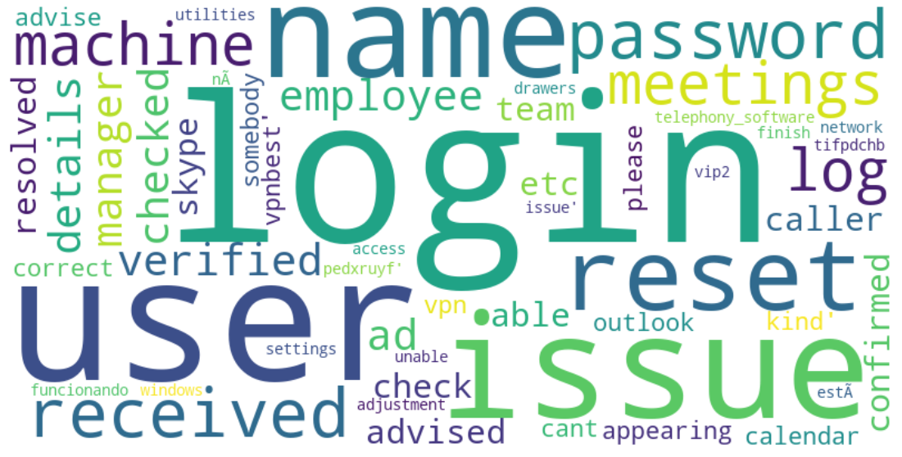

## Charts

### Bokeh

### Barchart

# Decide Model and Model building

Conventional, NLP, Valid reason to use

# Model performance - Approaches to improve model

# Code Snippet

# Finalized results

# Link to code and references