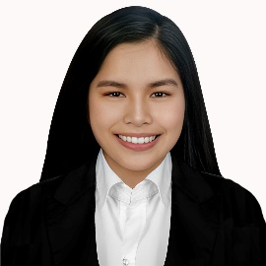

**Glaiza Lei San Jose**

Blk1 Lot 15 Casa Amaya South Tanza, Cavite

09662408597

[glaizaleis@gmail.com](mailto:glaizaleis@gmail.com)

**Objective**

To gain experience as a working student, I pledge to be good, trustworthy, and responsible in order to further improve my abilities in different aspects and enhance my skills in order to show my capabilities.

**Personal Information**

Gender : Female

Birthday : February 19, 2003

Birthplace : Makati City

Religion : Roman Catholic

Citizenship : Filipino

**Education**

2021 – Current Cavite State University-CCAT Campus Tanza, Cavite

2019 - 2021 Olivarez College (STEM-Strand) Parañaque City

2015 - 2019 La Huerta National High School Parañaque City

2009-2015 La Huerta National High School Parañaque City

**Related Skills**

* Capable of work in a challenging and busy environment
* Outstanding oral and written communication skills
* Fast Learner
* Great multitasked
* Fix-it attitude

**Reference**

Peter Kelly Estrada Philippine Navy 09751759067 Tanza,Cavite

Mark Edrian Yumol Engineering Aide 09109019904 Talavera, Nueva Ecija

Christel Cayao Agricultural Technologist 09058936819 Indang Cavite

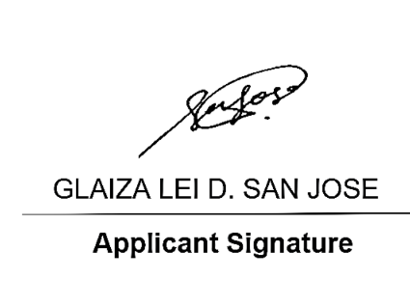

*I hereby declare that all the above information is correct and accurate. I solemnly declare that all the information furnished in this document is free of errors to the best of my knowledge.*