1. Go to <http://www.oracle.com/technetwork/java/javase/downloads/jre8-downloads-2133155.html>
2. Download JRE

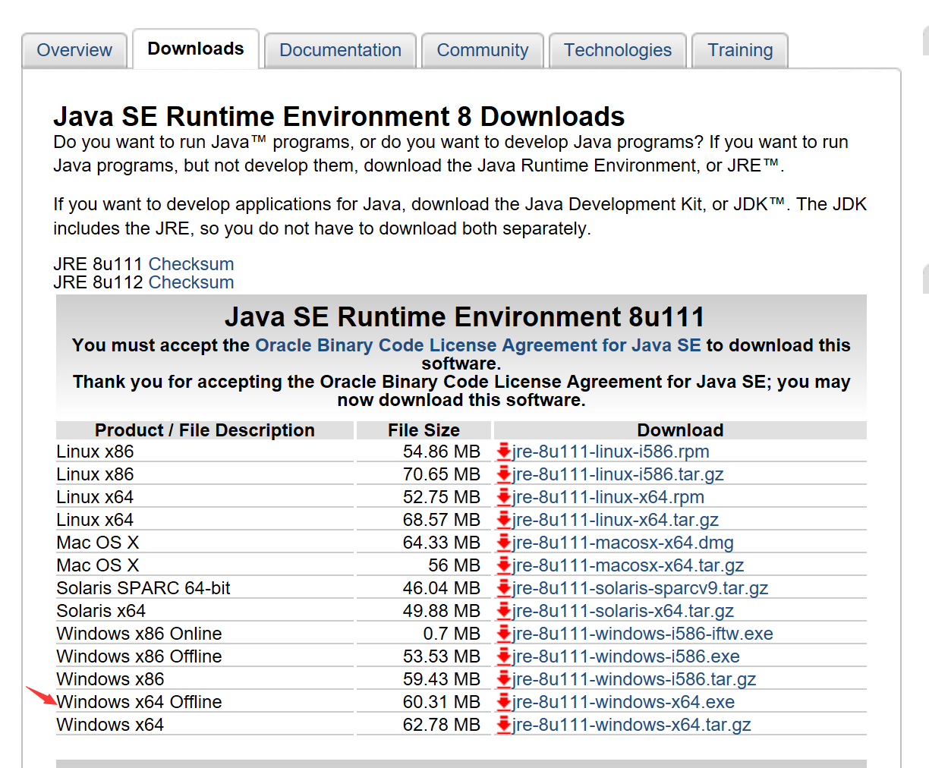

1. Install JRE

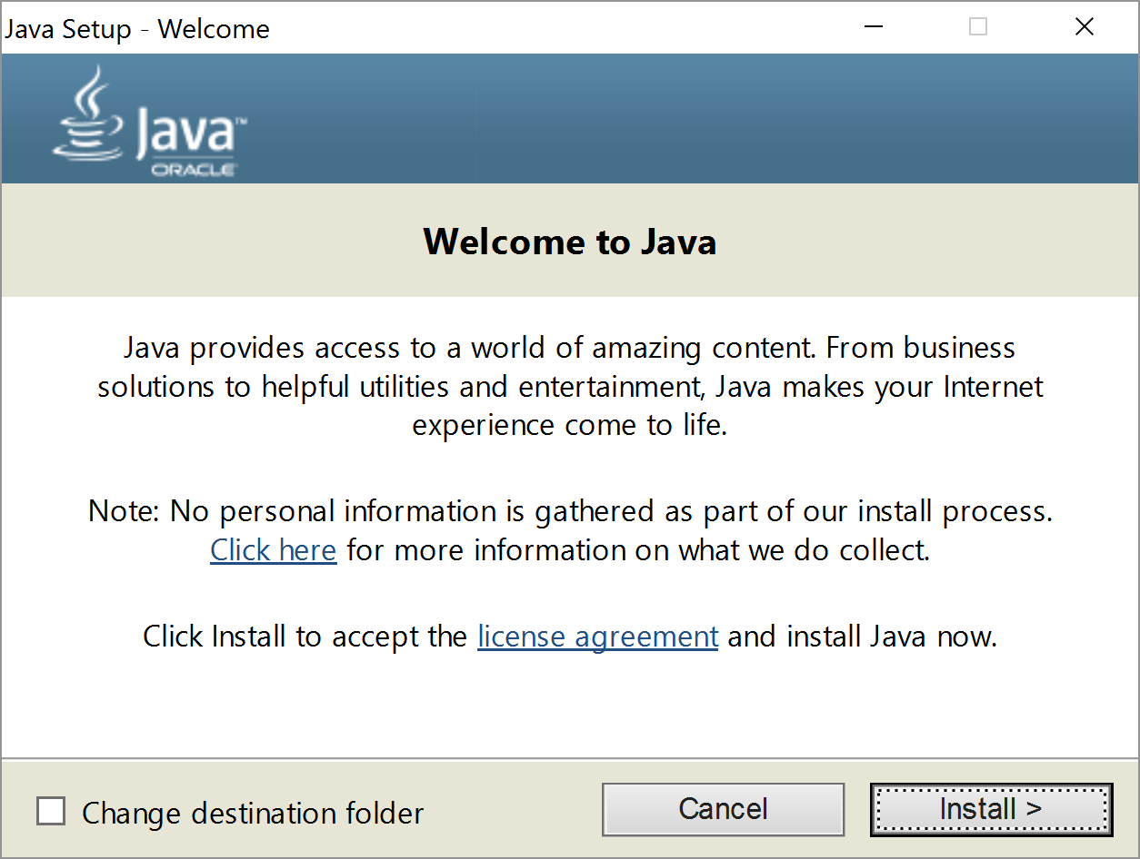.

1. Set up environment variables

Follow this video <https://www.youtube.com/watch?v=Hl-zzrqQoSE>

1. Double click this file

