
Xiaokang Zhou is currently pursuing the M.S. degree with the College of Electronics and Information Engineering, Sichuan University, Chengdu, China. His research interests include unsupervised domain adaptation and its applications in computer vision and pattern recognition.

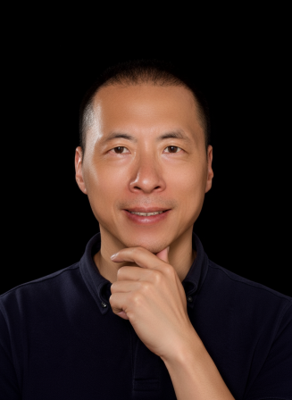
Hua Yan received the B.S. degree in Automation, the M.S. degree in Radio Electronics, and the Ph.D. degree in Mechanical Automation from Sichuan University in 1993, 1996, and 2008, respectively. Currently, he is a professor with the College of Electronics and Information Engineering at Sichuan University. His research interests include pattern recognition and intelligent system.

