Tree Implementation

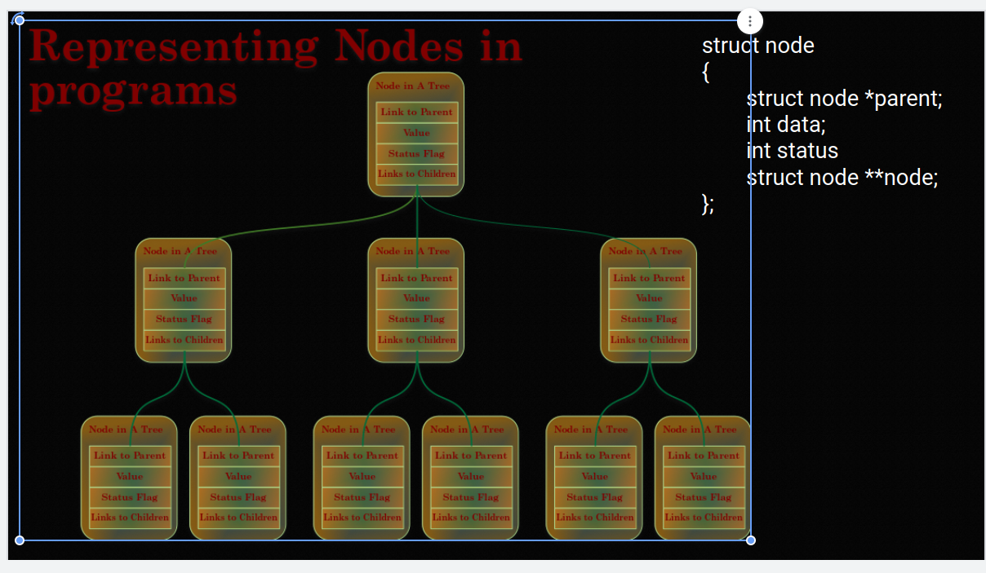

* Tree is a non-linear data structures and can be stored in different ways.
- Storing tree into an 1-D array is kind of storing a non-linear structure into a linear data structure. Generally used in Network drivers or programming.
- Tree can be stored in an 2-D array.
- Tree can be stored in a priority queue.
- Tree can be implemented in the form of linked lists as well.

Tree Implementaiton as in 1-D array
Storing a binary tree in a 1-D array is a good example to start with.

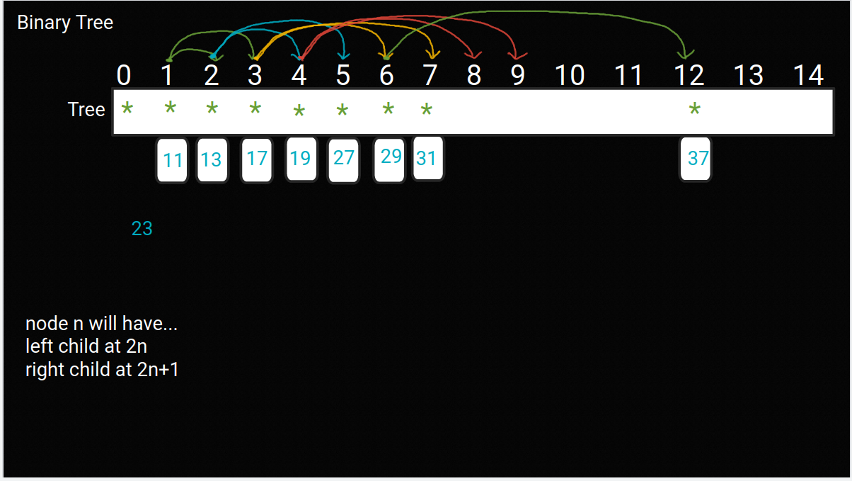

During the insert mode operation, first we will expand the tree then we will put value into it.

Tree will be a double pointer as it is storing the address of the node and using its address for further manipulation.

