February 2013

Race Information V1
Welcome to Glasgow Tri Club’s event:

The Bishopbriggs Tristars, Novice and Sprint Triathlon

Situated on the outskirts of North Glasgow, the “Leisuredrome” complex is a modern multi-sport facility on the banks of the Forth and Clyde canal. The Leisuredrome offers a modern 6-lane pool, access to a closed road bike loop and an off road run course.
We have significantly altered the event timing structure from 2010 to make it possible for, in particular, the Sprint competitors to arrive, register and rack much closer to the time of their race.

Finding the Leisuredrome
The Leisuredrome (Bishopbriggs Swimming Pool) is situated to the north of Glasgow in the suburb of Bishopbriggs, just off the main Kirkintilloch Road, on Hilton Road.

Directions:
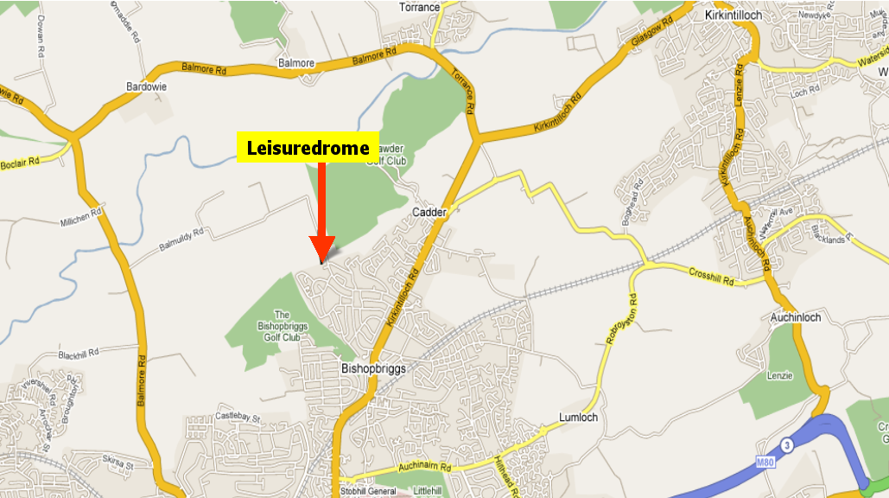

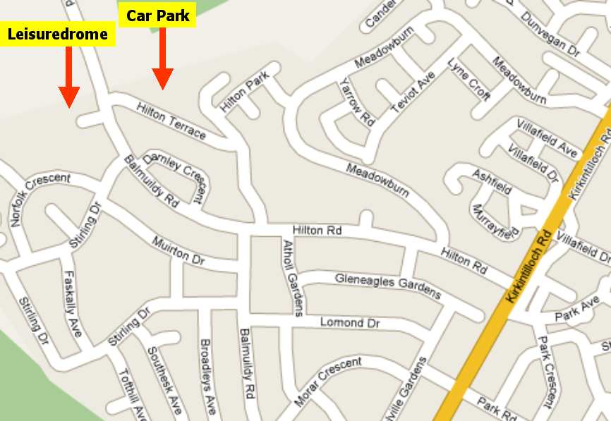

From the East (M8)
Follow the M8 to the Townhead junction (Junction 15: Take the white left hand “Kirkintilloch” slip road and turn right at the traffic lights back under the motorway. Turn left at the next traffic lights, and cross above the Springburn Road (A803). Turn immediately right to join the slip Road onto the dual carriageway (Springburn Road (A803).

From the West (M8)
At junction 15 (Townhead) take the left hand slip road which leads directly onto the Springburn Road (A803).

Follow this road (A803) for approximately 3 miles through Springburn, following signs for Kirkintilloch until you’ve passed through Bishopbriggs Town Center. Leaving Bishopbriggs Town Center the road raises though a set of traffic lights and then swings to the right past Allen Glens rugby pitches. At the third set of traffic lights turn left into Hilton Road, with the Eagle Lodge on the corner. If you reach ASDA you’ve gone too far). Follow the Hilton Road until Hilton Terrace on the right (sign-posted “carpark”) – the leisure center carpark will be closed for transition and a temporary carpark created on the adjacent all-weather football pitch.

From the North (M80)
Coming from Stirling (M80) or Falkirk (M876), leave the M80 at the last exit before it becomes the A80, (Banknock). Turn right onto the Kilsyth Road, passing through Kilsyth, Queenzieburn, and Kirkintillock. On leaving Kirkintilloch, pass the Rob Roy Football Club and the Stables Inn go straight on at the next two roundabouts, the second one being the entrance to a retail outlet. After a further 1km you will pass ASDA on the left. At the next set of traffic lights turn right past the Eagle Lodge into Hilton Road. Follow the Hilton Road until Hilton Terrace on the right (sign-posted “carpark”) – the leisure center carpark will be closed for transition and a temporary carpark created on the adjacent all-weather football pitch
.

Parking
Shortly before reaching the Leisuredrome on Hilton Road, you will be directed into a side road (Hilton Avenue) which will lead round to a temporary carpark on an all weather football pitch. NO parking will be allowed in the leisure centre as this is part of the Cycle Course.

Race Rules
You are recommended to familiarise yourself with the triathlonscotland rules and regulations since these will be applied to this race. You may be penalised for infringements and ignorance is no defence. The rules can be obtained from:
http://www.triathlonscotland.org/downloads/Rules.pdf

All athletes must produce their Race Licenses at Registration. If you forget your License or have not paid the TS day licence levy with your application – you will need to pay a surcharge of £5.00 at registration!

Probable Registration Plan – Sunday 5th May

Heats 1-5 10.30 – 11.30am

Heats 6 – 11 11.30 to 1.30pm
A split registration is planned to minimise the waiting associated with pool based swims and albeit if you are in a later heat you can register early, priority will be given to the early heat competitors.
Race licences must be produced. Please plan to leave yourselves plenty of time to complete the process and prepare yourself adequately for the race start.

Transition Area Opening Times

Heats 1-5 10.30 – 11.40am

Heats 6 – 11 10.30 to 2.00pm

Transition will be situated in the Leisuredrome car park. Bikes must be racked before the relevant section of transition closes. Only competitors will be allowed into the Transition Area and you will be asked to provide your race number for verification of status. Your approved helmet must be with your bike when you rack it. Slots will not be pre-numbered but the Bike Row’s will relate to your Wave Number - please rack anywhere in your designated wave row. Due to the relatively narrow space available to each competitor (1.1metres/competitor incl. bike) we will encourage a local “no large boxes or bags rule” to avoid your kit interfering with other competitors.

We are operating a rolling-transition to allow the event to be in progress while other competitors, scheduled in a later heat, complete their set up.

Please listen & adhere to the Transition Marshall’s’ instructions!

All competitors are reminded that it is their responsibility to ensure their bike is in a roadworthy condition.

Race Numbers
You will be issued with one body number & one helmet number. The body number must be clearly visible on your front for the run section of the race. Please bring your own pins.
Elastic number belts are permitted (number to the back on the bike).

Timing Chip
You will be issued with your timing chip on the day of the race. Please affix it securely to your ankle. No chip - no split time results. If you need to withdraw from the race - please make sure you hand your chip to the Finish Marshal. Failure to return a chip will result in a £20 replacement fee.

Race Briefing
There will be a thorough race briefing in the main Sports Hall the following times:

Heats 1 to 5 11.45am
Heats 6 – 11 13.45pm

You must attend this briefing since we will deliver any last minute course information and answer any final questions.

Race Starts:
It is estimated that the events will start at the following times:
Tristar 2/3 (Heat 1) at Noon
Youth/Novice (Heats 2/3/4) from 12.15pm

Sprint (Heats 5-11) from 13.20pm
Times are approximate, there may be less heats on the day and it is the responsibility of the competitor to be poolside on time.

Course Reconnaissance
The bike loop will be closed to cars from 11.30am. Competitors may cycle the route before this time but be aware of occasional fast moving traffic. No coaches are permitted on the course during the race. Sprint racers in particular should be aware that if reconnoitring the course, other competitors are in race mode. Please give them space!

SWIM COURSE – up to 750metres
The leisure centre has a modern 6 lane, 25m pool. The swim will follow the standard pool format with heats seeded according to the submitted estimated time, with the slowest swimmers taking to the water first.
Passing is only permitted at the end of the length and a desire to pass signaled by a solid tap on the competitors feet in front.
On completing the appropriate swim distance for the event, competitors will exit the pool by the fire exit and enter transition.
Distances:
Tristar 2 - 200m (8 lengths)
Tristar 3 - 300m (12 lengths)
Youth event - 400m (16 lengths)
Novice event - 400m (16 lengths)
Sprint event - 750m (30 lengths)
Lane counters will be provided but it is the competitor’s responsibility to count their lengths.

TRANSITION:
Helmets must be fastened before the bike is moved from its rack and remain fastened until after the bike is racked at the end of the bike (time penalty!!). Bikes may not be mounted or ridden within the transition area, and only once the competitor has crossed the mount line at transition exit

BIKE COURSE – up to 20Km

The bike course is a 5Km closed road loop which runs out and back along the Balmuidy Road.

All riders must wear BSI, ANSI or SNELL approved hard shell helmets will be compulsory and must be worn throughout the cycle section. They must be fastened prior to mounting your cycle and neither undone nor removed until your bike is racked.

This event is a non-drafting race for all categories. No rider is to ride within five bike lengths (7 metres) of the rider in front – unless completing an overtaking manoeuvre.
Please see the triathlonscotland web site for our Drafting Rules.
http://www.tri-scotland.org/
The rules will be enforced throughout the race.

The roads will be free of traffic but riders must still ride to the rules of the road and obey the Highway Code at all times. Our Marshall’s will direct or hold up any traffic requiring access to the course – to give you a clear passage throughout the race. Emergency vehicles have full right of way.

On mounting your bike you will turn left right left to exit the Leisure Centre car park and the loop proper starts with a gentle climb up the hill. There is a sharp left hand bend followed by a straight, an “s-shaped” kink and then a second straight before a sharp right hand then left hand corner. The distant turn point is at the entrance of the Whiteinch Works, which is rounded clockwise, and the course retraced. The “home” turn point this year will be on the main road and entrance into the car park will only be to exit and enter transition.
Bike distances:
Tristar 2/3 event - 1 lap
Youth/Novice event - 2 laps
Sprint event - 4 laps

Cyclists will be disqualified if they cross the mid-line of the road, especially on the sharp corners, as you will pose a danger to oncoming cyclists. Marshall’s (and Video) will be posted to observe compliance and also to scrutinize for drafting. The turn points at either end of the course are rounded clockwise.

Once the bike course has been completed, cyclists re-enter transition to rack their bike. Cyclists must dismount before re-entering transition at the marked dismount line. The bike must be racked in the slot from which it was first removed.

RUN ROUTE – up to 5Km

The run is an off road loop along the banks of the Forth and Clyde canal, finishing back at the Leisuredrome.
There will be a drinks station at the bridge over the canal. The path is shared with the general Public so competitors are advised to keep a close watch for pedestrians and “loose” animals.

Distances:
Tristar 2/ 3 event - 2 km
Youth/Novice event - 3 km
Sprint event - 5 km

Medical Advice
If you have any known medical condition (such as diabetes, asthma, allergy to penicillin, etc.) please inform us prior to the race by letter or e-mail. Please write all medical details on the back of your race number and put a small indelible red cross on the front of your number. Whether you have a medical condition or not, if you feel unwell on race day – don’t race.

AFTER THE RACE
Shower and change in the Leisure Center. Food and Hot Drinks are available in the Leisure Centre.

Prize Giving
The prize giving will follow the events as soon as the results emerge from the timing system. This will be held either at the front of the leisure center or inside depending on the weather.

Results
A complete set of results will not be provided to competitors on the day, but a provisional list will be posted and will be available the next day on:
www.glasgowtriathlonclub.co.uk. If you have a query over any results please inform us immediately on the day in writing by passing a note onto Club Officials in the transition area.

Map of transition

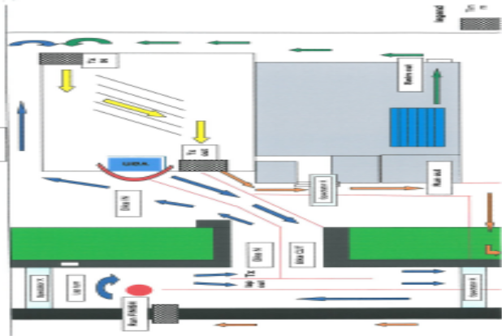

Bike route
