VERSION 3 – April 2014

Welcome to the Race Briefing for the:
2014 Strathclyde Standard Triathlon.

Situated between Motherwell and Hamilton the Park is highly accessible to Glasgow, The Trossacks and Highlands of Scotland, with the beautiful Borders Country only a short drive to the south. The race will be entirely contained within the Park with the roads being partially closed to traffic throughout the duration of the race.

Finding Strathclyde Park
It is very easy! The Park is signposted from the M74 and the race venue is just a couple of minutes drive from the motorway Junction 6. We ask you to use Exit 6 from the M74 since the access road from Exit 5 will be subject to restrictions. Leave the Motorway in the direction of Motherwell; take a left at the first junction and first left again to the parking area, which is a short drive past the Water Sports Centre – our Race Headquarters.

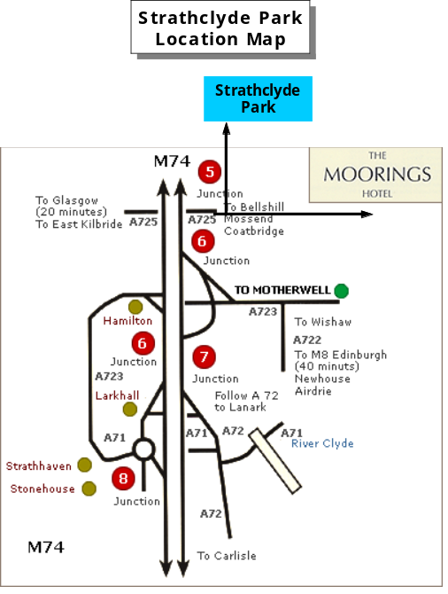

Accommodation
There are three Hotels, a Theme Park and a Caravan/Camping site on the Park:
http://www.northlan.gov.uk/leisure+and+tourism/visitor+information/accommodation/strathclyde+park++camping+and+caravan+site.html

The Alona Hotel: www.alonahotel.co.uk

And:
http://www.scotlandsthemepark.com/park/index.php

Parking
Shortly after entering the Park you will be directed to a parking area. If you choose to park in the area situated 200 metres beyond the Water Sports Centre, bear in mind you will have to exit North-wards along the side of the Loch toward Junction 5 of the M74. For a swift departure, you should park on the surfaced area available to your left immediately you turn off the main park road toward the Sports Centre. NO parking will be allowed on the access roads since these are part of the Cycle Course.

Race Rules
You are recommended to familiarise yourself with the triathlonscotland rules and regulations since these will be applied to this race. You may be penalised for infringements and ignorance is no defence. The rules can be obtained from www.tri-scotland.org

All athletes must produce their triathlonscotland or BTF Race Licenses at Registration. If you forget your License or have not paid the TS day licence levy with your application – you will need to pay a surcharge of £5.00 at registration!

Registration

Saturday 4.00pm to 6.00pm
We will be able to providing a Registration service on Saturday Afternoon. There is a secure facility to leave bikes overnight if you wish.

Competitors competing in the Scottish Standard Championships MUST use their triathlonscotland membership number to be recognised on the results.

Sunday 6.15am to 7.35am
A full Registration service will be provided. Please plan to leave yourselves plenty of time to complete the process and prepare yourself adequately for the race start.

The Transition Area will be located directly In-Front of the Water Sports Centre

Transition Area Opening Times
6.30am to 7.35am
Bikes should be racked between these times. Only competitors will be allowed into the Transition Area and you will be asked to provide your race number for verification of status. Your approved helmet must be with your bike when you rack it. Slots will be pre-numbered on the racks - please rack in the designated place to avoid confusion.

Transition for all competitors will close at 7.35am promptly. Only competitors will be allowed to enter the Transition area. If challenged by the Transition Marshals - please be prepared to present your race number which must correspond with the number on the bike to be allowed to remove it.

All competitors are reminded that it is their responsibility to ensure their bike is in a roadworthy condition.

Race Numbers
You will be issued with two body numbers and bike/helmet numbers. The body number(s) must be clearly visible on your back for the bike & front for the run section of the race. Please bring your own number belt and/or pins and remember to display the number correctly as above.
You will not be able to remove your bike from Transition after the race without showing your race number to the Transition Marshalls.

Timing Chip
You will only be issued with your timing chip on the morning of the race. Please affix it securely to either of your ankles. No chip - no split time results. If you need to withdraw from the race - please make sure you hand your chip to the Finish Marshal.

Race Briefing
There will be a thorough race briefing in front of the Water Sports Centre/transition at 7.40am for Wave 1 competitors.

You must attend this briefing since we will brief any last minute course information and answer any final questions at this point.

Wave One will start at 8.00am
We will announce the wave configuration no later than 10 days before Race Day on the race website. We expect to operate two waves. The second wave is likely to be released around 9.20am.

Course Reconnaissance
You are not permitted to swim in Strathclyde Loch at any time other between 4.30pm & 5.30pm on Saturday 17th May and at your designated Wave time. The run course will be marked up on Friday afternoon.

SWIM COURSE – 1500mtr

Strathclyde Triathlon Swim Course 2014
There will be a deep-water start from a designated point 50 metres into the Loch. Athletes will not be allowed to enter the water until after the conclusion of the race briefing. 3 - 5 minutes will be available for warm up prior to the start of the race in a designated area.
The swim course is two laps of a clearly marked rectangular course. There will be a lead canoe to ensure the correct route is followed. When you have completed the second lap you will head for the exit ramp and proceed to Transition for the bike section of the race.

All competitors please note: Scotland’s inland waters are not completely safe for swimming. Although risk of disease and serious infection is low, a swimmer may be susceptible to infection through immune suppression – particularly if they are not in good health at the time of swimming.

Be careful entering any open water swim if you are unwell. The Loch may be cold and Triathlon Wetsuits will be compulsory.
You are advised not to consume the Loch water.

Canoes and recovery craft will be on hand to guide you and provide safety cover.
If you get into difficulty – turn on your back and raise one arm; a canoe will then escort you to the bank or one of the safety boats. If you appear to be struggling on the swim or if you have been in the water for a long time - (Maximum 50 minutes) – you may be extracted.

BIKE COURSE – 37.2km

Strathclyde Triathlon Cycle Route 2014

The course is SEVEN LAPS of a 5.35km course.
All riders must wear BSI, ANSI or SNELL approved hard shell helmets will be compulsory and must be worn throughout the cycle section. They must be fastened prior to mounting your cycle and neither undone nor removed until your bike is racked.

This race is designated a non-drafting race for all categories. No rider is to ride within five bike lengths of the rider in front – unless completing an overtaking manoeuvre.
Please see the triathlonscotland web site for our Drafting Rules/Penalties.
http://www.tri-scotland.org/
The rules will be enforced throughout the race.

The roads will be completely free of traffic but riders must still ride to the rules of the road and obey the Highway Code at all times. The direction of travel is on the left hand side of the road. Our Marshall’s will direct or hold up any traffic requiring access to the course to give you a clear passage throughout the race. Emergency vehicles have full right of way.

You will be directed from transition across the rear building car park - leaving the Water Sports Centre in a Southerly direction and joining the main Park road..

Riders cover SIX Bike Laps
You must count your own laps.
You will be directed to turn LEFT out of the Sports Centre Area. At the top junction you turn left onto the Spine Road and maintain a northerly direction, keeping the Loch to your left. Continue to the roundabout, turn right up the hill to the Turn-Point where you will be directed to complete a 360 degree turn. Take care descending the hill back to the round-about! You will retrace your route back to the Water Sports Centre, turn into the car park and swing right at the constructed roundabout. This is ONE full lap. Complete a further FIVE laps (making SIX in all). On finishing your final lap, please turn left immediately after passing the Water Sports building. Dismount at the yellow line and proceed in the direction indicated back into transition to rack your bike in the slot from which you first removed it.

RUN ROUTE – 10km

Strathclyde Triathlon Run Route 2014
The run course is two laps of a 5km route consisting of a run from the Water Sports Centre forecourt out and around the edge of the Loch to the opposite side from the Water Sports Centre, then on to a designated point before turning back to the transition area prior to commencing the second lap at the marked turn point. Keep to the left at all times and watch for runners approaching in the opposite direction. There will be a drinks station at the halfway point.

You’ve now finished the
Strathclyde Standard Triathlon

Medical Advice
If you have any known medical condition (such as diabetes, asthma, allergy to penicillin, etc.) please inform us prior to the race by letter or e-mail. Please write all medical details on the back of your race number and put a small indelible red cross on the front of your number. Whether you have a medical condition or not, if you feel unwell on race day – don’t race.

Prize Giving
Principal prizes will be presented at or about 12.30pm, once the results have been confirmed.
This will take place on the Transition steps.

Catering
You will be issued with a Food Voucher entitling you to a light meal which can be taken in the Water Sports centre Cafe.

Results
On race completion competitors can obtain a time-printout by the Timers’ Van. A complete set of provisional results will be provided by Noon and posted on the Race Website by 3.00pm:
www.glasgowtriathlonclub.co.uk/
If you have a query over any results please inform us immediately by advising one of our Officials in the transition area or directly at the Timing Van situated by the Finish.

Enjoy a safe Journey Home

