A beginner's guide to get your through your first race
I’ve been asked by a number of people to post a short guide for those that are doing their first triathlon, and are feeling a bit nervous. Firstly don’t worry as the number one aim is to have fun and its actually much easier than you think - it will all make sense when you get there!
Triathlon is a VERY friendly and family oriented sport. We've all been there at our first event and know the feeling. If you have any doubts, walk up to another competitor say "Hi, this is my first event" and I have no doubt you will get all the help you need. Even down to scrounging bits of kit. Don't be afraid to ask!
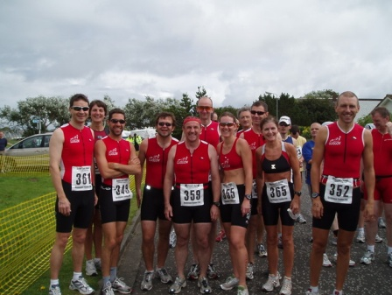
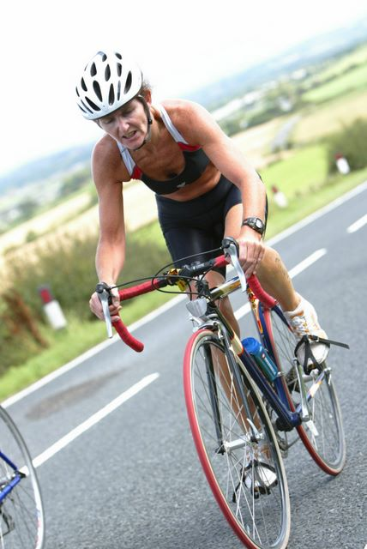
The distance
Briggs is one of the shorter "sprint" events. The swim is pool based, and the bike on closed roads to vehicles so should be safe. The swim is first, followed by the cycle, and finished off with the run. The changeover between each discipline is called a "transition" often referred to as "T1" for the swim to bike changeover, and "T2" for the bike to run changeover.
Bike - shopper, mountain bike, or carbon-fibre speed machine?
Help - I don't have a bike, or only have a mountain bike! Any bike will do as long as it is roadworthy and safe. You will see a whole range of bikes at the race from bikes with baskets on the front to high tech machines worth more than your car. Clearly a mountain bike with knobbly tires will cause you to slow down. The knobbles cause a lot of resistance, as does the width and pressure of the tyre. Note - the organisers may check your bike to see if it is roadworthy so don't ruin your day by not bringing it to the race in a safe condition. Your local bike shop should be able to check it over for you if your mechanic skills are a bit rusty.
What do I wear?
As with all sports, there is specific clothing designed for triathletes for swimming, biking and running without the need to change between disciplines. For a beginner you don't need to go out and buy any extra kit. I would suggest swimming in either speedo-style briefs for the guys, and regular swimsuit for the ladies followed by biking in a pair of shorts over the top and a cycle shirt, T-shirt or vest. Consider taking a warmer layer to the race as well in case it is colder when you change. You can run in the same outfit that you cycled in. Word of caution about cycle shorts - these can be good to swim in unless they have a thick lining such as a chamois insert to sit on. These generally take on water and you will do the rest of the event feeling like you are a toddler in an oversized nappy rather than an athlete! Better in this case to put them on over your swimsuit after the swim and before you ride! No real need to towel off, do your hair and have a full change of clothes after the swim - you will soon dry off on the bike!
On the day!
You are required you to register before you start. Check on the race details you have been sent to see the closing time. You may need to check in some time before your start, so don't leave it too late to arrive. Rushing around last minute will spoil your day. Once you've arrived at the event location, check out two things. One, where registration is; two where the transition area is - if you find registration, they will point you in the direction of transition. Usually you can leave your gear in the car and go and register before setting up your bike and getting your gear together.
There is a briefing before the race starts. If this is your first race this is worth going to. The race director will talk you through the race including transition, any changes to the routes and other important information to be aware of. You will also get a chance to ask any questions. If you're not sure ask!
Setting up your gear in transition
Once you have registered, picked up your numbers, start time etc you can go to transition and set up your bike. Before you go to transition check you have everything for the race - there is a list at the bottom of kit to take into transition. Get your bike out and check it over. Tyres inflated? Wheel bolts done up? In an easy gear to start cycling ? Handle bars straight? Saddle the right height? - In general, nothing moved or damaged in transportation, its better to fix it here and leave your tools and pump behind in the car.
Now take your bike and gear to transition and "set it up". You will not usually be allowed into transition without your number, and you may be required to stick a number on your bike frame for identification so take these with you. It is also worth pinning your number on to your shirt at the car in case you lose your pins on the way! Regarding race numbers - pin it to the FRONT of your t shirt with several safety pins – if you have a race number belt the number should be shown at the back on the bike and front on the run - make sure you can get it on after you've pinned the numbers on, and you haven’t pinned the front of the t-shirt to the back)
Not sure - ask!
Transition will have racks for you to put your bike on. You will have a heat and race number with an allocated space on a rack - this will have your number on it. Firstly hang your bike on the rack - usually by rolling the bike in backwards and hanging the bike by the underside of the saddle, or by going in forwards and hanging the bike on the brake hoods. Not sure - look at what everyone else does! Now set out your kit. Lay this out in the reverse order that you will put in on. This is often personal but I usually put my helmet upside-down on the handlebars with sunglasses etc inside it ready to put on. Next to the bike I put down an old towel, to dry my feet on if they are dirty or wet (nothing quite like running in shoes full of grit!). Shoes are put on the towel with socks on top. Most usually race sprint events with no socks - if you want to wear socks that's fine, it will slow your transition down either in T1 before the cycle, or in T2 before the run. You decide, but practice, your first race is no place to get blisters from old shoes you've never worn without socks! If changing into a dry shirt or any other clothes hang these over the bike frame. You may not have much space so don't spread your kit about too much unless you want it moved by your neighbour. Now mentally rehearse each changeover to ensure you've got all your kit. There is always someone who comes dashing out of the pool to discover that they have left their shoes in the back of the car!
Workout your route through transition
One last thing before you leave your bike! When you set up transition may be fairly empty. When there are 400 bikes in there it's often not easy to find yours! In the middle of a race transition can get a bit hectic! Where do you come from after the swim to get into Transition, once ready where do you go to get out? Now is the time to work this out. If in doubt, ask. If the person you ask isn't sure, ask someone else. Also, find out where the bike mount and dismount points are. You won't be able to ride in and out of the transition area for safety reasons. Find out where you get on your bike and where you get off on your return.
There are some rules about Transition areas. No nakedness - its actually against the rules. No marking your area. This means no flags, no talcum powder on the floor etc. Hence, try to remember where your bike is from the different parts of the transition area. If you put up a marker it will be removed. You can only touch your bike when you are wearing your helmet ( ie put your helmet on before picking up your bike and after the cycle the bike MUST be on the rack before you unfasten your helmet.
All done - now off to the start!
At the poolside
Go the poolside changed and ready to swim at least 10 minutes before your allocated swim start time, which you were given at registration or in your race details. Don't forget your goggles! A coloured swim cap will be given to you at poolside. Watch what is going on - when do people get in, how are they started, where do they go when they get out. Just before your start time you will be shown to the lane you are to swim in. You will usually swim up one side of the lane and down the other. Make a note of which way you have to swim - either clockwise or anti-clockwise. You will be told when to get into the water and when to start .You can usually only get a couple of lengths “warm up” in the water so do some stretching and warm up exercises beforehand. Starting is in sequence depending cap colour at 5 second intervals – e.g. all green caps go off together so even if there is a space in front of you wait until the starting signal for your cap colour .LISTEN for your instructions from the starter. 5-4-3-2-1-GO - your first triathlon has begun! Don't worry about what stroke to swim. The faster athletes will all swim freestyle (front crawl) but breaststroke is common for beginners. Drowning is prohibited so take a rest at the end of a length if your struggling and let people past. You can only pass people in your lane at the end of a length so if you wish to pass TAP the persons ankle deliberately in front as a signal and they will let you past at the end of the length. If your tapped pull to the side at the end of the length and let the person past. Note that you loose time when passing so changing order at the end of each lane isn’t in anyone’s interest. You also use less energy for the same speed swimming in someones wake so drafting behind someone is good as long as theyre not unduely holding you up.
Out of the Swim
Most pool races will have people to count lengths but keep a count yourself. There will usually be someone to signal that you have 2-lengths to go. If you disagree with them don't bother arguing, mistakes do happen and the counter has the last say. This is very rare but don't spoil your swim by starting an argument, just get on with swimming the extra lengths! If its a pool swim you'll be expected to haul yourself out of the pool.
Once out of the water watch as you run to transition (T1), you will be required to leave your swim hat behind in a pool swim, make sure you do. Be careful running indoors not to slip, also watch for any temporary mats as these may also become slippery when wet.
T1
As you run into T1 (the changeover between the swim and the bike), concentrate on what you have to do now. Find your bike, throw you swim goggles down, first shirt/shorts/socks, then shoes, then glasses if you need them and finally helmet. You MUST put your helmet on AND FASTEN IT before moving your bike at all. Now take your bike and head for the exit from T1. There will almost always be a formal mount line, you should have established this prior to the start. Do not ride your bike in transition!
On the road
At all times on the bike section please take the utmost care. Watch what you are doing, where you are going, just because you are in a race is no excuse to take a gamble with the roads and other road users. If you need to drink now is the time to do it rather than wasting time having a picnic in transition. It is better to sip than gulp. Watch for Marshals they are there to help you get around the course safely.
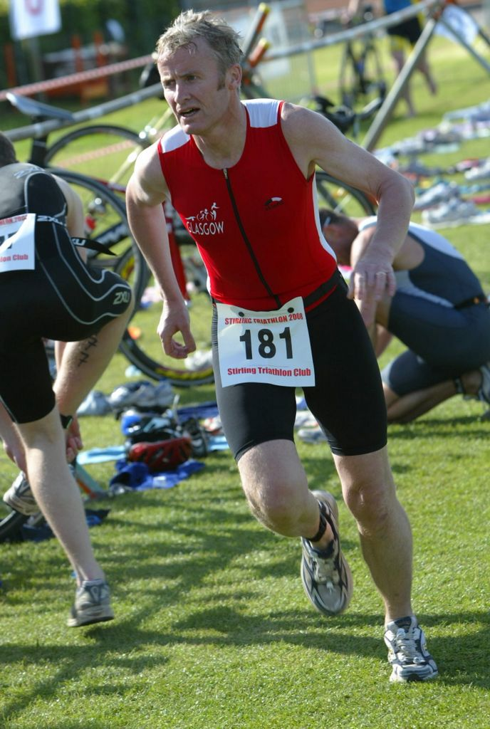
Drafting - the cardinal sin of triathlon!
Another rule that will be new to you in Triathlon is drafting. What? Drafting is basically slipstreaming a fellow competitor to gain advantage from their efforts. In essence, imagine a zone, 3-metres wide by 10-metres long around each competitor. You cannot get inside the zone of the rider in front unless you are overtaking. If overtaking then you get 30-seconds to complete the manoevre, if you can't you have to drop back outside the zone. Once passed, it is the overtaken rider's responsibility to drop back out of the draft zone. If you are caught drafting you will be penalised and if repeatedly caught you will be disqualified, followed by banishment to a far away land never to return. Drafting is one of those things that you "just don't do" and is treated almost as a "religious" issue by some triathletes. There are two main reasons for banning drafting. Safety - riding close behind someone at speed on unknown roads can be very difficult, the slightest wobble or unexpected breaking can cause wheels to touch and you'll come down like a house of cards! Cheating - it is definitely possible for a good cyclist to create turbulence that will allow less good cyclists to benefit. If you are caught drafting you will be subject to a two-minute penalty. As you return to the start point you will be required to dismount at a specific point. You can run or walk from there to your rack in transition. Take care!
T2
Once you are in T2 make sure you rack your bike BEFORE undoing and removing your helmet. This is an enforced rule! After that change your shoes if you have different shoes to run in, maybe grab a drink and off you go on the run. The run is the least complex part of the event, just make sure you know where you have exit the transition area.
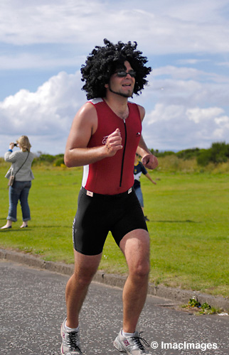
The run - go for it!
Once out on the run it may feel a little weird at first after cycling and your legs may feel a little heavy. Hang in there - this will wear off soon. Also, don't be ashamed to walk if you get really tired. When you finish it won't be important that you walked or not, you will be in a small number of people who've managed to complete this type of event. Walking just gives you something to improve on next time! No complex rules on the run just follow the course and again listen for any instructions should you have to cross any roads.
The finish
200 yards from the line. Now is the time to give it all you've got. Family may be there with a camera so don’t want to be walking!! Now get those hands in the air, cross the line, and .... You are a triathlete! Congratulations. Get yourself a drink (water or a sports drink only at the moment!) - you deserve it!
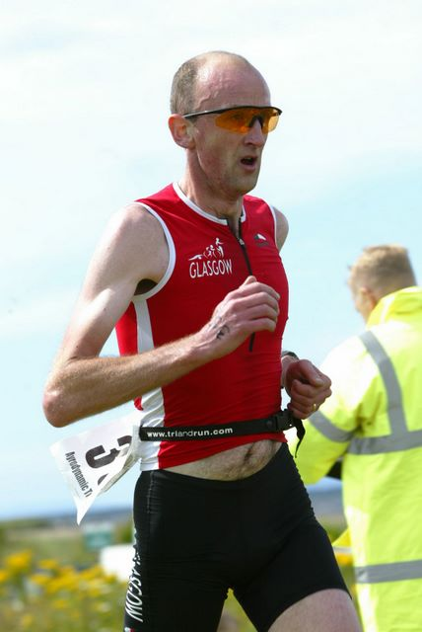
Watch how the "veterans" do it
Before the race when checking out transition you should have established when you could remove your gear/bike etc. There will be a short delay until all competitors in your section have finished. The Marshalls will only let you in and out of transition with a race number that matches the one on your bike! You are then free to hangout and soak up the atmosphere, especially if you got an early start, many of the fastest competitors will still be out on the course and it really is a great sight to see really fast people racing!
And a final thought-
So, your first race is over. One of the most important parts of the race are all the volunteers and organisers who give up there time to put the race on, without them you couldn't have done it. Take the opportunity to shout thanks to them as you pass them on the run and the bike, find an organiser after the race and simply tell them "thank you". If something goes wrong during or after the race, with the race or the results etc. keep your cool. No matter how upset you are, no matter how important the race was for you, it was more important to them for it to go right for everyone. Try to resolve any problems or issues by asking reasonable questions, not by making unreasonable demands or assertions. If they could have done something better tell them politely, after the event if it can wait - if they don't know it's broken they can't fix it.
If you are still keen to do more triathlons then ask about Glasgow TriClub and where the training sessions are – everyone is welcome
Kit List
Equipment
• TS License (if you have claimed the reduced fee for having an existing race licence);
• Swim goggles
• Swim hat (supplied by race organisers to aid lap counting in a pool).
• Two towels (one for the floor in transition, the other to use)
• Loose change (always useful to take with you, if the event has changing, the lockers may need this!)
• Bike – obviously!
• Bike tools and pump including basic spares to carry on the bike (spare inner tube, tyre levers, repair kit)
• Helmet – no helmet, no race
• Sunglasses (if needed)
• Race numbers (may not get until registration on race day)
• 8x Safety pins, race belt, or other mechanism to attach race numbers
Talcum powder can help getting wet feet into shoes!
Clothes
• Swim wear
Tri specific shorts/costumes exist but are expensive and are not essential for your first race. For many people starting regular Speedo style swim briefs of shorts for guys and a regular swimsuit for the ladies, and then either no shorts or running/cycling shorts on top for the bike and run).
• Bike/Running top
For a race in early May, depending on the weather, you might want to use a cycle jersey or similar- it can get cold. Get a top that wicks away the sweat. In warmer weather a T-shirt or vest will be fine. You would normally use the same top for the bike and run and not change in T2.
• Bike shoes (if needed)
• Running shoes (needed!)
• Socks (if needed, but if not practice beforehand to avoid blisters!)
Other bits and pieces to have to hand in the car or in transition
• Fleece and/or change of clothes to wear after the event.
• Big plastic bag to keep clothes dry while left in transition (in case of rain)
• Food/Drink including drink to take on the bike
• Bananas, energy bars, gels etc to eat in transition or out on the bike/run.
• First-aid kit including antiseptic cream, plasters etc
• Sun screen - hopefully

