Allander Aquathlon Run Routes 2014

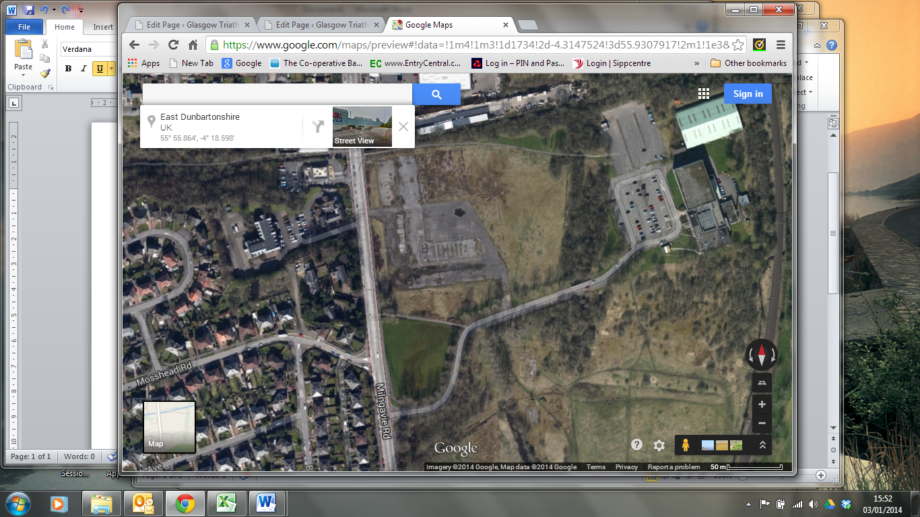

Run Start/Finish

8yr old Route – Out & Back

Other Kids – Out & Back