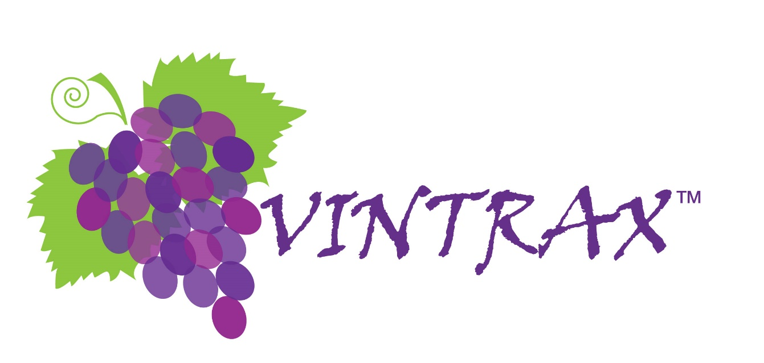

**VINTRAX by *Sci Data*  
P.O. Box 1037  
Los Alamos, CA 93440  
805-363-1648**

VINTRAX User Guide

Starting with the Vintrax Main Menu, the first thing to do is to always select a Vintage from the drop down list.   
The vintage selected will control many of the views on the screens and display relevant information for that vintage. By not selecting the correct vintage you may end up looking at data related to other vintages. It is the same requirement to select one of three forecasts. In most cases the default Sales Forecast is what you would select. The other 2 alternate forecasts will be used when you want to compare a range of forecast values and see how it changes factors such as tons required. This will be explained in more detail later in this guide.

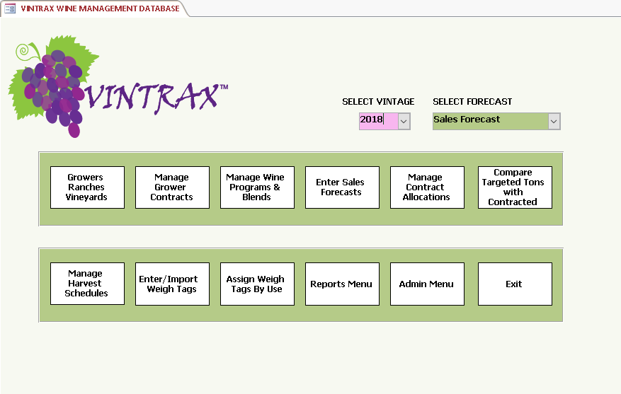

To fully benefit from Vintrax it is a general rule that the more detail you add the better. It will allow Vintrax to provide you much more useful information regarding your business. In many cases you will only need to add it once with possible occasional updates when things change. Doing things in a certain order also makes using Vintrax easier. Vintrax was designed to follow the winemaking process from planning stages through beginning fermentation. This user guide will proceed in that manner covering functions in the order you would generally follow. The Main Menu is laid out in general to also follow the wine making process.   
Although this user guide is 70 pages, you will find that when using Vintrax it will not take much time to enter your data. Adding your grower and vineyard information, creating contracts, designing your programs and blends, allocating the contracted tons to your programs, scheduling harvests and processing your weigh tags will proceed quickly and you will immediately see all you need in the Vintrax reports to keep everything in order.

**Adding Growers, Ranches and Vineyards**

The first place to begin is to add your current growers, along with the ranch locations and specific vineyards that you expect to contract for grapes, juice, or wine.

Vintrax considers a grower as the person or company you will contract with and in general pay for your grapes. A ranch is considered to be a location the grower has vineyards, with a defined ranch being in a single American Viticultural Area (AVA). Growers may have ranches in several AVAs within a state or region. A vineyard is within a ranch and defined for a specific varietal of grape. So a given ranch could have multiple varietals in various blocks, and each could certainly have differing soil characteristics, exposure, and other features that make it unique. Vintrax allows you to capture these details and will use the varietal and AVA throughout the application such as when a contract is created it will always be for a specific vineyard, varietal and AVA. This will be covered in more detail in the contracts section of the user guide.

Vintrax will come with sample data in the database for the 2017 vintage. This data is available to allow you to visualize how things look and navigate the application. The data will not in anyway show up in your reports or screens unless you want to see it. Selecting the 2017 vintage from the Main Menu will display sample data in the forms along with actual data for vintages from 2018 and beyond. For your business use of Vintrax, always begin with 2018 or later from the Main Menu.

Clicking the Growers, Ranches, Vineyards button on the Main Menu opens this screen.

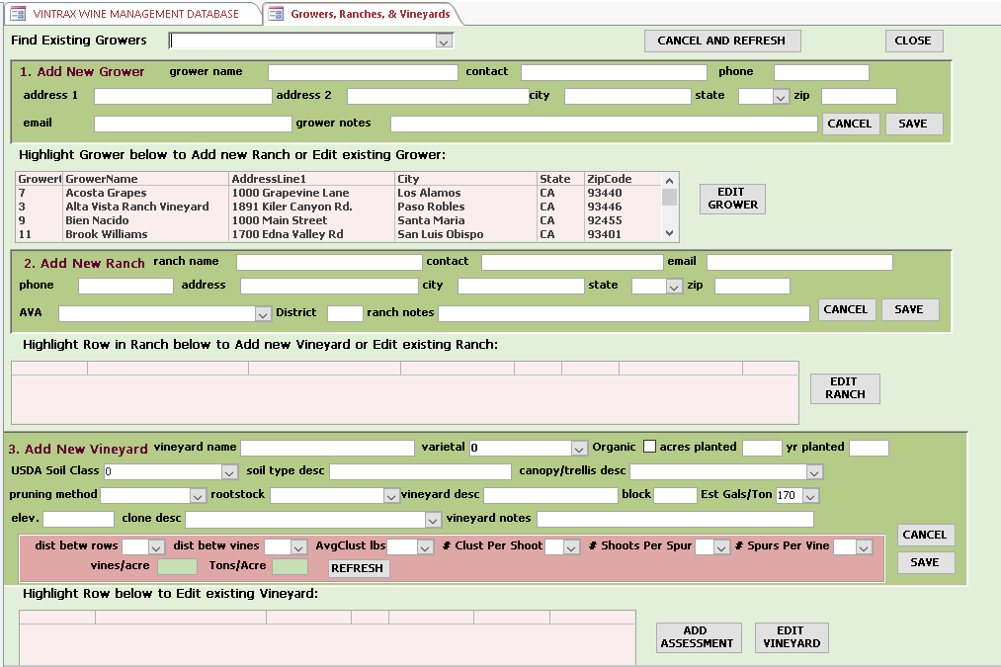

Begin by adding a new grower to the screen. This information is specific to the grower and not to any ranch locations or vineyards. It is best to fill everything in completely, although you can edit at any time. It is not recommended to change the Grower Name, however when first entering and before you have added information elsewhere in the database if you make a typo, the name can be edited. Vintrax uses an assigned ID field to track information, but changing the grower name could lead to confusion later on and make recordkeeping more complicated. When the section for grower has been filled in, click the SAVE button and the grower will appear in the box below. If you need to edit the grower highlight the row in the box and click the EDIT GROWER button, make your changes, and then click SAVE. If you decide not to change anything then click the CANCEL which will clear the entries, but not update any record. You can proceed and enter all your growers first, or just one at a time, followed by entering ranches and vineyards.

Note the CANCEL and REFRESH button at the top of the screen, resets all fields, essentially the same as when you first opened the form. It does not effect any saved records where SAVE has been clicked.



Next, in a very similar fashion you will enter ranches for each of your growers. Since a grower may have multiple ranches in several AVAs, you will enter a ranch for each of these locations.

The first step is to highlight the Grower in the box for growers that you want to add a ranch. The grower selected will be associated with this ranch when you SAVE the ranch record.



Note the AVA is pre-defined for you.

You can begin by typing the AVA such as Paso Robles and the list will move to that area to quickly find the AVA. The AVAs are by state and then alphabetically, so for example York Mountain in San Luis Obispo County will not be next to the other Paso Robles area AVAs. Also, for most forms if you put your cursor in the text field such as for notes and hit Shift-F2, the zoom window will open to make entering and reading text easier. These fields are limited to 255 characters.

When you have entered your ranch information click SAVE and that ranch will appear in the box below. The EDIT and CANCEL functions are the same as they were for grower above. If you leave the same grower highlighted you can enter another ranch or if you prefer you can proceed to enter a vineyard for the ranch you just entered and saved.

Adding a new vineyard has more specific information on the vineyard and since the location is within the ranch, it doesn’t need that information. However, this information will describe in much detail the characteristics of the vineyard from where the grapes will be sourced. There are several drop-down lists included as shown on the following page. Each allows you to record specific vineyard information that you will always be able to find within Vintrax, or in one of the many reports Vintrax provides. Having this documentation is a valuable resource.

The estimated gallons per ton is defaulted to 170 gallons, or you can select a better value based upon past experience from between 135 to 180 gallons per ton. When calculating cases and other parameters involving liquid, such as Sales Case forecasts, Vintrax bases a ton of grapes to produce a standard 170 gallons. However, Vintrax is also smart enough to know that when the actual gallons per ton from any particular vineyard, varietal or contract are not 170, it will make the adjustment automatically and produce the correct results. More on this in the user manual in the program allocations section.



The area in mauve above in the vineyard section allow Vintrax to do some very useful calculations for you. It will give you a better estimate of probable yield from the vineyard and give you a closer approximation of the number of acres that will need to be managed to produce the contracted tonnage of grapes you require. Of course it is a best estimate, with conditions such as weather, pests, and other variables all having an impact on the outcome. There are many reports in Vintrax that will use these values and once you have a track record from a given vineyard, it will allow you to fine tune estimates for the future. Consider it a useful planning tool.

An example vineyard with details completed follows where you can see the results of one of these calculations. Once the vineyard information is filled in, click the SAVE and the vineyard will appear in the box below. The CANCEL and EDIT buttons work the same as for grower and ranch.

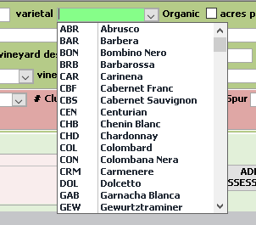 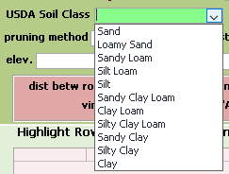

 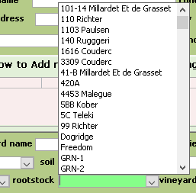

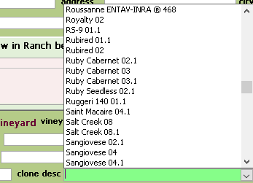

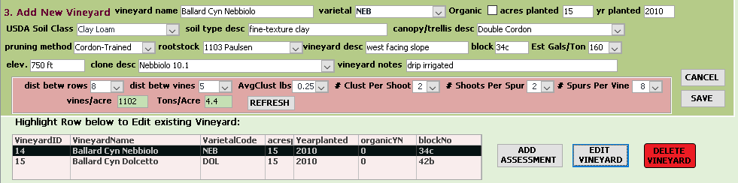

The Add Assessment button opens a vineyard assessment for. It’s a way to keep track of information gathered from various field visits to the vineyard. The example shown hasn’t been saved, once SAVE is clicked the Assessment will appear in the box below and can be edited or viewed at any time. Having a series of these assessments from each vineyard is important. The fields in yellow are required, the rest are optional. The spray reports can be saved in a file location and a hyperlink will open them when clicked for reading or printing.

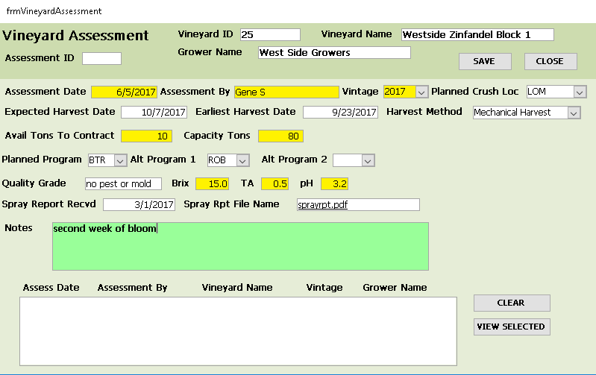

One final bit for this grower, ranch, and vineyard screen are the RED DELETE buttons, if used will delete any existing contracts or programs allocated to for the corresponding DELETE function. There should not be many needs to delete and would only do this if you are positive you want to delete the items. With Vintrax, only the active data will be used and most data can be set to inactive as opposed to deleting, if that is the objective. This will be covered in more detail. Note also, deleting a grower, will delete any ranches or vineyards associated with the grower.

Once the growers, ranches and vineyards have all been added, you will only occasionally need to open this screen unless you need to add more growers etc.

**Adding Grower Contracts**

In reality, managing your grower contracts and managing your wine programs and blends are directly related. In Vintrax you will be able to go between these functions according to your preferences and needs. Whether you start by adding contracts for your grape purchases or designing your programs first is a matter of choice and either way will give the same result. Sometimes time is of the essence and having contracts in place precedes designing the program. Along with the variability of sales forecasts, there will generally be some   
changes that occur throughout a vintage. Vintrax will make it easier for you to manage these changes.

It is also important to point out that even for wine makers using estate grown grapes where they may be no payments paid to other growers that by adding the contract with the associated tonnages and costs allow you to identify the source of your grapes used in your wine programs and blends. There is still a cost associated with estate grape tonnages and need to be reflected in the cost of producing your wine. It is recommended to add yourself as a grower with your corresponding ranches and vineyards and create contracts just as you would with outside growers.

For the user manual we will begin with adding the grower contracts and manage the wine programs and blends after the contracts. Begin by selecting the current vintage from the main menu, then click the Manage Grower Contracts.

Select the grower from the first drop down list and then the ranch from the second list. For this example, Rancho Descanso is a new ranch for Los Alamos Grapes.

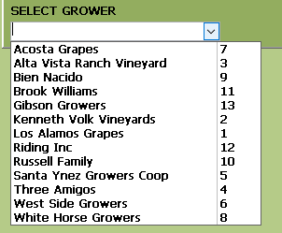 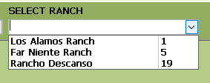

When there is no existing contract for a ranch, the message box will pop up. Click OK.

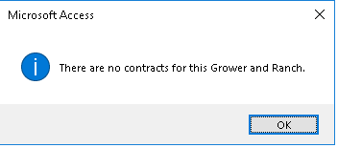

The Add New Contract screen will open.

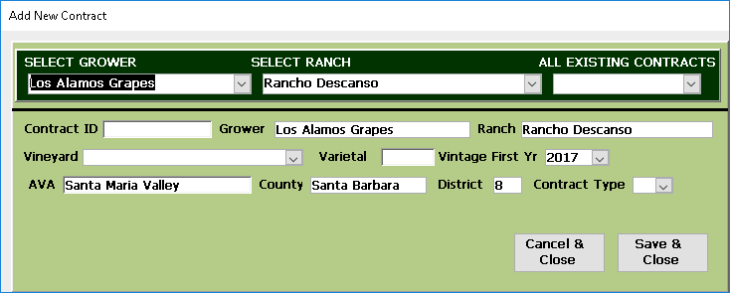

Note most fields are already populated for you. Verify the vintage is correct for the first vintage year. Then select the vineyard which will automatically populate the varietal for that vineyard. Enter a new contract ID, which can be any combination of letters, numbers, or underscore, but no blank spaces, and upwards to 12 characters long. Vintrax will use this contract ID in many places, so if it is easily identified it makes things easier. Use a format that you choose, for example LAG2017_001 or LAGTMP_171. Select the contract type which can be G for grapes or J for juice or W for wine. It is important to choose correctly as grapes will be calculated in tons while juice and wine will use gallons on the contracts. Vintrax will know how to use this throughout the application, converting between gallons and tons as required.

Click SAVE after completing the required information.

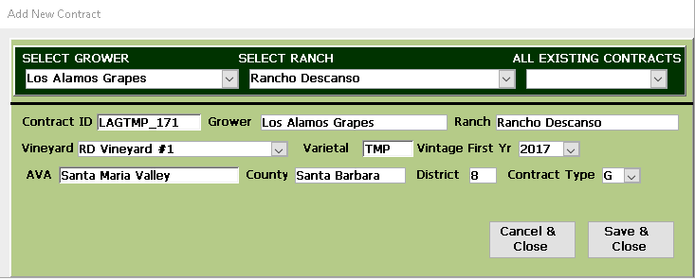

After saving, the contracts form will open blank and you can begin by selecting the grower and contract you just created a new contract for, or select an existing contract for another grower.

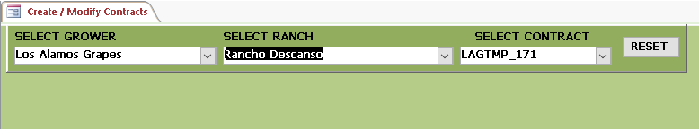

Once the contract is selected the screen will populate showing the initial contract data.

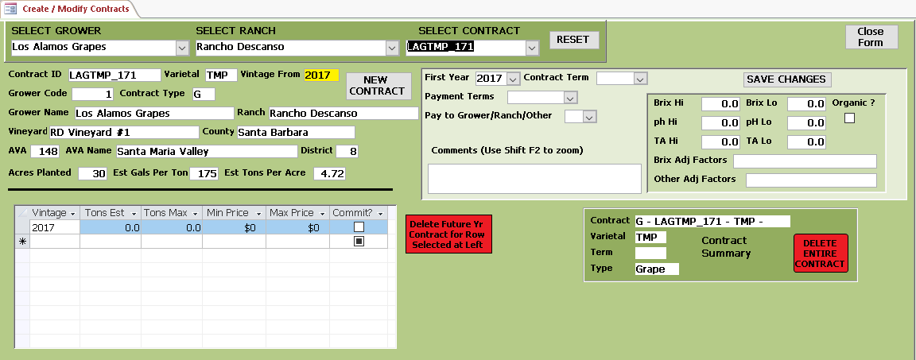

Note the screen also displays the acres planted, estimated gallons per ton and est. tons per acre that was calculated on the vineyard screen for your reference. The yellow box, in my case, Vintage from 2017 designates the first year for the contract. A contract can be for a single year or multiple years depending upon what you require.

Start in the upper right box to add specific information for the contract that will apply to all years. In the event there will be differences between years in these values, then it is suggested to create a new contract such as LAGTMP_172 to designate between the differences. Otherwise multiple vintages can use the same contract.

Payment terms can be created as required. For example N30, Net due in 30 days. Check organic it the contract requires organic grapes. Payments can be made directly to the grower, to the ranch or to other, such as a trust. O for other selected will show a text box to enter the information.

Brix and other adjustment factors can be entered as in my example following. Comments can include specifics to the contract. Vintrax uses the pH in a scientific definition, so pH Hi always has a higher number than ph Lo, also seen in my example. Vintrax will remind you when you enter it the other way around.

Click SAVE when you have entered the information required. For this part of the screen anytime you may need to edit anything, make your changes and then click SAVE again and it will update the information.

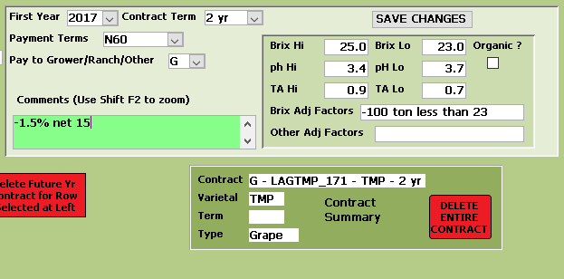

The final step is to add the tons for the contract and the prices. Vintrax allows for a range of tons and prices, or if you prefer you can make them both the same. Starting with your first contracted vintage, enter the tons and prices. If you want to enter multiple vintages move to the next row and enter.

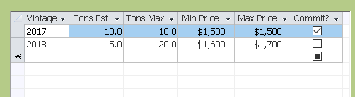

My example demonstrates a two year contract, first year committed with second year at a higher price and tonnage. The commit is just a flag that your contract agreement has a commitment at the terms identified.

If you were to close and re-open the screen for this contract you would see all your information is now in Vintrax.

When you have already added a contract for a grower and ranch and want to add a NEW contract, for example a different varietal, select any existing contract for that grower and ranch, and then click the NEW CONTRACT button to enter the new contract.

There are also other functions on this screen to be described.

When you select either Juice (J) or Wine (W) instead of grapes you will see gallons and price per gallon instead of tons. Enter the same way for each year of the contract using gallons as shown below.

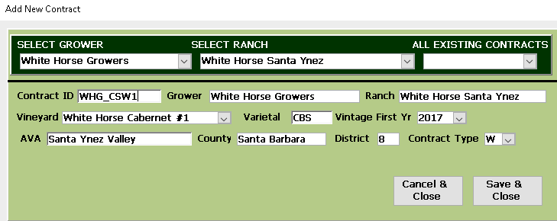

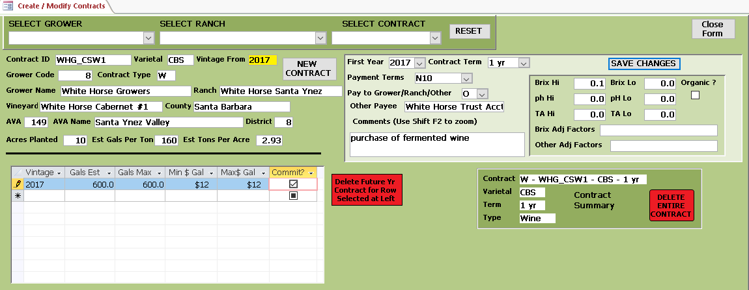

The RESET button along the top just clears the form. It doesn’t change or delete any data.

The NEW CONTRACT button will allow you to create a second contract for this same grower and ranch.  
If for example, there were two or more vineyards at this ranch with distinct varietals, you would require a contract for each, such as the first for Tempranillo as shown above, as well as a second contract for Cabernet Sauvignon, for example. If the vineyard for Cabernet has been added on the vineyard form it will show up in the list of vineyards for this ranch. Otherwise you would first need to add it on the vineyard screen. Once added it will be the same process to add the new contract as the one previously entered.

The two RED buttons are to be used sparingly if at all. The left button will delete whatever vintage is highlighted in the box at left. For example highlighting 2018 in my selection and clicking the red button will remove the record for 2018 from VINTRAX. The box will turn black as you are ready to click to signal to you.

Before clicking check to see that you do in fact want to delete the vintage from the contract.

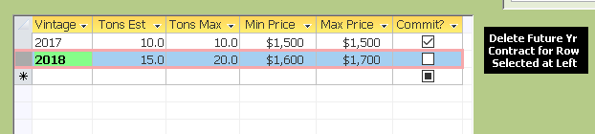

In the event you need to re-add the vintage, just re-enter it in the form and it will be back in VINTRAX.

The RED button on the right part of the screen is a little more extreme. It will delete everything about this contract, as if it never existed. About the only time this might be appropriate would be if something had been entered with so many mistakes or issues you want to start over clean. However, there is one caveat. Once you have allocated tons from this contract to a wine program or blend, deleting the contract will essentially erase those tons from any programs. If this is what you want to happen, then you can proceed to delete the contract. But be sure to find other available contracts to allocate those now missing tons to!

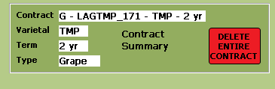

As a final note for this contracts screen, the Contract Summary next to the red delete button display the current contract information and is the contract that will be deleted.

Next

**MANAGE WINE PROGRAMS AND BLENDS**

Up until now, there hasn’t been a lot related to making wine. Now the fun begins. Start by selecting the vintage from the main menu and the sales forecast and click the Manage Wine Programs & Blends to open the screen.

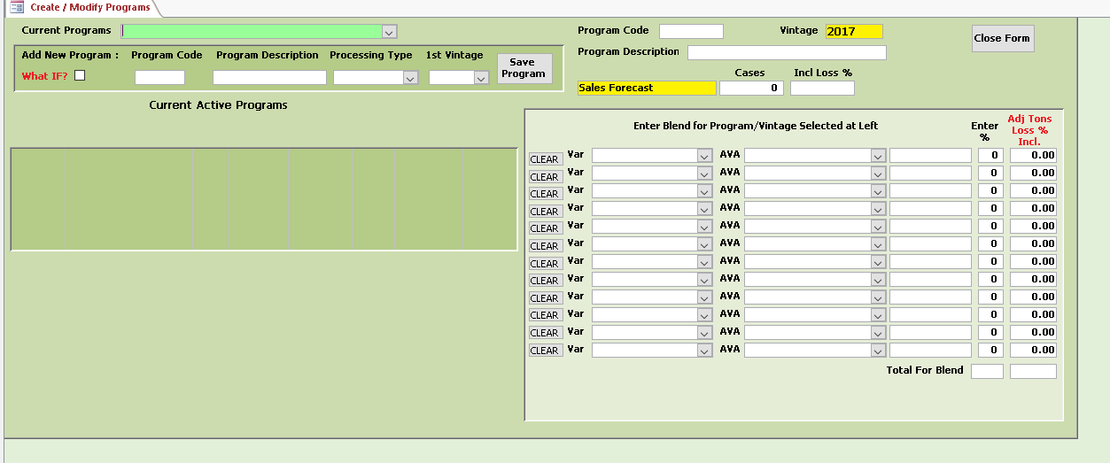

Since this will be your first program to add, begin with the Add New Program section:

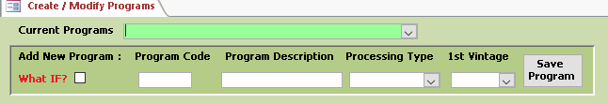

Leave the what IF box un-checked. What Ifs are programs to use for comparisons to actual programs. There can be up to 9 What Ifs for each valid program. Their main use is to test trial blends and see the tonnage required for various varietals and AVAs as compared to your actual program. In some cases, you may decide to take some of the composition of one of the What Ifs and change your actual blend in your program based upon some things you prefer in the What IF. This feature is an optional feature, so not having What Ifs doesn’t in any way effect the remainder of your data. There are reports however in Vintrax that display information from What Ifs to use for planning purposes if you elect to use some. Once you create an actual program and blend, you can begin to add What Ifs by checking the checkbox and the What If will be saved separately from your actual program. There is one requirement for naming a What IF. If your program code is named BTR, then your What Ifs will be named BTR1IF through BTR9IF. Vintrax uses the **IF** designation to identify these. The program description can be named accordingly, for example Big Tuscan Red WIF1 so you will easily identify it.

To add a new program, decide upon a unique name and a 3 letter code for it. An example would be BRD and Big Red Dog Table Wine. Vintrax will use this program code along with the vintage throughout the application.

Processing types are as follows, choose the one that matches the intended type of wine you will be making:

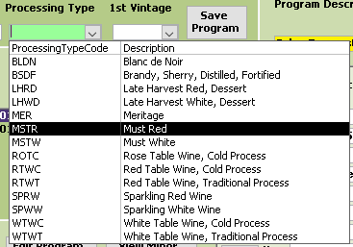

Vintrax will use processing type in various ways, mainly in reporting and grouping information that is related according to processing type. It is also helpful to identify the intent of the program blend.

For this example, adding PNG, Pinot Grenacha Gotcha for a Rose table wine, cold process with first vintage 2017. As this is test data I am not using 2018, which is also something you can do with Vintrax for learning.

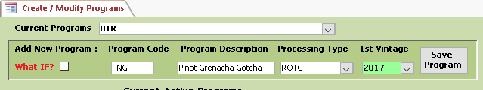

After clicking SAVE, it will open the forecast screen automatically so you can enter the expected case requirements based upon your best information at this time. In my screen shown, I have already added other programs, and my newest program has been added to the bottom. You will only have a single entry.

It is not a requirement to enter the forecast data at this time, the screen can be opened at any time and be edited as required. For example, at a later date you may discover you will require more or less cases to be produced and you would then update the amounts on this screen. Vintrax will then immediately use the new case requirements to determine the differences in tons required for all of the varietals that are associated with this changed sales forecast. Running reports before and after this change would give you a comparison quickly of what changes need to be made in your allocations and perhaps even in your contracts.

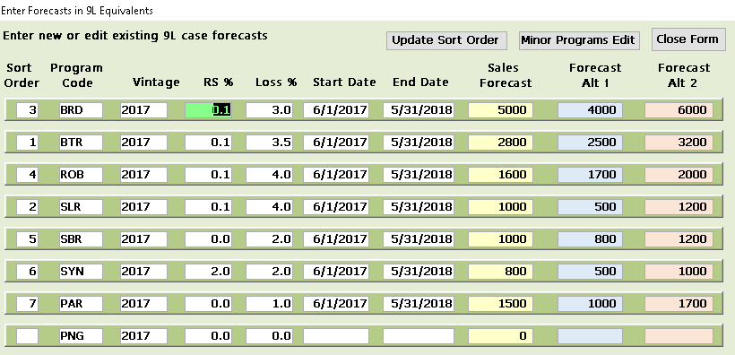

There are several features on this screen. The Sort Order is the way Vintrax allows you to prioritize your programs according to the importance of the program. If you will be short on a certain varietal you would want it to effect your least important program rather than causing problems with something of more importance.

At crush when weigh tags are being assigned to your programs according to tonnage requirements, Vintrax will allocate the correct varietals and AVAs to all your programs, but it will also determine which program is the most important with the highest priority. The sort order can be changed at any time before crush begins. Clicking the Update Sort Order button opens the screen where you can edit these values. I will make the new PNG program my #8.

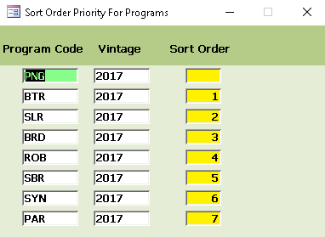



For the PNG program I decided upon a residual sugar of 1%, a loss percent of 2%, and sales forecast of 1000 9L cases with a low alternate forecast of 800 cases and a higher alternate of 1200 cases. Vintrax will allow you to see comparisons between the forecasts so you will know what to expect in the event some things change.

The Start and End dates are whatever you want to use for the forecast. Depending upon the expected release date of the wine and how you determine forecasts is up to you to decide.

Loss percent is used by Vintrax to make adjustments in the allocated tons required to meet the needs of the program so you end up crushing the tons of grapes required to achieve the sales forecast. If you expect to sell 1000 cases of wine you may end up crushing grapes to produce 1020 cases, considering between crush and bottling there will be losses from spillage, evaporation etc. that you should account for. Constantly coming up with less than expected is not a good practice, so this is an attempt to improve that situation. Over time you will have a good estimate for loss percent to provide to Vintrax. You may still use 0% if you decide to.

Later in the user guide we will cover the Minor Programs Edit button on the screen.

When you have entered the information for your new program, you can close this screen and re-open the Programs and Blends screen and navigate to your program.

Your screen will appear similar to mine below.

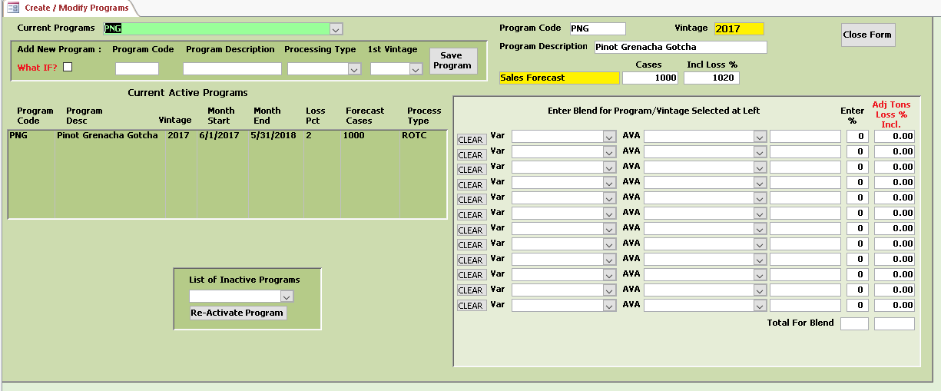

Vintrax has added a row of data for the program in the Current Active Programs window as well as some header information at the top right. Note Sales Forecast is displayed in yellow and that the 1000 cases and 1020 cases with loss percent are displayed. If you select an alternate forecast on the main menu, then these values will be different. Depending upon the forecast selected, Vintrax will display the tons required for each varietal in your blend to reach that forecast.

To design your blend for this program highlight the row at left in your current active programs window to activate the blend menu for this vintage.

Once selected, other fields will appear that will be described after we create your first blend.

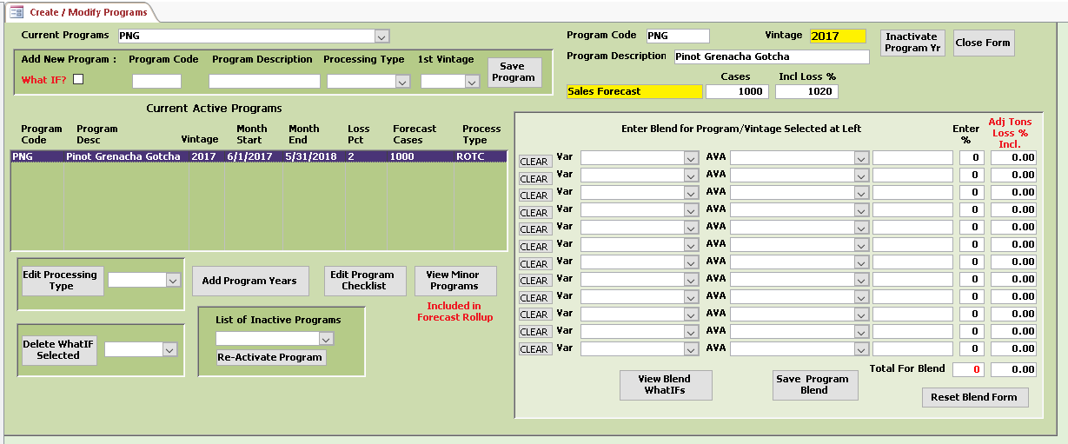

For my example I am going to select Grenache, Pinot Noir and Mouverdre for my program blend. Starting in the first row select a varietal from the drop down list. Then decide upon an AVA from the second drop down list and then enter a percent for this varietal for the blend you want to make.

My first row appears as follows:

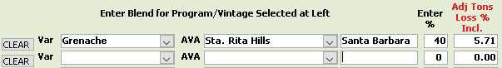

Vintrax uses the forecasted case requirements to determine the adjusted tons including whatever loss percent you may have included to calculate the tons required for this varietal.

Continue and enter your varietals in the blend noting that Vintrax is totaling the percentages to 100% for you.

The 100th of a ton rounding is just a display value, Vintrax will use the amounts for each varietal as displayed.

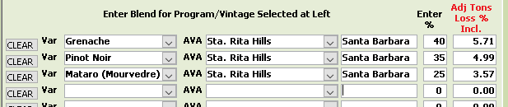  
 

Note how quickly you know exactly how many tons are required for each varietal and AVA to meet the sales forecast in cases required.

Once you have your blend the way you want and totaling to 100% click the SAVE Program Blend button.

If at any time before saving your blend you want to start over you can either click the Reset Blend Form button or for each individual line in the blend you can click the CLEAR button next to the row.

If you ever decide to change your blend for a program, just return to the same program, select the vintage and highlight the row and then make your changes to the blend and again click the Save Program Blend and Vintrax will update your blend.

Next, it is time to go over some of the other features on this screen, starting with the Add Program years.

If you click this button, Vintrax immediately inserts a new row for you right below the existing with the next vintage assigned. At this point you can open the Sales Forecast screen and enter the projected forecasts for the next vintage or wait until any time later to do that. Just be sure that from the main menu you select the next vintage if you want to see this information in the forecast screen. Leaving it at the current vintage will not display the next vintage forecasts.

Instead of entering a forecast for the next vintage, if you select the second row in the Current Active Programs window you will see the blend form is blank. Vintrax allows for you to either re-use the same blend in a program from the previous vintage, or make modifications to it. It is up to you and having this flexibility is important. Since Vintrax uses the vintage, data from one vintage does not alter data in another and they remain completely independent. The contracts and programs can be the same but each vintage will have its own unique sets of criteria.

You can design a blend for this added vintage now and save it or come back at any time and add it.

The Edit Processing Type allows you to easily change the processing type for any program or vintage. Just highlight the row you want to change, select from the drop-down list and click the Edit Processing Type button.

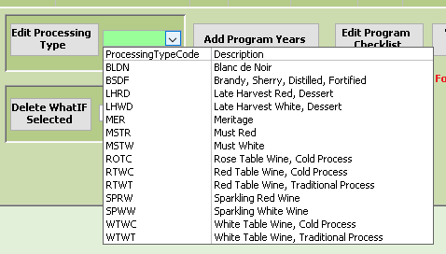

In the upper right corner of the screen, the Inactivate Program Yr. button allow you to set a program and vintage to inactive. By setting a program and vintage to Inactive it allow you to keep the program in the system, but tell Vintrax to temporarily not use it. At a future time it is then very easy to just re-activate the program when you want to begin again. The vintage that is displayed in the box to the left of the Inactivate button is the vintage that will be inactivated. In my example shown I will inactivate 2018 for Program Code PNG.



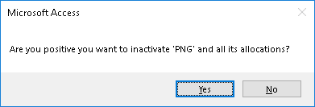

Note also that if the program has any current allocations of tons from contracts, these will be removed before the inactivation occurs. This frees up these tons to be used on other programs.

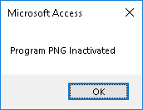

Once inactivated, you will be able to see this in the drop down list. In my case PNG 2018 has joined two others I previously inactivated.

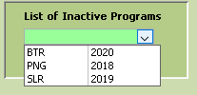

At any time you want to re-activate, select it from the list and click Re-Activate Program.

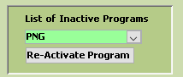

The next features are the Edit Program Checklist and View Minor Programs.  
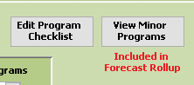

The Program Checklist button will open the screen shown next. It provides a convenient place to keep track of operations and processes associated with the program selected. Vintrax provides a Program Checklist report which can be printed and kept as a reminder and attached as a document to follow the grapes after crush through the wine making process. Check the appropriate checkboxes and SAVE when finished.

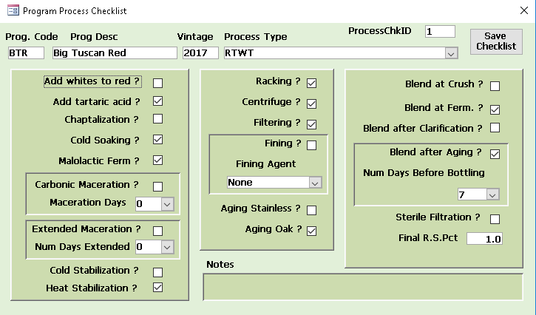

View Minor Programs opens a screen to view any Minor programs included in the forecasts for the main program. So far there are no minors for the 2017 vintage PNG as seen below. Vintrax allows for the creation of minor programs such as producing a shiner for another customer, a proprietary label for a restaurant or other possibilities. The minor case production would use the same blend as the major program and the same processing, the only difference is the sales forecast for these minor programs are independent of the major program forecasts. This allows you to calculate costs associated with a minor program separate from your major program.

The Minor Program code always uses the first three letter of the Major Program to track it throughout the database. The program code field can contain 6 characters allowing you to have 3 dedicated to the major and 3 for the various minors.

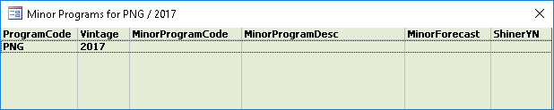

To add a Minor Program, open the Sales Forecast screen and click the Minor Programs Edit button at the top of the screen. The screen below shows three minor programs currently in my database, along with their corresponding program codes.

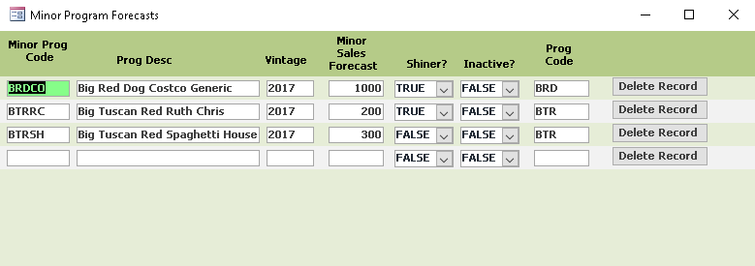

Enter a new line for the minor program you want to add, for this example, 100 cases are going to be produced for a local charity with their own label applied at bottling. Since these will be a donation, in this case keeping the costs separate is the purpose for having a minor program.

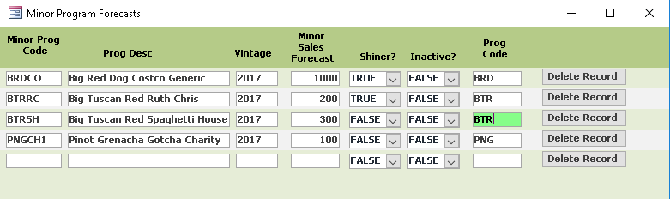

At any time you need to eliminate the minor program from your forecast, just click the Delete Record next to the row you need to delete.

Now when you return to the Programs and Blends screen and look at your program you will see Vintrax has updated your case requirements for the program by adding the minor program requirements to it.

For my example below, the added 100 cases + the loss percent now indicate 1102 cases need to be produced. The tons for the program increased by 1.43 tons from 14.26 tons to 15.69 tons reflecting the new demand and the varietal tons also increased. Whenever a change in a forecast is made, Vintrax will give you the information immediately.

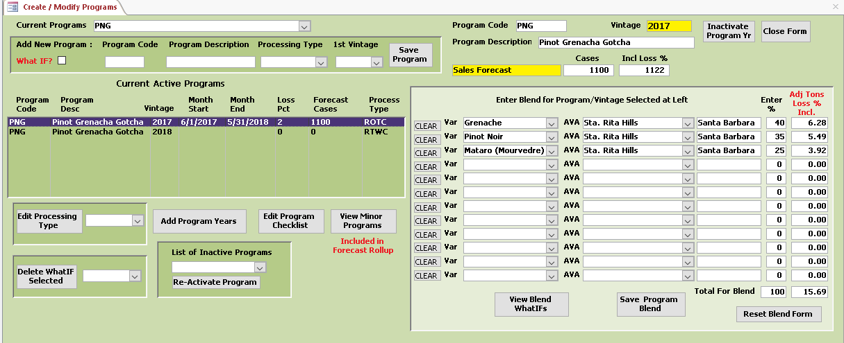

When you open the View Minor Programs screen now, you will see the new Minor Program listed.

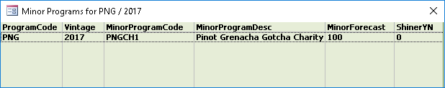

The last features to describe are related to the What IF programs. To create a new What IF for your program,

Check the checkbox as shown and enter your information and click Save Program.

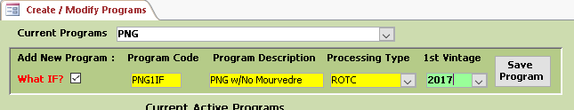

Be certain to include the IF as the right two characters in your Program Code for the What IF. As previously stated you can have up to 9 What Ifs for each program and vintage.

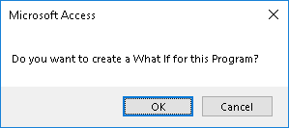  
 This is a reminder that you have the What If checkbox checked. If this is in error, just click Cancel otherwise proceed by clicking OK.

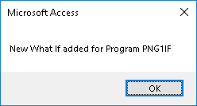

The Blend form will open ready to add the What IF blend information.

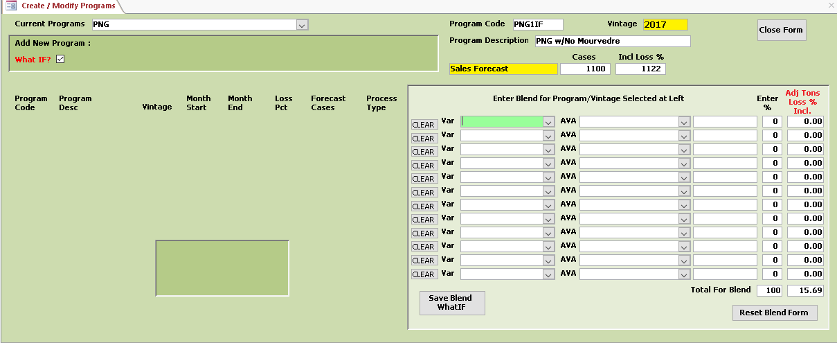

After entering your blend for the new What IF, click the Save Blend What If button.

The tonnage requirements remain the same for the program based upon the sales forecast, however each varietal now requires a different amount of tons than before.

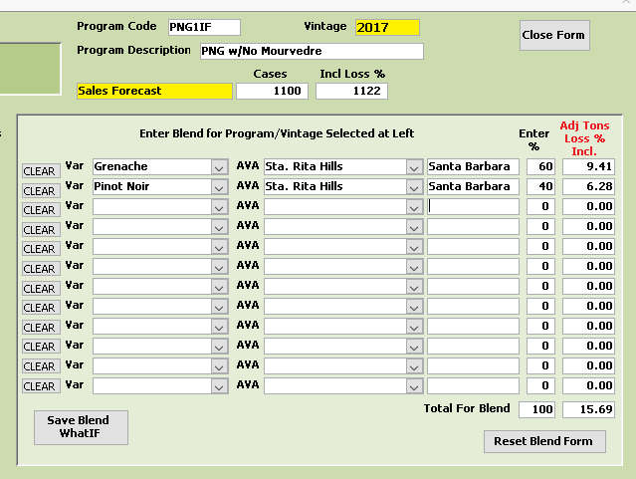

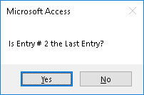

Yes, only 2 rows in the What IF blend above.

Once saved, go back and select your program, highlight the current vintage row and click the View blend What Ifs button and you will see the information on your new What If, along with the potential tons that would be required. Vintrax provides a report that shows all of your What Ifs along with which contracts are available to allocate grapes to that blend. In the event a change is required in a program, these What Ifs can be used to evaluate possible changes and what it means to your available tons and existing contracts.

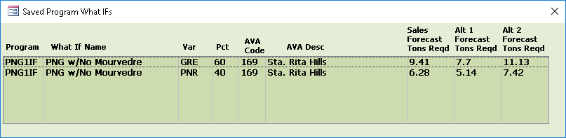

If you need to delete a What If, just select it from the drop down list and click the Delete What If Selected.

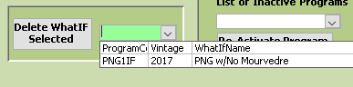

Next

**MANAGE CONTRACT ALLOCATIONS**

Click the Manage Contract Allocations button on the main menu. **It is very important to have the correct vintage and the sales forecast you would like to view before opening this screen** as Vintrax will use these to determine what to display.

When the screen first opens it will be blank. Depending upon what you would like to do, there are a couple of option as to where to start. In general the screen is laid out to start at the upper left and then work your way down the left side of the screen before moving to the right side. Some of the windows are meant to display information only, while in a few places you will do the majority of your work.

The left part of the top header is where you select the Vintage and Program or the Vintage and Contract.  
Depending upon the vintage you selected on the main menu, this form will only display from that vintage and into the future. It will not display earlier vintages than the vintage selected on the main menu.

So the two starting points would be to either select a vintage and a program you would like to work with and allocate tons to, or a vintage and contract if you want to see how that contract is currently allocated.

In both cases the form is interactive and as you change things the other parts of the form will update to reflect the changes.

In most instances you will be selecting a vintage and a program.

The upper right half of the header will display information specific to the program and vintage selected and is read-only information.

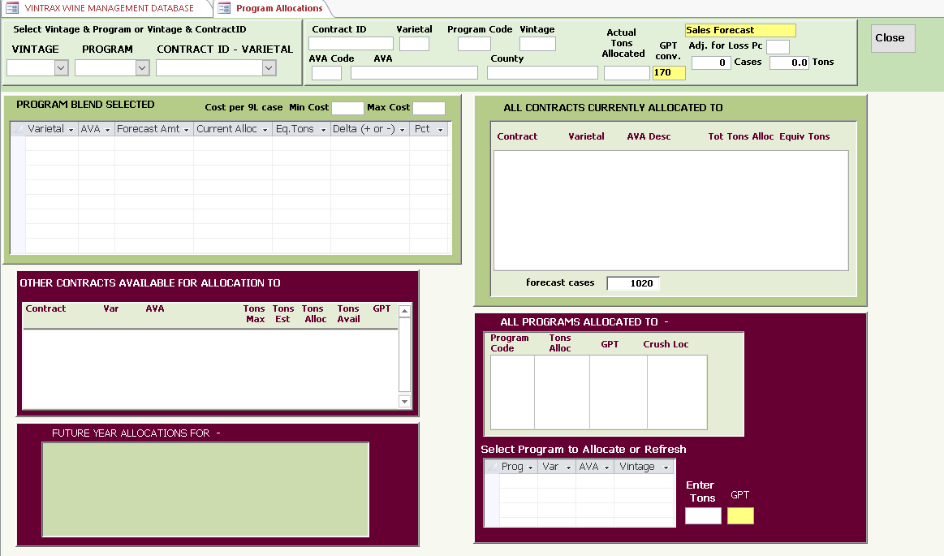

The first window on the left below the header displays the program blend for the vintage and program selected in the drop down lists in the header. The purpose of this window is to act as a balancing feature to show you whether the proper allocation of tons has been made to your program and blend.

Below this window, is a place to display all contracts that qualify according to varietal and AVA that are legitimate choices to allocate tons from. When you highlight a varietal in the program blend window, whichever varietal is highlighted will determine which contracts show up in this window.

The bottom left window will display all future year allocations to whatever Contract is highlighted in the second window. The labels on each window will update so you will know what is being displayed in each window,

Up to this point, you are just being provided information to allow you to make informed and correct allocations between your contracts and programs.

The upper right window below the header will display every Contract that has so far been allocated to whatever Program you have selected. The total tons in this window will equal the total tons in the upper left window.

This is also information that will show you quickly where you have used resources so far and in the event you need to free up some tons for another program, you will see what your options are.

The left and right middle windows are related. Whatever Contract you select from the left window, the right window will display ALL the Programs that currently have tons allocated from this Contract selected. This will tell you how the contract tons are currently being used, and let you know where you could remove tons if required to assign to another Program. Or just give you a current tally of the programs using this contract.

All of your allocation work takes place in the lower right burgundy colored box. This is where you allocate tons from a contract to a program, where you can remove tons if needed by entering a negative number of tons, or remove the total allocation from the contract completely from the program. As you are making these changes, all the other parts of the screen are going to be updating to reflect your changes.

You will see the contracts with their used tons being updated, the program blend will show what has been allocated and what remains to be allocated, and if you allocate to a new contract, that contract will show up in the upper right.

The goal is to fully allocate ALL of your contracted tons to programs and have ALL your programs completely allocated with the tons they require. If you have adequate contracts in place to meet these needs you will be able to balance everything. However, if you have insufficient capacity for any varietal or AVA requirement for any program you will immediately see a lack of available contracts to use. At the same time if you have all your programs fully allocated and have tons remaining in contracts, then you will have more grapes than you planned on using.

In the real world, change occurs and often when you weren’t planning on it to happen. In Vintrax you can modify the sales forecasts when they change, modify your contracts when you need to, and if required make changes to your programs and blends to satisfy the new conditions. Almost immediately you will see what effects these external events may have on your expected outcomes and be able to make adjustments proactively and not discover when its too late that either your programs or contracts do not meet your requirements. Generally this equates to either wasting resources, losing money or both.

Vintrax has 25 standard reports that provide a wealth of data to help you manage all that occurs up until assigning your grapes to their fermentation tanks. Once you are ready to begin wine making you don’t want to revisit problems that happened earlier or spend valuable time trying to devise a Plan B. You will also have all the documentation needed for the grapes that go into your wine, have a better understanding of your costs, and in the event of a TTB inspection or audit, you will have everything ready to provide.

Vintrax provides a report that will first show you which programs and blends do not have any current contracts that could be used to produce the wine. In these cases in order to allocate tons, the contracts with the growers need to be defined and entered into Vintrax. Its ok to begin with existing contracts for programs, but at some point very early it will be seen that you will not be able to fully provide the programs all their grapes. As you design programs and blends it is useful to run this report to see what contracts are still missing. Even when you do have an existing contract it is possible you will still not have adequate toms to meet the needs of all your programs. But Vintrax will make this very clear and you will see immediately where you have an inadequate supply of a particular varietal or AVA.

So let’s begin allocating some programs and contracts. I have selected the vintage 2017 from the main menu, opened the Contract Allocations screen and selected my new program PNG. The header displays the forecast selected, number of cases required and the total tons required for the program. In my case the 1122 cases represents the program requirement of 1000 cases plus the minor program 100 cases and the loss percent which is 2% of 1100 or an additional 22 cases to total 1122 cases. This is an equivalent tons using 170 GPT of 15.7 tons, which is allocated by percentage to the varietals in the blend.

Vintrax will automatically calculate a cost per 9L case by using any allocated contracts, the price per ton, and the gallons per ton, the percentages and the AMOUNTS CURRENTLY allocated to calculate it. So as you allocate tons from contracts this case cost updates reflecting the additional contract tons added. Once you have the program fully allocated at 100%, the final case cost will represent what the contracts used will cost for the grapes purchased for that program.

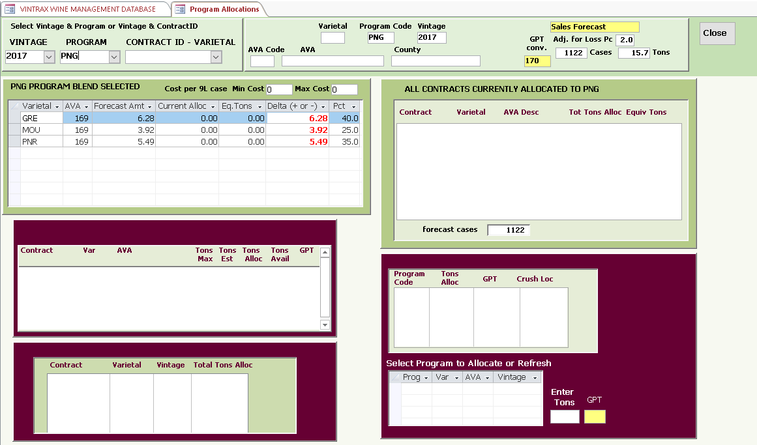

Start by highlighting the first component in your blend. For some programs it is possible you will be using a single varietal from a single AVA. That is ok, as Vintrax will work the same, and your entry process will just be simpler.

My grenache component requires 6.28 tons. When I highlight Grenache, the window below updates to show:

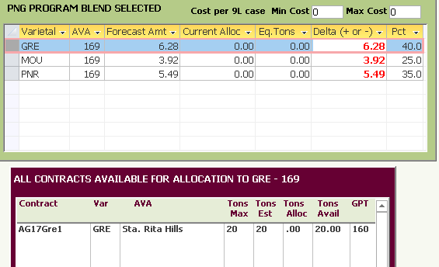

Since I have an existing contract that matches my needs for the program varietal, I see AG17Gre1 with 20 tons available, with 0 allocated from that contract so far. Once I highlight this contract the screen refreshes to show  
there is a future contract for the 2018 vintage and in the lower right the PNG program appears as it is a valid program to receive grapes from this contract. If there were other competing programs for this contract, then they would also appear here.

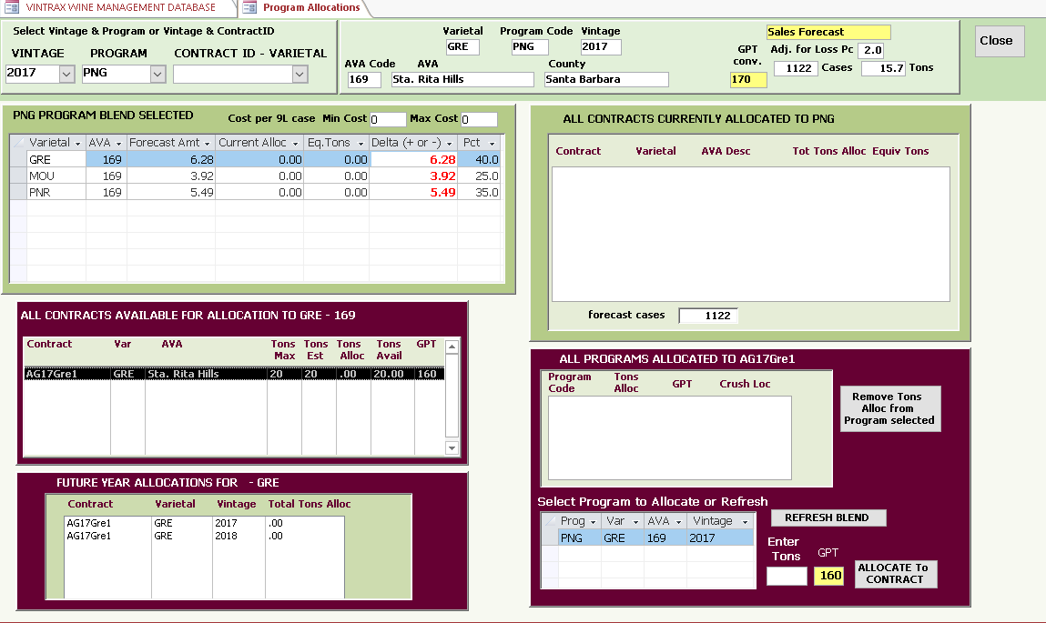

To allocate the tons I need from this AG17Gre1 contract I enter the amount I need 6.28 tons and click ALLOCATE TO CONTRACT.

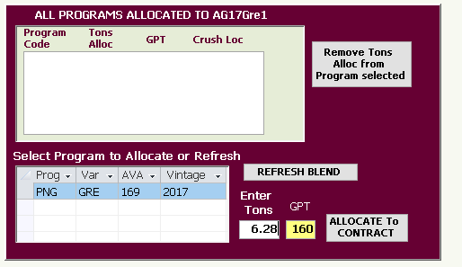

Vintrax determined that even though I asked for 6.28 tons that due to the fact that the expected gallons per ton from this contract was 160, it added 6.67 tons so the equivalent cases required would be satisfied. The delta for Grenache now shows as 0 which indicates that all the Grenache required for this program has been fully allocated. Note also that for the single varietal so far allocated the case cost would be between $28.23 and $29.72 per 9L case depending upon which price ended up being paid on the contract. As the other varietals are allocated this cost will update based upon the cost of the contract involved.

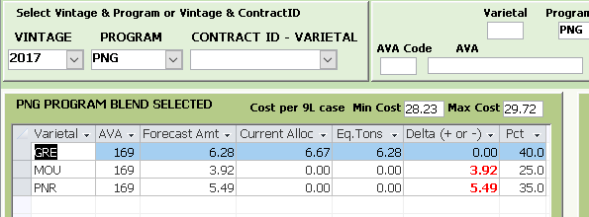

The allocated contract for the PNG program also shows up in the window in the upper right.

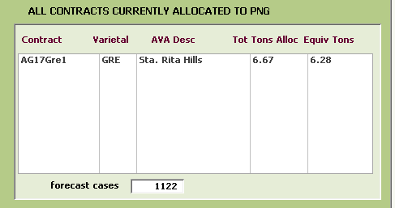

Continuing with my next two varietals I will follow the same system, highlight any available contract and then entering the tons required.

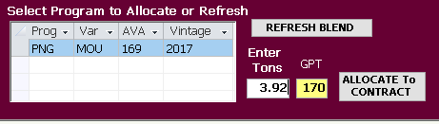 and the same process for PNR.

After allocating the three varietals my screen now looks like this

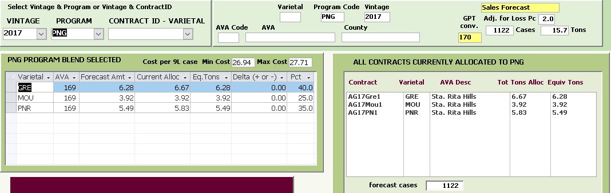

The deltas on all three varietals are zero which indicates this program is fully allocated from available contracts. The three contracts that were used show up in the upper right window. The costs per 9L case have been updated to reflect costs determined by the price per ton for the individual contracts.

If you temporarily close this screen and open the screen named Compare Targeted tons With Contracted,  
the contracts just allocated to the PNG program will appear with the tons used and tons available status.

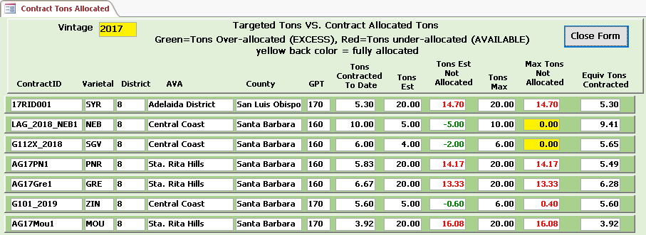

Note for the 3 Sta. Rita Hills contracts the actual tons allocated (which is what you will pay for by price per ton) and the equivalent tons (the gallons you expect per ton at crush) are shown as well as the tons that remain to be allocated on the contracts. Depending upon what you may eventually use the Tons estimated or Tons max are compared. For these 3 contracts, they appear in red in both columns as that indicates there are available tons remaining.

Closing this screen and returning to the Manage Contract Allocations screen, there are a few other features to explain.

First note if the Forecast Alt1 is selected on the Main Menu, the Program blend data will be different. Also if the Forecast Alt2 is selected. In the first case the deltas are green (negative) indicating more tons than required have been allocated. In the second forecast the deltas are red (positive) indicating more tons are needed.

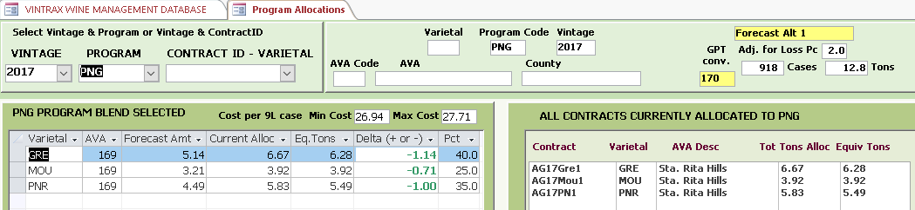

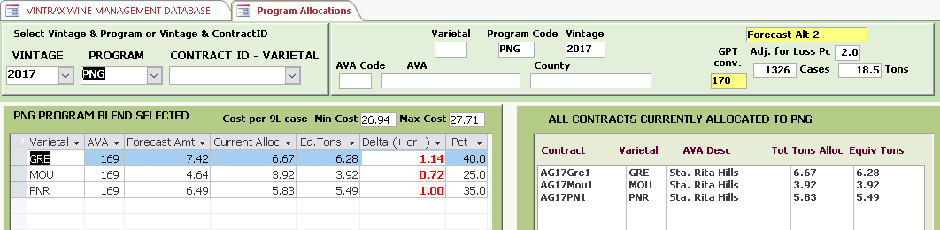

Where this is useful is when your sales projections have ranges of expected needs or where you haven’t yet determined the final case production you may need. These alternate forecasts are essentially a sensitivity analysis letting you analyze what impact differences can make with your available contracted tonnages. Since the two alternate forecasts used above both differ from the in-between sales forecast by 204 cases, they are the same values, one negative and one positive. This may not always be the case depending upon the forecasts you use. Analyzing this particular example lets you know your possible worst case scenarios, either being short an approximate ton or not needing the extra ton for the program. If this is not critical, then you can assume it’s not a risky situation. However if these numbers become a large amount of tonnage, then either your program requirements could be less than needed, or even worse ending up paying for and crushing tons you may not have an actual need to purchase.

Let’s go over a few other features now. For this I will use a screen for a program with several contracts allocated and not yet fully allocated. It’s typical of what things may look like when you have many different programs and contracts competing for the same resources.

The 2017 vintage and BTR program are selected. I have highlighted the Zinfandel in the blend and only one contract is currently available for allocation and has been used for a partial allocation of tonnage. The blend requires 6.21 tons and 5.60 tons have been allocated from contract G101_2019 (ignore the 2019 as its not related to vintage, it was just a contract name). As you look at this screen you will see the contract and 5.60 tons in several places as it should be. We will use this screen to describe the remaining features on this screen.

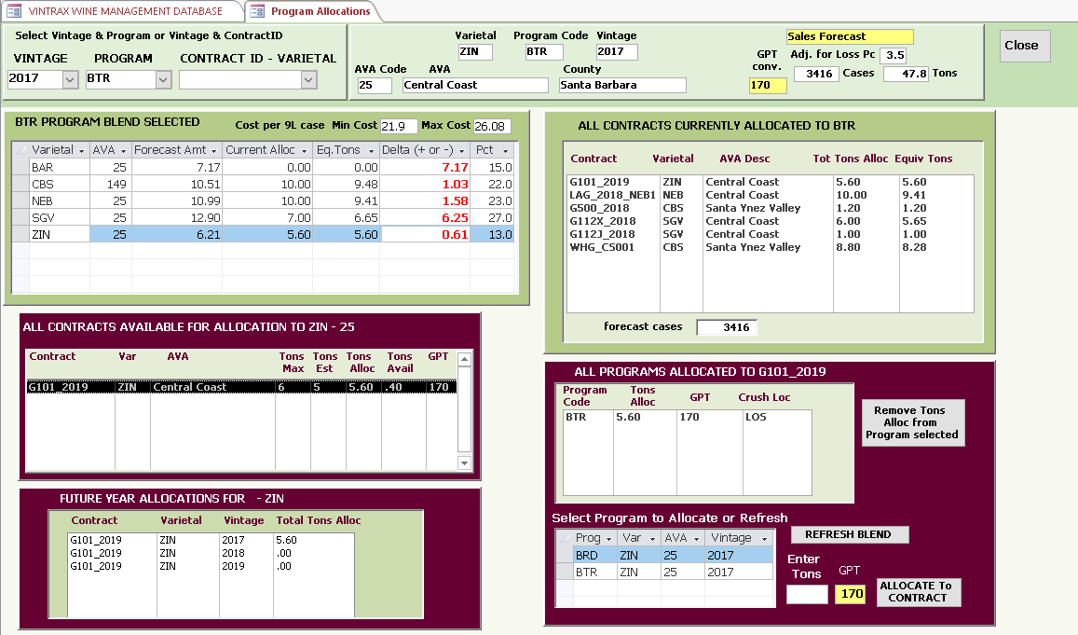

The first feature is when you want to remove either partial tons or all the tons from an allocation to a program from a contract. This may happen as a result of an improper or accidental allocation that was not intended, or perhaps you have decided to remove the tons from this program so they can be used on a different program.

If it was decided to remove just 0.60 tons for example, you would first highlight the BTR program which is not currently selected on the lower right (these are listed alphabetically), enter the -0.60 tons and click the Allocate To Contract and it would work the same as before, but just subtract the tons and update the screen.

If you wanted to remove the entire allocation you could enter the -5.60 tons, however the easier way would be to highlight the program adjacent to the left of the button which reads Remove Tons Alloc from Program Selected and click and it will zero that allocation. Either way will accomplish the same end result.

The next feature is the REFRESH BLEND button adjacent to the allocations button. The purpose of this button is in cases where you may want to quickly see the alternate program or program(s) that are matching the contract that is selected on the left. In the case shown it would be the BRD program also using ZIN. When you highlight BRD and click the Refresh Blend button, it will cause the screen to refresh to show the blend percentages for the BRD program. After I click the refresh blend my screen now looks as follows:

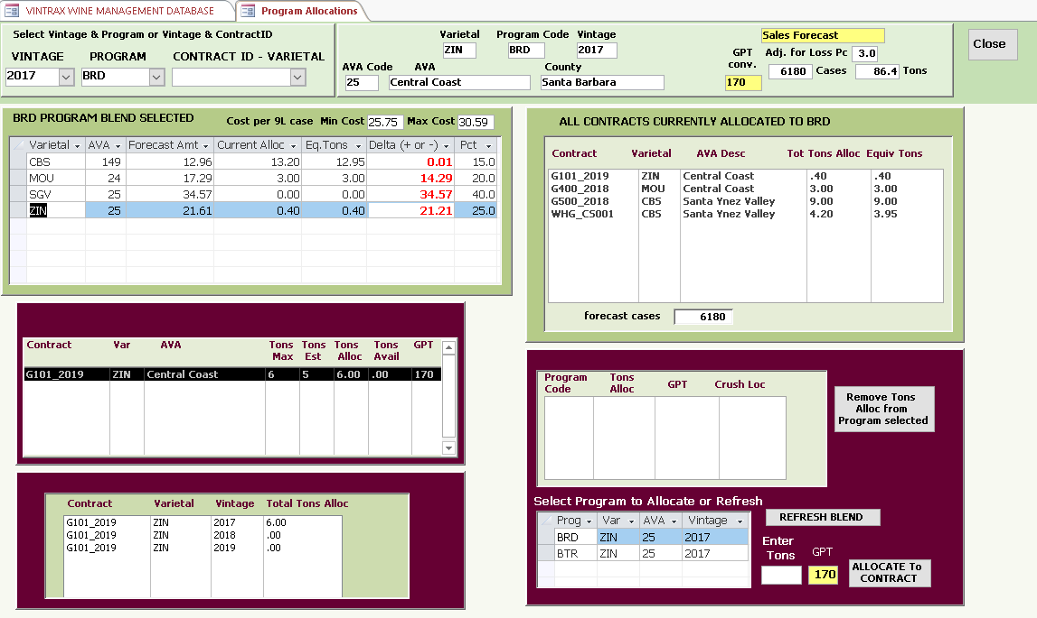

The BRD program is now displayed as well as all the contracts in the upper right. The header information also shows the BRD program forecast.

The last feature to look at is starting with the vintage and contract instead of the vintage and program.  
The main purpose of doing this would be if you wanted to look at a particular contract status and were not interested in looking at what the program blends were.

First select vintage from the drop down list at the top of the screen and then pick a contract from the contract list. I’ve selected 2017 vintage and contract G112X_2018 which is a grape contract with 6 tons allocated out of 6 tons max available, so this contract is completely allocated to program BTR. The other 2 contracts showing are also for SGV (sangiovese) in the Central Coast AVA of Santa Barbara County, so they would be alternatives for the BTR program if needed. For example the contract W113AG001 has 2.94 tons available that could be used. In most cases you can discover from selecting a program the alternative valid contracts, but this option is available if you may find it useful at times. Vintrax also will show you your options in several reports.

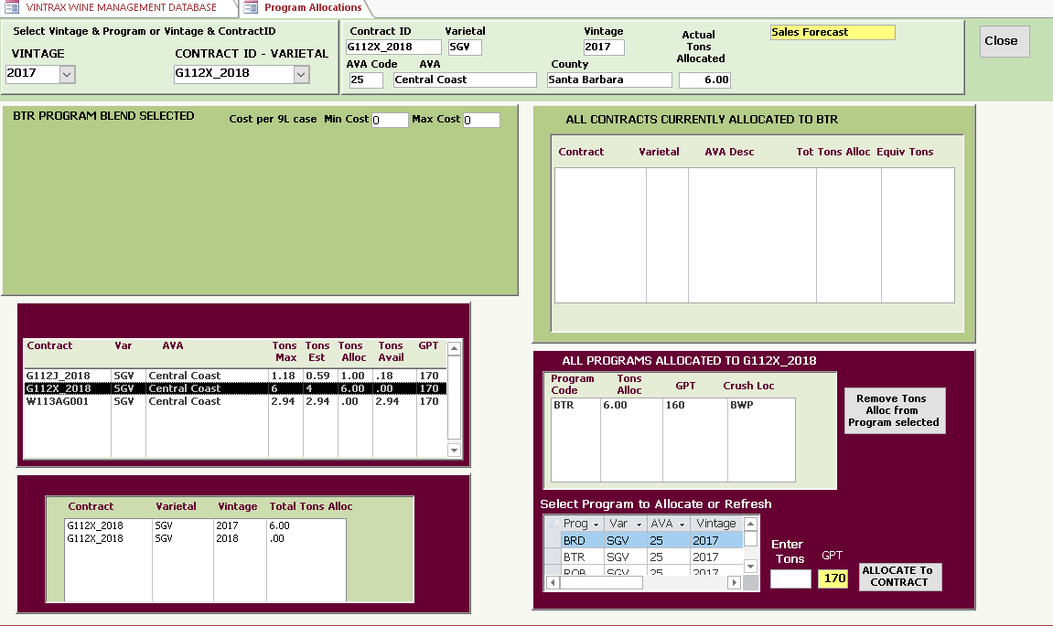

Next

**MANAGE HARVEST SCHEDULES**

During the time before scheduling for the crush, you will primarily be working with contracts and program allocations in Vintrax, while the grapes will be maturing in the vineyards. This will be the time when many of the Vintrax reports will be providing you with critical and timely information on the status and of your contracts and programs and assuring that you will begin the harvest in the best possible position.

It is important to note that harvest scheduling for a program should not be done until the final allocations from contracts have been completed. It would be a rare case that it wasn’t done a long time before harvest, but in the event the schedule is done too early and changes occur in the program allocations, it is possible to just delete the incorrect schedule and re-schedule as needed.

Vintrax allows for a 14 week harvest timeframe and the week start dates and end dates can be defined by the wine maker. Once defined the schedule screen and reports will use these definitions. For any given contract it would be highly unusual to use more than 2 or 3 of the weeks, with only the starting dates for crush being different between contracts. Once the crush has been scheduled for any given contract, Vintrax provides a Grower Booking report with includes the schedule which can be provided to the grower for coordination efforts to meet your crush planning. In the event the schedule needs to be modified, the existing schedule can easily be modified and re-submitted to the grower. This provides a mechanism to keep the grower and wine maker synchronized for arrival of grapes when you expect them.

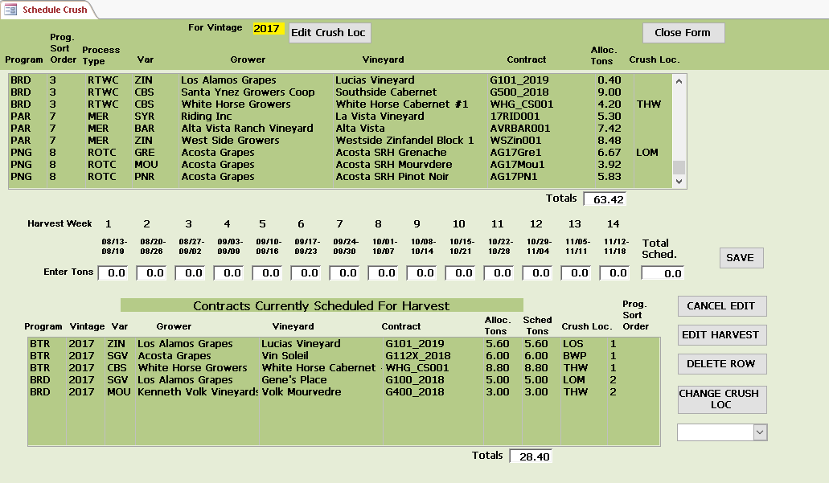

A quick word on weigh tags:

In most cases when a weigh tag is generated from a specific contract, the tonnage of the weigh tag would be assigned to a specific program, the one with the highest priority for the varietal and AVA for that weigh tag.   
There will be cases where the tonnage from the weigh tag is more than is required for a given program with the highest sort, and Vintrax will assign the remaining tonnage to the next highest program that qualifies for the specific varietal and AVA. In this split weigh tag example, a contract exists for 5 tons and the weigh tag totals 5.5 tons. The highest priority program requires 4.5 tons only, so the next highest program would receive the remaining 1 ton from the weigh tag. The must from the crush gets assigned to the same fermentation tank, and Vintrax will provide the gallons required for each program from what the fermentation tank produces. The highest priority program will receive 100% of the gallons required to meet the program requirements and whatever is left in gallons will go the program with the lower priority. In this way the program with highest priority is guaranteed to receive all that it needs and no more. In many cases the lowest priority programs will end up producing more generic, non-appellation specific wines so the actual gallons assigned are not as critical as they are for your premium labels.

To begin scheduling contract for harvest, the first step is to decide the crush location for the program and make the crush location for the contracts be the same. This decision should be made before harvest scheduling is started. Click the EDIT CRUSH LOC button at the top of the form and it will open the crush location editing window.

The top part allows you to define the crush locations that you will be using. Create a 3 character code and a crush location description for each location.

The bottom part of the screen displays the existing contracts and the programs they are allocated to. It is best to assign all contracts for a given program to the same crush location as it would be rare to crush at more than one location. However, if cases exist where that is required, Vintrax will allow assigning the crush location by contract.

Highlight a contract row in the bottom window, select the crush location from the drop down list and click the Assign Crush Loc To Selected button. The screen will refresh afterwards. Do this for all contracts before scheduling.

If you ever need to change the crush location, edits can easily be made on this screen.

The bottom image on the next page shows the contracts with the allocated tons and the now added crush locations. These contracts are ready for harvest scheduling.

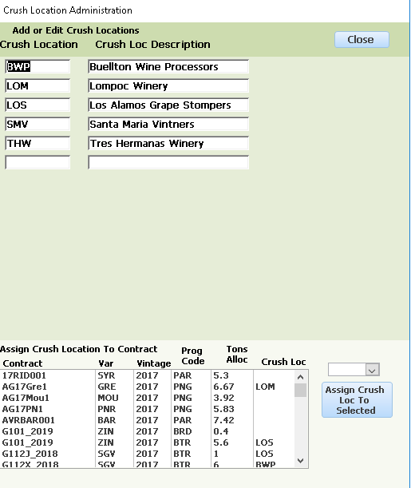

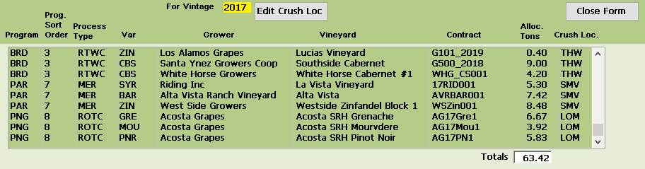

Highlight the row for the contract that you want to schedule. Enter the tons in the appropriate weeks. The case shown reflects the grower plans to deliver 5 tons on 10/21 and the remaining tons on 10/22, hence the split assignment. Depending upon the weight of the first weigh tag, the second delivery may be adjusted. Assignments are made in 200 lb (1/10 ton) increments as a practical consideration. A small amount of anything extra will end up being assigned to a lower priority program that is not dependent upon exact ratios in the blend.

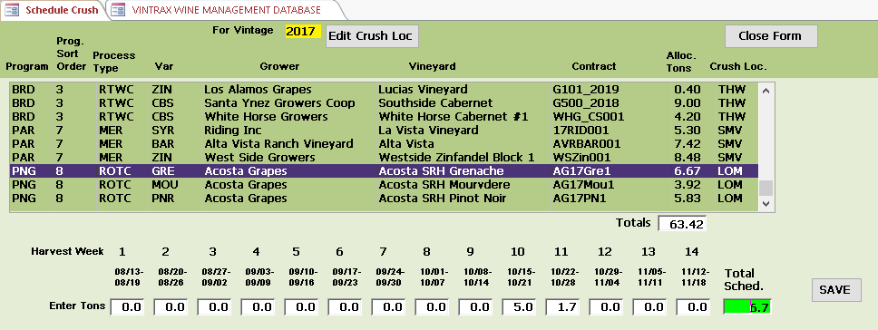

Click the SAVE button and the contract moves from the top window to the bottom window.

Note the total allocations for contracts to be scheduled and the totals for scheduled contracts has updated.

If you need to view or edit an existing scheduled contract, highlight the contract row and click the Edit Harvest button. You can make changes and then click Save or Cancel the Edit.

As a convenience if needed you can also highlight the scheduled contract, select a new crush location from the drop down list and change the location.

If you want to delete the schedule for a contract, highlight the row of the contract and click Delete and the contract will move back to the top window so it can be re-scheduled later.

Anytime between from beginning your scheduling through crush you can view or print the Vintrax Harvest Schedule report or the Grower Booking report to see the status of your schedules.

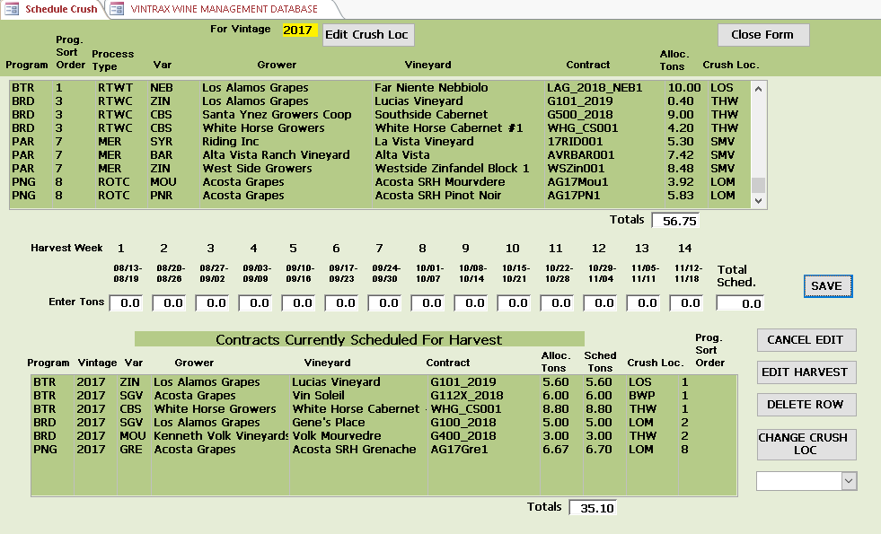

Next

**ENTER / IMPORT WEIGH TAGS**

Once harvest begins and you begin receiving contracted grapes with the weigh tags, Vintrax allows you to either enter each tag manually into the application or as an option import your daily tags from a formatted excel worksheet directly into Vintrax. The import method requires your excel template to match the Vintrax column naming and column ordering and the excel file needs to be saved to a file location required by Vintrax. This will be explained in more detail in the administrative section of this guide. If you need assistance in designing the interface between your weigh tag application and the Vintrax excel template, it generally is a routine process and can be completed in a few hours.

When using the Vintrax screen for entering weigh tags the process is as follows:

Click the Enter / Import Weigh Tags button on the main menu to open the screen to enter weigh tags. When the screen first displays it will be ready to add a weigh tag.

Any previously entered weigh tags will appear in the window at the bottom. If you need to view or edit an existing weigh tag, highlight the weigh tag and click the Search button and the details will populate in the screen fields. You can now make edits to the fields, or just view the tag. When finished click the SAVE button again and any changes will be updated in Vintrax. If you do not make any changes Vintrax will leave the record as it was.

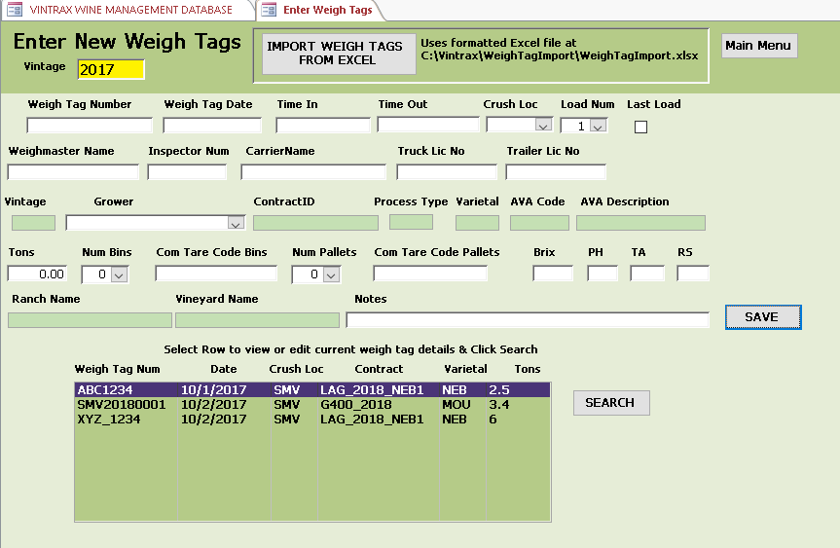

As weigh tags are an important part of wine compliance requirements, it is worth the effort to fill in the screen fields as thoroughly as possible. Vintrax will provide very detailed reports which can assist you in an inspection or audit situation, but the more data available, the better the report output becomes.

Many of the fields shaded green on this screen will auto-populate based upon your entries, so there is not as much to complete as it may appear.

For purpose of describing the screen, I have selected an existing weigh tag using the Search to enter Edit mode. When you select the grower for the weigh tag, the options will allow you to choose the varietal and contract based upon the delivery records for the weigh tag.

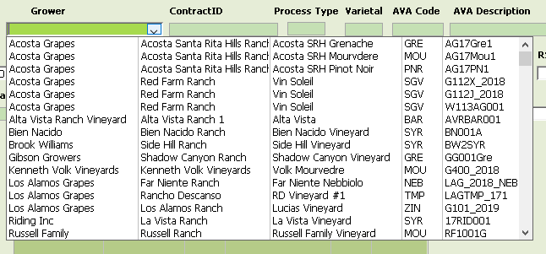

Your booking report to the grower would have had the contract ID, varietal, and vineyard location and the weigh tag should be matched to this information.

The example shown below has all the required fields completed that will comply with weigh tag requirements.   
In cases where macro bins or pallets are used, complete the associated fields with quantities and descriptions such as 7 bins with Common Tare Code as MacroBinHT.

Once all the information is entered click SAVE and the weigh tag will move to the window below.

Vintrax provides a Daily Crush Log by crush locations as well as a Crush Report for all dates and crush locations to make it easy to manage your incoming weigh tags.

Once configured, to Import your daily weigh tags from an excel file, Click the Import Weigh Tags from Excel at the top of the screen and the imported tags will show up in the lower window. By running the Daily Crush Log at the end of every day you will see all the incoming weigh tags for every crush location for that day.

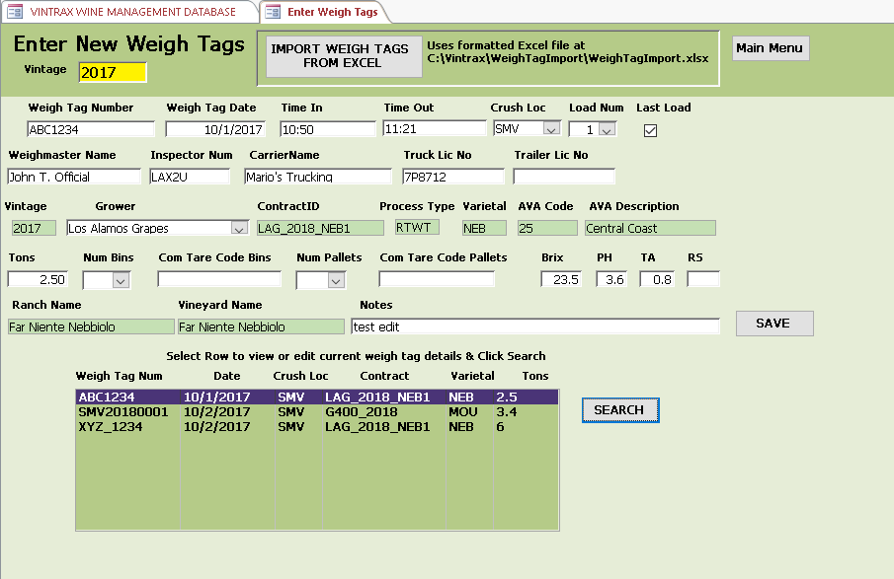

Next

**ASSIGN WEIGH TAGS BY USE**

As your incoming weigh tags get entered in Vintrax, you may begin assigning the grapes from the weigh tags to the correct program for the varietal and AVA source. Vintrax performs this assignment quickly for you using the sort priority of the program and the specification for the source of the grape varietal.

Click the Assign Weigh Tags By Use on the main menu to open the assignment screen.

To begin, some features of this screen will be explained.

The left window will list all the weigh tags that have been entered into Vintrax that need to be assigned to programs. The right window will list all the weigh tags that have been processed by Vintrax into their intended use programs according to their tonnage requirements. The two drop down lists in the bottom left will display the processed weigh tags by contract and the processed weigh tags by program. For example when I select the BTR program I get the popup window with the 2 weigh tags matching the two in the processed window.

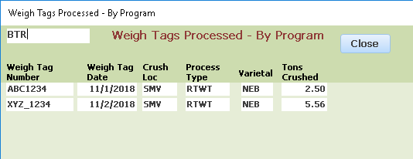

Likewise, when I select a contract the popup window shows the contracts that have had weigh tags processed.

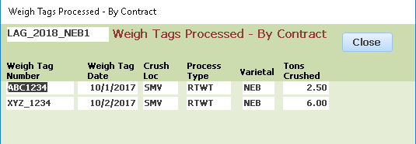

Note weigh tag number XYZ_1234 was a split weigh tag with partial tons going to the primary program with the highest sort and the remaining to a program with the next highest sort.

Should you need a reminder as to what the AVA code references, the drop down list at the top of the screen will allow you to quickly look up the description.

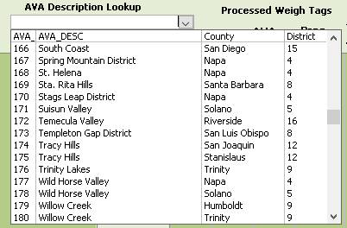

The final item is the drop down list to assign the processed weigh tags to a fermentation tank.

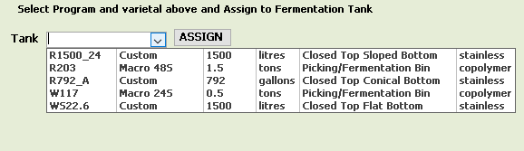

These tanks and descriptions can be edited to your requirements as needed to match your exact conditions in your winery. Right click the list and select Edit List Items to enter this form.

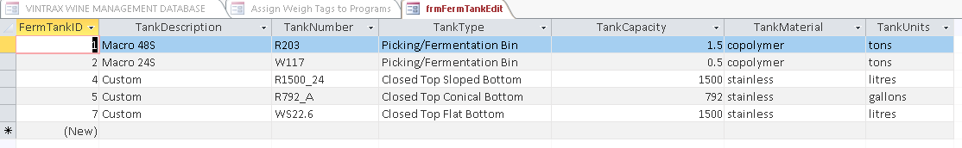

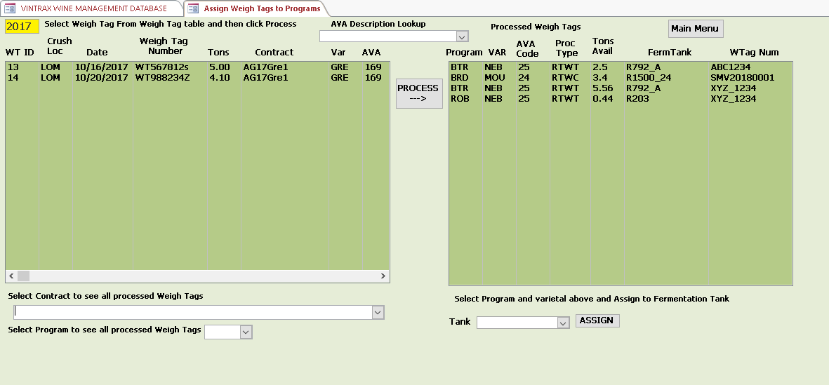

The screen shown above has 2 un-processed weigh tags on the left and 3 weigh tags on the right that have been processed with fermentation tanks also assigned. (Weigh Tag XYZ_1234 being split between two programs.) Once assigned to a fermentation tank you can print a report from Vintrax with the details for the tank and attach it with your paperwork on the tank for reference.

Once the weigh tag has been assigned to its intended use and the fermentation tank you will have a cradle-to-grave record of all the grape varietals, AVAs, tons, blend percentages in your program and together with sales forecasts, case forecasts to compare with actual cases produced and bottled. There are several reports in Vintrax to provide you details along with a complete vintage summary for all of your programs. This information will serve you in many ways from future planning to inspections and audits, determining label contents and compliance and knowing you have the details necessary to manage and grow your business. Along the way, you may also have avoided costly mistakes, lost time and loss of revenue.

To process a weigh tag highlight a weigh tag in the left window and click the Process button. Vintrax will find the program with the highest priority and assign as many tons as required. In some cases the tons from the weigh tag will fully supply the requirements of the program, in other cases it will only meet part of the programs tonnage requirements. The next weigh tag that comes in for the same varietal and AVA from a contract allocated to the program will pick up the remaining difference. This will continue until the programs needs are met. Any remaining tons from a weigh tag get distributed to the program with the next highest priority.

After processing weigh tag WT567812s it now has moved to the right window for processed tags. The fermentation tank has not yet been assigned. All 5 tons were allocated to the PNG program. In the original allocation requirements the Grenache requires 6.67 tons, so this weigh tag only partially fulfilled that need. The next suitable weight tag that comes in will also go to this program until the 6.67 ton requirement has been met.

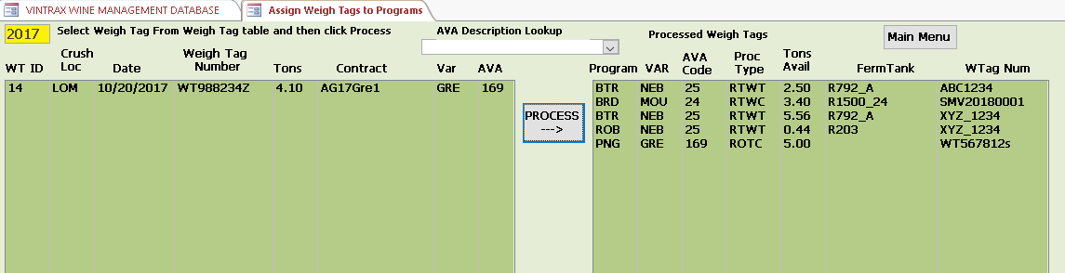

Inspecting the Daily Crush log for this date part of the report shows

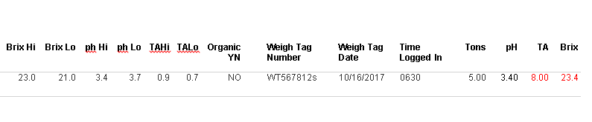  
The brix sampled for the weigh tag is highlighted in red just to show it is outside the contract range for brix. The TA in red reflects a typo in entering the weigh tag value for TA and can be noted was probably 0.8.

The Processed Weigh Tags report reflects the new processed weigh tag and the expected gallons from the 5 tons crushed using the gallons per ton estimated from the vineyard calculations. Note the second weigh tag has been assigned to the fermentation tank.

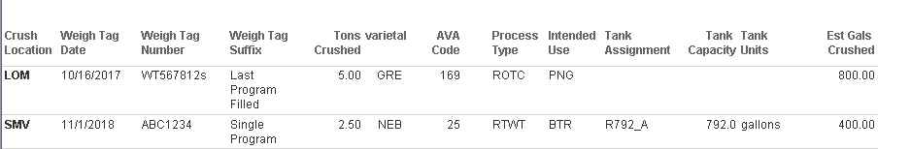

After processing the second weigh tag a total of 9.1 tons or 2.4 tons more than was needed has been assigned. In this example the weigh tag suffix reported Last Program Filled for both weigh tags as this was the only program using this varietal and AVA. The split tag XYZ_1234 also shows that BTR got the tons it required with the excess going to the ROB program which was the lowest priority for this varietal and AVA.

This is only a simple example. By knowing in advance which programs have allocations you will be able to prevent a situation like this from happening by either not receiving the extra 2.4 tons of grapes which you may not have an actual need but end up paying for, or alternatively having a second program that would require these extra tons in the blend. Having Vintrax show you well before crush will prevent this problem.

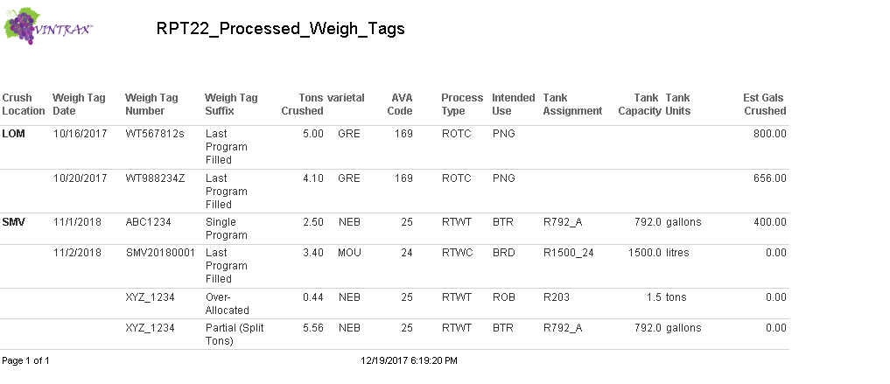

After the two new weigh tags have been assigned to the same 1500 gal fermentation tank, he process is completed for these two weigh tags. Paperwork can now be added to the fermentation tank with the grape source information provided by Vintrax. As the blend proceeds through the wine making process, the paperwork from each varietal and AVA can accompany the wine until bottling. At any time Vintrax will provide the reports you need to manage the sourcing and recordkeeping for the grapes that were used in your wine.

A few more reports are included below.

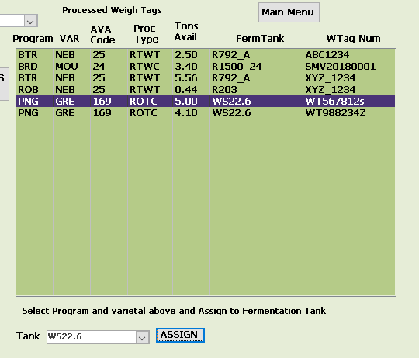

Looking at the top part of the Harvest Report the two weigh tags for the PNG program are listed and total 9.1 tons crushed. All contract allocations including those where weigh tags have not yet been received are included in the top part of the report, such as the bottom one in this screenshot.

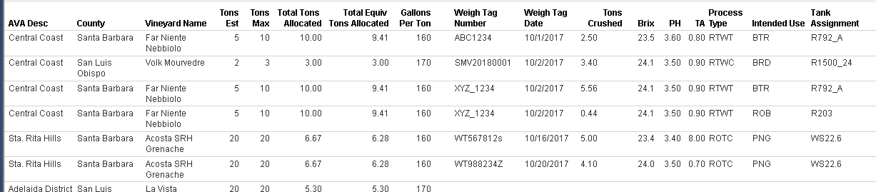

The bottom part of the same report shows the two weigh tags from the contract and the 9.1 tons is in red as it indicates more tons were crushed and assigned than originally allocated. The bottom part of the report ONLY shows contracts where weigh tags have been entered.

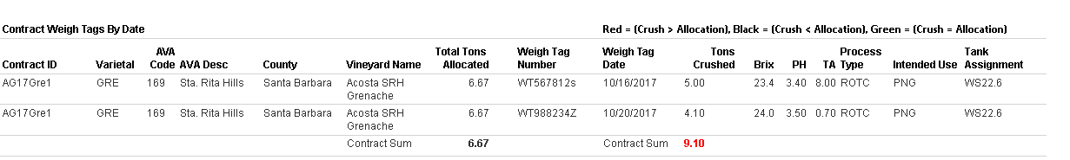

On the Fermentation Tank Detail report for the PNG program only the two weigh tags have been processed for the Grenache. The 2.29 tons in red indicates an over-crush for this varietal and AVA. Once all the weigh tags are in for the entire program, with all the varietals showing for the blend, the total program allocation tons will show also. For the BTR program immediately above the PNG program the green for the Nebbiolo indicates not enough tons have yet been crushed.

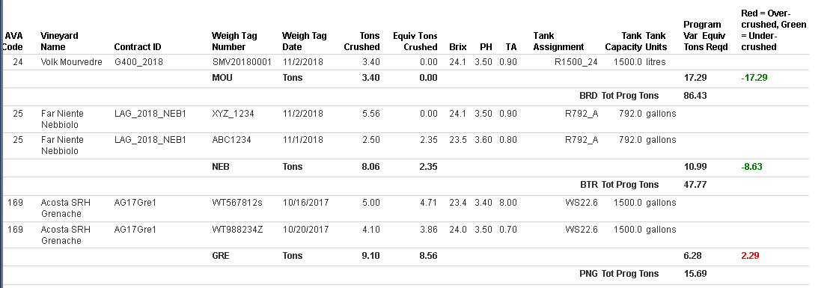

An additional note on how Vintrax processes weigh tags and assigns to the correct program. Once the sort order for a program has been assigned giving to it the corresponding priority it has for receiving the tons from weigh tags for the varietal and AVA required, Vintrax will use the program with the highest priority to assign tons. Each crush location and process type determine how the tons are assigned. If there are three competing programs for the same varietal, same AVA, same processing type, then the priority determines which program gets assigned the grapes from the weigh tag UNTIL that programs needs are fulfilled. At that point the next highest priority receives any remaining tons from the weigh tag, if any remain. The Rpt26 Fermentation Tank Program Gals on the next page shows the end result of this assignment.

Note the SGV at the LOS crush location in the screen shot following. There were 3 programs that required the same SGV from the same AVA. The BTR program with the highest priority received all the tons from weigh tags until its 8.96 ton requirement had been met, followed by the BRD program with the next highest priority, and last the ROB program received the balance remaining. When it comes time to process the fermented wine, the gallons for each program are also assigned according to sort order. For the case shown two programs were processed together in the fermentation tank GW5000_1 for a total of 2623 gallons. The BTR program will receive the first 1523 gallons from this fermentation tank and whatever remaining is assigned to the ROB program. This guarantees that the highest priority programs always receive the exact amounts they require.

For recordkeeping purposes the exact gallons removed from the tank can be traced back to each weigh tag that contributed to that amount. As it is by process type, mixing quantities from several programs together during fermentation does not change the composition of the wine, by varietal or by AVA.

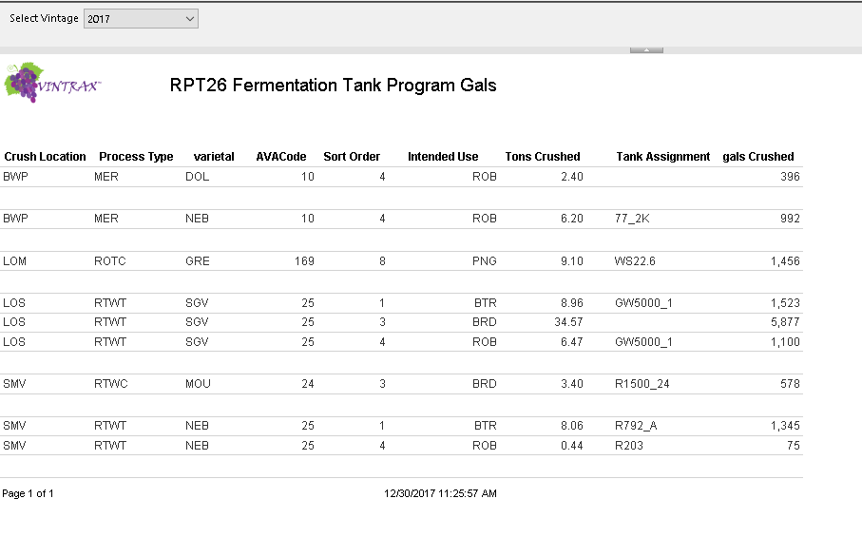

To illustrate the use of two Vintrax reports, I am including the Missing & Incomplete Blends Report and the Current Allocations report which I have exported to excel. (The report image has been reduced in size to fit this document, you can zoom to 200% in word to view easier). The column named Delta near the right side with the green zeros is showing the amount in tons that still need to be allocated from contracts to the various programs. There are three programs in need of Sangiovese from the Central Coast Santa Barbara AVA, totaling 56.3 tons. Rather than contract for tons individually by program, a new contract(s) for approx. 56-57 tons would be required to meet the needs of the 3 programs.

Before a contract is added with growers, it’s important to see what residual amounts in current contracts may still be available for allocation for the Sangiovese, so looking at the Current Allocations report for SGV we can find the existing contracts and check what amounts remain.

From the Current Allocations report there are 3 contracts for Sangiovese, the far right column shown adds to 0.18 tons still available for allocation. So it looks like contracts for 56 tons of grapes need to be sourced.

Keeping track of all your contracts, programs and managing changes that may occur with forecasts, weather, pests, fires, and other factors beyond your control will become very complicated if you have to wade through files to find what you need. With Vintrax you will see what needs to be done as things happen and can make your adjustments while there is time to correct things. Waiting until crush to find out you are under or over allocated, have inadequate contracts in place or programs designed with unsuitable blend requirements not matching your supply of grapes will lead to wasted resources, and reduced profit margins.

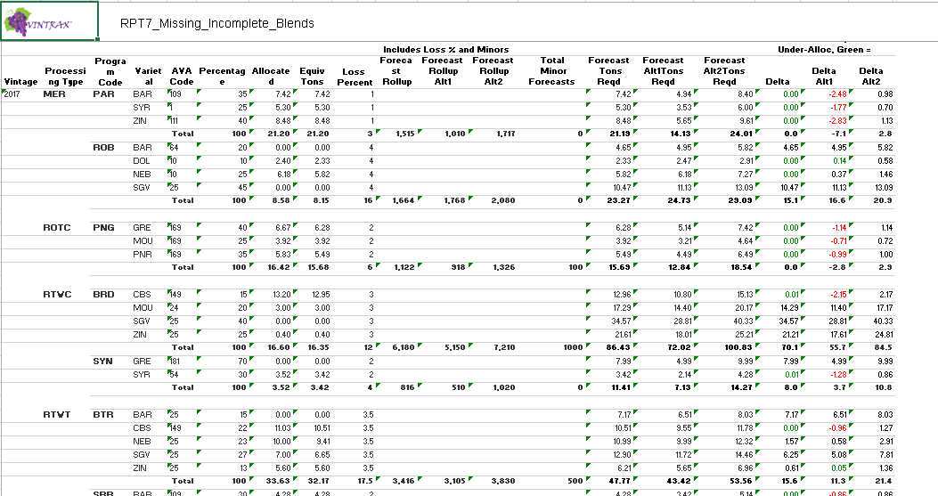

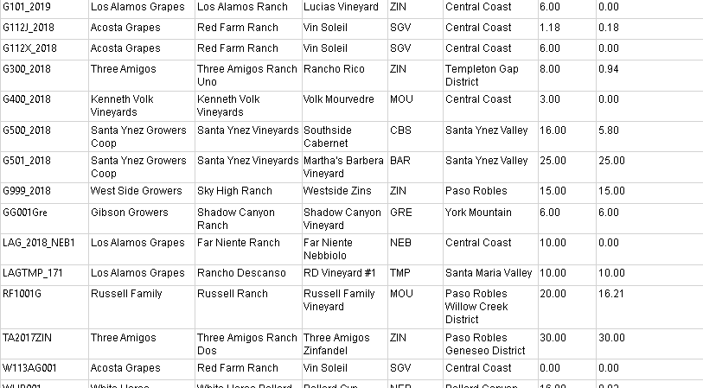

The lower part of the Current Allocations report also tells us the same information we see in the Missing & Incomplete Blends report. The equivalent tons remaining for the 3 programs using the Sangiovese total  
to 56.3 tons remaining to be allocated.

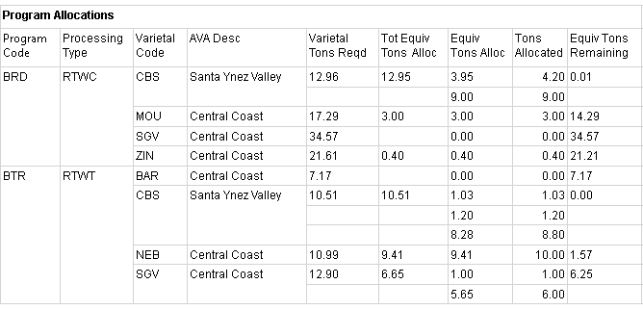

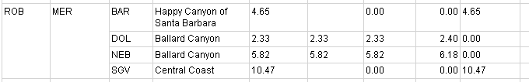

Finally, assume at the end after all your wine programs and blends have been fully allocated from the contracted tons, you have 4-5 miscellaneous tons remaining of several varietals and AVAs that are not needed for your programs. This equates to approximately 800 gallons or 336 cases of wine to be made. One option would be to go to the program blend tool, begin entering these remaining varietals into the blend tool until the tons used equal the amount remaining. By creating one or more programs to utilize these remaining tons, you will have created documentation and are now able to more easily track the source of the grapes that reach the fermentation tanks and finished bottled case goods. This is far better than trying to decide after the fact when you have many other tasks at hand or perhaps end up wasting these resources. In some cases the selling price of the wine could actually be higher as you may be able to label a specific appellation as you now have the documentation to prove the source of these grapes in your wine program. An extra $1 per bottle in selling price just made you over $4000 in added revenue!

This and many other features provided with Vintrax will help you with proper recordkeeping and documentation, prevent costly mistakes, and allow you to fine tune your processes that will result in a more efficient operation.

**A Few Last Minute Additions**

On the Manage Grower Contracts screen a hyperlink field has been added to open a pdf document in a file location located under Vintrax\Grower Contracts. The naming convention is contractID_Varietal_ContractType_GrowerCode which will be populated automatically by Vintrax. Double clicking in this text box will open the pdf saved with the same name at that location. Any contract documents you create can be named with this name and saved to this location which will allow you to open them at any time from Vintrax when the contract is selected on this form.

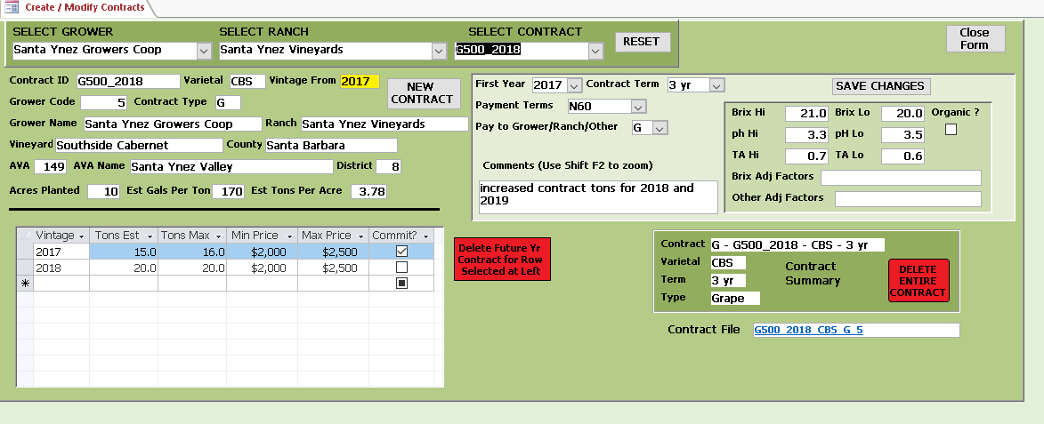

There is also a similar field on the Manage Harvest Schedules screen for a Grower Booking File which is the booking document either mailed or emailed to the grower after the grapes have been scheduled for crush.   
You have the option of saving directly from the Grower Booking Report as a pdf to this location or as another option saving any other document you may use with this name to the Vintrax\GrowerBookingRpt directoy.

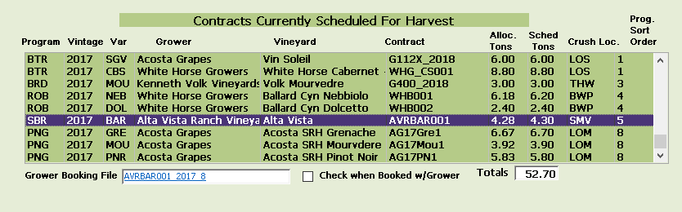

Note also, the checkbox next to the file name should be checked once you have provided the booking to the grower. The Vintrax Grower Booking report will indicate booked on all scheduled contracts that have been checked here.

Next

**Admin Menu**

Click the Admin Menu button on the main menu to open the admin screen. Here you will find various features  
for managing tasks in Vintrax.

The Freeze Current Vintage and Un-Freeze Current Vintage buttons are designed to mark records in Vintrax for vintages that should no longer be edited or changed. Tables with columns named Freeze will b changed from a value of 0 to 1 when set to Freeze and re-set to 0 with the Un-Freeze. At the end of every vintage, once per year, the just completed vintage records should be set to 1 with the freeze button. Final reports should be run and saved for the vintage and a database backup run to be saved as an archive.

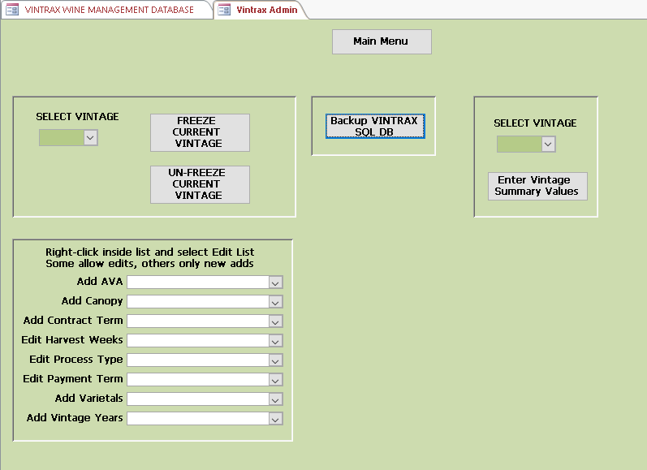

On the lower left are a series of drop down lists for the purpose of making it easy to edit many of the lookup tables, such as process types and payment terms. This gives you more flexibility in defining these values. Right-clicking in any of the list boxes and selecting Edit List will open an editing window where you can add rows. Some of these will not allow edits, only additional rows, as once a row has been used in the database with a matching value, the lookup value should remain. An example of the editing pane for process type is shown following.

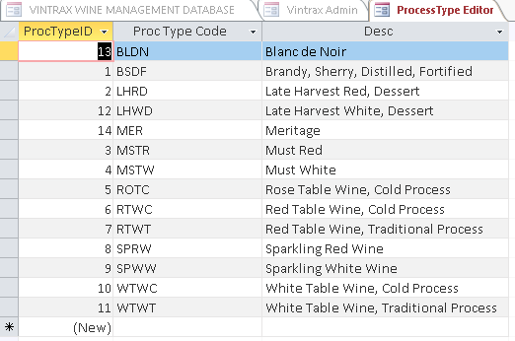

The Enter Vintage Summary values would be entered by the wine maker after racking and again after bottling.  
These will be the final three values needed by Vintrax to complete the Vintage Summary report. The Actual Cost of Total Tons Crushed for the program will be the sum of what you actually paid the grower for the grapes. The gallons produced after racking and final number of cases bottled will come from your production records for the program. Once entered click the Update Vintage Summary button and the Vintage Summary report will produce information such as final cost per 9L case and final loss percent difference between gallons produced at crush vs gallons bottled for the program. These numbers will help you compare programs and measure efficiencies and help you identify relative costs between programs.

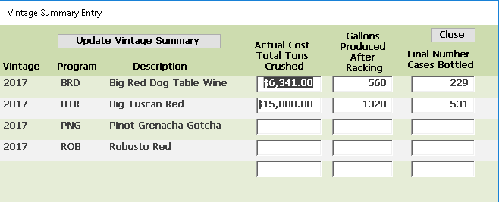

The Backup Vintrax Database button produces a backup of your Vintrax tables and can be run as often as required. It will save the current database with the date saved as part of the file name to the directory C:\VINTRAX\VINTRAX_SQL_BU\. An example name would be VINTRAX1205.bak

Periodically you can delete older versions of the backups, but should retain at least 3 with the most recent dates as an added preventive measure. You should not experience any loss of data using Vintrax. SQL Server is a rugged and proven database that will adequately protect and secure your data. The backups will give you what you need in the event you have a computer or operating system error unrelated to the database. It is also good practice to keep a copy of the backups, either on a thumb drive or removable drive as a second option.

Your backups are more than likely going to be in the MB size not GB’s, so they will not take up a lot of storage space.

Next

**Reports Menu**

Clicking the Reports Menu from the main menu.

Each report will open in Sql Server 2016 Report Builder where you will be able to view and export the Vintrax reports.

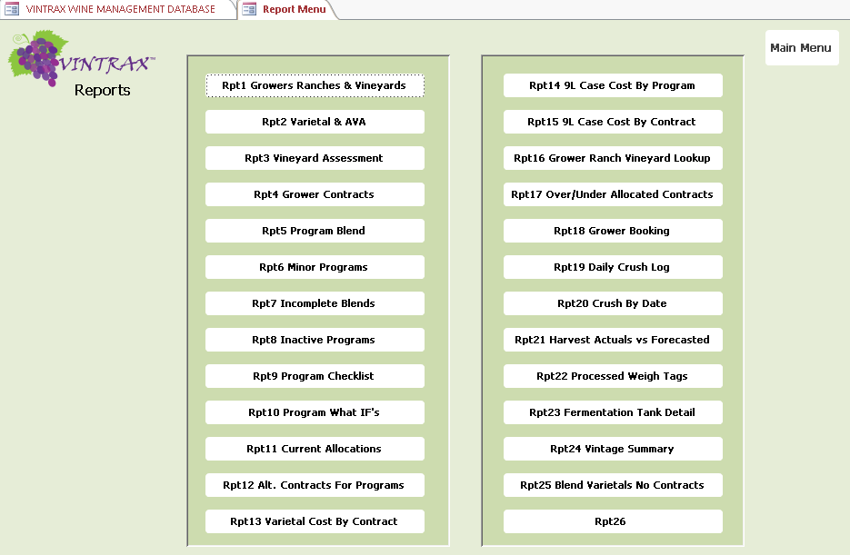

The Vintrax reports provide the information you need to manage the grape sourcing from vineyard to fermentation. There are 25 reports configured to provide this information. Each report can be exported directly to excel for further analysis if required. Exports to PDF and Word are also supported.

Partial examples from each of the 25 reports follow with some comments on each.   
Zoom to 200% in Word to view these in more detail.

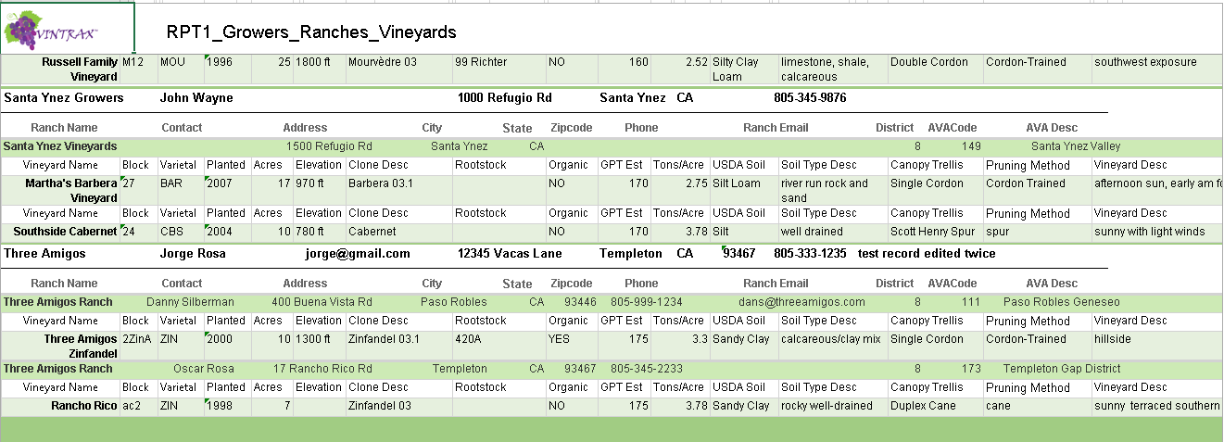

Details on growers, ranches and vineyards in one convenient reference location.

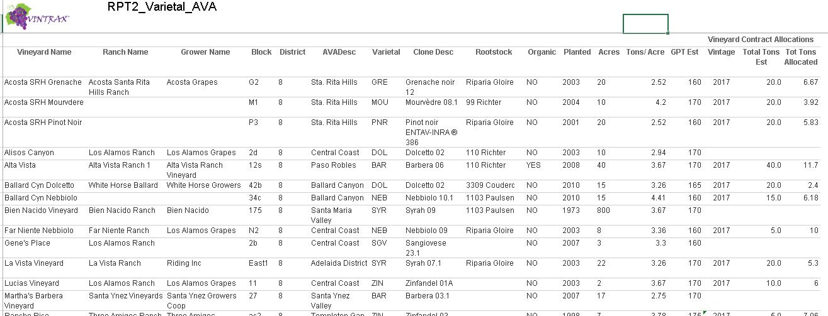

Displays varietals used, AVAs, Clone, rootstock, and current contract allocations.

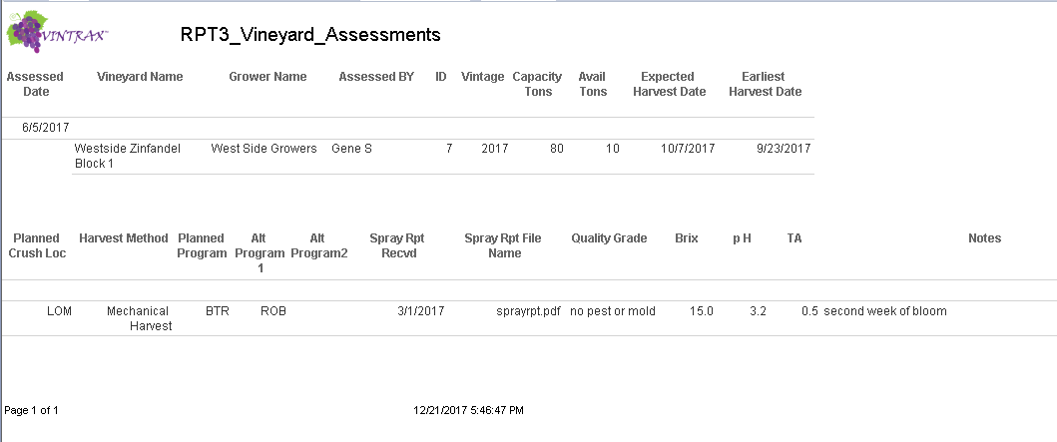

Maintain a log of vineyard inspections during the year.

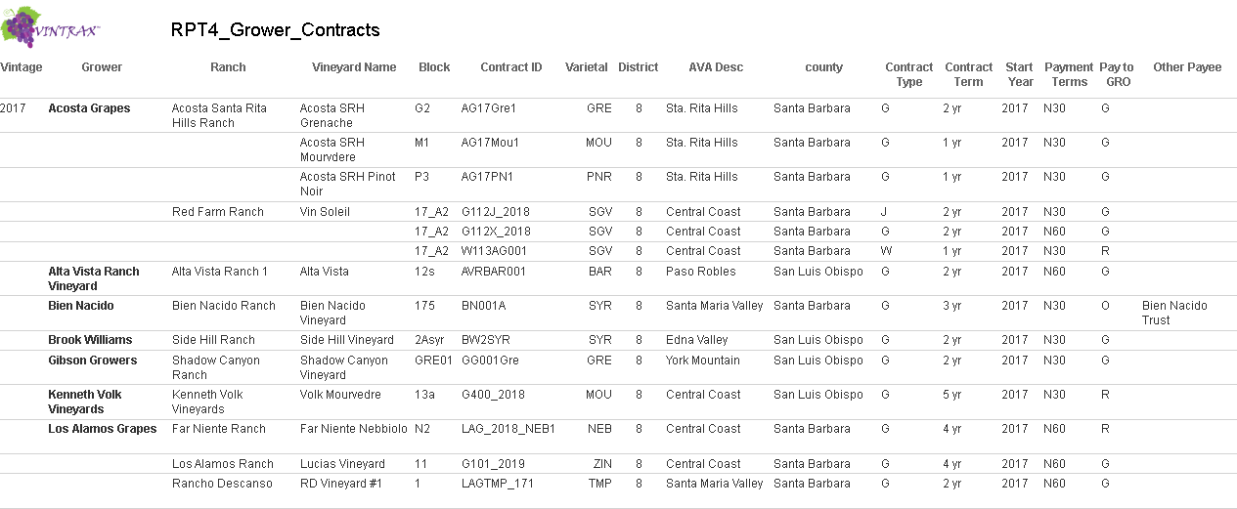

View all your existing contracts from one location.

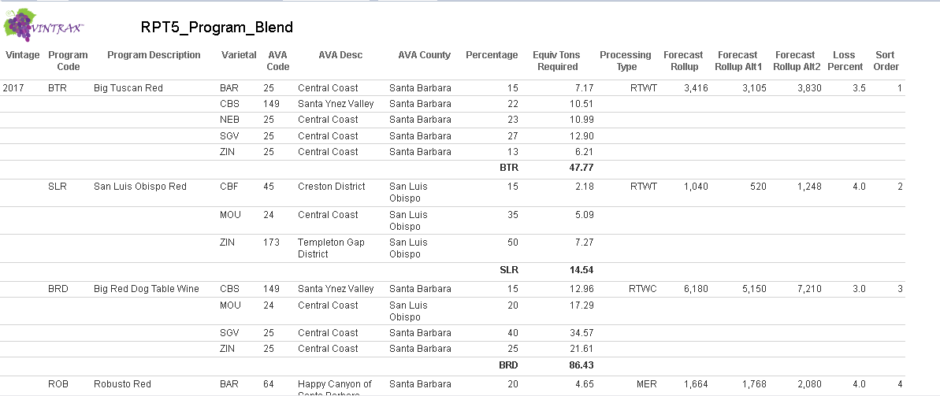

Be able to see all your wine programs and blends at a glance along with forecasts and tons required for each.

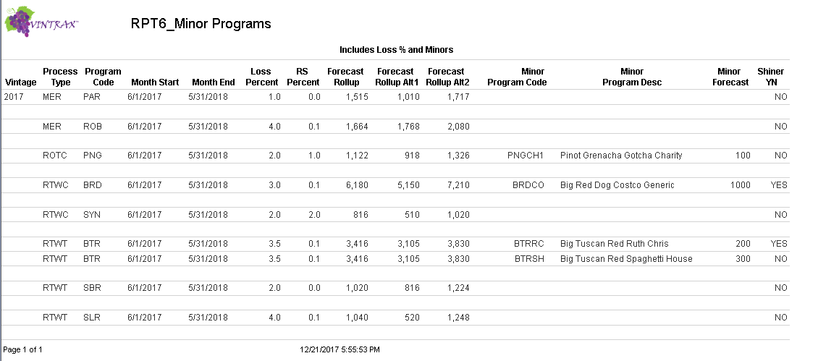

Know the status of your Minor Programs.

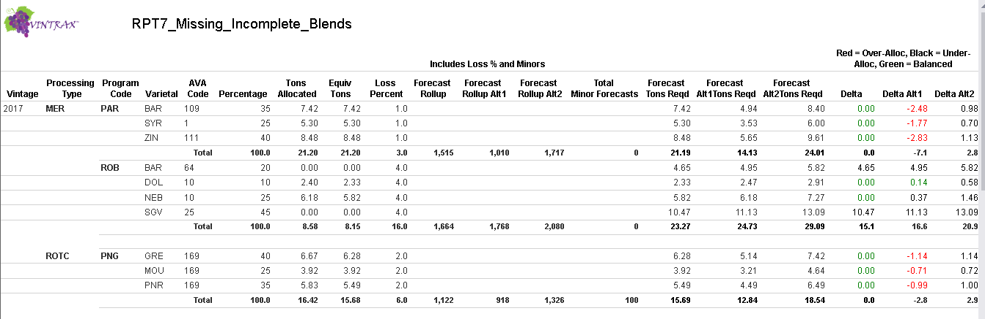

Identify programs and blends with over-allocated or under-allocated tons.

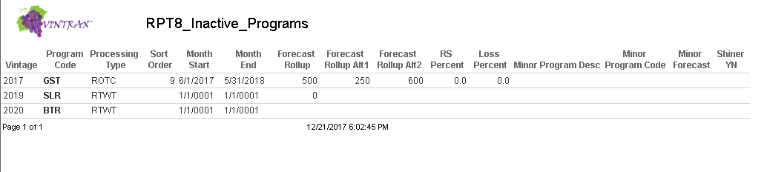

Check for Inactive Programs status.

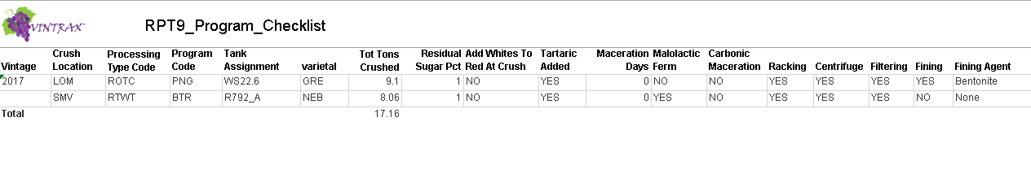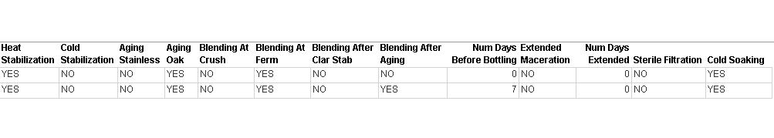

Keep a checklist reminder for each program.

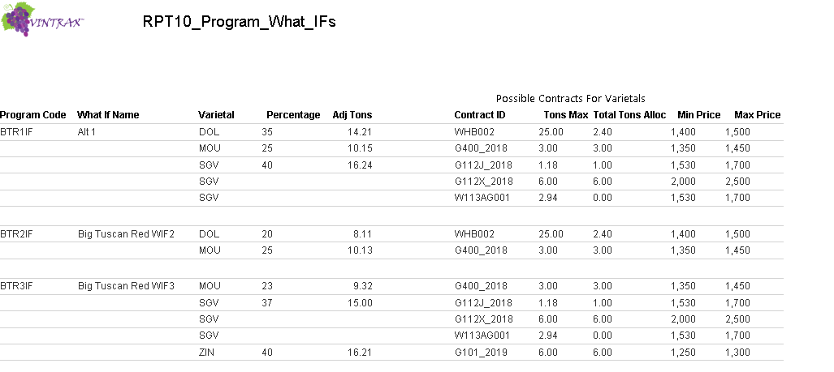

Use What Ifs for contingency planning and alternative scenarios and see what contracts are available and how the tons are distributed across programs.

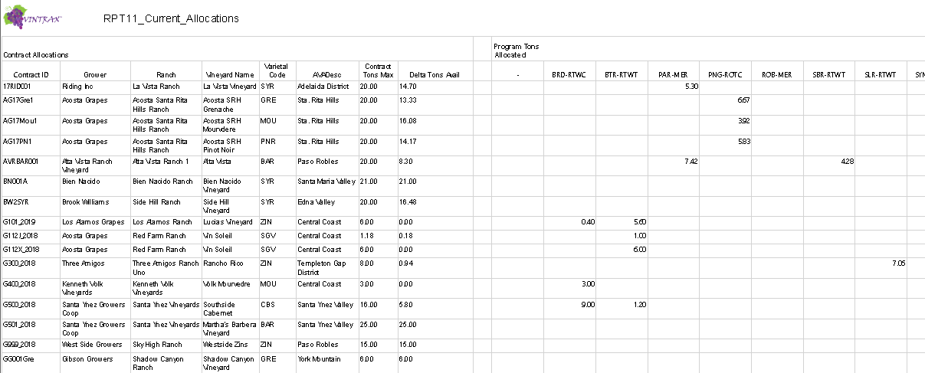

See how your current allocations align with your programs and process types. Bottom half of report pivots by program to show contracts allocated from.

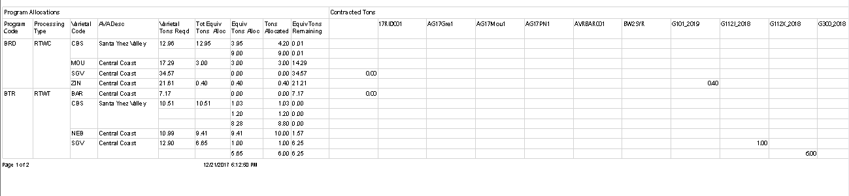

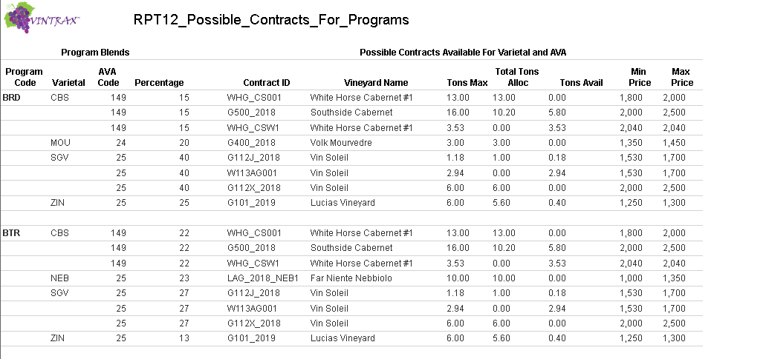

Identify alternative contracts that meet the program blend requirements for varietal and AVA.

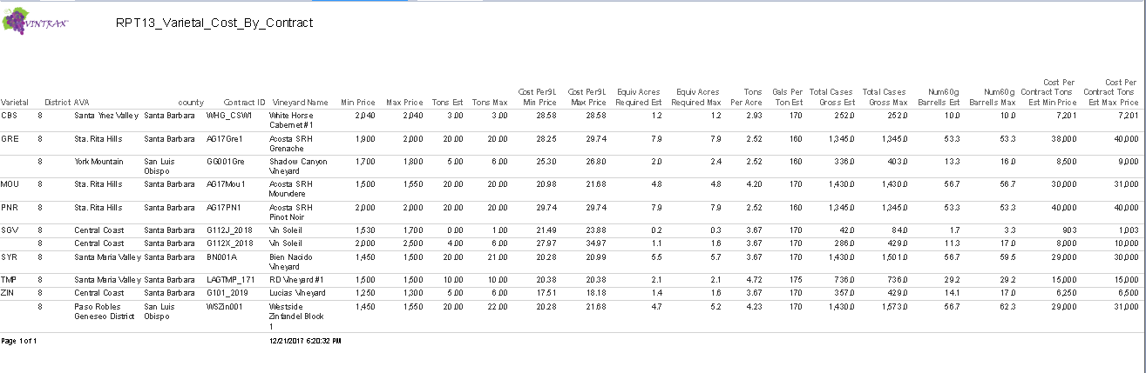Know the cost of each contract for any varietal and AVA and quickly compare details.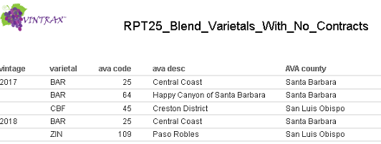  
Before you begin allocations, check to see if you have the required contracts in place.

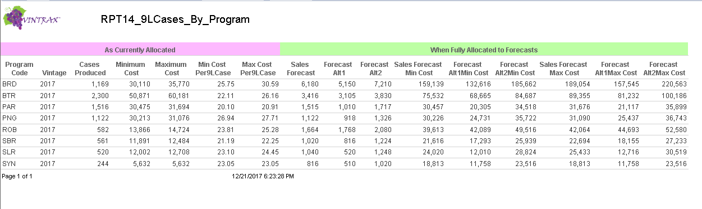

Analyze at any time the current status of as-allocated programs and expected costs when fully allocated.

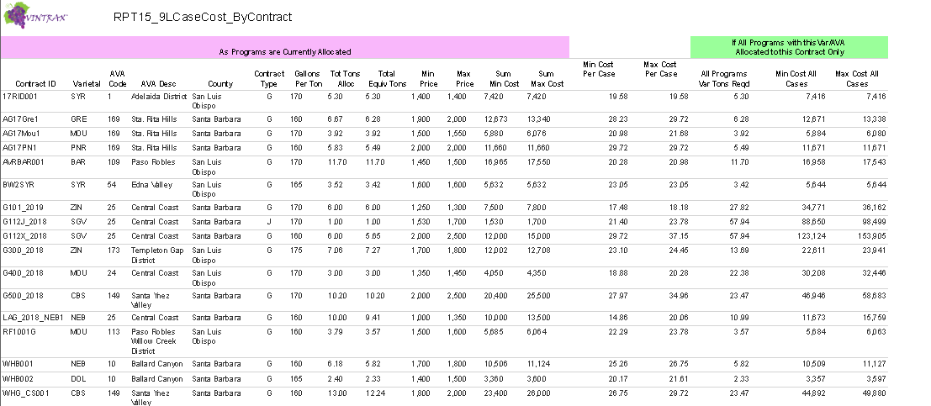

Analyze at any time the current contract costs associated with the tons allocated to programs as well as a comparison of contract costs for the same varietal and AVA.

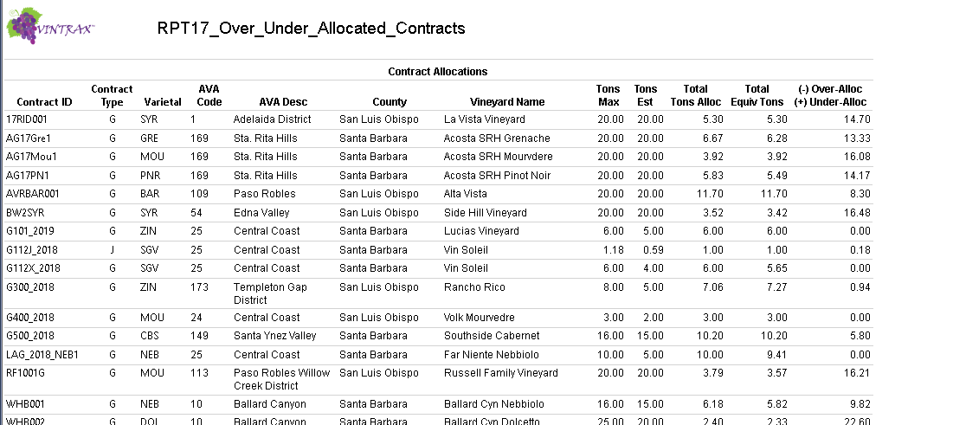

View the current status of contracts and remaining tons available for allocation to programs.

On the bottom part of the report see the actual programs that the contracts have been allocated to.  
This is useful when changes and events require you to re-allocate and prioritize resources for the best outcome.

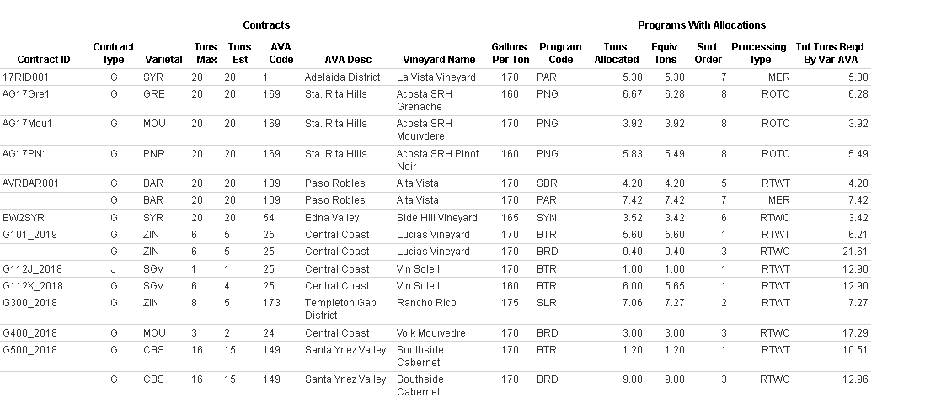

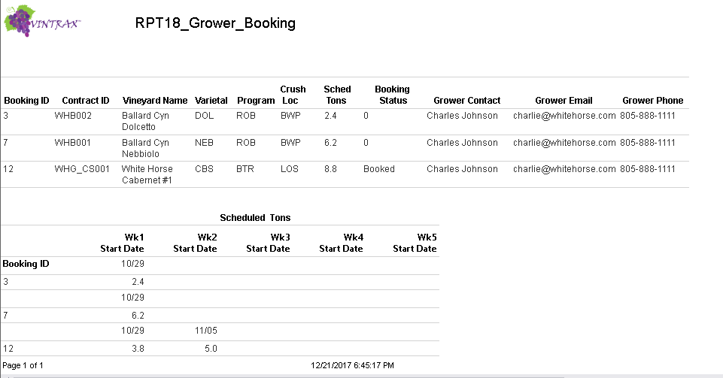

Coordinate your harvest schedule with your grower booking to avoid receiving grapes when you aren’t expecting them or not receiving them when you need them.

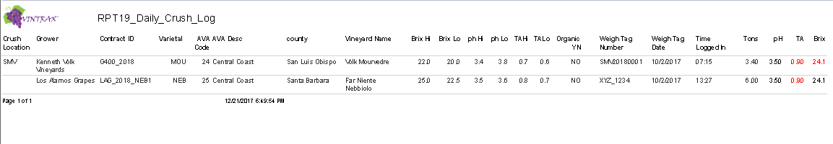

Maintain a Daily Log of crush by location, contract and compare crush chemistry with contract chemistry.

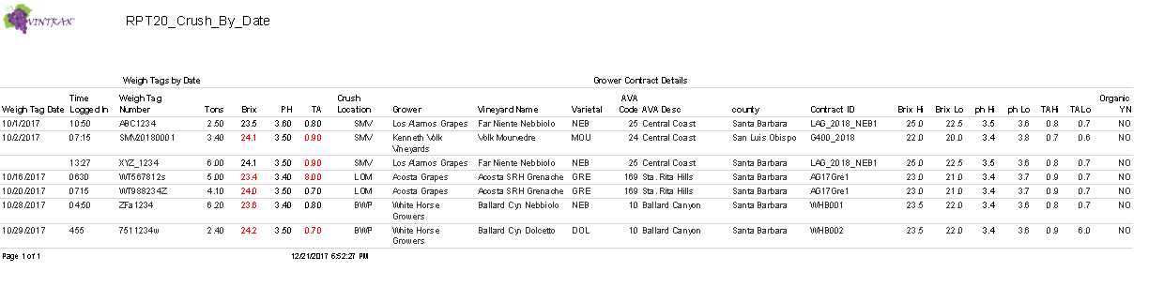

View the entire crush by vintage as it happens by crush date.

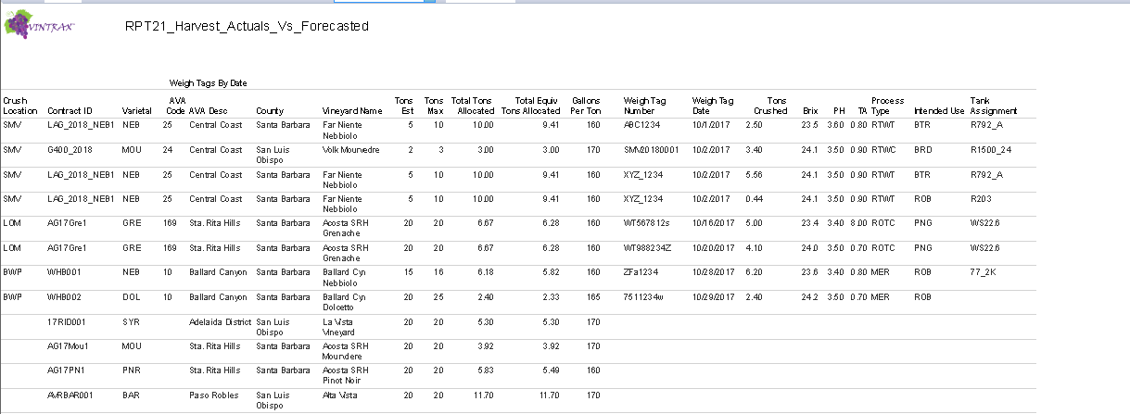

Compare actual tons crushed with expected tons for each weigh tag and identify the destination by program and fermentation tank for every varietal and AVA.

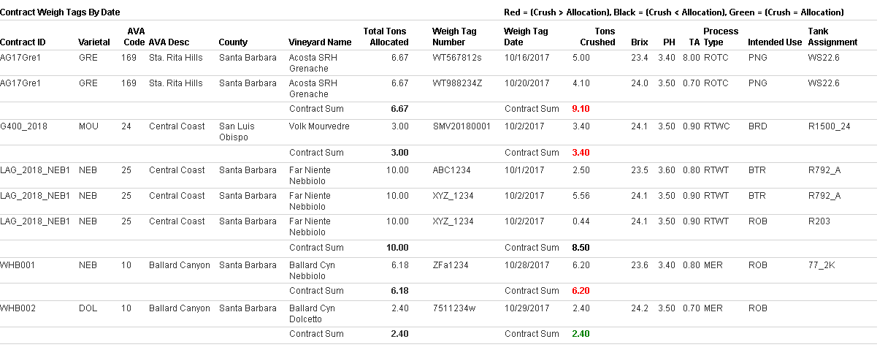

The bottom part of this report sums tons crushed by contract and identifies where crushed amounts vary with allocated tons. These amount change with every weigh tag entered and allow you to track the progress of every contract.

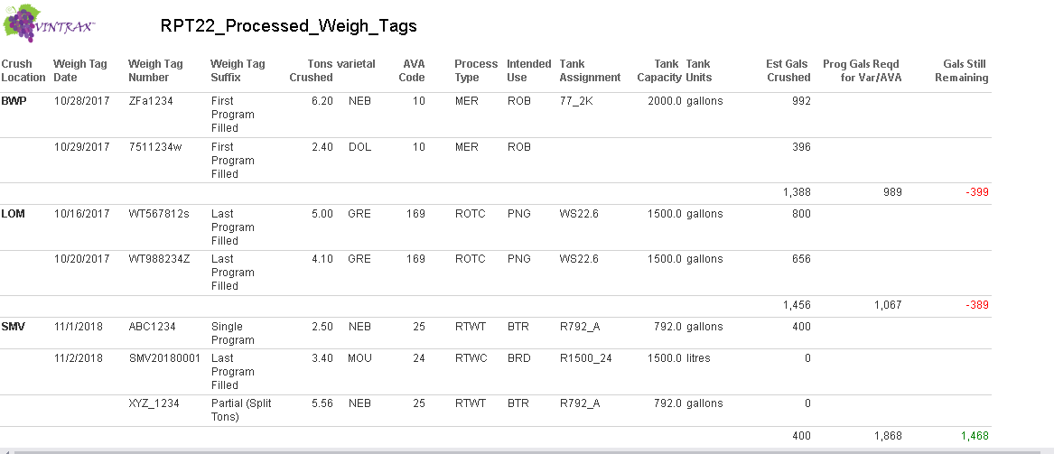

The processed weigh tag report identifies the weigh tags that have been assigned to their intended use programs by Vintrax according to the program priority to receive the weigh tag tons. As weigh tags are entered and assigned by Vintrax, the gallons remaining to fulfill the needs of the program are updated.

The 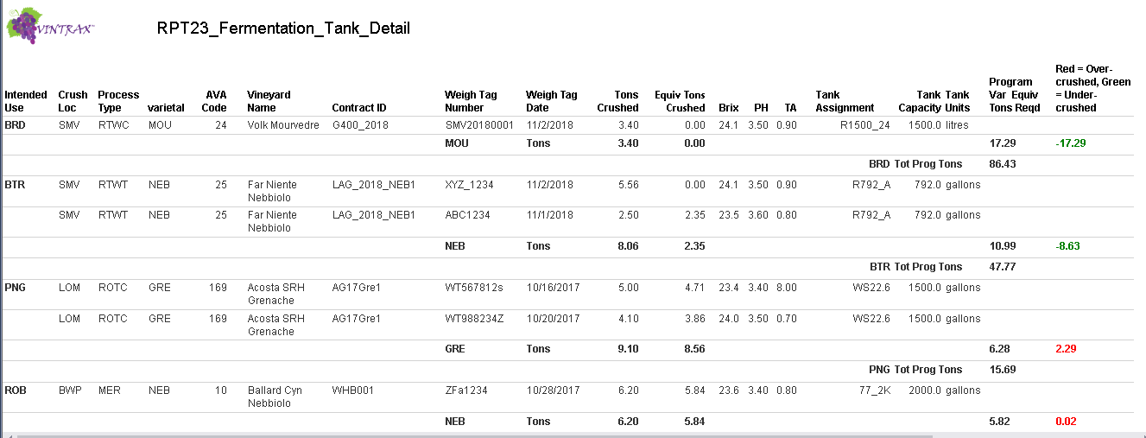

The Fermentation Tank report identifies where the grapes ended up. It tallies where the tons crushed were more or less than expected. Once all the weigh tags for the grapes are received, entered into Vintrax, and assigned to the final destination, you will have complete documentation from the vineyard to the fermentation tank and make your recordkeeping much more robust and useful. When it comes time to meet labelling requirements you will have the information to produce a valid label with the correct percentages and AVA’s.

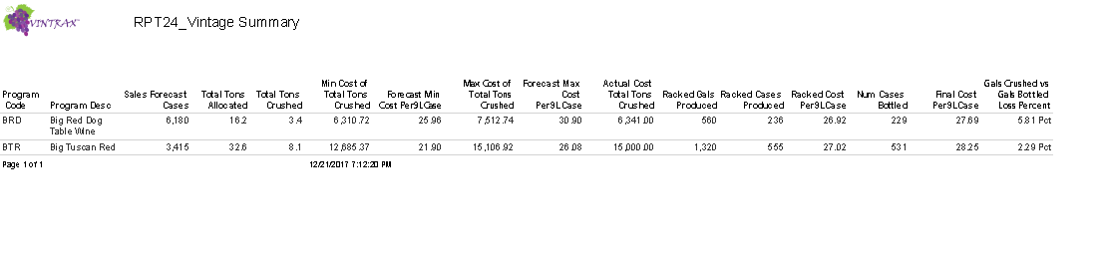  
The Vintage Summary report will list every program for the vintage along with sales forecasts, crushed tons, gallons produced, costs per 9L cases and loss percentages. This information will help you identify your profitable programs, production issues involving losses and help you plan for the next vintage using the current vintages results. In this way, over time, your processes will improve and you will be able to fine tune your efficiencies while identifying a strategy to make your business more profitable. This will allow you to make better wine and spend less time fixing costly errors that may happen when you don’t have the needed metrics in place.

In some ways I like to think making wine and sitting at the poker table in Vegas are really no different. Without having a strategy in place, knowing the rules of the game, and identifying the pitfalls and outcomes possible, the house will always win. As a competitive industry, you can’t allow yourself to be at a disadvantage to the house.

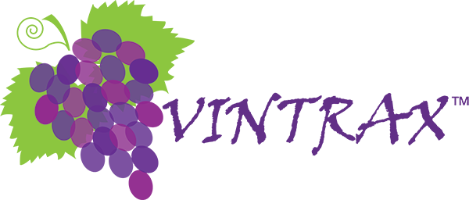

Visit our website at [www.vintraxdatabase.com](http://www.vintraxdatabase.com)  
  
for more information on Vintrax please contact Gene Stebley, 805-363-1648  
or email [vintraxdatabase@gmail.com](mailto:vintraxdatabase@gmail.com)  
  
P.O. Box 1037, Los Alamos, CA 93440