3GPP TSG RAN WG5 Testing Tdoc R5s050583
01 Mar - 31 Dec 2005
CR-Form-v7
CHANGE REQUEST
 | 34.123-3 |  |  |  | CR | 1610 |  |  |  rev |  |  | - |  |  Current version: |  |  |  |  | 5.3.0 |  | 
For HELP on using this form, see bottom of this page or look at the pop-up text over the  symbols.
Proposed change affects:  |  |  |  | UICC apps |  |  |  | ME |  |  | x | Radio Access Network |  |  |  |  |  |  |  | Core Network
Title:  |  | Correction to GCF WI 10 RLC testcase 7.2.2.2
Source:  |  | 3GPP TSG RAN WG5 Testing
Work item code:  |  | TEI_Test |  |  |  |  |  |  |  |  |  |  |  |  | Date:  |  | 13/12/05
Category:  |  | F |  |  |  |  |  |  |  |  |  |  |  |  | Release:  |  | Rel-5
 |  | Use one of the following categories:  F (correction)  A (corresponds to a correction in an earlier release)  B (addition of feature),  C (functional modification of feature)  D (editorial modification)  Detailed explanations of the above categories can  be found in 3GPP TR 21.900. |  |  |  |  |  |  |  |  |  |  |  |  |  | Use one of the following releases:  2 (GSM Phase 2)  R96 (Release 1996)  R97 (Release 1997)  R98 (Release 1998)  R99 (Release 1999)  Rel-4 (Release 4)  Rel-5 (Release 5)  Rel-6 (Release 6)
Reason for change:  |  |  | In Radio Bearer Setup message for the 15 bit LI DL UM RLC LI Size is set to OMIT.  However as per 25.331 v5.13.0 section 8.6.4.9,  1> if the IE "Downlink RLC mode" is present and is set to "UM RLC":  2> if the IE "DL UM RLC LI size" is not present:  3> configure the corresponding RLC entity with an LI size of 7 bits;  The above mentioned IE is added in Rel-5 core specification and hence cannot be added for the WI-10 test case. Thus a Rel-5 UE will always assume that 7 bit LI will be used for the RLC entity as above the specified IE is not set. This will cause the test case to FAIL.  It is proposed to remove testing of 15 bit LI for a Rel-5 UE.  A Prose CR for this test case will be submitted in the coming RAN5 meeting.
Summary of change:  |  |  | 15 bits LI testing for Rel-5 UE is removed from the test purpose.
Consequences if   not approved: |  |  | TTCN implementation may fail a Rel-5 conformant UE.
Clauses affected:  |  |  | tc_7_2_2_2
 |  |  | Y | N
Other specs  |  |  |  | X | Other core specifications 
affected: |  |  |  | x | Test specifications
 |  |  |  | X | O&M Specifications
Other comments: 

How to create CRs using this form:
Comprehensive information and tips about how to create CRs can be found at http://www.3gpp.org/specs/CR.htm. Below is a brief summary:
1) Fill out the above form. The symbols above marked  contain pop-up help information about the field that they are closest to.
2) Obtain the latest version for the release of the specification to which the change is proposed. Use the MS Word "revision marks" feature (also known as "track changes") when making the changes. All 3GPP specifications can be downloaded from the 3GPP server under ftp://ftp.3gpp.org/specs/ For the latest version, look for the directory name with the latest date e.g. 2001-03 contains the specifications resulting from the March 2001 TSG meetings.
3) With "track changes" disabled, paste the entire CR form (use CTRL-A to select it) into the specification just in front of the clause containing the first piece of changed text. Delete those parts of the specification which are not relevant to the change request.
Change 1:
Testcase | Tc_7_2_2_2, lt_Loopback15
Reason for change | In Radio Bearer Setup message for the 15 bit LI DL UM RLC LI Size is set to OMIT.  However as per 25.331 v5.13.0 section 8.6.4.9,  1> if the IE "Downlink RLC mode" is present and is set to "UM RLC":  2> if the IE "DL UM RLC LI size" is not present:  3> configure the corresponding RLC entity with an LI size of 7 bits;  The above mentioned IE is added in Rel-5 core specification and hence cannot be added for the WI-10 test case. Thus a Rel-5 UE will always assume that 7 bit LI will be used for the RLC entity as above the specified IE is not set. This will cause the test case to FAIL.  It is proposed to remove testing of 15 bit LI for a Rel-5 UE.  A Prose CR for this test case will be submitted in the coming RAN5 meeting.
Summary of change | 15 bits LI testing for Rel-5 UE is removed from the test purpose.
Source of change | New change

Before : 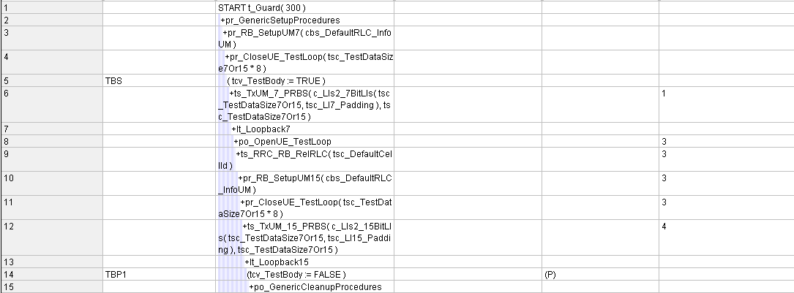
After : 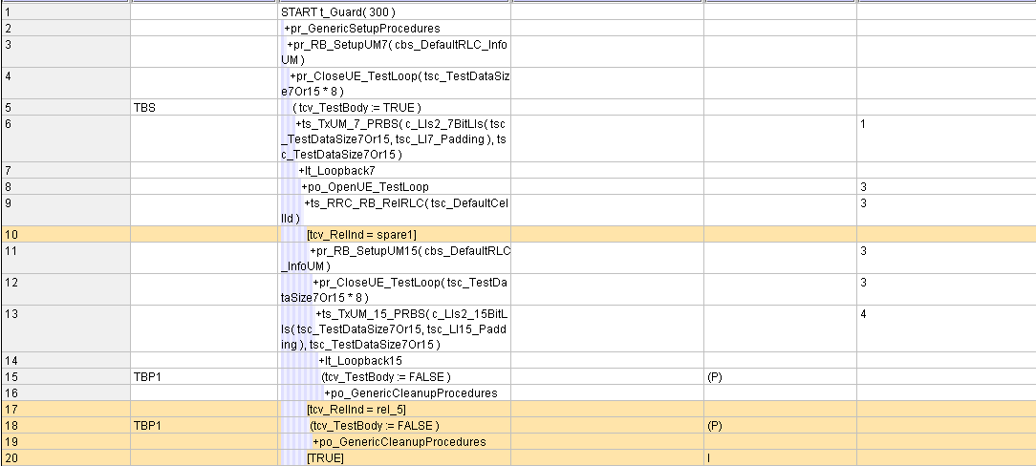
Before: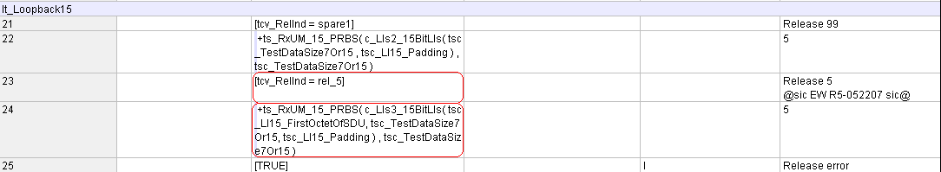
After: