**3GPP TSG RAN WG5 TestingTdoc** ⌘**R5s050580**

**01 Mar - 31 Dec 2005**

|  |  |  |  |  |  |  |  |  |  |  |  |  |  |  |  |  |  |  |  |  |  |  |
| --- | --- | --- | --- | --- | --- | --- | --- | --- | --- | --- | --- | --- | --- | --- | --- | --- | --- | --- | --- | --- | --- | --- |
| *CR-Form-v7* | | | | | | | | | | | | | | | | | | | | | | |
| **CHANGE REQUEST** | | | | | | | | | | | | | | | | | | | | | | |
|  | | | | | | | | | | | | | | | | | | | | | | |
| ⌘ | **34.123-3** | | | | **CR** | **-** | | | ⌘ **rev** | | | **-** | | ⌘ Current version: | | | | | **5.3.0** | | ⌘ | |
|  | | | | | | | | | | | | | | | | | | | | | | |
| *For* [***HE******LP***](http://www.3gpp.org/3G_Specs/CRs.htm#_blank)*on using this form, see bottom of this page or look at the pop-up text over the* ⌘ *symbols.* | | | | | | | | | | | | | | | | | | | | | | |
|  | | | | | | | | | | | | | | | | | | | | | | |
| ***Proposed change affects:*** ⌘ | | | | UICC apps⌘ | | |  | ME | | | **x** | Radio Access Network | | | | | |  | | Core Network | |  |
|  | | | | | | | | | | | | | | | | | | | | | | |
| ***Title:*** ⌘ | | Summary of regression errors in the wk49 WI-10 and WI-12 ATS | | | | | | | | | | | | | | | | | | | | |
|  | |  | | | | | | | | | | | | | | | | | | | | |
| ***Source:*** ⌘ | | Anite | | | | | | | | | | | | | | | | | | | | |
|  | |  | | | | | | | | | | | | | | | | | | | | |
| ***Work item code:*** ⌘ | | TEI_Test | | | | | | | |  | | | | | ***Date:*** ⌘ | | 18/11/05 | | | | | |
|  | |  | | | |  | | | | | | | | |  | |  | | | | | |
| ***Category:*** ⌘ | | **F** |  | | | | | | | | | | | | ***Release:*** ⌘ | | Rel-5 | | | | | |
|  | | *Use one of the following categories:* ***F*** *(correction)* ***A*** *(corresponds to a correction in an earlier release)* ***B*** *(addition of feature),* ***C*** *(functional modification of feature)* ***D*** *(editorial modification)*  Detailed explanations of the above categories can be found in 3GPP [TR 21.900](ftp://ftp.3gpp.org/specs/). | | | | | | | | | | | | | | *Use one of the following releases: 2 (GSM Phase 2) R96 (Release 1996) R97 (Release 1997) R98 (Release 1998) R99 (Release 1999) Rel-4 (Release 4) Rel-5 (Release 5) Rel-6 (Release 6)* | | | | | | |
|  | |  | | | | | | | | | | | | | | | | | | | | |
| ***Reason for change:*** ⌘ | | | Correction of errors found in TTCN as part of Regression on wk49 WI-10 and WI-12 ATS. | | | | | | | | | | | | | | | | | | | |
|  | | |  | | | | | | | | | | | | | | | | | | | |
| ***Summary of change:*** ⌘ | | | This document lists all changes applied to wk49 WI-10 and WI-12 ATS required for testing of the approved test cases.  See detailed change description for further information. | | | | | | | | | | | | | | | | | | | |
|  | | |  | | | | | | | | | | | | | | | | | | | |
| ***Consequences if*** ⌘ ***not approved:*** | | | TTCN implementation may fail a conformant UE. | | | | | | | | | | | | | | | | | | | |
|  | | |  | | | | | | | | | | | | | | | | | | | |
| ***Clauses affected:*** ⌘ | | |  | | | | | | | | | | | | | | | | | | | |
|  | | |  | | | | | | | | | | | | | | | | | | | |
|  | | | **Y** | **N** |  | | | | | | | |  | | | | | | | | | |
| ***Other specs*** ⌘ | | |  | **X** | Other core specifications ⌘ | | | | | | | |  | | | | | | | | | |
| ***affected:*** | | |  | **x** | Test specifications | | | | | | | |  | | | | | | | | | |
|  | | |  | **X** | O&M Specifications | | | | | | | |  | | | | | | | | | |
|  | | |  | | | | | | | | | | | | | | | | | | | |
| ***Other comments:*** ⌘ | | |  | | | | | | | | | | | | | | | | | | | |

**How to create CRs using this form:**

Comprehensive information and tips about how to create CRs can be found at <http://www.3gpp.org/specs/CR.htm>. Below is a brief summary:

1) Fill out the above form. The symbols above marked ⌘ contain pop-up help information about the field that they are closest to.

2) Obtain the latest version for the release of the specification to which the change is proposed. Use the MS Word "revision marks" feature (also known as "track changes") when making the changes. All 3GPP specifications can be downloaded from the 3GPP server under [ftp://ftp.3gpp.org/specs/](ftp://ftp.3gpp.org/specs/#_blank) For the latest version, look for the directory name with the latest date e.g. 2001-03 contains the specifications resulting from the March 2001 TSG meetings.

3) With "track changes" disabled, paste the entire CR form (use CTRL-A to select it) into the specification just in front of the clause containing the first piece of changed text. Delete those parts of the specification which are not relevant to the change request.

# Table of Contents

1 Table of Contents 1

2 Generic changes 2

2.1 Change 1 2

2.2 Change 2 2

3 Corrections required for RRC_wk49 test suite 4

3.1 Change 1 4

4 Corrections required for IR_U_wk49 test suite 6

4.1 Change 1 6

# Generic changes

## Change 1

This change is applicable to all ATS except RLC and MAC.

|  |  |
| --- | --- |
| **Testcase Variable name** | tcv_PktDataProtoAddr |
| **Reason for change** | Constraint cs_PktDataProtoAddrMT_lv is used to initialise tcv_PktDataProtoAddr.  This constraint makes use of TSO o_IA5_IP_ToOct to set the IE "addrInfo". The input to the constraint which affects TSO output are px_PDP_IP_AddrInfoDCH and TRUE(p_IP_V4_Flag).  The above implementation always assume that the PIXIT is set for a IPv4 address.  However in case user is testing a IPv6, then the TSO will return error and will make the test case execution to stop. |
| **Summary of change** | The initial value assignment for this variable has been removed. |
| **Source of change** | New change |
| **MCC 160** | Accepted as improvement |

Before:



After:



## Change 2

|  |  |
| --- | --- |
| **Teststep** | ts_RRC_NAS_SessionActPS_MT_P9_P10 |
| **Reason for change** | 1. TSO “o_IA5_IP_ToOct” has been used while calcutaing length of Access Pt Name by passing “tsc_AccessPtNameDCH” as the first parameter. This is incorrect as TSO “o_IA5_IP_ToOct” can only take a valid IP address as it’s first parameter. 2. Second parameter passed to TSO “o_IA5_IP_ToOct” has been hardcoded to TRUE. This will result in error if Ipv6 addresses are used. |
| **Summary of change** | 1. Use of TSO has been removed as it is not required for calculating the length of Access Pt Name. 2. Second input parameter to the TSO o_IA5_IP_ToOct is now corrected to “tcv_IPv4_Flag”. |
| **MCC 160** | 1) Accepted  2) Accepted |

Before:

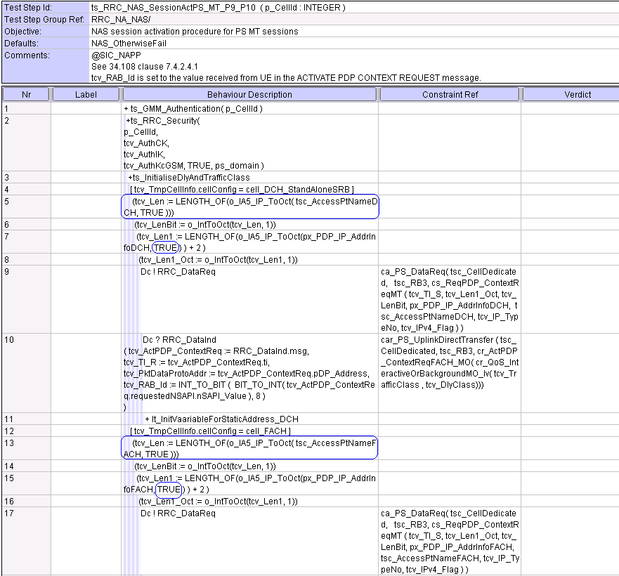

**After:**

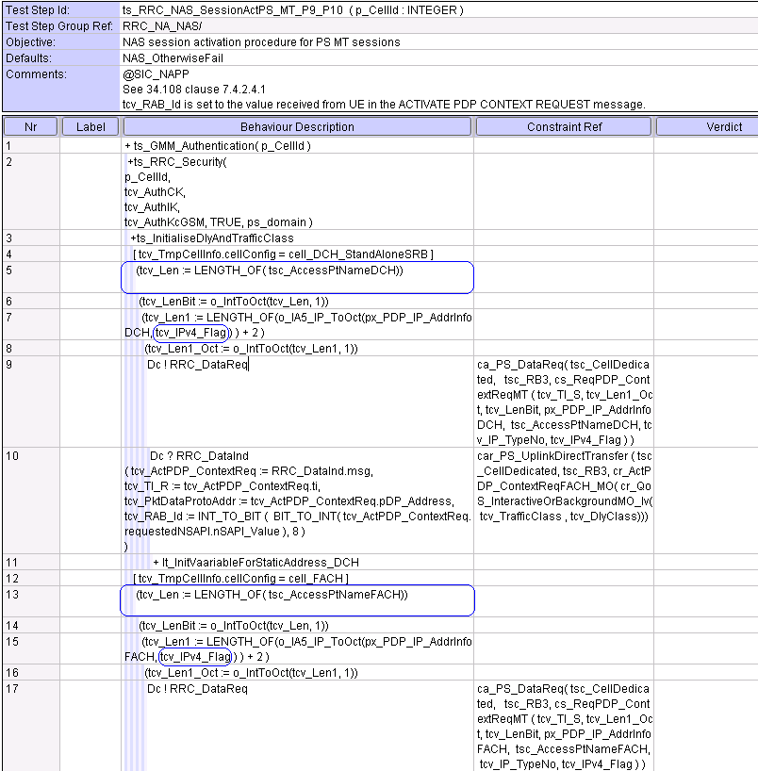

# Corrections required for RRC_wk49 test suite

## Change 1

|  |  |
| --- | --- |
| **Constraint** | cr_MeasReportIntraFreqEventTrigger |
| **Reason for change** | TTCN CR R5s050512 raised for this constraint is not properly implemented. |
| **Summary of change** | Need to change the constraint cr_MeasReportIntraFreqEventTrigger as per TTCN CR R5s050512. |
| **Source of change** | Modification. |
| **MCC 160** | accepted |

**Before:**

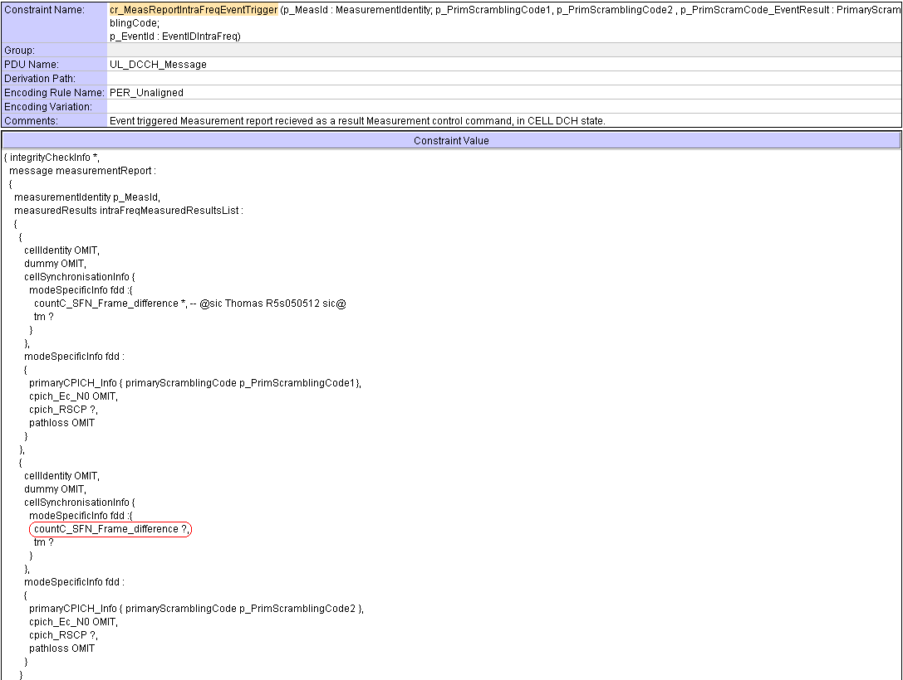

After:

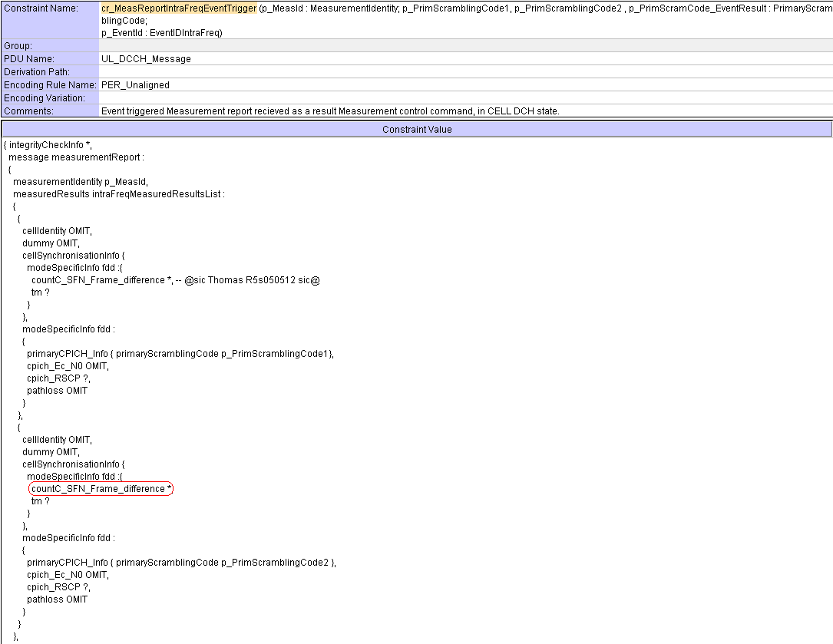

# Corrections required for IR_U_wk49 test suite

## Change 1

|  |  |
| --- | --- |
| **Constraint** | ts_SendDefSysInfo_LongNeighCellInfo_NewSIB1 |
| **Reason for change** | The above test step is being used in test cases 8.3.7.12 and 8.3.11.4. The ts_SaveBackMIB_SB1 is not being called at the end of this test step. This causes problem in scheduling later of System Information following this test step.  Note: The test step ts_SendDefSysInfo_LongNeighCellInfo_NewSIB1 is being used in RRC ATS inside the test step ts_SendDef_sysInfo_MultiCell_NewSIB1. However the test step ts_SendDef_sysInfo_MultiCell_NewSIB1 calls ts_SaveBackMIB_SB1 and thus this problem does not happen in RRC ATS. |
| **Summary of change** | The ts_SaveBackMIB_SB1 is been added at line#22 in the test step ts_SendDefSysInfo_LongNeighCellInfo_NewSIB1 |
| **Source of change** | New change. |
| **MCC 160** | accepted |

After: