**INDIAN INSTITUTE OF TECHNOLOGY KANPUR**

**XLI CONVOCATION**

**MAY 30, 2009**

**PRESS NOTE[1]**

**ON**

**THE GRADUATING CLASS AND AWARD WINNERS**

**&**

**SOME SALIENT ACCOMPLISHMENTS**

The Indian Institute of Technology Kanpur has scheduled its XLI Convocation on May 30, 2009 at 10:00 A.M. Established in 1959, the Indian Institute of Technology Kanpur, in its continual endeavor to achieve excellence in both undergraduate and postgraduate education and research, ithas earned a superb academic reputation in the global arena. The Institute will be celebrating its golden jubilee, shortly.

Professor M. Anadakrishnan, Chairperson, Madras Institute of Development Studies, who is the Chairman of the Board of Governors of this Institute, will preside over the proceedings of the Convocation. A number of celebrities from academia, administration and industry along with the students receiving the degrees and their parents/ guardians among other guests will be present on this occasion.

The Institute has had a distinguished tradition of being graced on the occasions of this Convocation by well-known personalities and dignitaries from various fields such as education, research and development, industry, etc. Dr. Sarvapalli Radhakrishnan, the doyen among educationists and a great philosopher, was the Chief Guest for its first Convocation held on October 31, 1965.

Shri Jeet Singh Bindra, President, Chevron Global Manufacturing is the Chief Guest and will deliver the XLIth Convocation address.

The number of students to be awarded degrees at this Convocation is **933.** The table below shows the number of students receiving the various degrees that the Institute offers. The highest degree of Doctor of Philosophy will be awarded to 96 scholars. Besides the award of degrees the Institute will also award various medals and prizes for meritorious performance**.**

|  |  |  |  |  |  |  |  |  |
| --- | --- | --- | --- | --- | --- | --- | --- | --- |
| B.Tech. | B.Tech-M.Tech  (Dual Degree) | M.Sc. Integrated  (5Year) | M.Sc.  (2Year) | MBA | M.Design | M.Tech | Ph.D. | **TOTAL** |
| **299** | **52** | **39** | **68** | **45** | **12** | **322** | **96** | **933** |

The **PRESIDENT'S GOLD MEDAL** for the best academic performance in the graduating class in all disciplines of B.Tech. and M.Sc. (5-year Integrated) degree programme will be awarded to **PIYUSH SRIVASTAVA of COMPUTER SCIENCE AND ENGINEERING**.

**The DIRECTOR'S GOLD MEDAL** for outstanding all-round performance and excellent organizational abilities and leadership qualities in the graduating class in all disciplines of undergraduate programmes of study will be awarded to **SHUBHONMESH BOSE of ELECTRICAL ENGINEERING.**

**RATAN SWARUP MEMORIAL PRIZE** for outstanding all-round performance and excellent organizational abilities and leadership qualities in the graduating class among all disciplines of the undergraduate and dual degree programme of study will be awarded to **VARUN** **KHAITAN of ELECTRICAL ENGINEERING.**

**Dr. SHANKAR DAYAL SHARMA MEDAL** for outstanding all-round graduating M.Tech./ Ph.D. student for general proficiency including character and conduct, extra–curricular activities and social service will be awarded to **KRISHNAN T.S.** **of ELECTRICAL ENGINEERING.**

In addition, twenty seven students will be awarded **GENERAL PROFFICIENCY MEDALS FOR THE BEST ACADEMIC PERFORMANCE** in various programmes.

IIT Kanpur has demonstrated its excellence in research in many areas. The research profile of the Institute is continually growing every year. As a result, the Institute is well-recognized as one of the centers of academic excellence. During 2008-2009, about 140 sponsored projects and 122 consultancy projects were undertaken by the faculty and research engineers/scientists of the Institute. The faculty members have published research papers in reputed national and international journals. 17 patents have been filed in India and overseas. The Institute has signed several Memoranda of Understanding (MoU) with Indian as well as international academic/research institutions and industries to strengthen its collaborative research efforts. Some of the organizations include: Bhabha Atomic Research Center, Chevron, Indian Space Research Organisation, Indira Gandhi Centre for Atomic Research, European Aeronautic Defence and Space Company, Institute for Plasma Research, Gas Authority of India Limited, and United Nations Development Program.

One example of a Memorandum of Understanding that the Institute has signed is with Indian Space Research Organization (ISRO) to support the design, development and launch of an indigenous nano satellitecalled **Jugnu**. The satellite is planned to be built around a standard cuboid configuration as designed and is expected to weigh less than 5 kg. In this joint program, the satellite will be launched in the polar orbit by the ISRO. The satellite shall carry payloads for earth observation, for establishing communication links, for studying atmospheric phenomena, for testing scientific instruments and for novel applications. The mission life shall be for a minimum period of 6 months.

New focused research initiative culminating in to advanced centers such as The DST Unit of Nanosciences, the Tandetron Ion Beam facility, Telecom Center of Excellence, INDO–US Center for Research Excellence in Fabrionics, Center for Development of Metal-Ceramic Composites, the Indo-US joint center on Biomaterials for health care, National Fire Facility, Foundation for Research in Algorithms have been established.

Professor Sanjay Govind Dhande

Director, Indian Institute of Technology Kanpur

**SOME PHOTOGRAPHS**

**1. Piyush Srivastava (President's Gold Medal)**

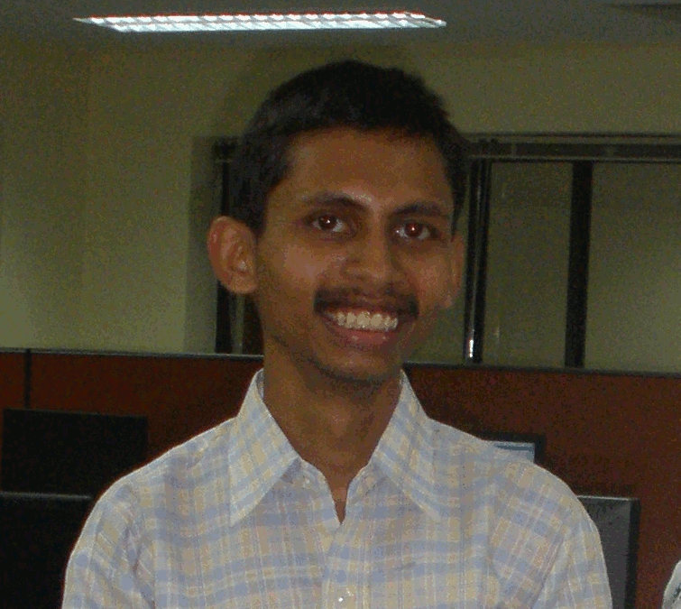

**2. Subhonmesh Bose. (Director's Gold Medal)**

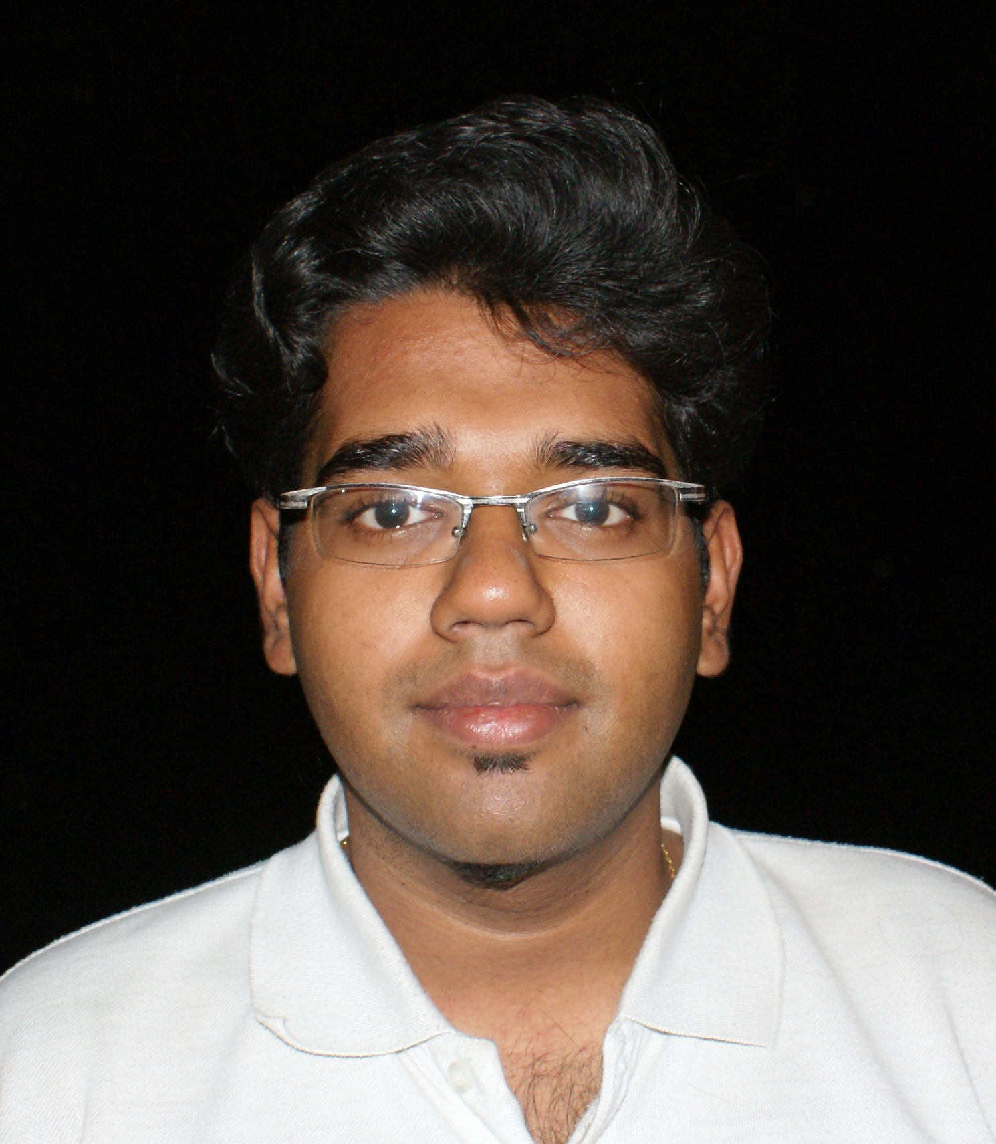

1. **Krishnan T.S. (Dr. Shanker Dayal Sharma Medal)**

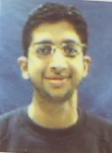

**4. Mr. Jeet Singh Bindra (Chief Guest, Convocation XLI)**

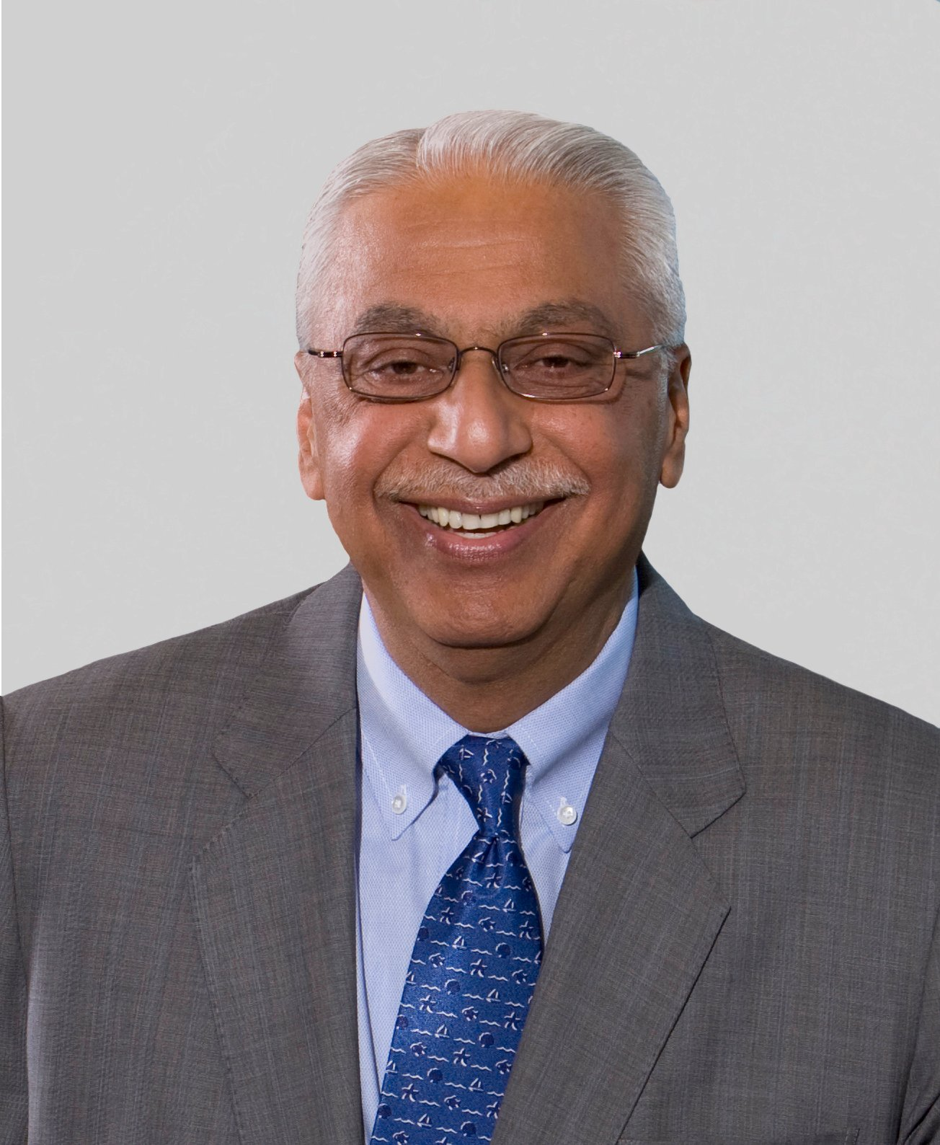

1. Soft copy is available at <http://www.iitk.ac.in/doaa/convocation2009/> in doc and pdf format