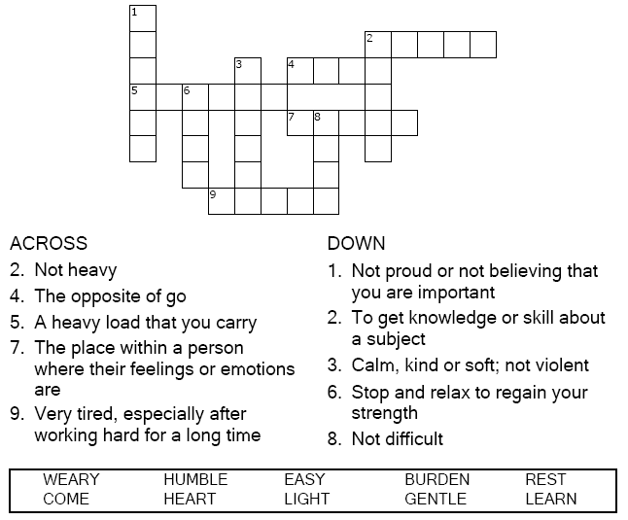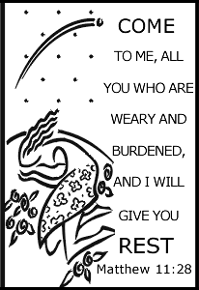

Copyright © Sermons4Kids, Inc.

May be reproduced for Ministry Use

**Children’s Worship Bulletin**

Mathew 11:28-30

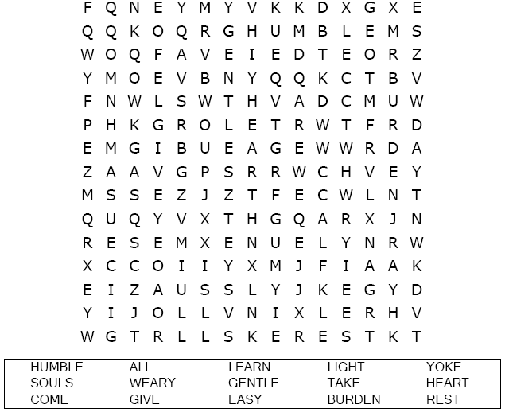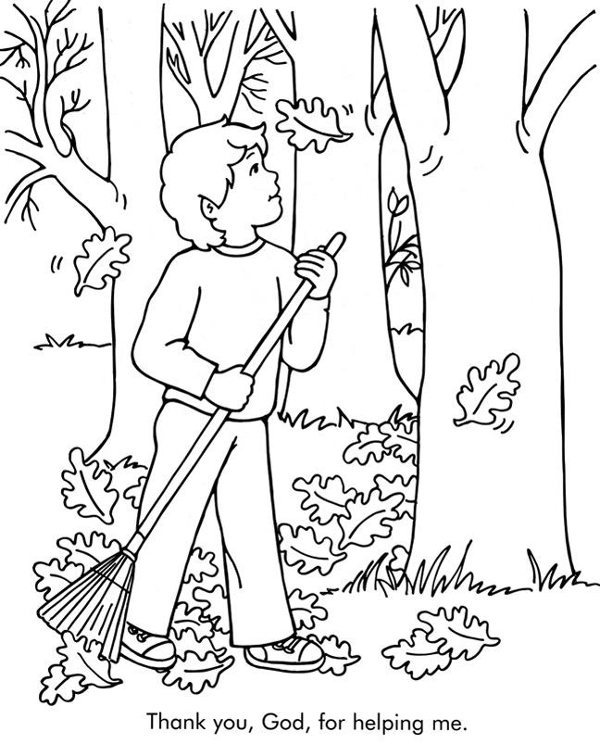

From Thru-the-Bible Coloring Pages for Ages 4-8. © 1986,1988 Standard Publishing.

Used by permission. Reproducible Coloring Books may be purchased from

Standard Publishing, www.standardpub.com, 1-800-543-1301.

Each number represents a letter of the alphabet. Substitute  
correct letter for the numbers to reveal the coded words.

