委托单位：
Customer：
地 址：
Address ：

样品名称Sample Name | ：ECU
主机厂OEM | ：吉利
以上测试之样品及信息是由申请者提供并确认
The above sample(s) and information are provided and confirmed by the applicant
检测项目Test Item：请参见下页Please refer to the following pages
检测依据Test Method：请参见下页Please refer to the following pages
检测结果Test Result：请参见下页Please refer to the following pages

编 制  Written by |  | 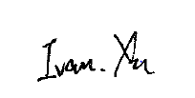 |  |  |  |  | 审 核  Inspected by |  |  | 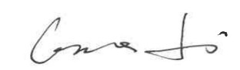
批 准Approved by |  |  | 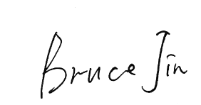 |  |  |  |  | 日 期Date | 2026.08.07
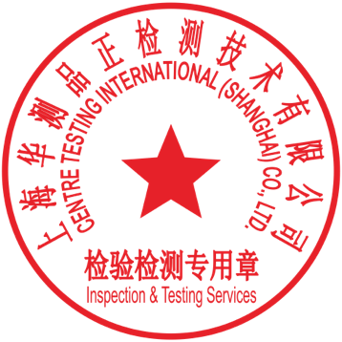 |  |  | Bruce Jin  Technical Manager
No.
上海华测品正检测技术有限公司 上海市闵行区新骏环路777号5号楼
Building 5, No. 777, Xinjun Ring Road, Minhang District

样品信息表Sample information table
序号  No. | 样品名称  Sample Name | 零件号  Part No. | 送样数量  Quantity of Samples | 样品编号  Sample No.
1 | ECU | / | 1pcs | A01

结果汇总Summary of results
序号  No. | 检测项目  Test Item | 检测方法  Test Method | 样品编号  Sample No. | 结论  Conclusion
1 | 振动试验 | / | A01 | 合格/Pass
备注：
合格：符合要求
不合格：不符合要求
N/A：不应用于判定或不适用
Note：
Pass：Meet the requirements
Fail：Does not meet the requirements
N/A：Not apply to the judgment or Not applicable

1. 检测项目Test Item：振动试验
（1）检测环境条件Test environment：（23±5）℃，（50±25）%RH
（2）检测设备Test equipment：
/
（3）检测方法Test method：/
（4）检测条件Test condition：
/
（5）检测数量Quantity：1pcs
（6）评判要求Evaluation requirement：
/
（7）检测结果Test result：
（8）结论Conclusion：合格/Pass

检测照片Test photos

备注：此报告所有/部分项目不在CMA资质认定范围内，出具的数据结果供科研、教学、企业内部质量控制、企业产品研发等目的用。
Note：Indicates the item(s)/method(s) is (are) not in CMA accreditation scope, the testing data and result is just for scientific research, education, internal quality control and product development etc.

检测报告无批准人签字及“检验检测专用章”无效，本报告检测结果仅对被测样品负责。实验室不负责抽样，本报告检测结果仅适用于收到的样品。未经CTI书面同意，不得部分复制本报告。无‘CENTRE TESTING INTERNATIONAL’数字证书签章的电子版报告视为无效。
The test report is effective only with both signature and Inspection & Testing Service stamp. The result(s) shown in this report refer only to the sample(s) tested. The laboratory has not been responsible for the sampling stage, the result apply to the sample as received. Without written approval of CTI, this report can’t be reproduced except in full.
An electronic report without the signature of the ' CENTRE TESTING INTERNATIONAL ' digital certificate is considered invalid.

*** 报告结束 End of Report ***

