Customer：
Address：
Sample Name | ：
OEM | ：
Sample Received Date | ：2026.08.01
Testing Period | ：2026.08.02~2026.08.10
The above sample(s) and information are provided and confirmed by the applicant
Test Item：Please refer to the following pages
Test Method：Please refer to the following pages
Test Result：Please refer to the following pages

编 制  Written by |  | 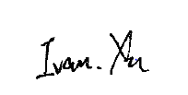 |  |  |  |  | 审 核  Inspected by |  |  | 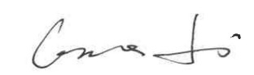
批 准Approved by |  |  | 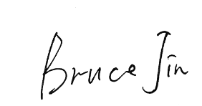 |  |  |  |  | 日 期Date | 2026.08.07
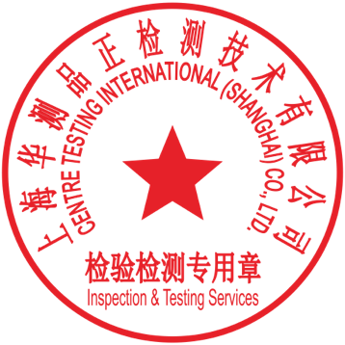 |  |  | Bruce Jin  Technical Manager
No.
Building 5, No. 777, Xinjun Ring Road, Minhang District

Sample information table
No. | Sample Name | Part No. | Quantity of Samples | Sample No.
1 | / | / | 1pcs | A01

Summary of results
No. | Test Item | Testing Period | Test Method | Tester | Sample No. | Conclusion
1 | / | 2026.07.03~2026.07.23 | / | 黄佳林 | A01 | Pass
Note：
Pass：Meet the requirements
Fail：Does not meet the requirements
N/A：Not apply to the judgment or Not applicable

1. Test Item：/
（1）Test environment：（23±5）℃，（50±25）%RH
（2）Test equipment：
/
（3）Test method：/
（4）Test condition：
（5）Quantity：1pcs
（6）Evaluation requirement：
（7）Test result：
（8）Conclusion：Pass

Test photos

Note：Indicates the item(s)/method(s) is (are) not in CMA accreditation scope, the testing data and result is just for scientific research, education, internal quality control and product development etc.

The test report is effective only with both signature and Inspection & Testing Service stamp. The result(s) shown in this report refer only to the sample(s) tested. The laboratory has not been responsible for the sampling stage, the result apply to the sample as received. Without written approval of CTI, this report can’t be reproduced except in full.
An electronic report without the signature of the ' CENTRE TESTING INTERNATIONAL ' digital certificate is considered invalid.

*** End of Report ***

