委托单位： | {{委托方名称}}
Customer：
地 址： | {{委托方地址}}
Address ：

{{样品信息表}}
检测项目Test Item：请参见下页Please refer to the following pages
检测依据Test Method：请参见下页Please refer to the following pages
检测结果Test Result：请参见下页Please refer to the following pages

编 制  Written by |  | 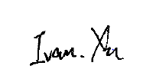 |  |  |  |  | 审 核  Inspected by |  |  | 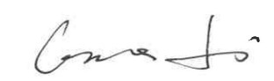
批 准Approved by |  |  | 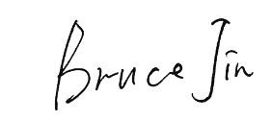 |  |  |  |  | 日 期Date | 2026.08.07
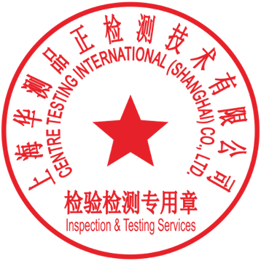 |  |  | Bruce Jin  Technical Manager
No.
上海华测品正检测技术有限公司 {{实验室地址_cn}}
{{实验室地址_en}}

样品信息表Sample information table
{{样品清单表}}

结果汇总Summary of results
{{结果汇总表}}
备注：
合格：符合要求
不合格：不符合要求
N/A：不应用于判定或不适用
Note：
Pass：Meet the requirements
Fail：Does not meet the requirements
N/A：Not apply to the judgment or Not applicable

{{试验明细}}

备注：此报告所有/部分项目不在 CMA 资质认定范围内，出具的数据结果供科研、教学、企业内部质量控制、企业产品研发等目的用。 Note: Indicates the item(s)/method(s) is (are) not in CMA accreditation scope, the testing data and result is just for scientific research, education, internal quality control and product development etc.

声明：
1.检测报告无批准人签字及“检验检测专用章”无效。
2.本报告检测结果仅对被测样品负责。实验室不负责抽样。本报告检测结果仅适用于收到的样品。3.未经 CTI 书面同意，不得部分复制本报告。
4.无‘CENTRE TESTING INTERNATIONAL’数字证书签章的电子版报告视为无效。
5.除非另有说明，报告参照 CNAS-GL015 使用简单接受的二元判定规则进行符合性判定（w=0）。 Statement:
1.The test report is effective only with both signature and inspection & Testing service stamp.
2.The result(s) shown in this report refer only to the sample(s) tested. The laboratory has not been responsible for the sampling stage, the result apply to the sample as received.
3.Without written approval of CTI, this report can’t be reproduced except in full.
4.An electronic report without the signature of the ' CENTRE TESTING INTERNATIONAL' digital certificate is considered invalid.
5.Unless otherwise specified, the report adopts the decision rule based on simple acceptance for conformity assessment (w=0) in accordance with CNAS-GL015.
*** 报告结束 End of Report ***

