委托单位： | {{委托方名称}}
Customer：
地 址： | {{委托方地址}}
Address ：

{{样品信息表}}
检测项目Test Item：请参见下页Please refer to the following pages
检测依据Test Method：请参见下页Please refer to the following pages
检测结果Test Result：请参见下页Please refer to the following pages

签 发Approved by |  | 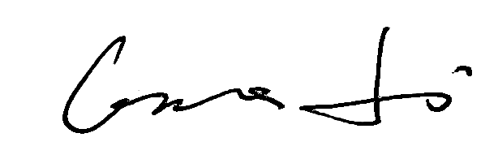 |  |  | 日 期Date | 2026.08.07
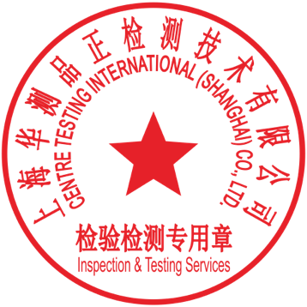 |  | Grace Li  Technical Manager
No.
上海华测品正检测技术有限公司 上海市闵行区万芳路1351号
Certre Testing International Pinzheng (Shanghai)Co., Ltd. No.1351, Wanfang Road, Minhang, Shanghai, China

样品信息表Sample information table
{{样品清单表}}

结果汇总Summary of results
{{结果汇总表}}
备注：
合格：符合要求
不合格：不符合要求
N/A：不应用于判定或不适用
Note：
Pass：Meet the requirements
Fail：Does not meet the requirements
N/A：Not apply to the judgment or Not applicable

{{试验明细}}

备注：此报告所有/部分项目不在CMA资质认定范围内，出具的数据结果供科研、教学、企业内部质量控制、企业产品研发等目的用。
Note：Indicates the item(s)/method(s) is (are) not in CMA accreditation scope, the testing data and result is just for scientific research, education, internal quality control and product development etc.

检测报告无批准人签字及“检验检测专用章”无效，本报告检测结果仅对被测样品负责。实验室不负责抽样，本报告检测结果仅适用于收到的样品。未经CTI书面同意，不得部分复制本报告。无‘CENTRE TESTING INTERNATIONAL’数字证书签章的电子版报告视为无效。
The test report is effective only with both signature and Inspection & Testing Service stamp. The result(s) shown in this report refer only to the sample(s) tested. The laboratory has not been responsible for the sampling stage, the result apply to the sample as received. Without written approval of CTI, this report can’t be reproduced except in full.
An electronic report without the signature of the ' CENTRE TESTING INTERNATIONAL ' digital certificate is considered invalid.

*** 报告结束 End of Report ***

