委托单位： | 奥托立夫（上海）汽车安全系统研发有限公司
Customer： | Autoliv (Shanghai) Vehicle Safety System Technical Center Co., Ltd
地 址： | 上海市嘉定工业区北和公路1000号
Address ： | No.1000, BEI HE Highway, JIA DING Industrial Zone, Shanghai 201807, China

 | 样品名称Sample Name |  | ：VW316-6 FCA
 | 零件号Part No. |  | ：6710820
 | 车型Model |  | ：VW316-6
 | 生产商Producer |  | ：ACS
 | 生产日期Production date |  | ：2026/07/10
 | 项目代码Project Code |  | ：VW316-6
 | 项目阶段Project Verification |  | ：PV
 | TO号TO No. |  | ：TO-26108862-02
 | 主机厂OEM |  | ：一汽大众FAW-VW
 | 以上测试之样品及信息是由申请者提供并确认
 | The above sample(s) was/were submitted and identified on behalf of the client as：
 | 客户送样数量Quantity of sample  supplied by client |  | ：8pcs
 | 样品接收日期Sample Received Date |  | ：2026.07.20
 | 样品检测日期Testing Period |  | ：2026.07.21~2026.07.22
 | 检测项目Test Item |  | ：请参见下页Please refer to the following pages
 | 检测依据Test Method |  | ：请参见下页Please refer to the following pages
 | 检测结果Test Result |  | ：请参见下页Please refer to the following pages
签 发Approved by |  | 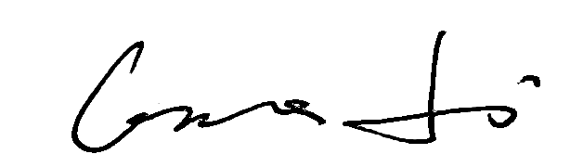 |  |  | 日 期Date | 2026.08.07
 |  | Grace Li  Technical Manager
No. R2636D55B2
上海华测品正检测技术有限公司 上海市闵行区万芳路1351号
Certre Testing International Pinzheng (Shanghai)Co., Ltd. No.1351, Wanfang Road, Minhang, Shanghai, China
样品信息表Sample information table
序号  No. | 样品名称  Sample Name | 零件号  Part No. | 送样数量  Quantity | 样品编号  Sample No.
1 | VW316-6 FCA | 6710820 | 8pcs | TP-262686912~  TP-262686919

结果汇总Summary of results
序号  No. | 检测项目  Test Item | 检测方法  Test Method | 样品编号  Sample No. | 结论  Conclusion
1 | 机械冲击试验  Mechanical shock test | VW 82517-2010-11-8.3.2 | TP-262686912~  TP-262686919 | 合格  Pass
备注：
合格：符合要求
不合格：不符合要求
N/A：不应用于判定或不适用
Note：
Pass：Meet the requirements
Fail：Does not meet the requirements
N/A：Not apply to the judgment or Not applicable

1. 检测项目Test Item：机械冲击试验Mechanical shock test
（1）检测环境条件Environmental Conditions：（23±5）℃，（50±25）%RH
（2）检测设备Test Equipment：
序号  No. | 名 称  Name | 型 号  Model | 设备编号  Equipment No. | 校准有效期  Valid Date to
1 | 水平冲击试验台  Horizontal Impact Machine | SY12-100A | TTE20236127-V066 | 2027-01-22
2 | 温湿度环境箱  Temperature and humidity chamber | HTHV3500-40WL | TTE20231178-C063 | 2027-02-11
3 | 单轴加速度传感器  Uniaxial acceleration sensor | BW23108 | SHAED-V067 | 2027-03-09
4 | 安全气囊脉冲电源  Airbag pulse power supply | FT833012A-6-1 | TTE202521553-P299 | 2026-11-02
5 | 安规综合测试仪  Electrical Safety analyzer | AN1637HD | TTE202602268-E124 | 2027-04-06
6 | 六位半万用表  6 ½ digital multimeter | 34461A | TTE20232737-E068 | 2027-04-08
（3）检测方法Test Method：VW 82517-2010-11-8.3.2
（4）检测条件Test Conditions：
每个气囊模块仅可沿模块水平/纵向轴线方向（见图3），在下列温度条件下承受400次连续冲击：试验温度：(-35±2.5) ℃、室温 (23±5) ℃、(85±2.5) ℃。总计1200次冲击，每个试验温度各400次冲击。试验频率的选取应确保不会影响模块在每次冲击后的衰减过程。
Every airbag module is subjected to 400 consecutive shocks, only in the direction of the horizontal/longitudinal axis of the module (see Figure 3) at the following temperatures：Test temperatures：(-35±2.5) °C、RT (23±5) °C、(85±2.5) °C、This results in a total of 1 200 shocks, with 400 shocks per test temperature. The test frequency must be selected such that the dying out of the module after each hock is not influenced.

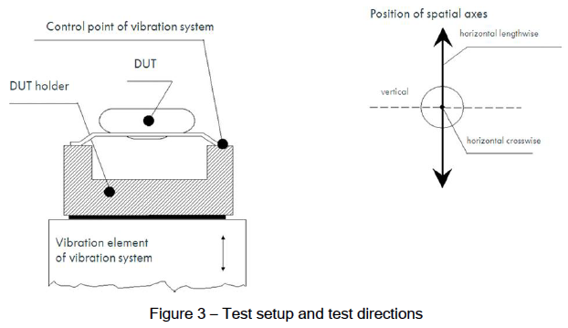
试验设备应接近图5中虚线所示的冲击波形，该波形为正弦半波（标称冲击）。加速度A与冲击持续时间D的实测值须在公差范围内。
The test machine must approximate the shock form indicated by a dashed line in Figure 5. It represents a half-period of a sine wave (nominal shock). The actual values of acceleration A and shock duration D must be within the tolerance range.
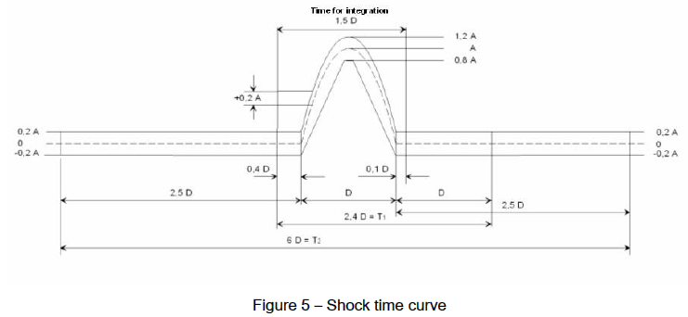
试验应采用以下试验参数开展：
The test must be performed with the following test parameters：
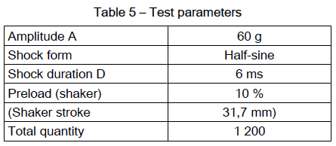
（5）检测数量Test Quantity：8pcs
（6）评判要求Evaluation Requirements：
试验完成后，模块、电气接插件零部件以及靠背内的模块固定部位不得出现任何功能失效。所有可见损伤均应予以记录。应重点关注模块的紧固螺钉。即使受试样品出现可见损伤，仍必须按照表2完成试验程序。允许对模块进行修复，以便继续开展试验。记录相关阻值。
After completion of the test, the module, the components of the electrical plug connection, and the
module fastening in the backrest must not display any functional impairments. Any visible damage must be documented. Special attention must be paid to the fastening screws of the module. The DUT must undergo the test program according to Table 2 even if it suffers visible damage. It is permissible to repair the module so that the test can be continued. The relevant resistance values shall be recorded as required.
（7）检测结果Test Results：
样品编号  Sample No. | 试验结果  Test result | 试验结论  Conclusion
TP-262686912 | 试验后，模块、电气接插件零部件以及靠背内的模块固定部位没有出现任何失效及损伤。After the test, the module, the components of the electrical plug connection, and the module fastening in the backrest exhibited no failures or damage. | 合格  Pass
TP-262686913 | 试验后，模块、电气接插件零部件以及靠背内的模块固定部位没有出现任何失效及损伤。After the test, the module, the components of the electrical plug connection, and the module fastening in the backrest exhibited no failures or damage. | 合格  Pass
TP-262686914 | 试验后，模块、电气接插件零部件以及靠背内的模块固定部位没有出现任何失效及损伤。After the test, the module, the components of the electrical plug connection, and the module fastening in the backrest exhibited no failures or damage. | 合格  Pass
TP-262686915 | 试验后，模块、电气接插件零部件以及靠背内的模块固定部位没有出现任何失效及损伤。After the test, the module, the components of the electrical plug connection, and the module fastening in the backrest exhibited no failures or damage. | 合格  Pass
TP-262686916 | 试验后，模块、电气接插件零部件以及靠背内的模块固定部位没有出现任何失效及损伤。After the test, the module, the components of the electrical plug connection, and the module fastening in the backrest exhibited no failures or damage. | 合格  Pass
TP-262686917 | 试验后，模块、电气接插件零部件以及靠背内的模块固定部位没有出现任何失效及损伤。After the test, the module, the components of the electrical plug connection, and the module fastening in the backrest exhibited no failures or damage. | 合格  Pass
TP-262686918 | 试验后，模块、电气接插件零部件以及靠背内的模块固定部位没有出现任何失效及损伤。After the test, the module, the components of the electrical plug connection, and the module fastening in the backrest exhibited no failures or damage. | 合格  Pass
TP-262686919 | 试验后，模块、电气接插件零部件以及靠背内的模块固定部位没有出现任何失效及损伤。After the test, the module, the components of the electrical plug connection, and the module fastening in the backrest exhibited no failures or damage. | 合格  Pass
试验数据Test data
样品编号Sample No. | 试验前  Before test |  |  | 试验后  After test
/ | 桥路电阻Bridge resistance  (Ω) | 短路电阻Shunt resistance  (Ω) | 绝缘电阻Insulation  resistance  (MΩ) | 桥路电阻Bridge resistance  (Ω) | 短路电阻Shunt resistance  (Ω) | 绝缘电阻Insulation  resistance  (MΩ)
TP-262686912 | 1.92 | 0.97 | ＞550 | 1.90 | 0.94 | ＞550
TP-262686913 | 1.85 | 0.92 | ＞550 | 1.87 | 0.96 | ＞550
TP-262686914 | 1.85 | 0.96 | ＞550 | 1.83 | 0.96 | ＞550
TP-262686915 | 1.87 | 0.96 | ＞550 | 1.91 | 0.98 | ＞550
TP-262686916 | 1.88 | 0.96 | ＞550 | 1.93 | 0.99 | ＞550
TP-262686917 | 1.87 | 0.99 | ＞550 | 1.93 | 0.97 | ＞550
TP-262686918 | 1.84 | 0.98 | ＞550 | 1.87 | 0.98 | ＞550
TP-262686919 | 1.85 | 0.99 | ＞550 | 1.89 | 0.96 | ＞550
（8）结论Conclusion：合格/Pass

检测照片Photo of the test
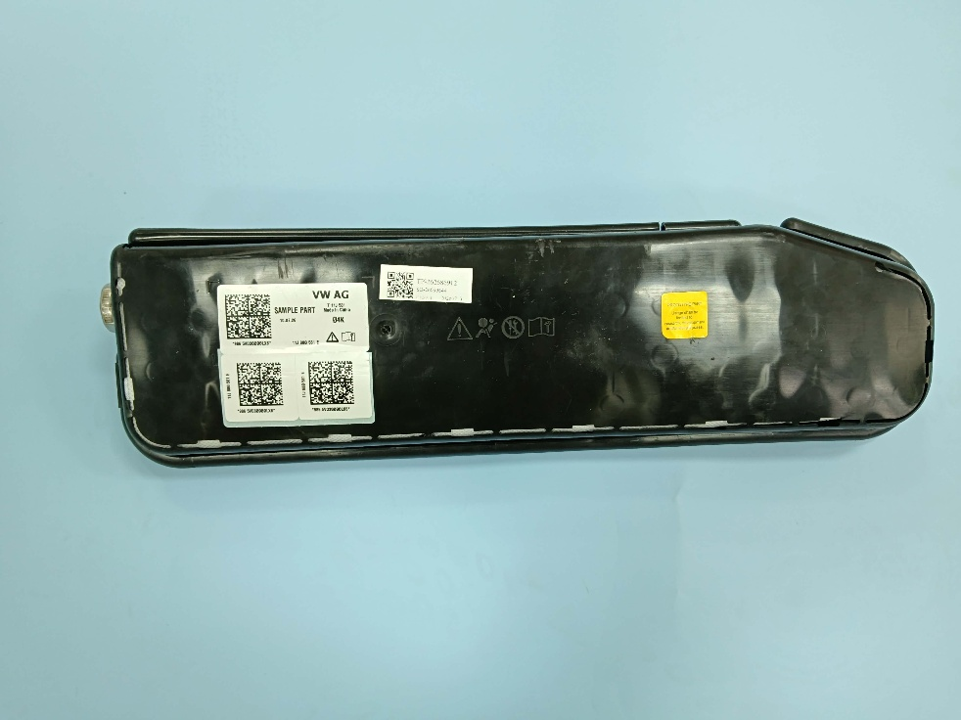TP-262686912试验前Before test-1 | 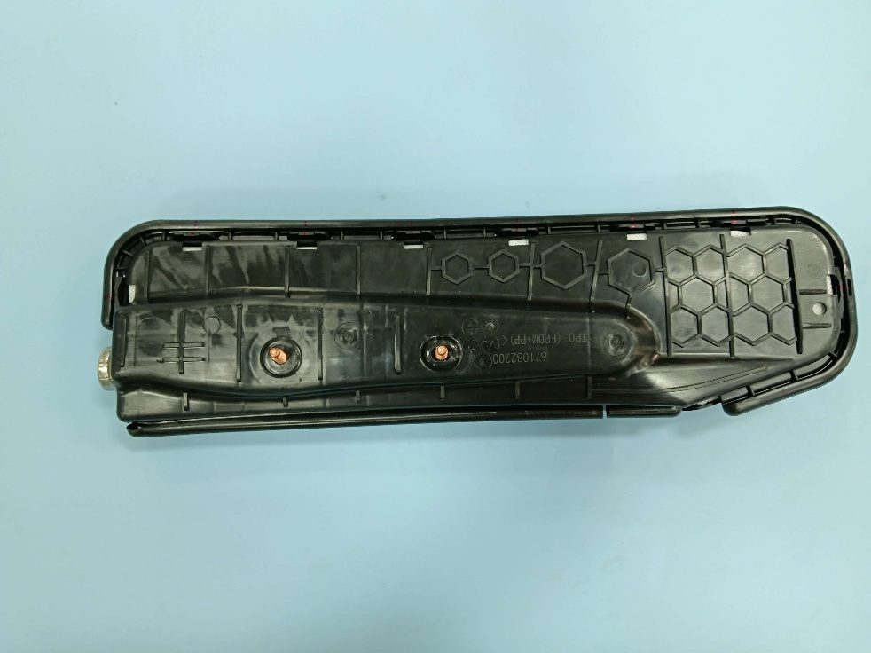TP-262686912试验前Before test-2
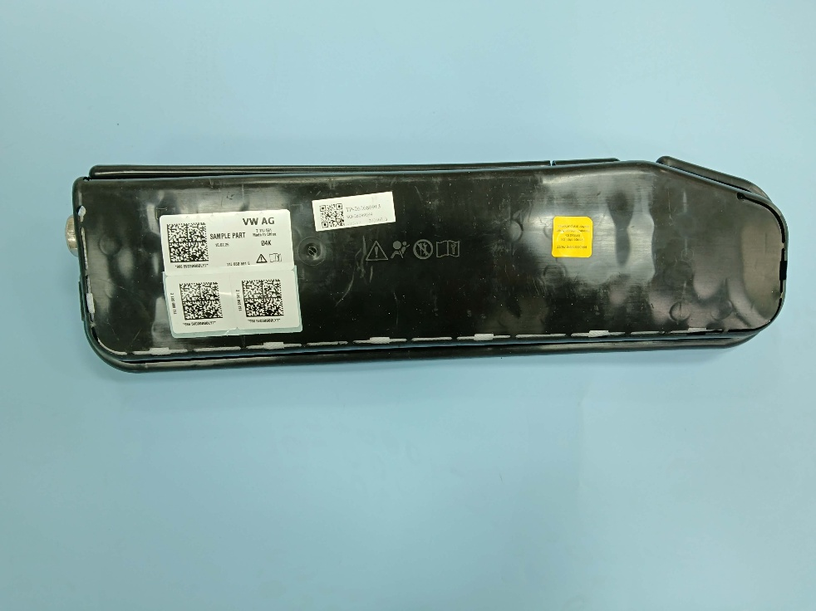TP-262686913试验前Before test-1 | 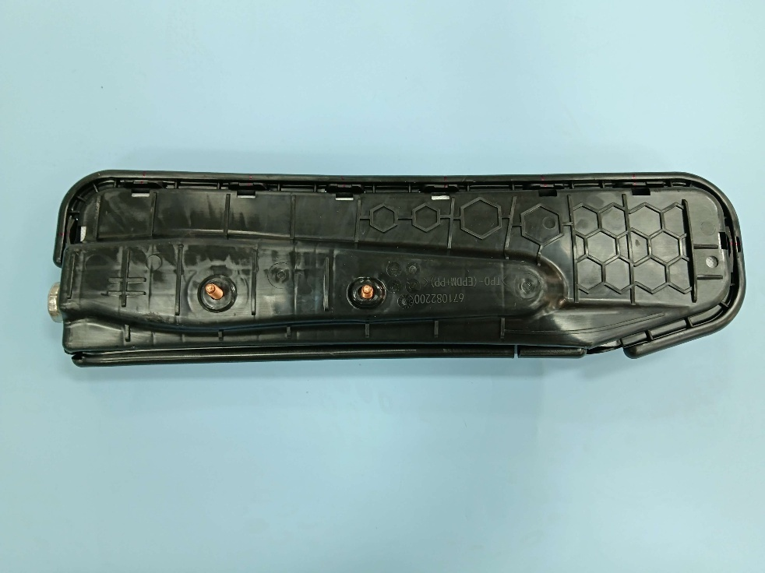TP-262686913试验前Before test-2
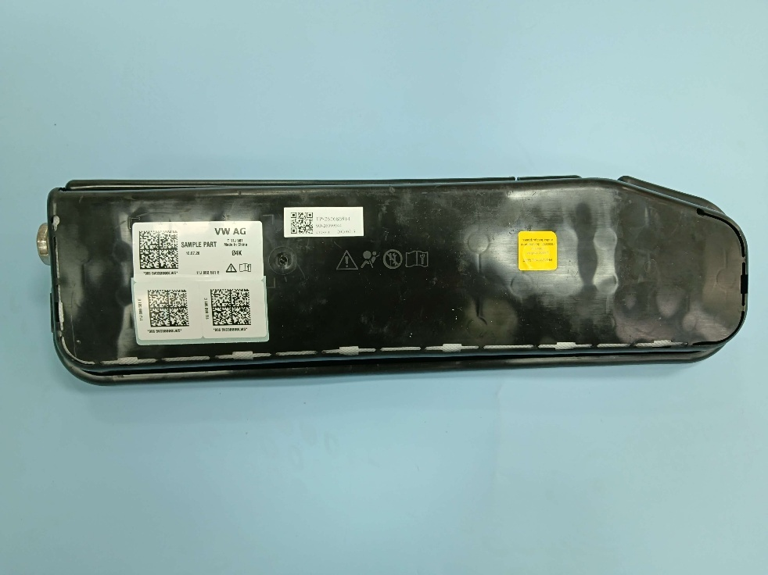TP-262686914试验前Before test-1 | 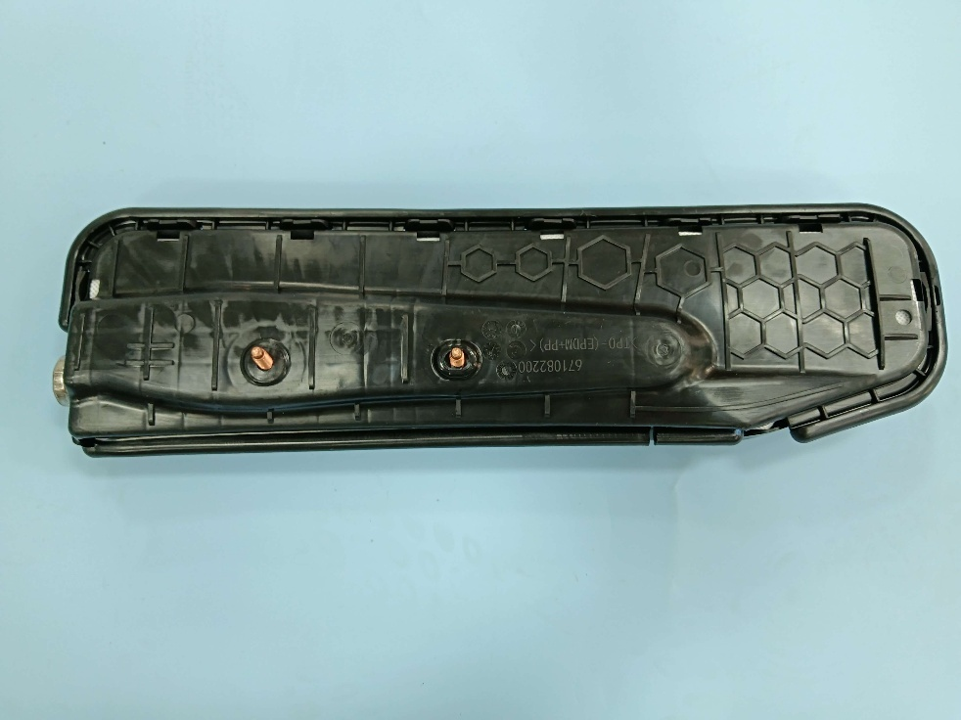TP-262686914试验前Before test-2
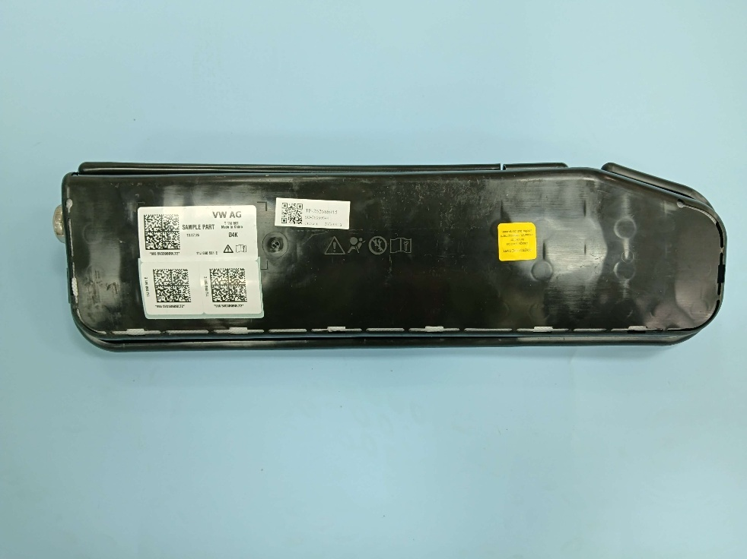TP-262686915试验前Before test-1 | 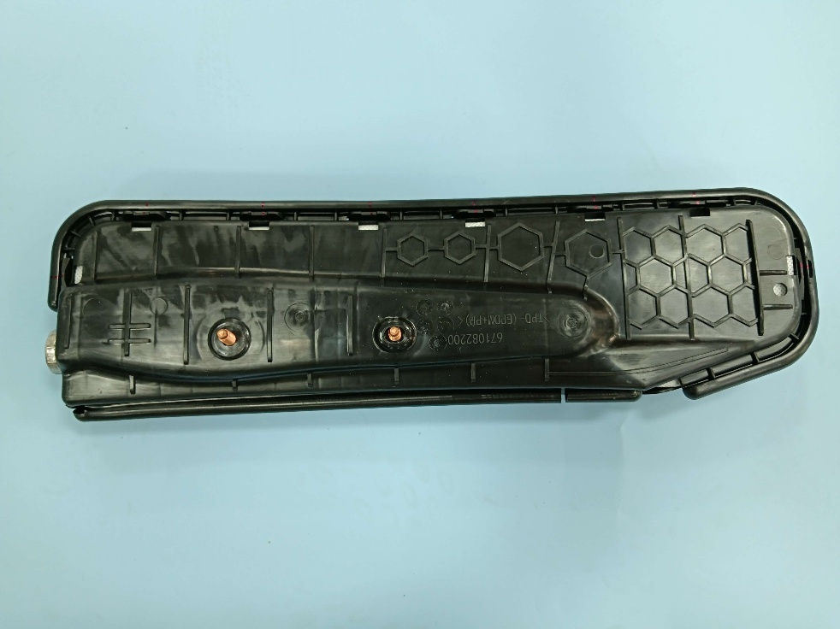TP-262686915试验前Before test-2
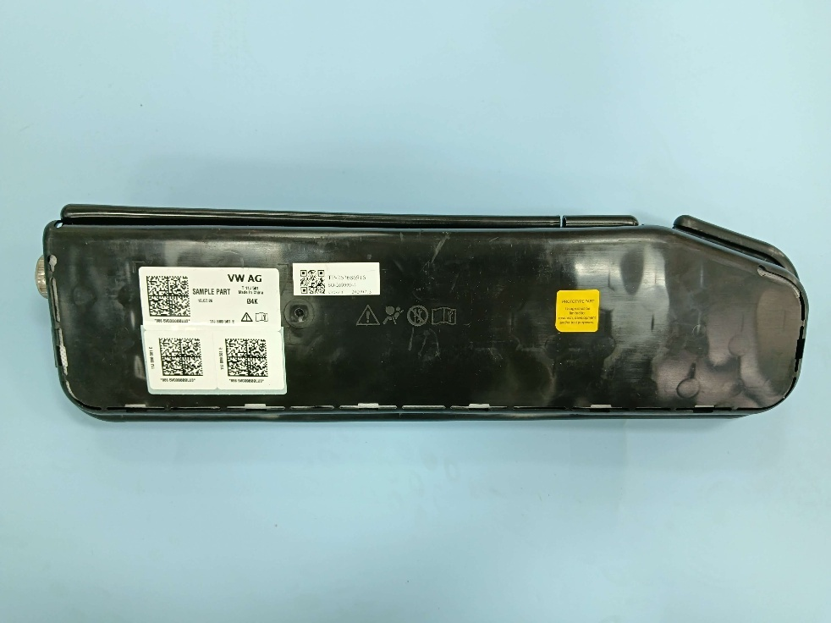TP-262686916试验前Before test-1 | 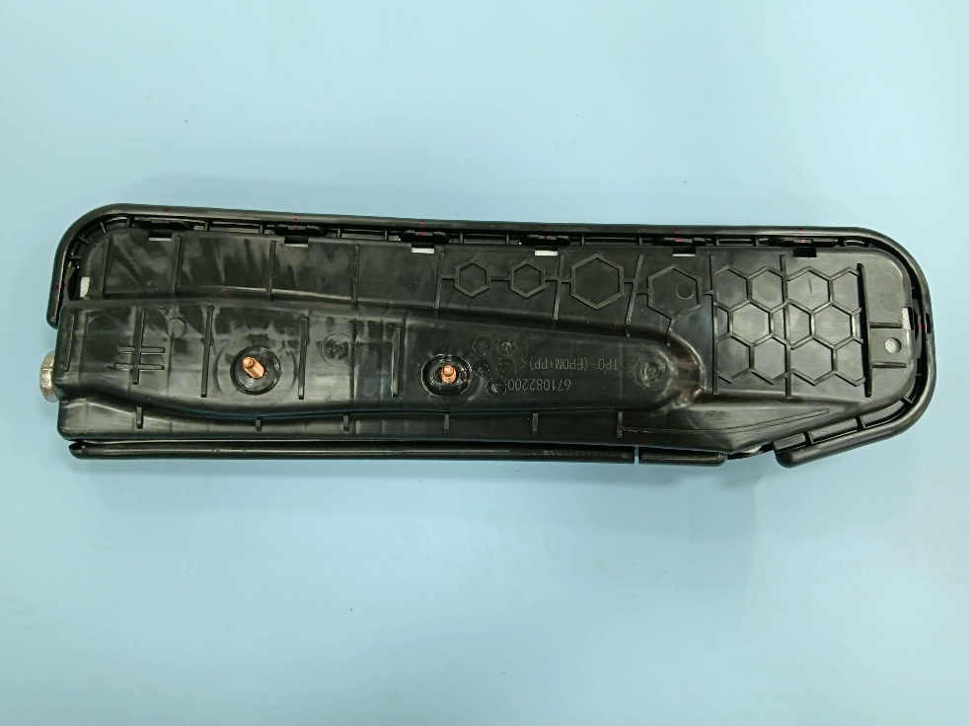TP-262686916试验前Before test-2
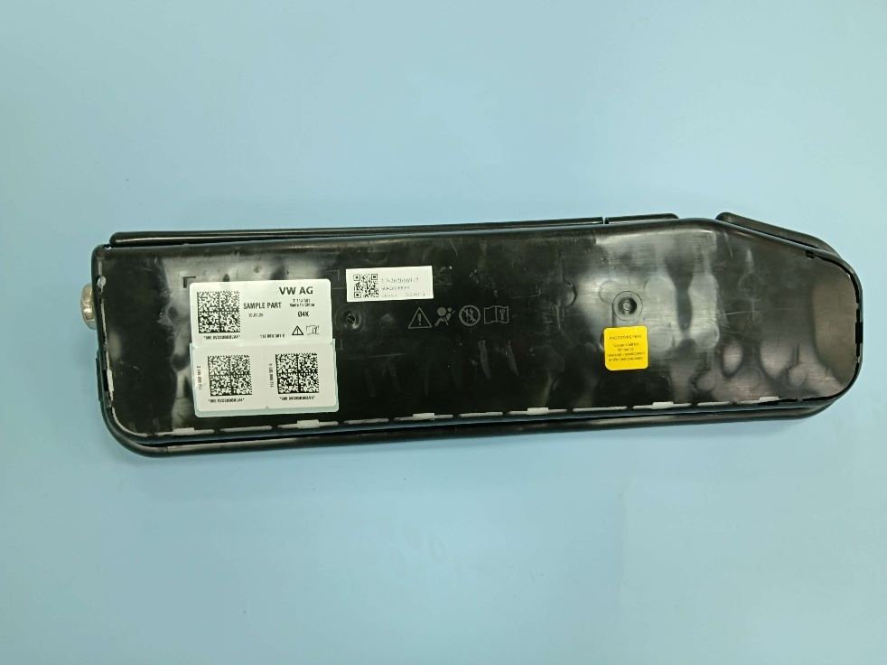TP-262686917试验前Before test-1 | 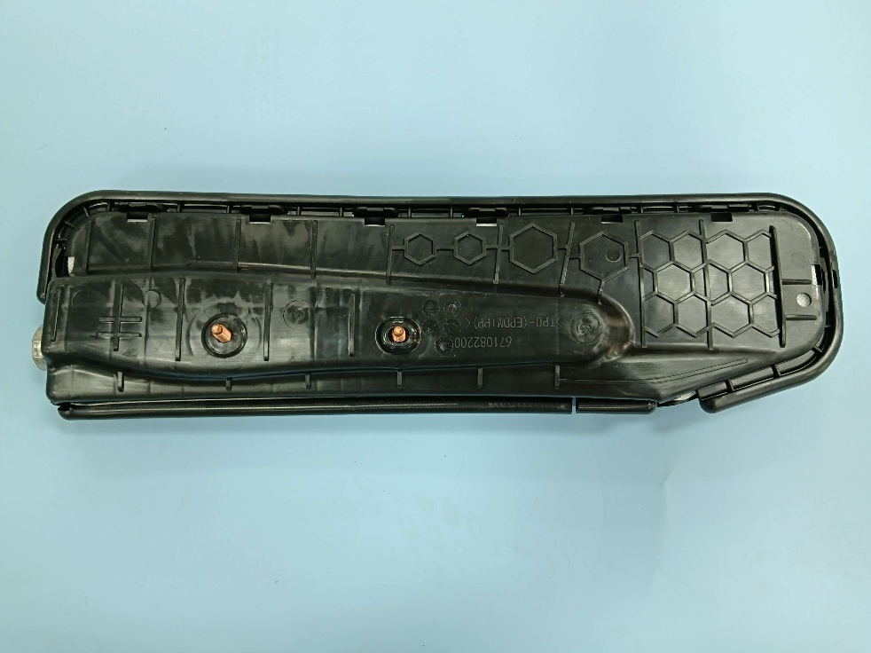TP-262686917试验前Before test-2
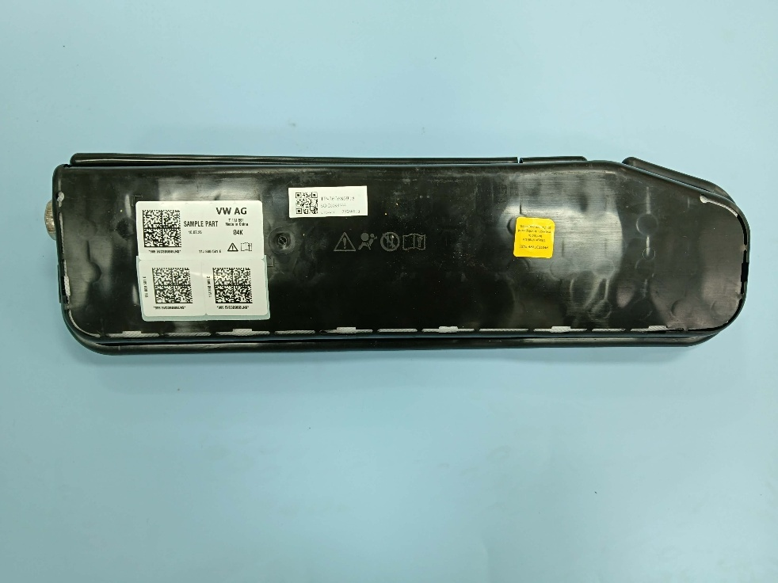TP-262686918试验前Before test-1 | 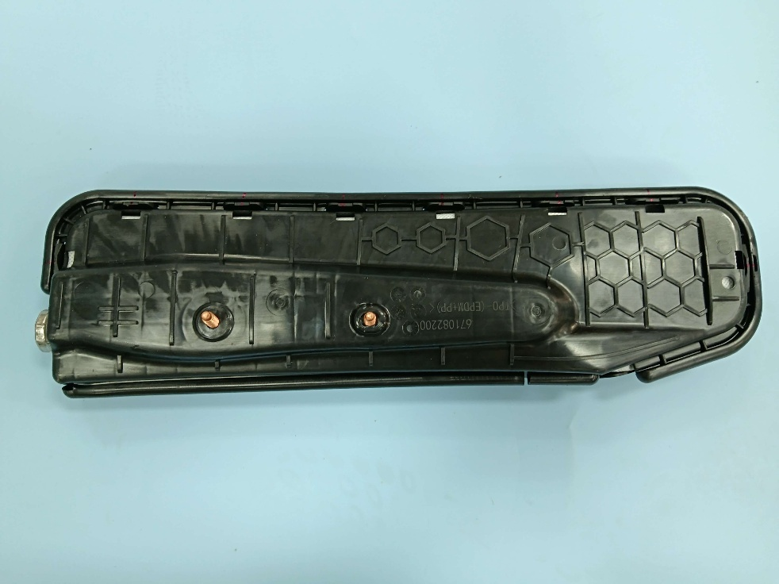TP-262686918试验前Before test-2
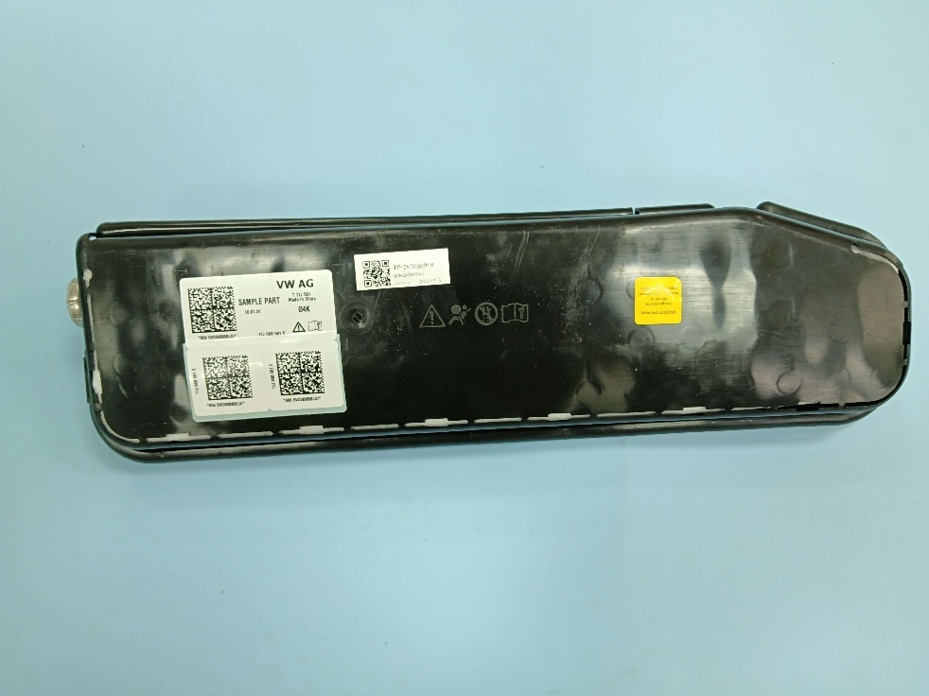TP-262686919试验前Before test-1 | 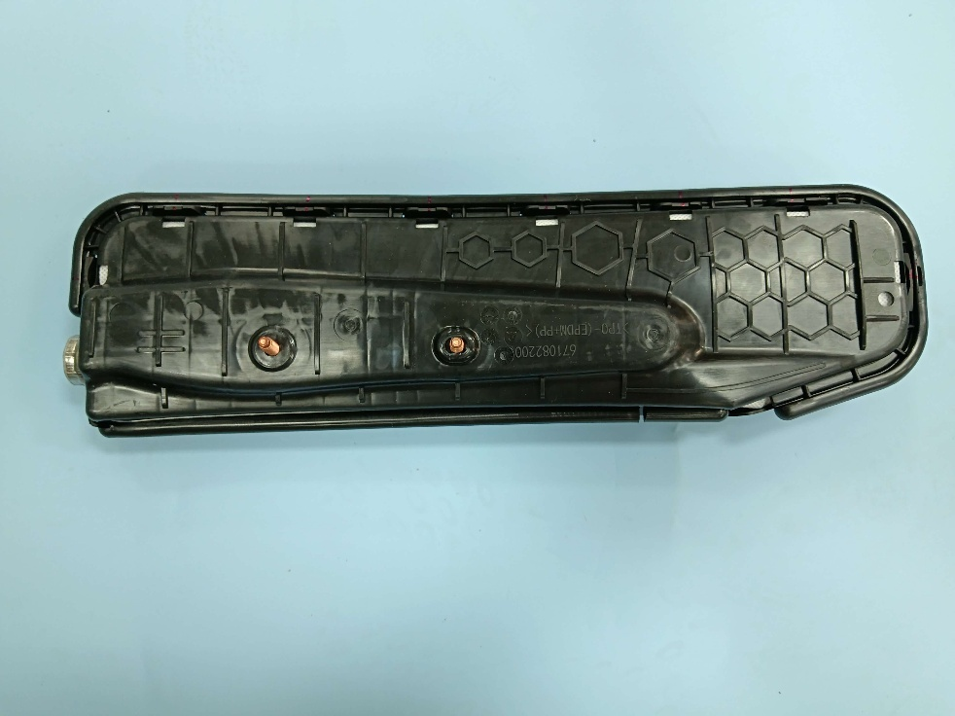TP-262686919试验前Before test-2
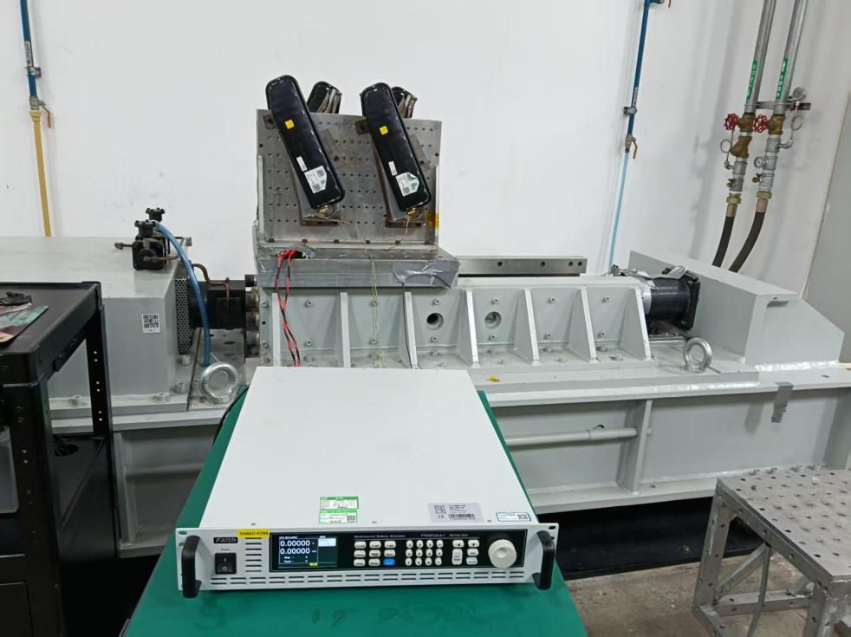 | 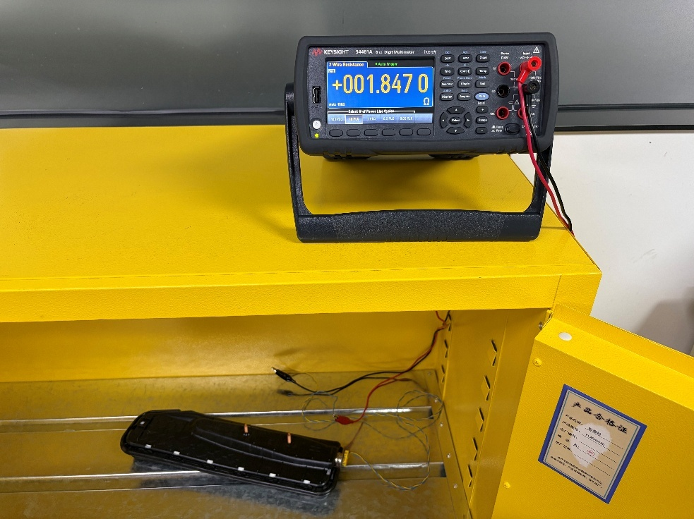
试验设置Test setup | 桥路电阻设置Bridge resistance setup
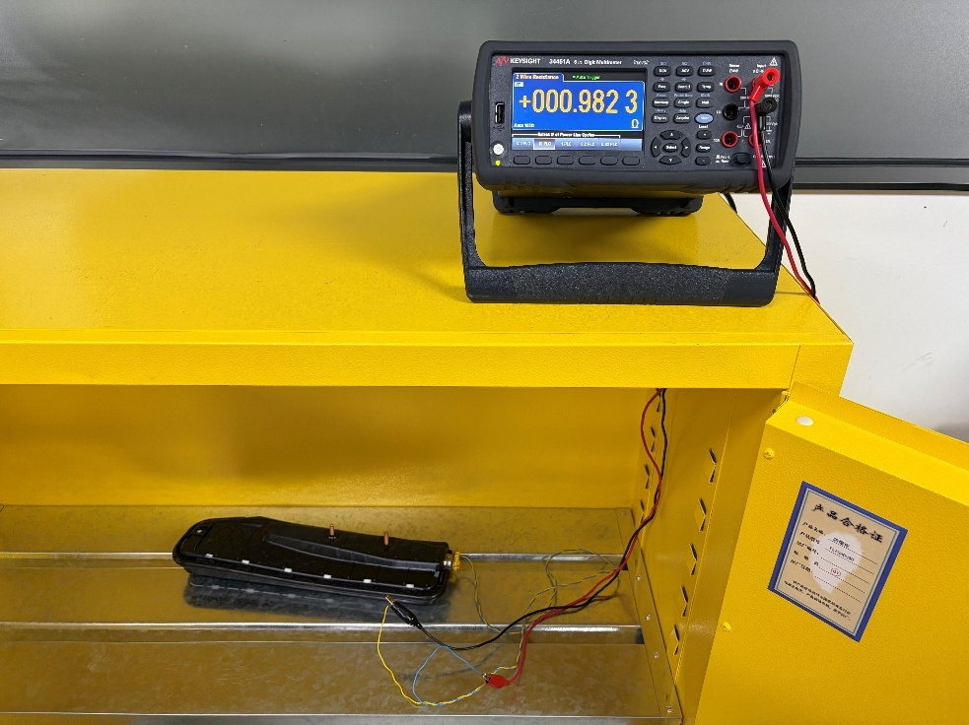 | 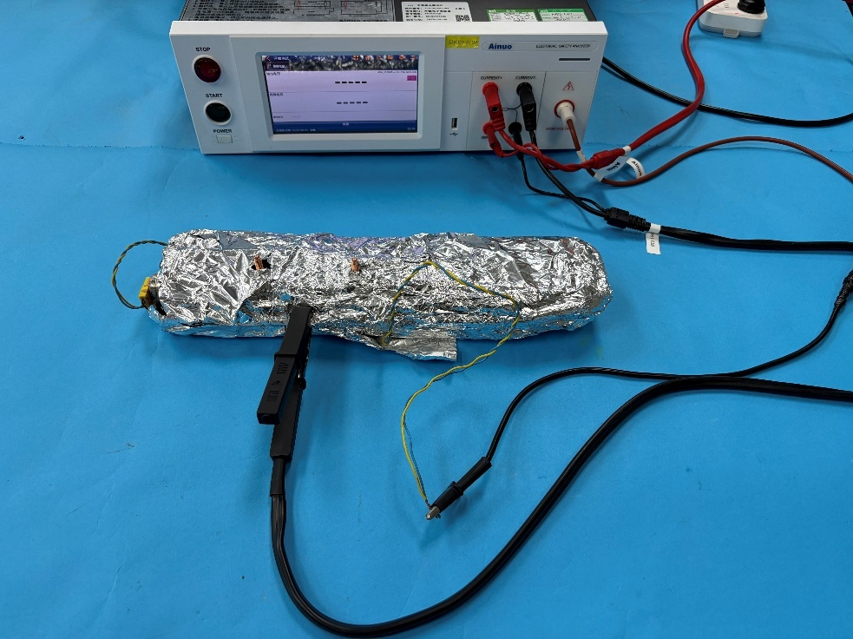
短路电阻设置Shunt resistance setup | 绝缘电阻设置Insulation resistance setup
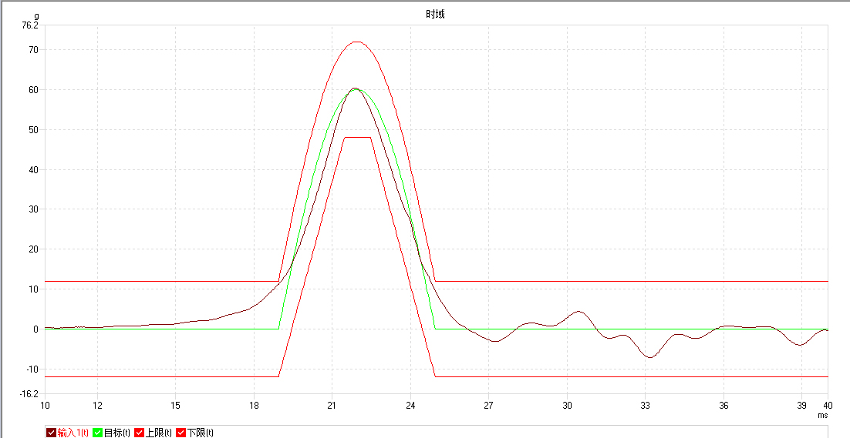
试验数据Test data-1
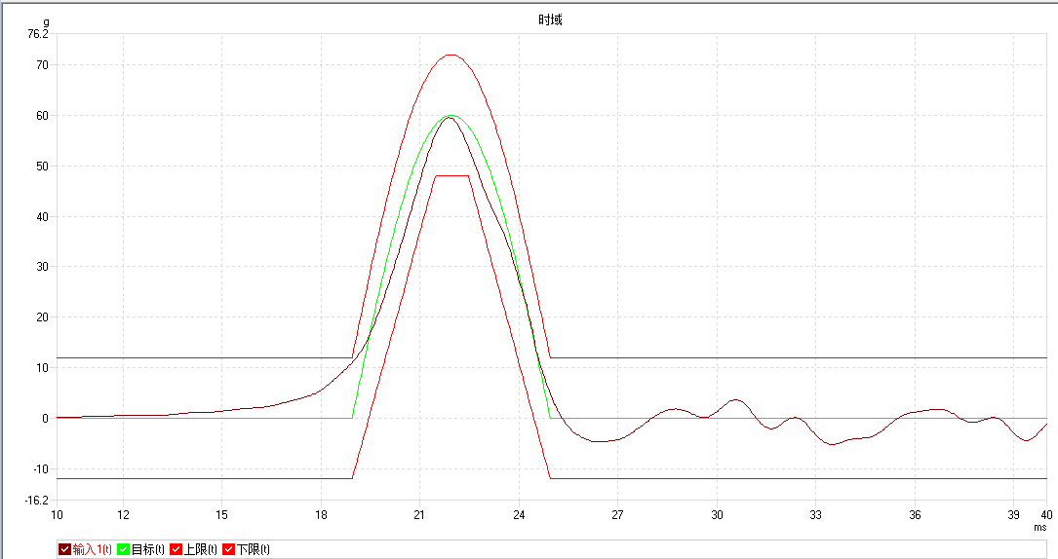
试验数据Test data-2
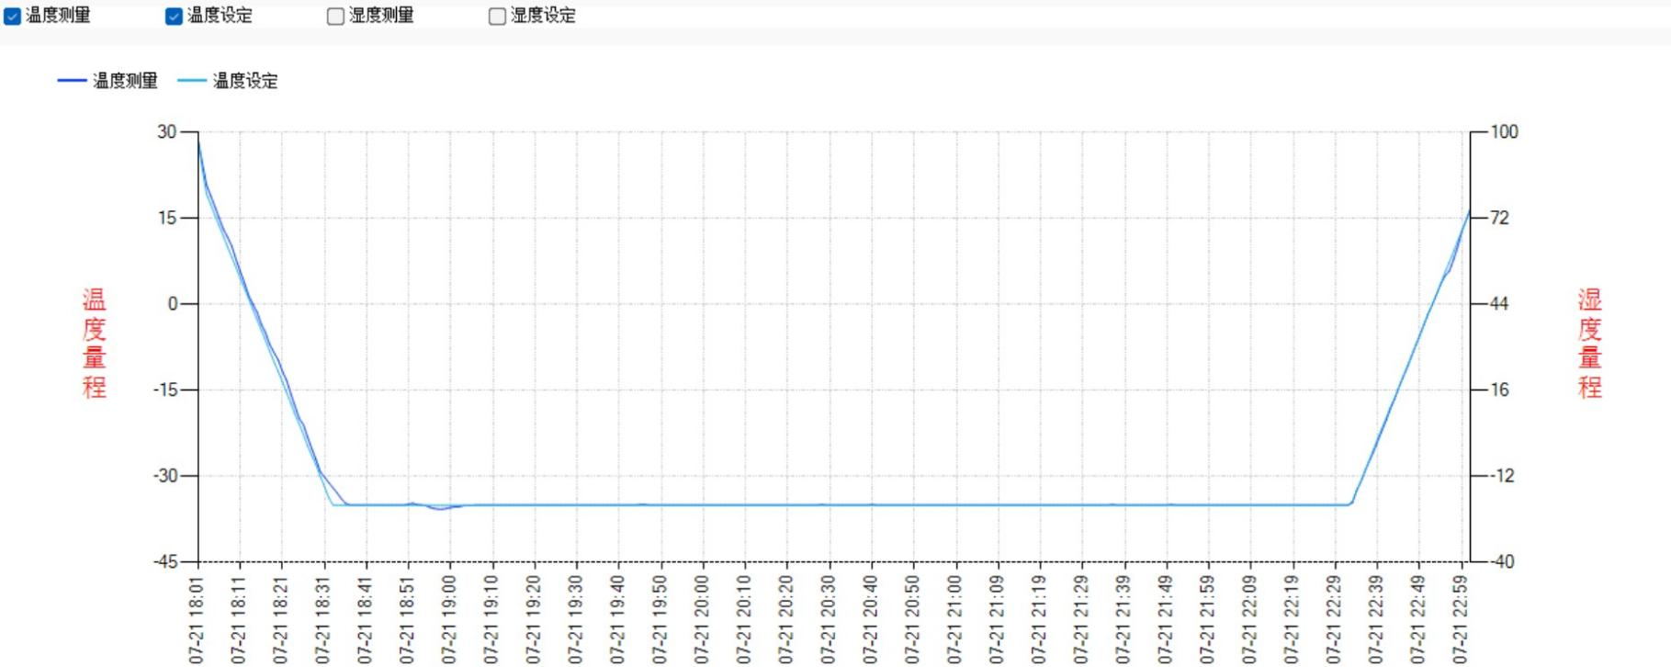
试验数据Test data-3
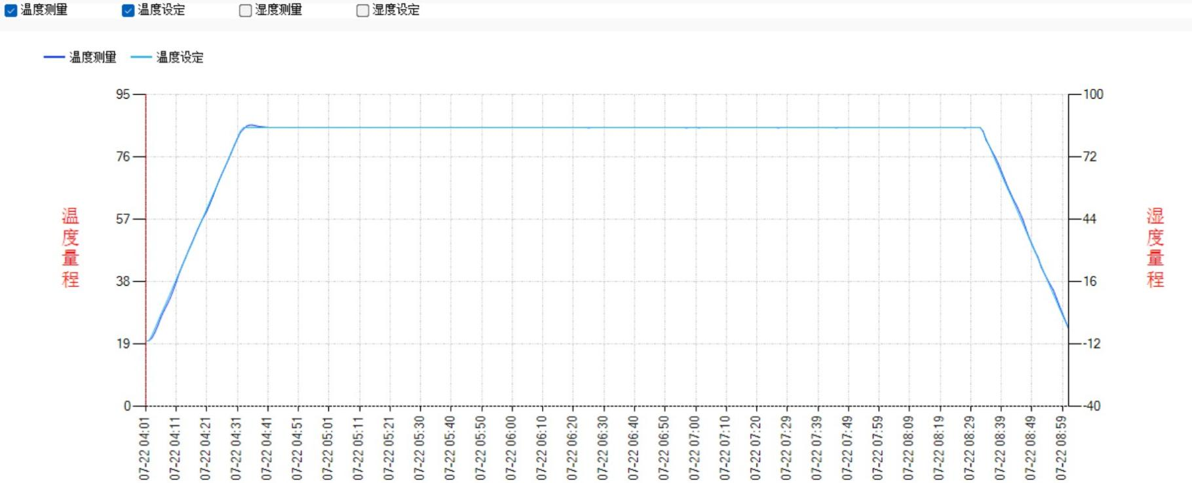
试验数据Test data-4
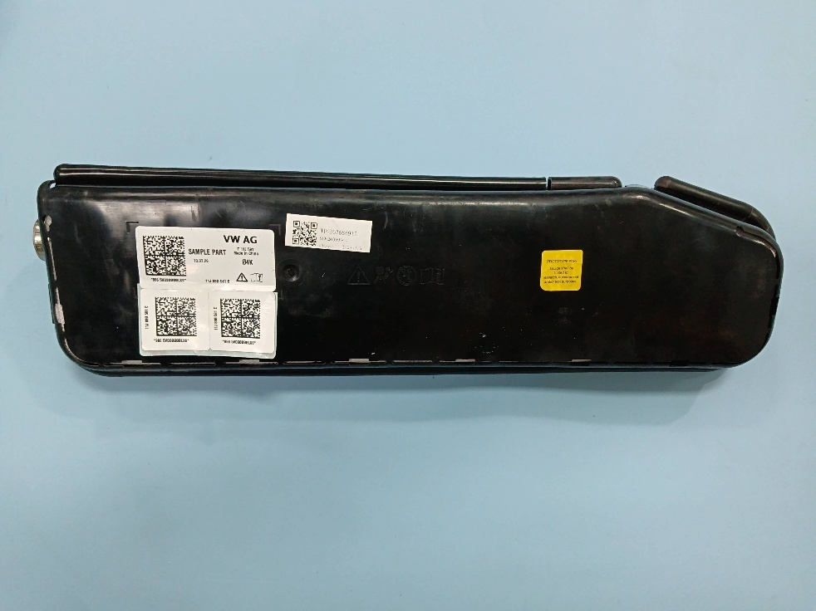TP-262686912试验后After test-1 | 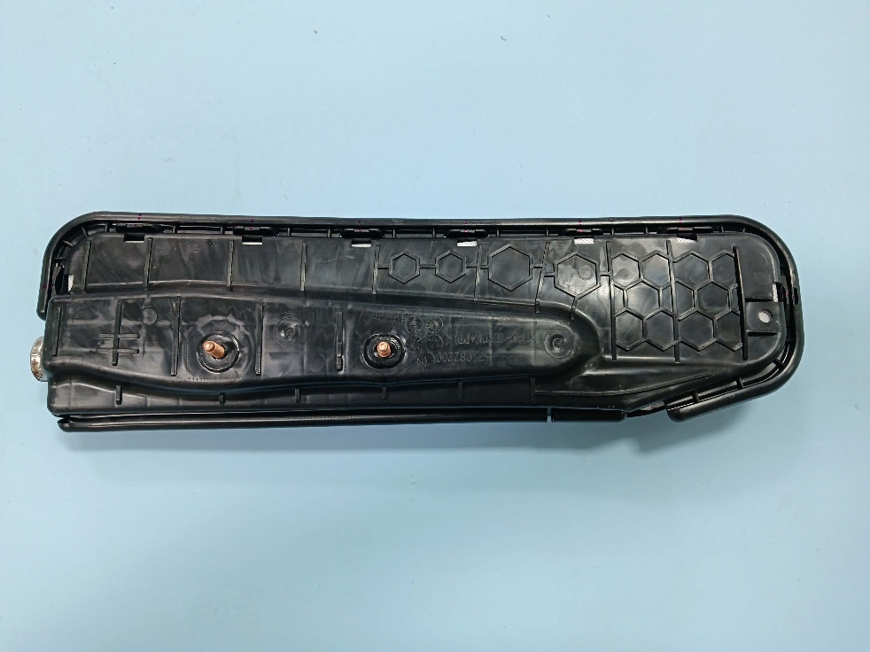TP-262686912试验后After test-2
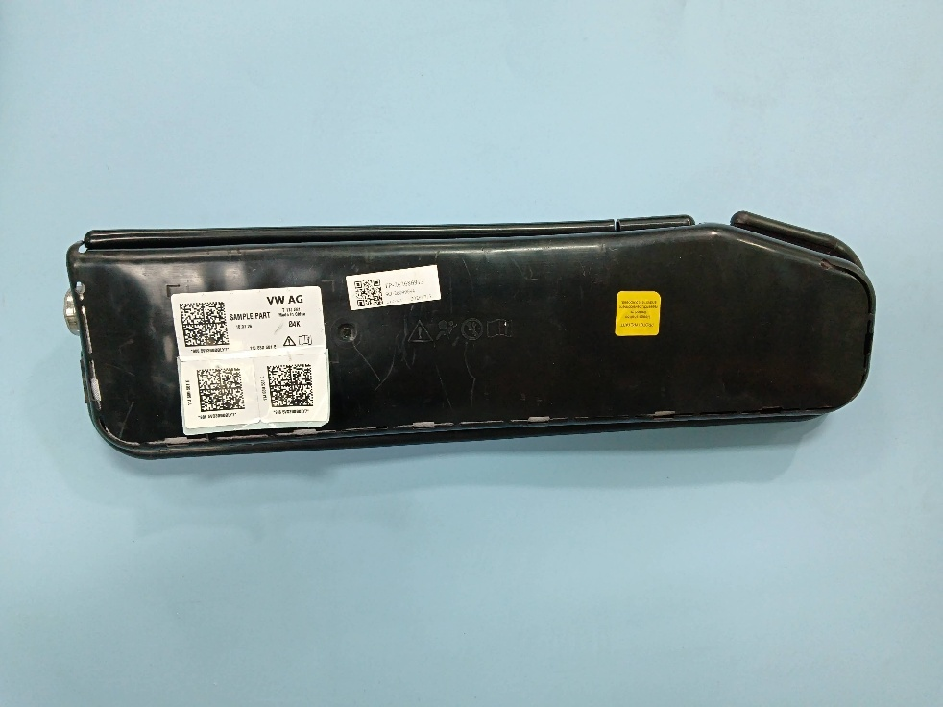TP-262686913试验后After test-1 | 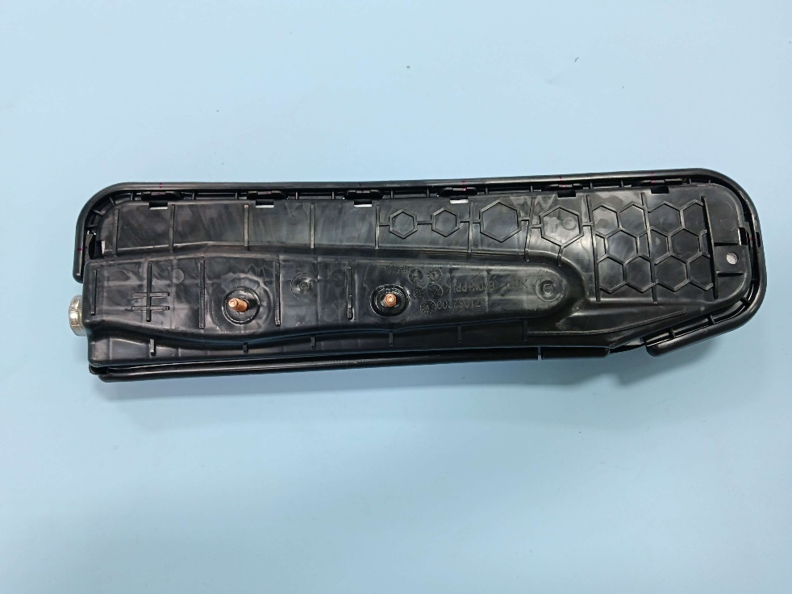TP-262686913试验后After test-2
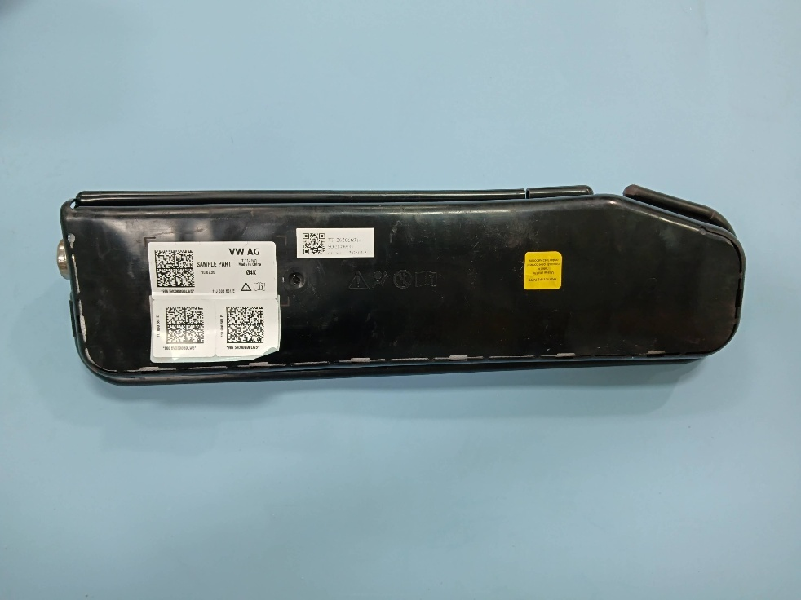TP-262686914试验后After test-1 | 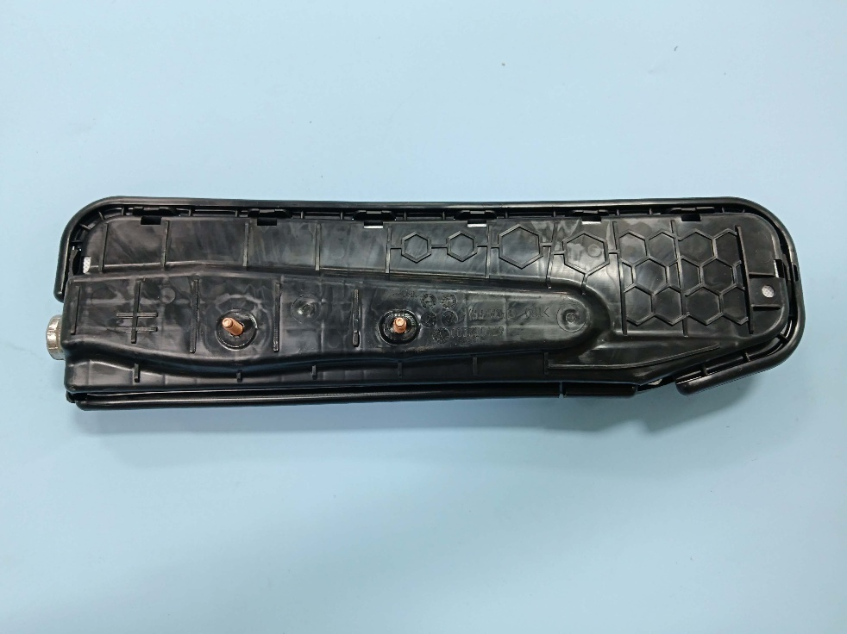TP-262686914试验后After test-2
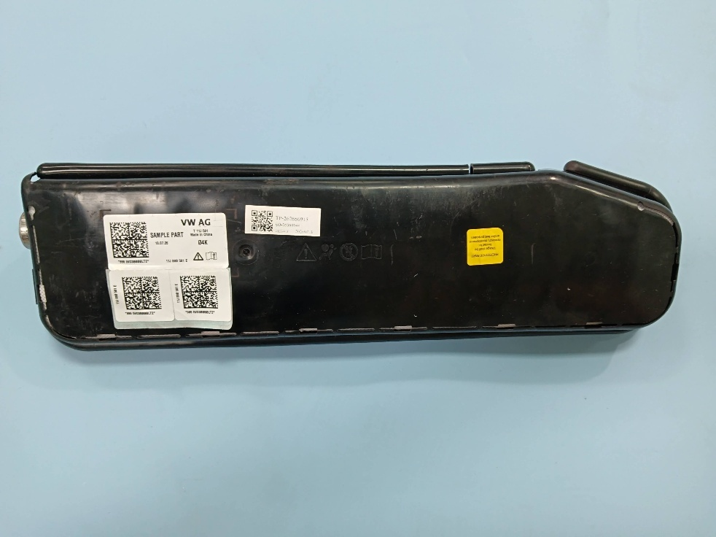TP-262686915试验后After test-1 | 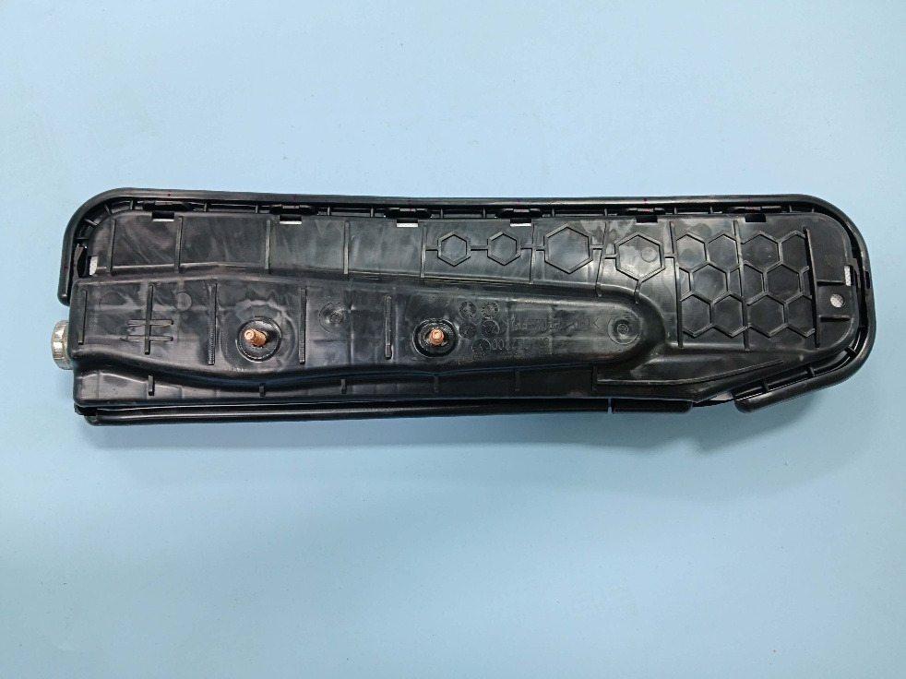TP-262686915试验后After test-2
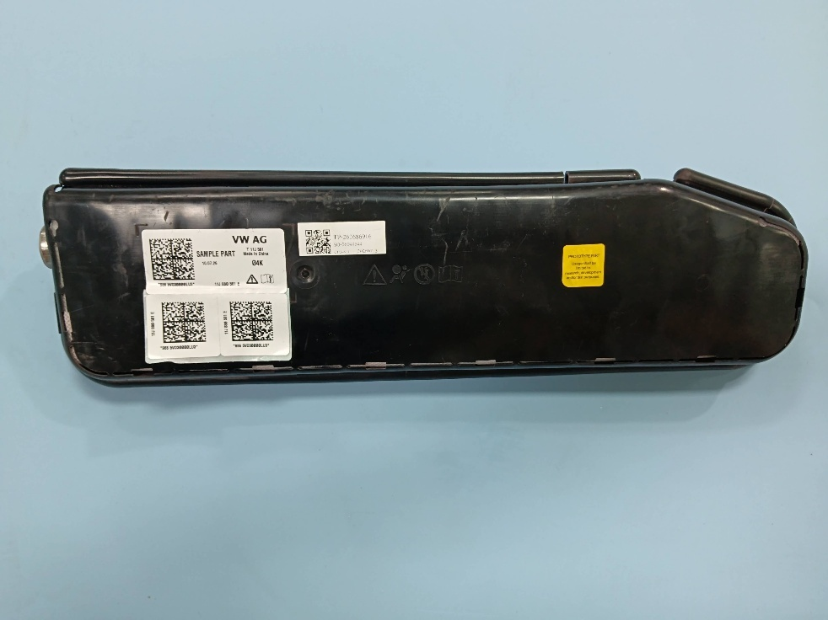TP-262686916试验后After test-1 | 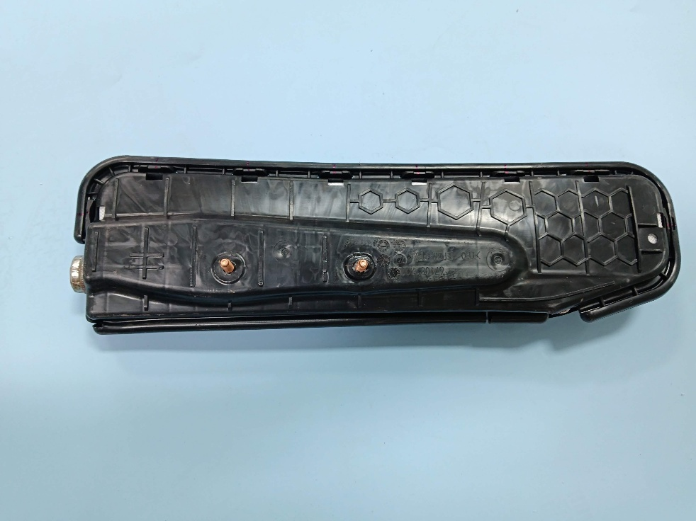TP-262686916试验后After test-2
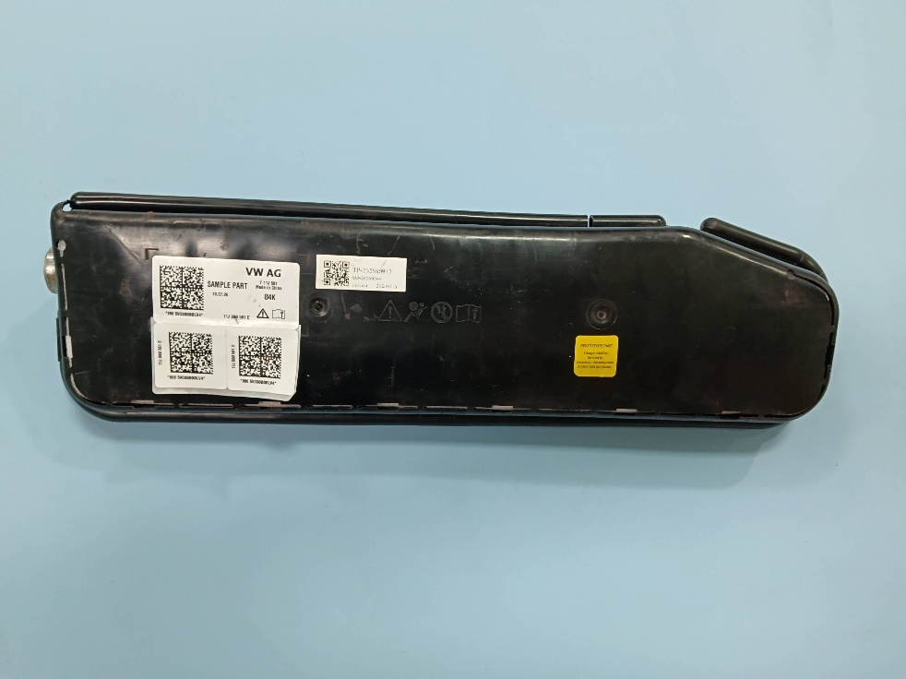TP-262686917试验后After test-1 | 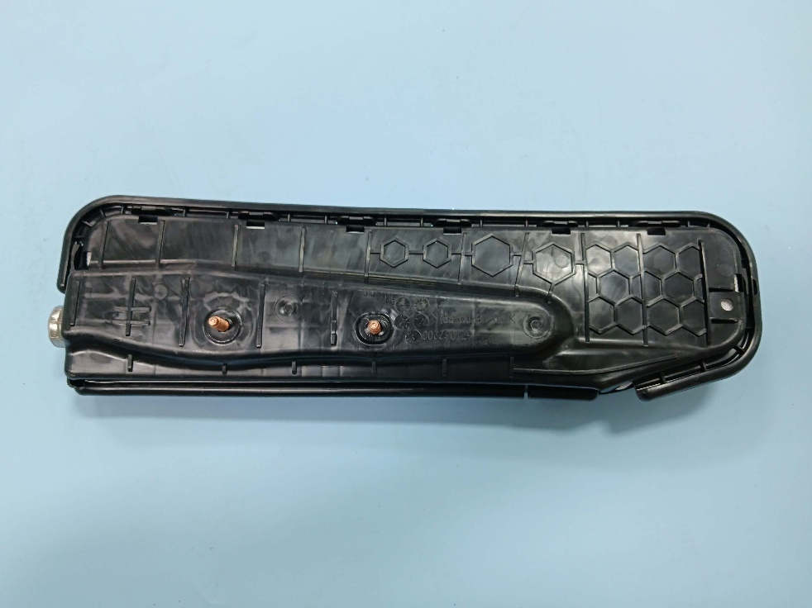TP-262686917试验后After test-2
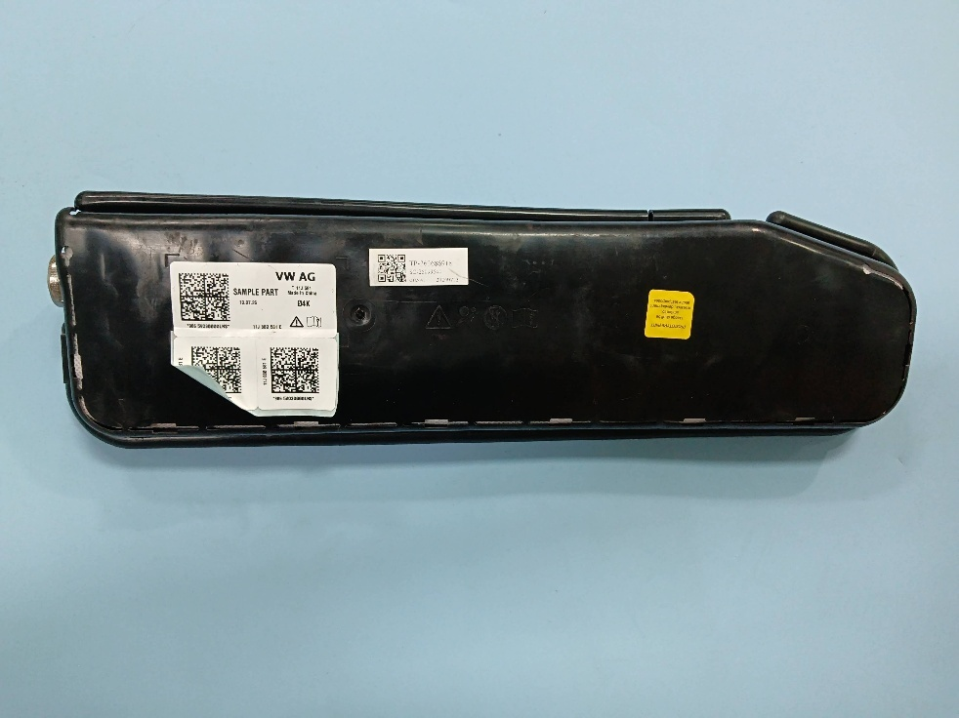TP-262686918试验后After test-1 | 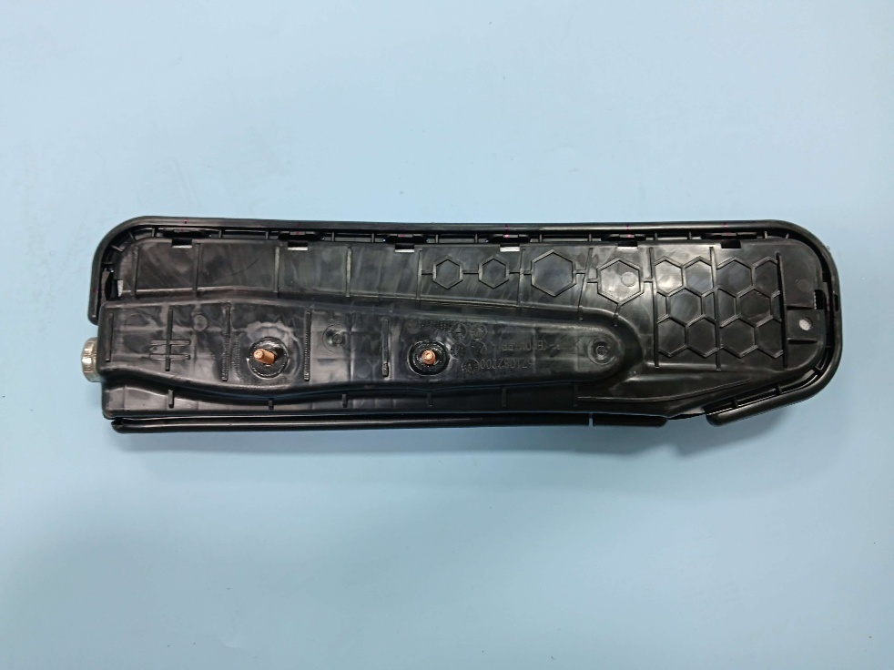TP-262686918试验后After test-2
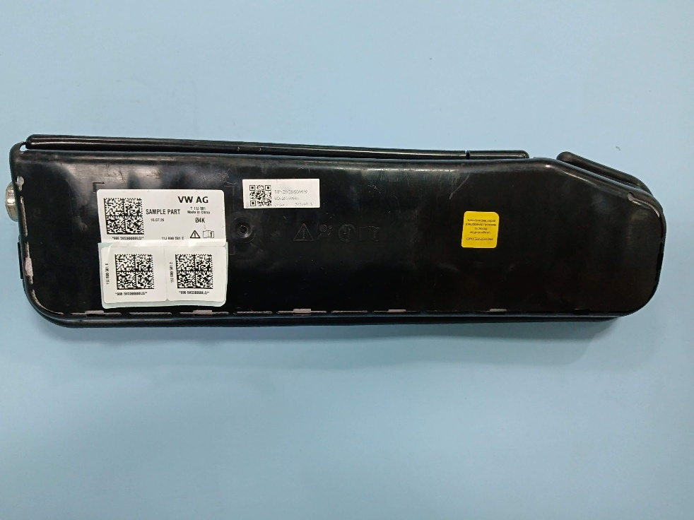TP-262686919试验后After test-1 | 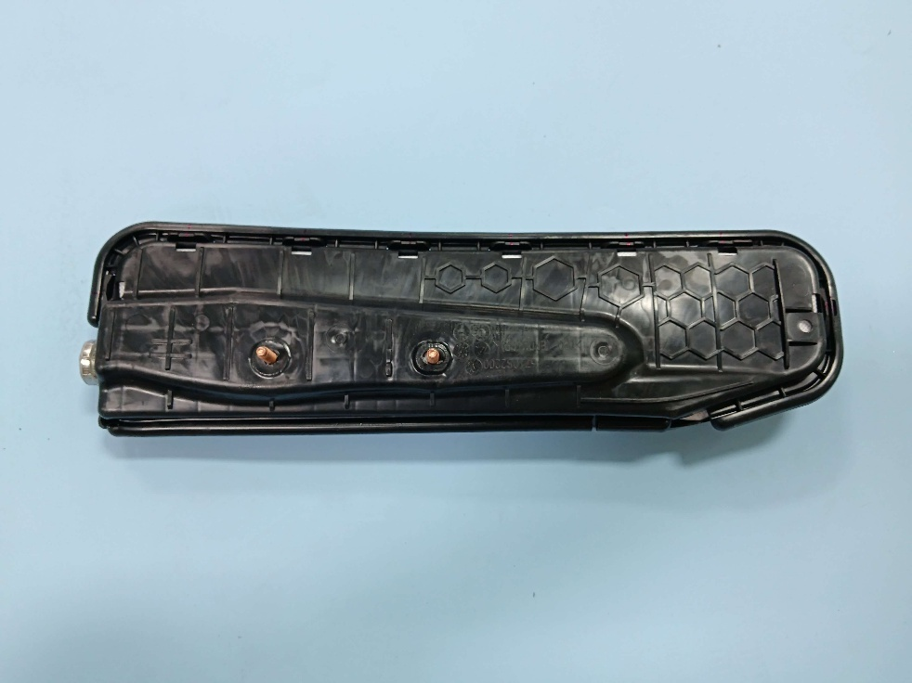TP-262686919试验后After test-2
备注：此报告所有/部分项目不在CMA资质认定范围内，出具的数据结果供科研、教学、企业内部质量控制、企业产品研发等目的用。
Note：Indicates the item(s)/method(s) is (are) not in CMA accreditation scope, the testing data and result is just for scientific research, education, internal quality control and product development etc.

检测报告无批准人签字及“检验检测专用章”无效，本报告检测结果仅对被测样品负责。实验室不负责抽样，本报告检测结果仅适用于收到的样品。未经CTI书面同意，不得部分复制本报告。无‘CENTRE TESTING INTERNATIONAL’数字证书签章的电子版报告视为无效。
The test report is effective only with both signature and Inspection & Testing Service stamp. The result(s) shown in this report refer only to the sample(s) tested. The laboratory has not been responsible for the sampling stage, the result apply to the sample as received. Without written approval of CTI, this report can’t be reproduced except in full.
An electronic report without the signature of the ' CENTRE TESTING INTERNATIONAL ' digital certificate is considered invalid.
*** 报告结束End of Report ***

