Customer： | {{委托方名称}}
Address： | {{委托方地址}}
{{样品信息表}}
Test Item：Please refer to the following pages
Test Method：Please refer to the following pages
Test Result：Please refer to the following pages

编 制  Written by |  | 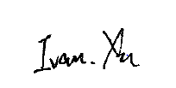 |  |  |  |  | 审 核  Inspected by |  |  | 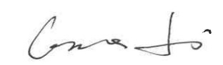
批 准Approved by |  |  | 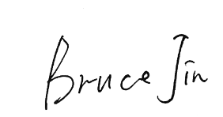 |  |  |  |  | 日 期Date | 2026.08.07
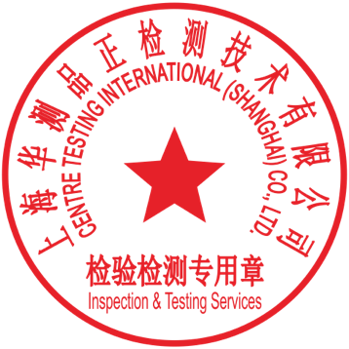 |  |  | Bruce Jin  Technical Manager
No.
{{实验室地址_en}}

Sample information table
{{样品清单表}}

Summary of results
{{结果汇总表}}
Note：
Pass：Meet the requirements
Fail：Does not meet the requirements
N/A：Not apply to the judgment or Not applicable

{{试验明细}}

Note：Indicates the item(s)/method(s) is (are) not in CMA accreditation scope, the testing data and result is just for scientific research, education, internal quality control and product development etc.

The test report is effective only with both signature and Inspection & Testing Service stamp. The result(s) shown in this report refer only to the sample(s) tested. The laboratory has not been responsible for the sampling stage, the result apply to the sample as received. Without written approval of CTI, this report can’t be reproduced except in full.
An electronic report without the signature of the ' CENTRE TESTING INTERNATIONAL ' digital certificate is considered invalid.

*** End of Report ***

