GLAZIA — WELCOME + HUB REGISTRATION
UI Design Specification & Figma Handoff
Prepared from the supplied editable SVG source assets and the supplied background image. Exact source values are distinguished from visual/placement guidance.
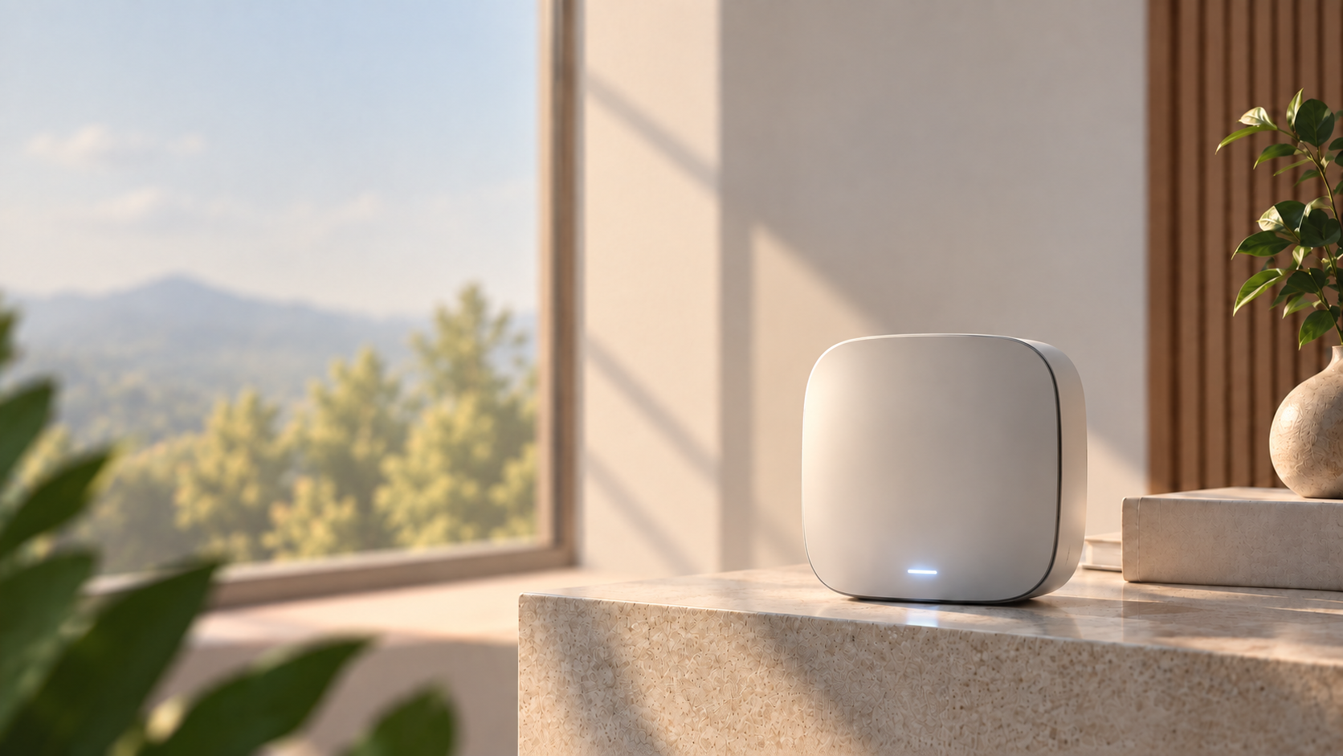
Background reference embedded in this document • 1672 × 941 px • RGB • no logo/footer overlay

At a glance
Master frame | Hero fonts | Core UI ink | Primary CTA
1280 × 720 px | Space Grotesk / Inter / IBM Plex Mono | #0D141A | #151D22

1. Master frame, background & transform
Item | Exact value | Source | Figma implementation
Artboard | 1280 × 720 px | Glazia_Welcome_Page_1280x720_Editable.svg | Frame = 1280×720
Background-only SVG | 1280 × 720 px | a356…2.svg | Full-bleed background layer
Embedded background PNG | 1672 × 941 px | embedded in a356…2.svg | Use at 1280×720; same 16:9 ratio
Background source in editable welcome SVG | 1536 × 939 px | BACKGROUND_PHOTO | Full-screen raster background
Root group transform | translate(0 -31.2500) scale(0.83333333) | DESIGN_1280x720 | Important when reconstructing source coordinates
Because 1672×941 is also 16:9, it fits the 1280×720 frame without distortion. The latest background reference is intentionally soft-focus while the hub stays readable.

Coordinate conversion
- For elements inside the full-page welcome SVG: rendered size = source size × 0.83333333.
- Rendered Y = source Y × 0.83333333 − 31.25; rendered X = source X × 0.83333333.
- This explains why numeric font sizes/positions in the source are larger than their visible 1280×720 values.

Background treatment
- Warm daylight / cream wall / light marble / wood slats / greenery.
- Mild depth-of-field blur in the environmental background; do not blur the main hub excessively.
- No logo and no bottom footer text baked into the background image.

2. Typography system
Element | Font | Weight | Size in SVG | Visible size @1280×720 | Color | Tracking
SMARTER LIVING | IBM Plex Mono | 600 | 16 px | 13.3 px | #5F6C78 | 5.2 px
Welcome to | Space Grotesk | 700 | 66 px | 55 px | #0D141A | normal
Glazia | Space Grotesk | 600 | 66 px | 55 px | #647184 | normal
Hero body | Inter | 400 | 27 px | 22.5 px | #68747D | normal
Get Started | Inter | 600 | 22 px | 18.3 px | #FFFFFF | normal
Help | Inter | 600 | 20 px | 16.7 px | #0D141A | normal
Editorial lines | IBM Plex Mono | 400 | 18 px | 15 px | #5F6973 | 6 px
Footer | IBM Plex Mono | 400 | 13 px | 10.8 px | #F4F2ED | 4.5 px
Setup badge | Inter | 600 | 21 px | component scale | #151B20 | normal
Setup heading | Space Grotesk | 700 | 33 px | component scale | #0D141A | normal
Setup helper | Inter | 400 | 20 px | component scale | #68747D | normal
Setup OR CODE | Inter | 650 | 16 px | component scale | #252D33 | normal
Setup MAC | IBM Plex Mono | 400 | 16 px | component scale | #68727C | normal
Setup CTA | Inter | 600 | 21 px | component scale | #FFFFFF | normal

3. Color tokens
Swatch | HEX | Usage | Notes
 | #0A0B10 | Logo primary | GLAZIA logo / Vector.svg
 | #0D141A | Primary ink | Headlines + Help
 | #151D22 | Primary CTA | Welcome Get Started
 | #647184 | Secondary accent | Glazia wordmark
 | #68747D | Support text | Hero body / setup helper
 | #5F6C78 | Eyebrow | SMARTER LIVING
 | #5F6973 | Editorial text | A SAFER / BRIGHTER / TOMORROW
 | #56606A | Editorial line | Editorial rule
 | #F7F7F7 | Help surface | 86% opacity
 | #F4F2ED | Footer text | Footer copy
 | #D8D8D5 | Footer rules | Footer line
 | #252D33 | Setup label | OR CODE
 | #68727C | Setup data | MAC
 | #FFFFFF | White | Border / CTA text / QR surface
 | #F7F3EE | Setup gradient | 82% opacity
 | #EEEAE5 | Setup gradient | 72% opacity
 | #DCD9D5 | Setup gradient | 76% opacity
 | #20282C | Setup CTA gradient | Start
 | #10161A | Setup CTA gradient | End

4. Geometry, spacing, opacity & shadows
Token | Value | Where | Source
Base rhythm | 4 px / 8 px | Global | Glazia rhythm
Help pill | 125×52 rendered; source 150×62; radius 25.8 rendered | Help | HELP_BUTTON.svg
Get Started | 345.8×65 rendered; source 415×78; radius 32.5 rendered | Welcome CTA | Welcome-page SVG
Setup outer | 601×820 inside 621×840; radius 34 | Setup | Setup-card SVG
QR area | 333×310; radius 17 | Setup QR | Setup-card SVG
Setup CTA | 503×83; radius 42 | Setup | Setup-card SVG
Help opacity | 86% | Help surface | #F7F7F7 @ .86
Setup badge | 82% | Setup badge | White @ .82
QR surface | 96% | Setup QR | White @ .96
Setup card shadow | 0 / 10 / 14 • #171D21 @ 20% | Setup card | dx / dy / blur / opacity
Welcome CTA shadow | 0 / 8 / 10 • #000 @ 16% | Get Started | dx / dy / blur / opacity
Help shadow | 0 / 3 / 6 • #000 @ 10% | Help | dx / dy / blur / opacity
Setup soft blur | Gaussian stdDev 18 | Setup card | Available in source

5. Source asset inventory
File | Role | Canvas | Format | Key detail
Vector.svg | GLAZIA logo | 89×81 | Path vector | #0A0B10
Group(2).svg | Logo + hero + Get Started | 395×480 | Path vector | Standalone component
HELP_BUTTON.svg | Help pill | 125×52 | Path vector | 86% surface
FOOTER.svg | Footer rule + mono label | 424×15 | Path vector | 1.66667 px rule
EDITORIAL_MESSAGE.svg | Editorial block | 72×105 | Path vector | #56606A/#5F6973
a356…2.svg | Background-only | 1280×720 | SVG + embedded raster | 1672×941 PNG
Glazia_Setup_Card_Editable.svg | Hub registration card | 621×840 | Editable SVG | Vector QR + glass CTA
Glazia_Welcome_Page_1280x720_Editable.svg | Full welcome screen | 1280×720 | Editable SVG | Font CSS + full transform
The standalone path-only SVGs do not retain original font-family metadata. The editable welcome/setup SVGs explicitly define Space Grotesk, Inter and IBM Plex Mono, so those are the text families to use when making the path assets editable again.

6. Supplied component visuals
Group(2).svg  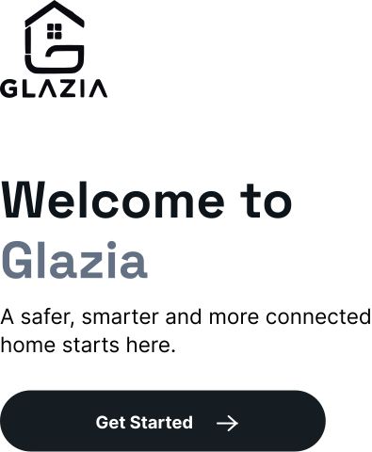 | HELP_BUTTON.svg  
Vector.svg   | EDITORIAL_MESSAGE.svg  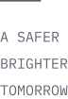

7. Hub registration / setup card
Part | Exact source geometry | Typography / color | Notes
Outer card | 601×820 at x=10,y=10; canvas 621×840 | 2 px white border; radius 34 | Gradient #F7F3EE → #EEEAE5 → #DCD9D5
Setup badge | 150×51 at x=240,y=49; radius 26 | Inter 21/600 #151B20 | White @82%
Heading | center x=310.5; baseline y=160 | Space Grotesk 33/700 #0D141A | Scan to Register the Hub
Helper | center x=310.5; baselines 202/230 | Inter 20/400 #68747D | Two lines
QR area | 333×310 at x=144,y=292; radius 17 | #FFFFFF @96% | Vector QR
OR CODE | center x=310.5; baseline y=633 | Inter 16/650 #252D33 | Outlined text in some exports
MAC | center x=310.5; baseline y=664 | IBM Plex Mono 16/400 #68727C | Example address retained in source
CTA | 503×83 at x=59,y=701; radius 42 | Inter 21/600 white | Gradient #20282C → #10161A
The setup card source is 621×840. A proportional display around 420×568 on a 1280×720 screen is approximately a 0.676 scale of the source; exact screen placement is composition-dependent and not stored in the standalone component.

8. Welcome-page placement map
Element | Source position / size | Rendered @1280×720 | Style | Notes
SMARTER LIVING | x=98, baseline y=228 | x≈81.7, baseline≈159.0 | 13.3 px mono | Scaled by root transform
Welcome to | x=98, baseline y=307 | x≈81.7, baseline≈224.6 | 55 px Space Grotesk 700 | Primary headline
Glazia | x=98, baseline y=384 | x≈81.7, baseline≈288.7 | 55 px Space Grotesk 600 | Accent #647184
Hero line 1 | x=98, baseline y=442 | x≈81.7, baseline≈337.1 | 22.5 px Inter 400 | Support copy
Hero line 2 | x=98, baseline y=478 | x≈81.7, baseline≈367.1 | 22.5 px Inter 400 | Support copy
Get Started | x=98,y=526; 415×78 | x≈81.7,y≈407.1; 345.8×65 | 18.3 px Inter 600 | Radius≈32.5
Help | x=1340,y=20; 150×62 | x≈1116.7,y≈−14.6; 125×51.7 | 16.7 px Inter 600 | Root transform applied

9. Figma implementation rules
- Frame: exactly 1280×720 px. Background: full-bleed 1280×720 image, no distortion.
- Logo: use Vector.svg or the editable logo group. Do not redraw or approximate the GLAZIA mark.
- Text: keep editable; Space Grotesk for display/headings, Inter for UI/body, IBM Plex Mono for mono/editorial/footer labels.
- Components: Background, GLAZIA Logo, Hero Copy, Get Started, Help, Setup Card, QR Area, Editorial Message, Footer.
- Preserve the setup-card gradients, opacity, border, radius and shadow values from source rather than adding extra effects.
- Use the current background with mild softness; keep the hub and UI overlays readable.

10. Source notes & exactness
- The editable welcome-page SVG is an exact 1280×720 SVG and includes text elements, font-family CSS, positions, fills and the root transform.
- The setup-card SVG is an exact 621×840 component and includes text styles, gradients, card geometry, vector QR content and CTA geometry.
- Path-only component files do not preserve their original font metadata; their vector geometry is exact, while text font reconstruction uses the explicitly documented Glazia families.
- The background image embedded in this document is the logo-free, footer-free 1672×941 background extracted from the supplied background-only SVG.
GLAZIA DESIGN HANDOFF • 1280 × 720 • Figma-ready reference

