## Task for Citizens Monitoring – Northeast Ohio TDS Monitoring

## QQ

1. What system will we do OCR on? (Pi, VmWare Linux?)

## DELIVERABLES

|  |  |  |
| --- | --- | --- |
|  | Flow that receives emailed pictures and invokes and processes the data with steps to form OCR steps   * Checks for a picture with the temp data and a picture with the TDS data. * NODE Convert image to ?? * NODE Read OCR * Output OCR text.   This data is published  Failures send an alert email back to the submitter and to the system manager. |  |
|  | Flow that monitors the stream   * Provides a **sanitycheck** on the data ensuring it is from the correct location, is from a registered data source and that numbers are in acceptable ranges. * Applies a calibration correction * Compares to previous values from this location. Alerts if the values are significantly different. |  |
|  |  |  |
|  |  |  |
|  |  |  |
|  |  |  |

* Node that invokes the OCR command line software and returns the OCR data.
* A custom function that takes the OCR data and creates

|  |  |  |
| --- | --- | --- |
|  | Document all problems with docs you have used.  Include the document name, page and issue. |  |
|  | Build a form to enter the salinity data manually.  Data should include   * reporting location ID (9 digit ID) * TDS in PPM * Temperature in degrees F | This is for testing nodes  See *Creating Custom Forms* Guide. |
|  | Develop a functionset and function   1. sanityCheckTDS() is in a range and temperature is in a range. | See *Creating Custom Function Sets.* |
|  | Pick a collection container that can be have a label attached to it with the reporting location ID. | ?? Bonnie |
|  |  |  |
|  | Install all programs needed for OCR on a Unix system. |  |
|  | Try OCR reading and try to read the meter from the command line. |  |
|  |  |  |
|  |  |  |
|  |  |  |

## NOTES

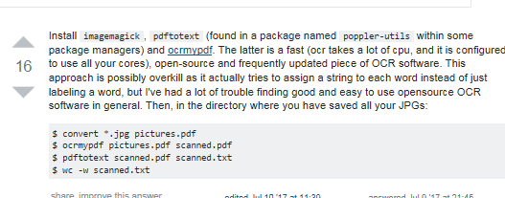

1. sudo apt-get update
2. sudo apt-get install imagemagick
3. sudo apt-get install pdftotext