## Backing up to the GLDW Backup Server

* Run the ***backupContainer*** administrative action from the Android UI (This will place a copy of the backup in the ***local container*** ***vdab/backup*** directory as well as the **backup.gldw.org server vdab/backup** directory

## Making a backup of the Backup

* 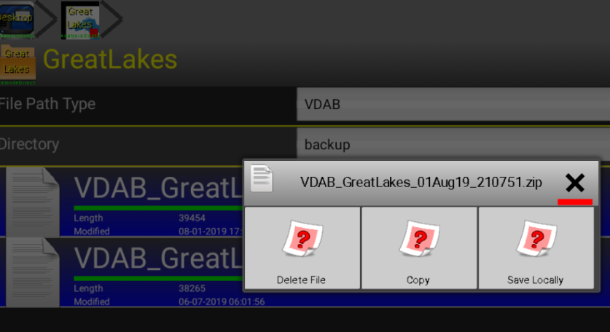After running the ***backupContainer*** use the VDAB Android file manager go and copy the desired backup
* 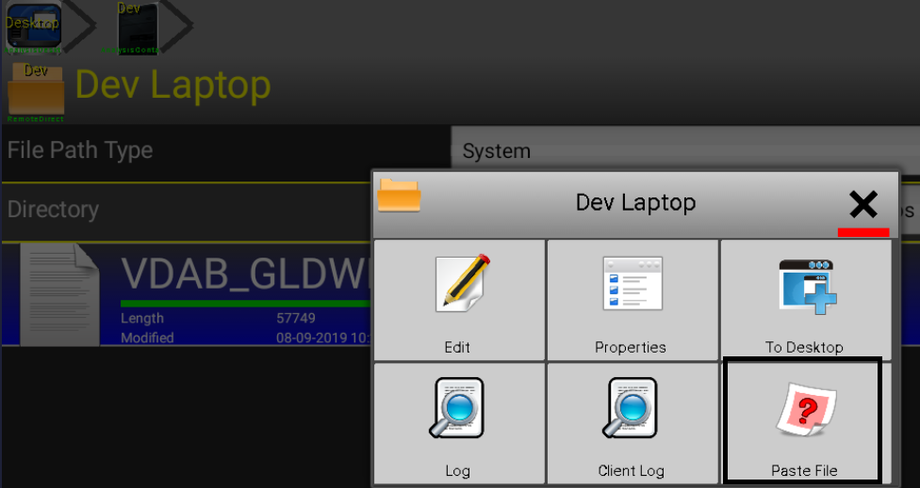Goto the VDAB server where you wish to copy the file to and paste it once you have gone to the desire directory (