# September 15, 2019 5:50AM: High Algae at Edgewater Beach

At about 5:50AM on September 15th the values for blue green algae and chlorophyll at Edgewater Beach spiked suddenly and stayed high for most of the day. 24 hours later the value for blue green algae has gone down but is still elevated.

## Alert Screen from Incident on GLDW

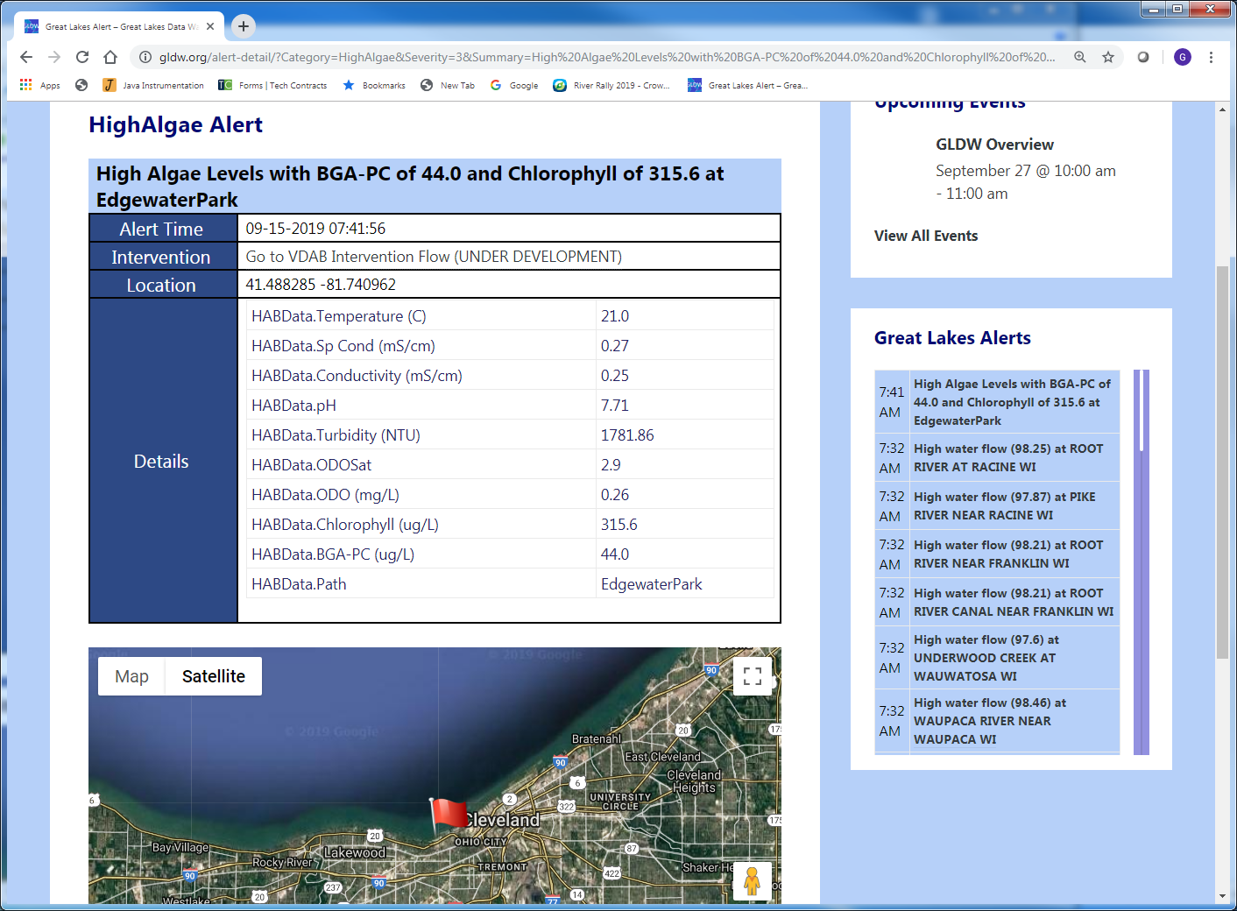

## Values on September 15th from GLDW

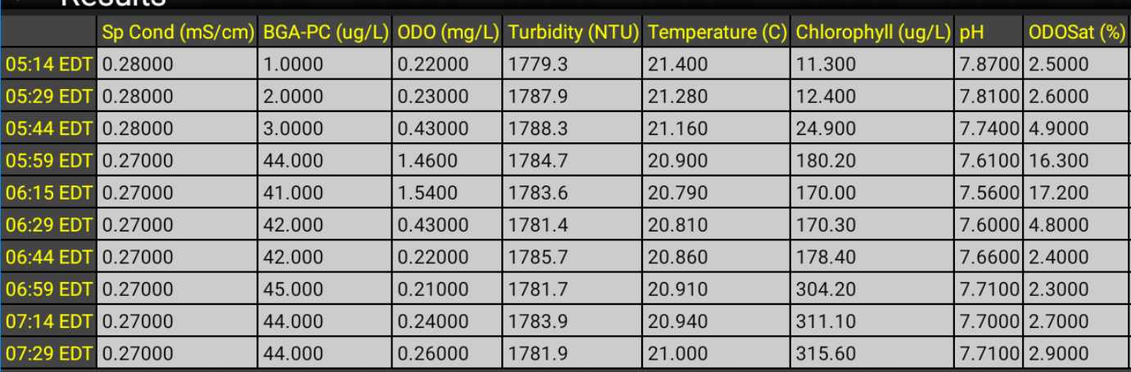

## Values on September 16th from GLDW

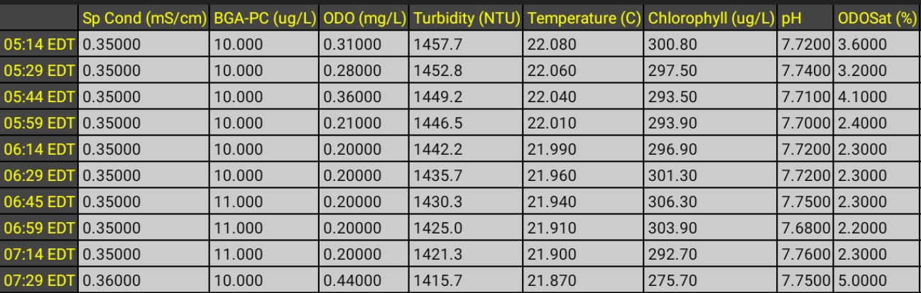

## Historical BGA data from WQDataLive website

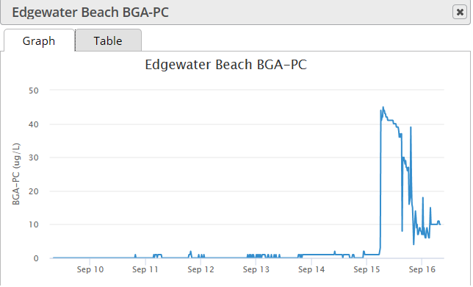

## Historical Chlorophyll data from WQDataLive website

