DESIGN: EnviroDIY Nodes

Great Lakes Data Watershed (gldw.org)

Instrument Toolkit Program

Revised: June 18, 2019

# Overview

The Great Lakes Data Watershed (gldw.org) Instrument Toolkit program provides software and hardware components that can be assembled to build low-cost customized environmental monitoring instruments and stations.

After researching available options, it has been determined that the EnviroDIY Mayfly board is an excellent building block for construction of these stations.

**This document describes the design of VDAB processing nodes that enhance the integration of VDAB with the Stroud tm Water Research Center’s Mayfly data logger board and their MyWatershed environmental data repository.**

|  |  |
| --- | --- |
| Node | Description |
| MayflyControlService | This node can be used to control and configure a sketch. Initially it will only be used to control the type its connectivity to a VDAB server.  A corresponding sketch will be developed which supports handling this control data from a serial port or using HTTP to the Mayfly. |
| MayflyParseFunction | This node takes input received from a Mayfly received using MQTT, HTTP or Serial Input and parses and interprets the data. A standard VDAB data event is created. |
| EnviroDIYTarget | Publishes environmental data to the EnviroDIY MyWatershed data repository |

# EnviroDIYTarget

## ZWave Luminance Sensor to EnviroDIY Repository

VDAB many different types of data sources including ZWave based sensors. In this example flow luminance data from a AeoTec environmental sensor can be sent to an EnviroDIY ODM2 Data Repository.

## Smartphone TDS Data with Prevalidation

VDAB can be used to validate citizen data prior to publishing it to EnviroDIY. This flow illustrates receiving citizen data in a structured email. Data is only published to MyWatershed after it is validated and determined to be reasonable. Emails are sent to the originator if the data is questionable.

# ParseMayflyFunction

The ParseMayflyFunction takes JSON formatted data received from any protocol and converts it to a proper VDAB event.

## ParseMayfly with HTTP

## ParseMayfly with MQTT

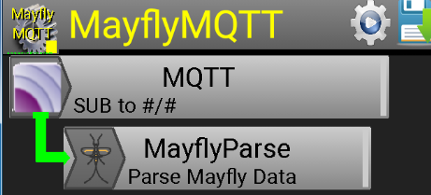

# Appendix: Node Documentation

# 

# 

# 