## Implicit constructor

The code below creates and instance called **osb3low** of the class **CampbellOBS3**

CampbellOBS3 osb3low(OBS3Power, OBSLowADSChannel, OBSLow_A, OBSLow_B, OBSLow_C, ADSi2c_addr, OBS3NumberReadings);

|  |
| --- |
|  |
| BaseClasses |  |
|  |  |
|  |  |

|  |  |
| --- | --- |
| LoggerBase | A logger creates an independent logging group. |
| LoggerModem | Works with the Tiny GSM library (???) |
| SensorBase | Base for all sensor objects. |
| VariableBase | The base for a variable. Each sensor may have more than one variable |
| dataPublisherBase | Base of a http data publisher |

## OtherClasses

|  |  |
| --- | --- |
| VariableArray | An array of variable bases. |
|  |  |
|  |  |
|  |  |

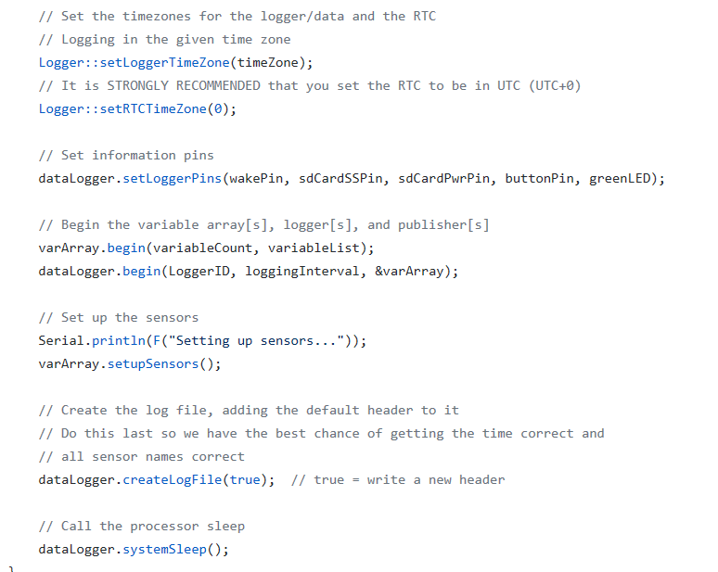

## ModularSensor Callabacks

All devices are created using the appropriate custom constructors.

SensorBase.cpp

|  |  |  |
| --- | --- | --- |
| Setup |  |  |
| Wake |  |  |
| Sleep |  |  |
|  |  |  |