## Setting Up the Arduino

1. Install Arduino 1.8.9
2. Open Arduino and set the sketchbook location
3. 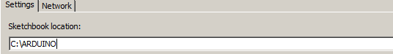
4. Set the additiona boar d manager to the location specified by EnviroDIY
5. Set the board to Enviro Mayfly
6. Unzip the entire repository into the sketch directory
7. Select an example to run it.

